Chapter 10 HOW DID LAW, ORDER, AND GROWTH DEVELOP IN OKLAHOMA?

I. DEFINE VOCABULARY. Write a brief definition of each word or term below.

1. Oklahoma_______________________________ 7. school lands ______________________________

2. implement (verb)_________________________ 8. bicameral _____________________________

3. provisional ______________________________ 9. endowment ____________________________

4. vigilante ________________________________ 10. subscription ___________________________

5. “dugout” ________________________________ 11. carpetbagger ___________________________

6. “soddie” _______________________________ 12. indemnity lands _________________________

II. MAP. Identify the Oklahoma counties and county seats that were in Oklahoma Territory in 1899. In the empty rectangles, make your keys with numbers 1-8 and letters A-Q, based on the map in the textbook.

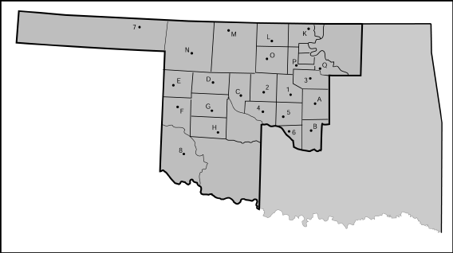

III. COMPLETE THEPARAGRAPHS ABOUT THE ORGANIC ACT, SCHOOLS, AND GOVERNORS.

1) The day after the first land run, settlers set up _________________________________ governments. Then the President signed the Organic Act in 1890. 2) It was important because it made the _________________ half of Indian Territory into the Territory of Oklahoma and created a more official ____________________. 3) It created ________ (number) counties and named 4)________________ as the territory capital. The Organic Act also established a Supreme Court and a 5) ___________________________ legislature with 39 members.

6) Early on, settlers paid for schools with a ____________________. 7) The early government set aside
property for ___________________ in Sections 16 and 36. In 1890, the first legislators placed a university at
8) _____________________ , an agricultural and mechanical college at 9)________________________, and a
school to train teachers in 10)___________________ (town names).

11) The first territorial governor was _________________________. 12) He was appointed to the job
and resigned after a year and a half. 13) The least controversial of the nine territorial governors was
______________________________. 14) The last territorial governor was ______________________________
15) His term was short, without a legislative session, because most of his work was smoothing the transition to
_____________________________.

IV . MATCH NAMES. Some match more than once and some do not match at all.

_____1. A Choctaw chief who coined the word “Oklahoma” A. George W. Steele
B. Allen Wright
_____2. Public Land Strip C. No Man’s Land
D. Chickasaw Nation
_____3. Cimarron Territory E. Cookson Hills
F. Pushmataha
_____4. Robber’s Roost

_____5. First Territorial Governor

V. TIMELINE. Each event has a letter. Refer to your textbook and put the letters above the timeline.

G H A F D B C E
/ / / / \ / / / / / \
1889 1890 1891 April 1892 June 1892 1893 1894 1895 1896 1900 1906

A. Cheyenne-Arapaho lands opened F. Gov. Seay estimated 7,600 people settled in
B. Kickapoo lands opened Cheyenne-Arapaho Lands
C. Congress ruled Greer County in Oklahoma Territory G. Harrison appointed the Jerome Commission
D. Cherokee Outlet opened H. There was a run for 900,000 acres in
E. The Big Pasture, wood reserve sold at public auction Lincoln and Pottawatomie Counties

VI. COMPLETE. Fill in the word or words that complete each sentence correctly.
- The Jerome Commission was also known as the ______________________________ Commission.
- Farmers found that the most suitable crop for the Cheyenne-Arapaho lands was _________________.
- When land openings began, many people waited for land to be opened in the ___________________.
- _______________________was a frontier photographer who took famous photographs of the land run.
- The last area opened by a land run was the _______________________Reservation.
- The Kiowa-Comanche-Wichita lands were opened and settled by _______________________(method).

- Officials reserved nearly 500,000 acres of Kiowa-Comanche-Wichita lands for _________________.
- Officials reserved more than 50,000 acres for ____________________________________________.
- After native people and European-Americans, the largest population settling in Oklahoma was ______________________________.
- The Oklahoma ______________________ Act ordered a lawsuit to determine the actual boundary between Oklahoma and Texas.
- ______________________ County was in dispute between Oklahoma and Texas.
- The county that became a part of Roger Mills and Ellis Counties was ________________ County.

