Chapter 11 WHAT WAS THE EARLY STATEHOOD MOVEMENT?

I. DEFINE VOCABULARY. Define each word briefly.

1. allotment__________________________________ 5. suffrage____________________________________

2. initiative__________________________________ 6. progressive_________________________________

3. referendum________________________________ 7. constitute__________________________________

4. sedition ___________________________________ 8. controversy ________________________________

9. Jim Crowism ___________________________________________________________________

10. Grandfather Clause _____________________________________________________________

II. FILL IN THE BLANKS. Write the word or words that complete each sentence correctly.
1. A leader who hoped to make Oklahoma Territory a black state was________________________, who founded ____________________________.
2. The man elected as president of the Sequoyah Convention was_______________________.
3. The capital of this state was going to be at ___________________________________.
4. The Hamilton Bill was also known as the _________________________________. It combined the
_____________________________ into a single state.
5. The constitution for the state was declared legal by President __________________________________.

IV. FILL IN THE TIMELINE. Each event has a letter. Put the letter with the right year.
(This timeline uses /// to show a jump in years. Do not put letters with those marks.)

///
1891 1892 1896 /// 1905 June 1906 Nov. 1906 Sept. 1907 Nov. 1907

A. First statehood bill introduced
B. Constitutional Convention in Guthrie held
C. First state officials elected
D. Oklahoma became a state
E. Oklahoma Enabling Act passed
F. First statehood convention in Oklahoma City held
G. Enrollment of Indians began
H. Five bills introduced into Congress to make twin territories one state

V. MATCH NAMES AND DESCRIPTIONS. Use some more than once.

______ 1. A Cherokee lobbyist A. James Norman

_______ 2. An attorney and builder of railroads B. William H. Murray

______ 3. A Creek chief C. W. C. Rogers

______ 4. Cherokee representative at Sequoyah Convention D. Pleasant Porter

______ 5. Choctaw representative E. Green I. Currin

______ 6. Seminole representative F. Charles N. Haskell

_____ 7. Creek representative G. John F. Brown

_____ 8. Chickasaw representative H. Green McCurtain

______ 9. First African American elected to political office

_____ 10. President of Constitutional Convention at Guthrie

_____ 11. The first governor of the state of Oklahoma

_____ 12. Legislator who introduced first civil rights bill into the Oklahoma legislature

V. COMPLETE SENTENCES. Write in the word or words that complete each sentence correctly.
1. The temporary state capital in Oklahoma City was in the______________________________________.
2. The first official act of the first state governor was to prevent ________________________________________________________________________
3. Haskell’s administration is best known for the removal of the ______________________.
4. Oklahoma City was ratified as the official state capital by the legislature on __________________________.
5. The greatest problem of early oil producers was ___________________________.
6. The ______________________Commission was given authority to regulate and govern the oil industry.
7. The Grandfather Clause was declared unconstitutional because of the _______________Amendment.
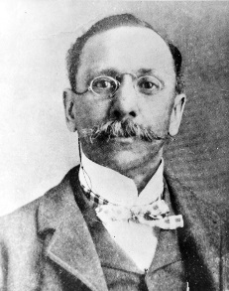
8. Who is this man on the left? Why is he important? __________________________________________
_______________________________________________________________________________
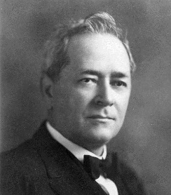

9. Who is the man at the right? Why is he important?

____________________________________________________

VI. IDENTIFY LEADERS. Match the name to the identification. Use one name twice.

_____ 1. Governor when capital was moved A. Dennis T. Flynn

_____ 2. First Commissioner of Charities and Corrections B. Thomas P. Gore

_____ 3. Congressional delegate who prevented moving the C. W. B. Anthony
capital to Oklahoma City
D. H. H. Munson
_____ 4. One of the first senators from Oklahoma
E. Kate Barnard
_____ 5. Second governor of Oklahoma
F. Lee Cruce
_____ 6. First woman to be elected to state office
G. Charles N. Haskell
_____ 7. A socialist leader

_____ 8. The governor’s secretary who removed the state seal
to Oklahoma City

