Chapter 12 HOW DID PEOPLE IN OKLAHOMA EXPERIENCE WORLD WAR I?

I. DEFINE VOCABULARY. Write a short definition for each word listed below.

1. impudent __________________________________ 5. subversive _______________________________

2. hysterical __________________________________ 6. indictment _______________________________

3. fundamental _______________________________ 7. yellow journalism _________________________

4. infiltrate __________________________________ 8. workman’s compensation ____________________

II. IDENTIFY PEOPLE AND DATES.
1. World War I began in Europe in the year _____________.
2. The U.S. became involved in World War I in the year ____________.
3. The Great War, or WWI, ended in November of _____________.
4. One of Oklahoma’s biggest contributions to the war effort was supplying ___________. (See the last few pages of Chapter 10 for this answer.)
5. Identify the man below and his achievement. ___________________________________________
_______________________________________________________________________________________

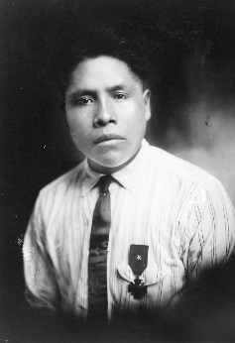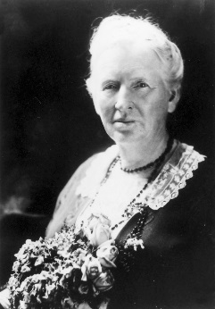

6. Who is the woman on the right? What are some of her accomplishments?
__________________________________________________________________________________________________________________________________________________________________________________
7. Oklahoma women were given the right to vote in the year ___________.
8. Congress ratified women’s suffrage for the whole country in the year ____________.
9. Oklahoma allowed Indians to vote since the year ____________.
10. Congress allowed Indians to vote in national elections after the year ____________.

III. COMPLETE. In the blank, write in the word that completes the sentence correctly.
1. The _______________Amendment to the Constitution of the United States allowed women to vote.
2. The first Congresswoman from Oklahoma was a member of the ________________ Party. (continued)

3. “Minerva Place” later became_______________________.
4. In this state, Indian men could vote before _______________________________ could vote.
5. The treaty that set the Texas boundary at the Red River’s south bank was the ________________Treaty.
IV. MATCH NAMES. Match the name to descriptions 1-10. Use some names more than once.

____ 1. First American woman to earn a doctor of philosophy A. Sawakla
degree B. Martin E. Trapp
C. Alice Mary Robertson
____ 2. Governor who broke the hold of the Ku Klux Klan on D. Alice Brown Davis
state government E. Jack Walton
F. E. K. Gaylord
_____ 3. First woman to preside over the U.S. House of Representatives G. Ann Eliza Worcester
Robertson
_____ 4. A governor impeached and removed from office

_____ 5. A governor who couldn’t succeed himself because he had served more than half of his predecessor’s term

____ 6. An orphanage for Creek Indian girls

_____ 7. Publisher of the Daily Oklahoman

_____ 8. First governor under whose administration Klansmen were convicted of crimes

____ 9. Second woman ever to be elected to the U.S. Congress

_____10. Chief of the Seminole tribe

V. TRUE or FALSE. Write “true” for true statements and “false” for false statements.

_____ 1. The first woman to be elected to Congress from Oklahoma was opposed to Women’s Suffrage.
_____ 2. Governor Robertson escaped impeachment by a single vote.
_____ 3. The two houses of the legislature worked in harmony during the Robertson administration.
_____ 4. Indians throughout the country were granted full citizenship as a result serving in the war.
_____ 5. Unlike the rest of the nation, Oklahoma had little unrest after World War I.
_____ 6. The Spanish Influenza was one of the worst epidemics in history.
_____ 7. Many social and labor reforms were enacted in the post-World War I period.
_____ 8. Economically, Oklahoma was thrust into a major depression in the 1920’s.
_____ 9. Although the southern bank of the Red River was established as the state boundary between
Oklahoma and Texas, Texas was given the mineral rights of the southern half of the river.
_____10. By 1920, the lynchings of African Americans by angry mobs had ceased in Oklahoma.

VI. TULSA RACE RIOT. At the end of Chapter 12, read the Spotlight section (3 pages) on the Tulsa Race Riot. Below, checkmark the 15 names/items which relate to the riot.

____1. Oklahoma National Guard ____11. detention camps ____21. Greenwood
____2. Col. W. J. Simmons ____12. church ____22. Sarah Page
____3. ammunition ____13. elevator ____23. impeachment
____4. Indian problems ____14. labor strikes ____24. bootleggers
____5. Dick Rambo ____15. Bolshevism ____25. Democrats

____6. Alice Mary Robertson ____16. Thanksgiving ____26. Claremore
____7. Tulsa Post-Dispatch ____17. Hollywood ____27. maids
____8. racial prejudice ____18. Dick Rowland ____28. Tulsa Tribune
____9. concentration camps ____19. Sarah Parker ____29. Col. L.J.F. Rooney
____10. telephone operators ____20. Convention Hall ____30. mob violence

