CHAPTER 13: WESTWARD EXPANSION
SECTION 1: THE WEST
- WHAT WAS, “THE WEST?”
  - People used to think of land before Mississippi River the Frontier, or the land that forms the farthest extent of a nations settle regions.
  - In the 1820’s land before the Mississippi River is all settled and no longer called the Frontier. The “WEST” is past the Mississippi River.
  - GREAT PLAINS
    - Areas that had little trees and lot of grassland. Farming it would be hard labor.
  - THE NORTHWEST
    - Land was fertile with lots of trees, but it was claimed by many countries, Great Britain, Russia, Spain. Today it is Oregon and Washington area
  - THE SOUTHWEST
    - Many wanted the Mexican Southwest known as the Spanish Borderlands (California, Texas, New Mexico, Arizona, Nevada, Utah).
    - Much culture there and good farm land.
- MEXICAN SETTLEMENTS
  - It was illegal for settlers in NEW SPAIN to trade with America. All goods made in NEW SPAIN had to be traded with EUROPEAN SPAIN.
  - Many groups of people in New Spain intermarried creating new groups of people called: CREOLES & MESTIZOS.
    - NATIVE AMERICANS
        - Missionaries from all over created cities. JUNIPERO SERRO in CALIFORNIA converted Natives to Catholic
        - Natives at the Catholic Mission would herd sheep, cattle, and raise crops
        - Many Natives died from diseases when Spain arrived
        - Native Americans shared their culture with Spanish settlements. Many Spanish used some of Native culture
  - Over time Spain becomes weak because it was so far away from NEW SPAIN. Eventually in 1821, Mexico declares independence.
  - Mexico started trading with the United States and began giving some Americans RANCHEROS, or owners of ranches because there was so much land.
    - Natives often raided American RACHEROS because it was their land and Mexico should not have given it to them.
    - 1850 the Natives land and population had been drastically reduced in Mexico (NEW SPAIN)
- MANISFEST DESTINY
  - Thought up by Thomas Jefferson where USA should own land ocean to ocean.
  - Came up with by John O’ Sullivan in his newspaper called the Democratic Review
  - Main reasons for Manifest Destiny:
    - Immigrants were coming in from other countries
    - the birth rate was expanding rapidly
    - Cheap Frontier lands for new opportunities
    - Economic Depressions and Population growth in the 13 states.

SECTION 2: TRAILS TO THE WEST
      - TRADERS LEAD THE WAY
        - Americans love the idea of moving west, these people who moved west were called, “TRAILBLAZERS.”
        - Some Americans went west because of the FUR TRADE to Oregon like John Jacob Astor. Astor was a Mountain Man or fur trapper.
          - John Jacob Astor went to where Lewis and Clark did. He set up a Fort there in Oregon called, Fort Astor in 1808. This led to the Oregon Trail eventually. He would have RENDEZVOUS with other trappers in Louisiana to trade fur.
        - SANTE FE TRAIL
          - Created by William Becknell, had a wagon full of goods and went from Missouri to Santé Fe.
          - Becknell wanted to go there because there were no manufactured goods in Mexico (NEW SPAIN).
          - Many Americans followed William Becknell’s Santé Fe Trail. Santé Fe becomes the stopping point for settlers going to California eventually
          - Mostly military supplies were moved along the Santé Fe Trail, dragoons protected it.

          - 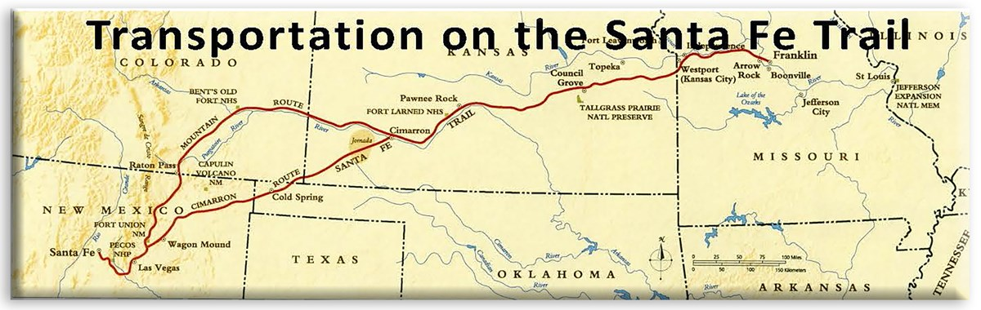
      - OREGON TRAIL
        - Many Americans want the Fur trade and to teach Christianity to the Natives in Oregon Country. Missionaries begin to head out that way like Marcus and Narcissa Whitman. They created the first settlement. Natives named the “Cayuses” attacked them and others that went out there but survived!
        - More and more settlers go out to the Whitman settlement and word spreads about OREGON FEVER!
        - OREGON TRAIL
          - This trail was 2,000 miles long from Missouri to Oregon.
          - People die from various things like snake bites, to disease, to native attacks, Dust from the trail in their lungs
          - The people on the Oregon trail did not use horses in their wagons, they used OXEN
          - 50,000 people reached Oregon by 1860
          - 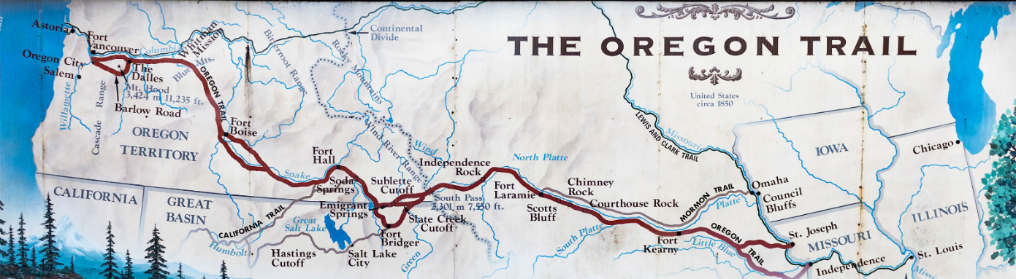
      - LIFE IN THE WEST
        - Life going west was hard, you died of disease, accidents, native attacks, and natural disasters.
        - John Bidwell & his wife Annie headed to California & led people on a trail where they met these hardships. Eventually he became a US Congressman and ran for President. Annie his wife pushed for Women Right to vote
        - WOMEN IN THE WEST
          - Women worked alongside men on farms. Women in the west got rights quicker than the ones in the East.
          - Wyoming in 1869 gave women the right to vote in their territory.
        - NATIVE AMERICANS & SETTLERS
          - Natives and settlers did not exactly get along. Settlers took land and did not ask to be on their land.
          - Gold was discovered in Oregon in 1855 and Chinese immigrants came, and a war broke out. Many Chinese and Natives died. Eventually Chinese immigrants and whites win, and peace treaties were made.
SECTION 3: CONFILICT WITH MEXICO
- Texas vs. Mexican War
  - Many Americans went to Texas for lots of land for cattle ranching. Including a man named Moses Austin & his son Stephen H. Austin went there because they would land.
  - Austin and his son led 300 Americans into Texas. Moses Austin died and his land in Texas went to his son Stephen H. Austin.
  - The only stipulation for coming to Texas and getting this land was they had to 3 things:
    - Ban Slavery (Slavery ban in Congress)
    - Convert to Roman Catholic (Christianity)
    - And Limit American Settlement
  - Texans would not ban slavery or convert or stop American settlement, so they revolted.
  - Antonio Lopez de Santa Anna (President of Mexico) eventually becomes dictator of Mexico
    - 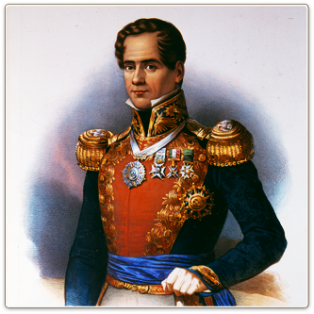
    - Considered himself the Napoleon of the West
    - Was a harsh dictator (or a one person ruler) , who decided to ban American settlement of Texas in 1830.
    - Made heavy import taxes on American settlers in Texas.
    - Decided to march to attack a mission in San Antonio called the Alamo
      - Mexico and Texas had the Battle of the Alamo & it was a complete slaughter of the brave 128 Texans, the battle lasted very short, but the Mexicans surrounded it for 12 days. Davy Crockett, Jim Bowie, and Col. William Travis were all heroes and all perished in the Alamo.
      - 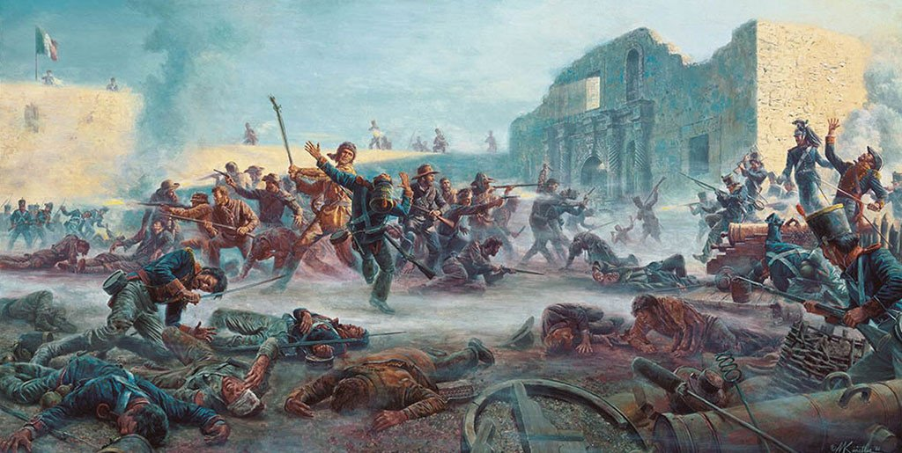
      - 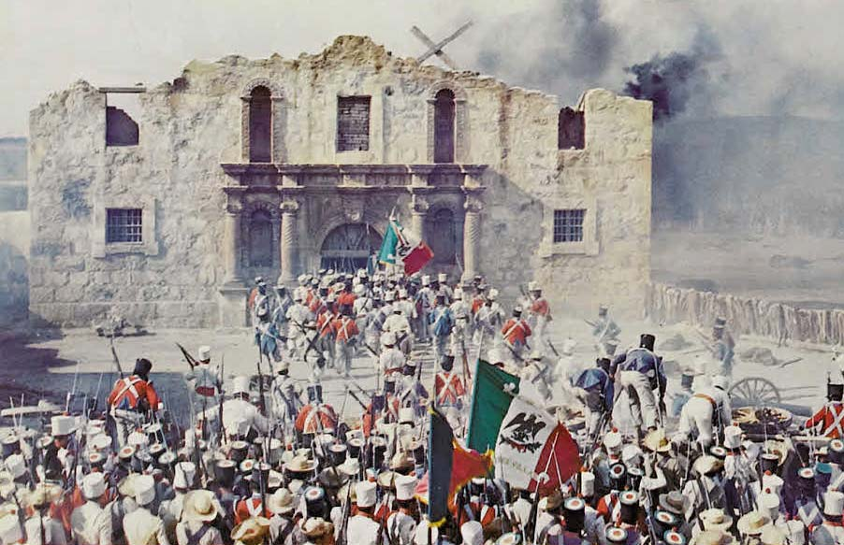
      - 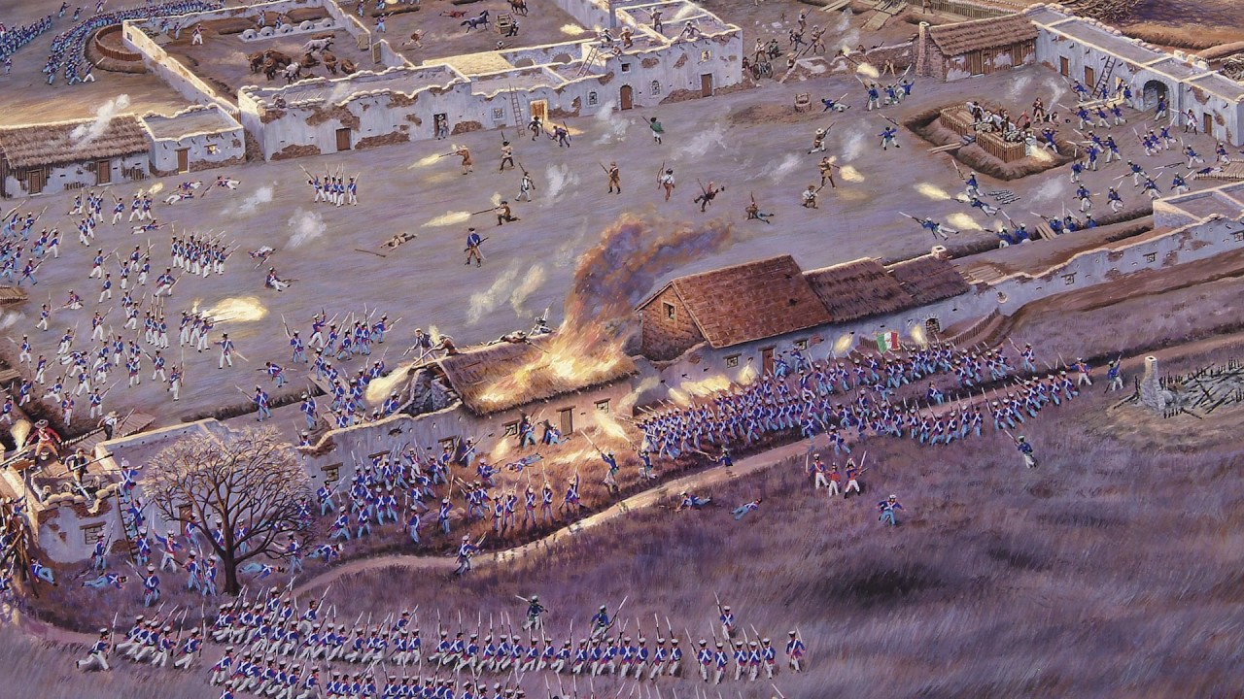
      - 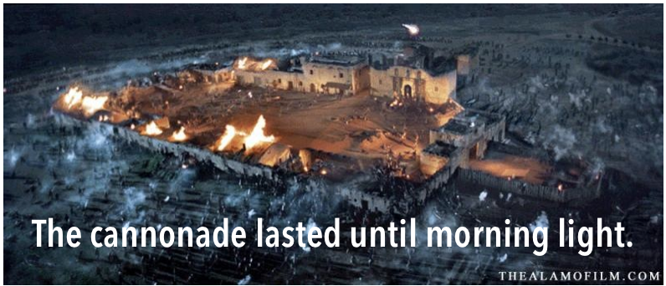
      - 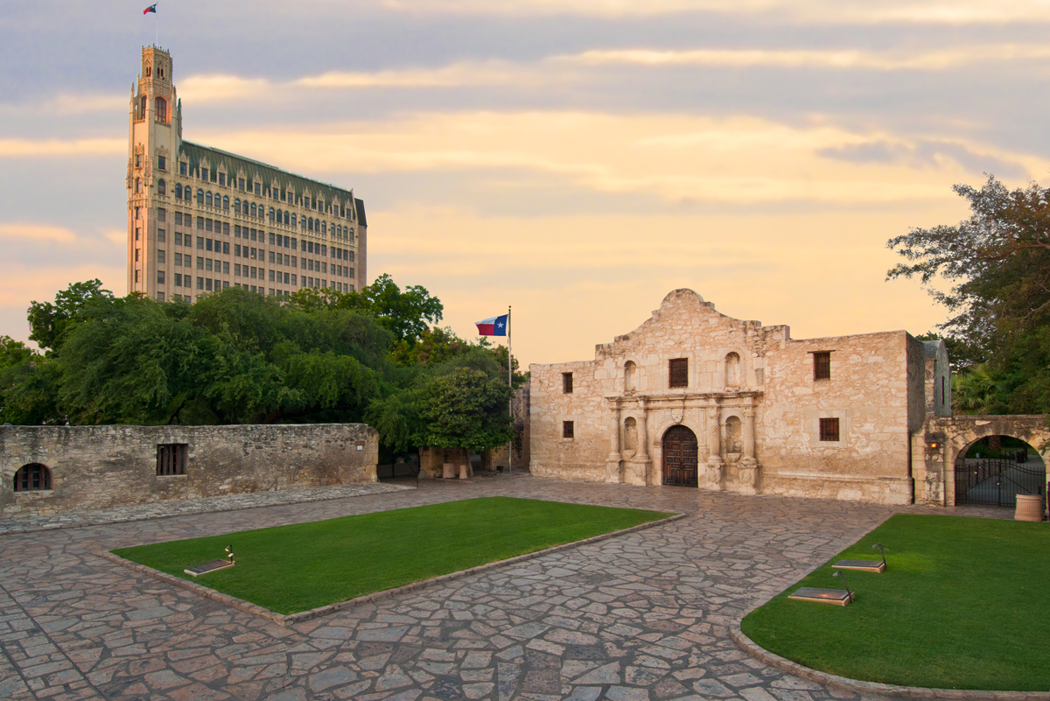
        - Jim Bowie, 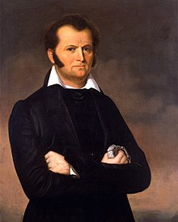
        - Col. William Travis, 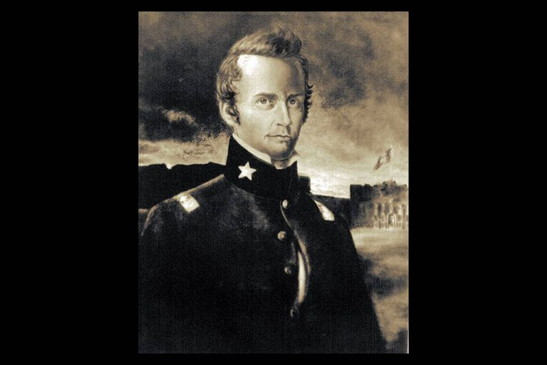
        - Davey Crockett 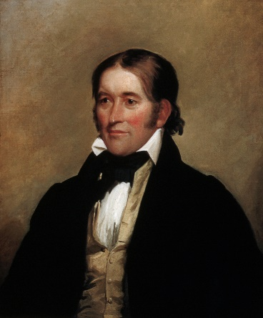 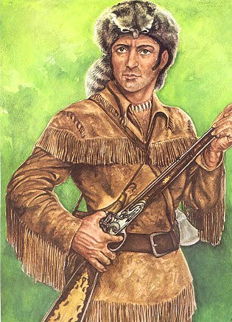
      - Slaves, women, and children inside the Alamo, mission was not killed. The slave of William Travis brought all of his letters he sent out and documents with him outside the fort and that is how we know the day by day account of the Alamo.
  - General Sam Houston avenged the Alamo and defeated the Mexican Army and captured Santa Anna forcing him to surrender and give Texas their Independence. He said a famous quote before the final battle, “REMEMBER THE ALAMO.” In 18 minutes, he defeated Santa Anna’s army and arrested him. Santa Anna signed over Texas and lost it.
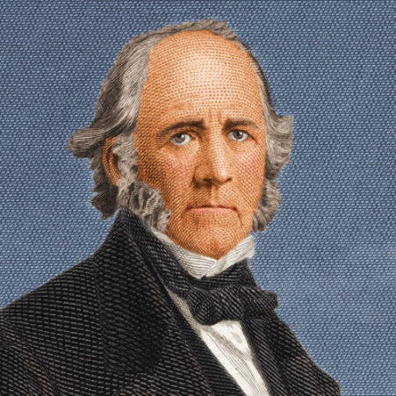General Sam Houston
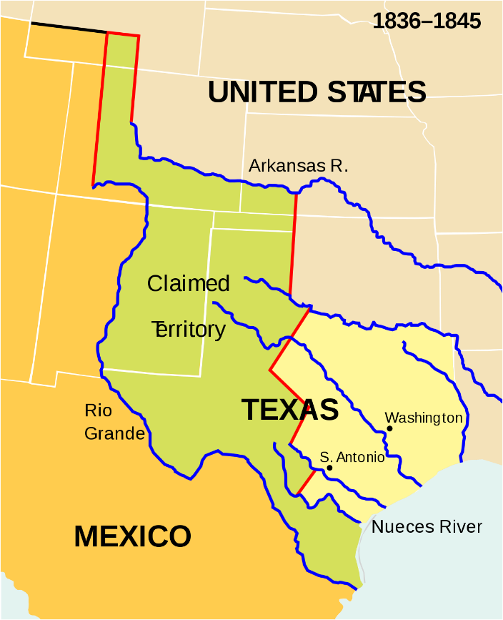
- ANNEXING TEXAS AND OREGON
  - Texas Annexation (Bringing into a place)
    - Given their independence, first President was Sam Houston
    - Texas was bankrupt and could not sustain an economy.
    - They asked to be annexed or part of the United States and was allowed in 1845 as a state.
    - America was split over whether it should be a state. Because it would be a slave state not a free state.
    - 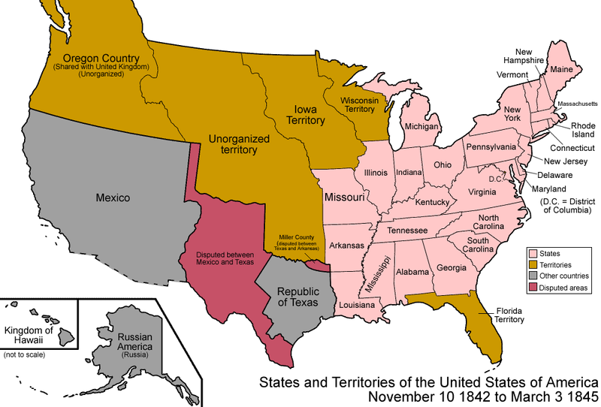
  - Election of 1844
    - President John Tyler did not favor Annexation, so he did not get to be President a 2nd time.
    - The Whigs nominated someone new, “Henry Clay” He wanted to avoid the Annexation debate, so he was not also elected.
    - Democratic candidate, “James K. Polk” said, “I want TEXAS & OREGON in the UNITED STATES” He won the election because of it.
    - Polk asked Great Britain to leave Oregon where it would be divided. USA got 49 degrees North. Eventually these states were: Washington, Oregon, and part of Idaho
  - 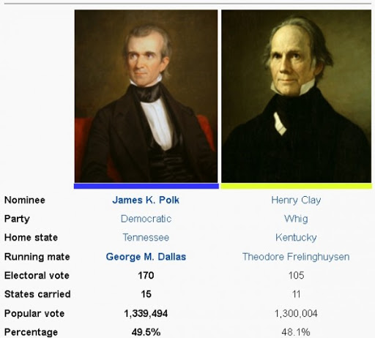
  - 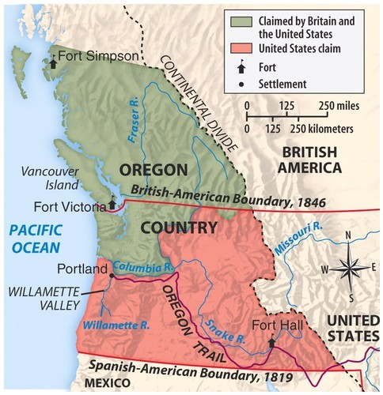
- THE MEXICAN AMERICAN WAR
  - 11th USA President James K Polk knew Mexico needed money after the Texas Mexican War. He offered them money for the area Rio Grande around Texas. Mexico said NO!
  - Polk offered to buy up California & New Mexico again Mexico said NO!
  - Polk decided he would provoke Mexico into a fight by sending General Zachary Taylor into disputed lands of Mexico and USA and try to get the Mexicans to start a fight. IT WORKED!
  - 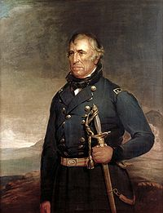General Zachary Taylor – FUTURE PRESIDENT
  - Mexicans attacked General Taylor, next day America declared war on Mexico
  - 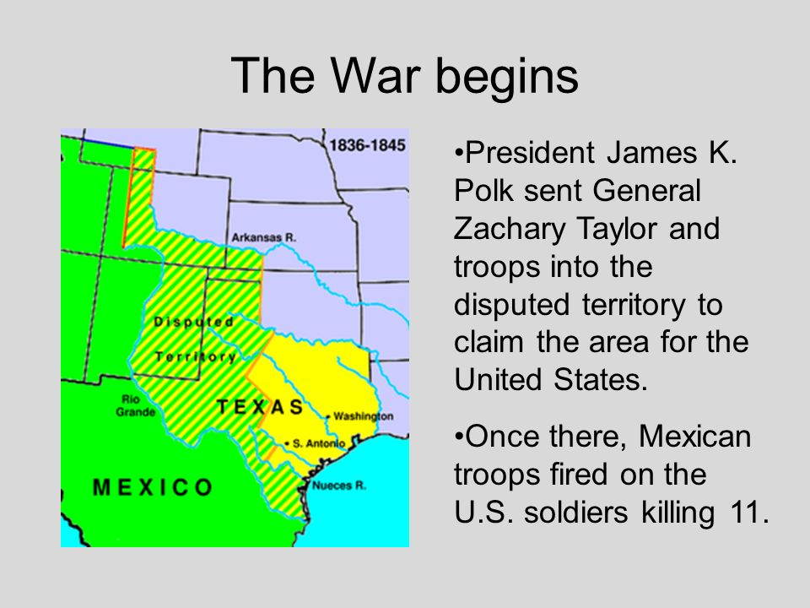

  - Overall the Mexican-American War was popular. Americans liked the idea of taking up arms and gaining more lands in west
  - Abraham Lincoln and some other Northerners did not like the war, said that we invaded and provoked it. Lincoln said “Polk that is not American soil.”
  - Polk ordered troops to invade the following areas: New Mexico, California. California then flew a grizzly bear flag and declared itself independent, John C. Fremont did this.
  - Fremont led the California rebellion and then joined the United States army.
  - 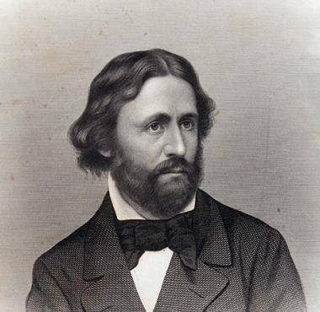 John C. Fremont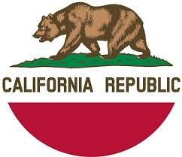
  - 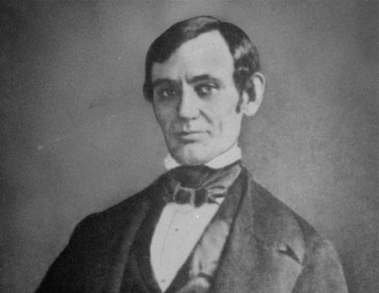 Young Abraham Lincoln
  - 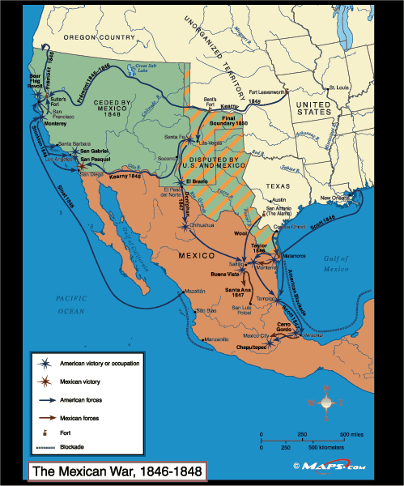
  - As the war went on Captain Zachary Taylor captured Mexico City, the capital of Mexico and the place where Santa Anna had his palace.
  - Captain Zachary Taylor and his men fought and won a huge battle against the Mexican army in the Capital of Mexico called, Chapultepec. Most of the Mexican army died that day. They are honored today.
  - After their defeat at Chapultepec, the dictator of Mexico Santa Anna fled after the major loss that near ended the war.
  - 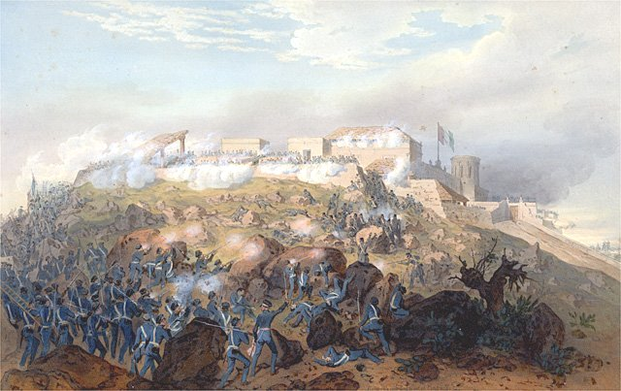
  - Battle of Chapulttepec Above
  - Invasion of Mexico City Below
  - 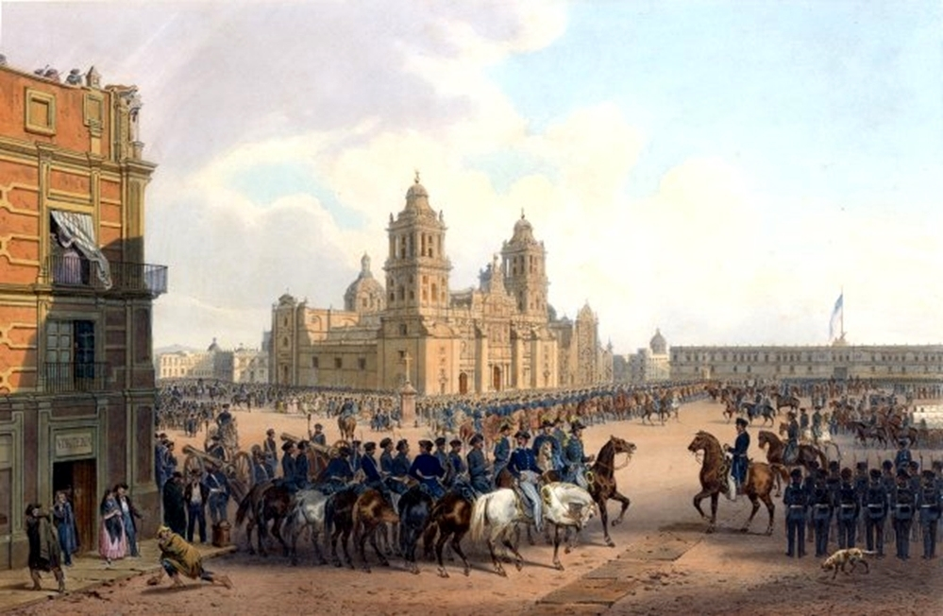
- ACHIEVING MANIFEST DESTINY
  - After the Americans occupying Mexico City for nearly 3 months. Santa Anna gave in. President Polk sent Nicholas Trist and General Winfield Scott to make the peace treaty called, “The Treaty of Guadalupe Hidalgo.”
  - TREATY OF GUADALUPE HIDALGO
    - Ended the Mexican American War
    - Recognized the Annexation of Texas
    - Allowed where America gets the Mexican Cession: California, Nevada, Utah, Wyoming, Colorado, Arizona, New Mexico
    - America gives Mexico 18 Million Dollars ($18,000,000) for the Mexican Cession
    - Also, America gives Mexico another 10 million Dollars (10,000,000) for the Gadsden Purchase: Arizona and New Mexico land.
  - 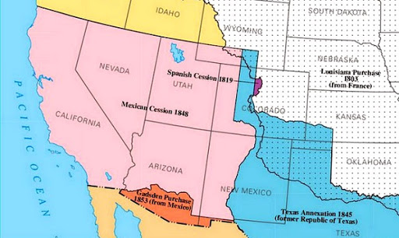

SECTION 4 : A RUSH TO THE WEST
      - JOSEPH SMITH, BRINGHAM YOUNG MORMONS SETTLE IN UTAH
        - Some Americans began to move west before the Mexican American war, one group were called, “Mormons.”
        - Mormons were a church called, “Church of Jesus of Latter-day Saints” founded by New York farmer, Joseph Smith in 1830.
        - 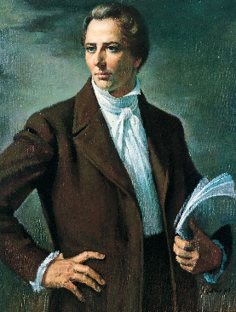
        - Joseph Smith wrote a version of the Christian Bible called the, “Book of Mormon.” He said that Heavenly visions showed him the path to writing this.
        - Mormons caught grief from their neighbors and believed that held equally.
        - Mormons believe in POLYGAMY or having more than one wife.
        - Mormons could not find peace where they lived, they moved from New York to Ohio to Missouri to Illinois.
          - In Illinois Joseph Smith their leader was murdered with his brother Hyrum Smith while in jail waiting on a trial.
          - An angry mob of 200 people stormed the prison and. The mob shot Hyrum Smith first in the face he yelled, “I am a dead man Joseph.”
          - Joseph Smith tried to defend himself with a pistol he picked up but was shot many times, he jumped out the window where he died in the streets after being mutilated.
        - 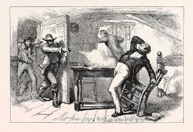
        - 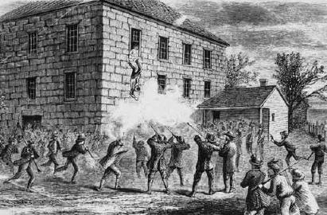
        - 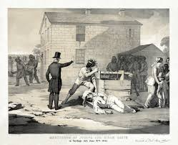
        - Joseph Smith was the mayor of a town called Nauvoo, Illinois. He ordered a newspaper printing company to shut down because they were anti-Mormon. As a result, the people called a vote to get him out of office. Instead they chose violence after a vote.
        - A new Mormon leader steps up after Joe Smith death, Bingham Young. He tells the Mormons that Illinois is no longer safe. He takes them in 1847 to Utah near the Great Salt Lake.
        - 15,000 Mormons took a long tough journey. With hardships and tough farming, they get back on their feet.
        - After the Mexican American War, Utah becomes a Territory. The Mormons had hardships in making Utah becoming a state, the Government of the United States told the Mormons no because Polygamy in USA was illegal, and Mormons wanted control of Utah,
        - After much arguing Mormons banned Polygamy and made things tough on Mormon way of life.
        - After 40 years, Utah becomes a state in 1896.
        - 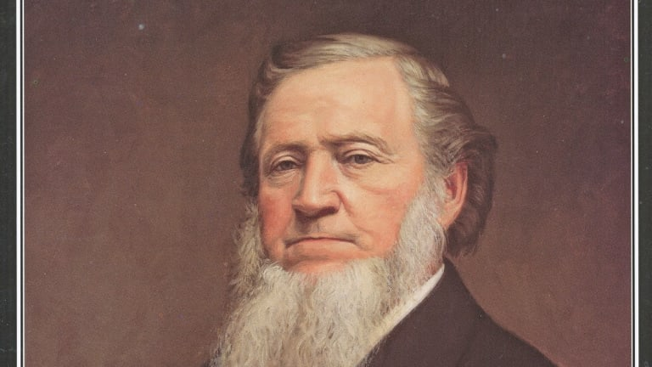BRINHAM YOUNG
      - THE CALIFORNIA GOLD RUSH
        - With California becoming USA territory in 1848, many Americans wanted to migrate to California. Problem is, there are former Mexicans living in California who did not like the newcomers. Many never did get along until today.
          - When Gold Rush happens, former Mexicans had to pay high taxes on their ranches they owned because they were discriminated against.
        - In 1848, James Marshall built a sawmill on land near Present day Sacramento. He found in a river a gold nugget.
        - James Marshall tried to keep it a secret, but in 1849 everyone found out and fled to California calling it the “California Gold Rush”
        - 80,000 people came, they were called FORTY NINERS or people that came to California for Gold.
          - Some miners who owned slaves brought them with them. Some miners didn’t like slavery.
          - Free African Americans had to set up their own newspapers and churches.
          - Native Americans were killed by 49ers and stole their land. Nearly 100,000 Natives died during Gold Rush.
        - People looked in mountains, streams, rivers, if you dug down and found gold you found, “pay-dirt.”
        - Mining gold was expensive and a huge gamble for Americans.
        - The one thing Miners needed was water, Water rights or legal rights to use the water in a river. Miners had to pay some people to use their water for mining.
        - Towns pop-up all-over California. The problem is they would go up and go down just as soon as they started. They were called, BOOM TOWNS. Crime was out of control because of saloons and drinking.
        - Women in California were outnumbered by men 12 to 1. Women were offered profitable work by men. Women sometimes created their own hotels, restaurants, and laundry services.
        - Not many 49ers made it rich, but many of them settled in the west for good!
      - CALFORNIAS CHANGING POPULATION
        - Not only Americans came to California for gold. But people from Europe, Asia, Australia and South America. But many were Chinese.
        - 45,000 Chinese came for Gold, they were good at dynamite, so they could blow up mountains looking for gold.
        - Chinese helped build railroads and helped areas like San Francisco prosper! But, many were not paid well.

