Chapter 14 Topic 8
SECTION 1: CONFLICTS & COMPROMISES
1. MISSOURI COMPROMISE
a. In 1819 the number of free and slave states were the same, but Missouri wanted to become a state, it applied to be a slave state.
b. If it became a slave state that would not make the number of seats in SENATE (1/2 of CONGRESSS) equal.
c. So they allowed another state to be in the USA, Maine. Missouri was allowed as a slave state.
d. For the future, they decided any state BELOW Missouri would be slave and any ABOVE would be free. 36-30 Meridian.
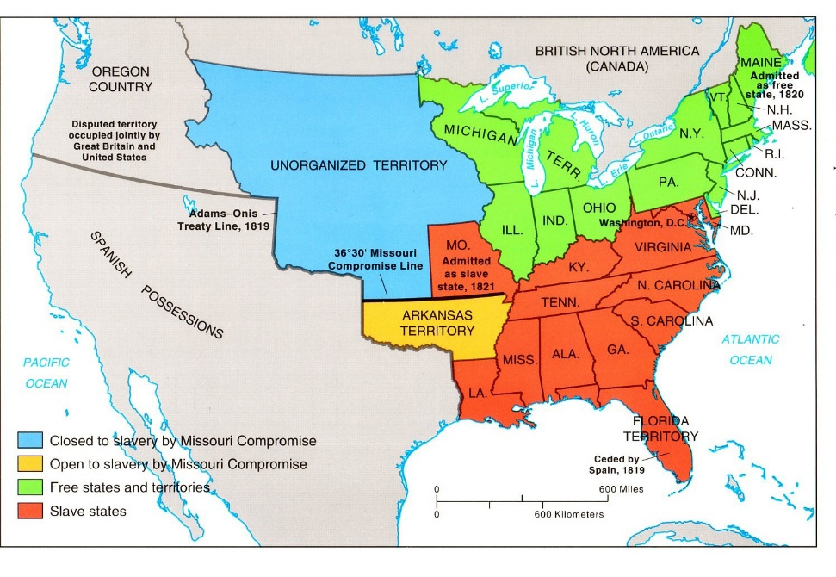

2. WILMONT PROVISO
a. It was a law created by a guy named, “David Wilmot” from Pennsylvania. AN ABOLITIONIST
b. It was to ban slavery in any new territories that were going to become states in “UNORGANIZED TERRITORY”
c. The House of Reps passed it, but the Senate defeated it.
d. Most northern ABOLITIONISTS wanted slavery banned in the WEST, but many wanted POPULAR SOVEREIGNTY or (people get to choose by vote)
3. FREE SOIL PARTY
a. In 1848 a new political party began called the FREE-SOIL PARTY, it was to try and keep SLAVERY out of the WESTERN TERRITORIES. They chose their PRESIDENTIAL CANDIDATES that would push for this.
b. Their first candidate was, MARTIN VAN BUREN. But WHIGS chose a hero from the MEXICAN AMERICAN WAR named ZACHARY TAYLOR.
c. MARTIN VAN BUREN said, BAN SLAVERY. TAYLOR did not speak on the issue and won the election of 1848
3A. ELECTION OF 1848
a. ZACHARY TAYLOR was a WHIG & the HERO of the Mexican American War so the people loved him. He also did not speak about SLAVERY in NEW TERRITORIES, the others ARGUED about SLAVERY in the WEST.
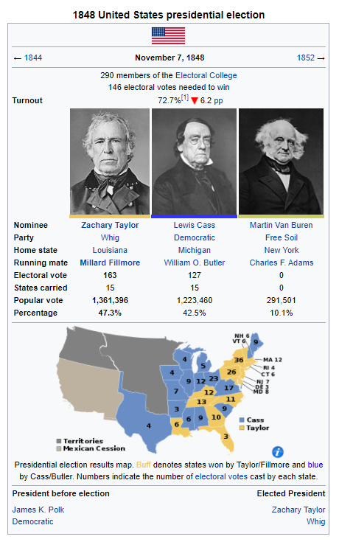

4. CALIFORNIA AND SLAVERY DEBATE
a. In 1849 there were 15 Slave states and 15 free states. Adding CALIFORNIA would give one side more power than the other in the SENATE.
b. Other territories were going to open as STATES as well: OREGON, UTAH, and NEW MEXICO. All wanted to be FREE STATES. SOUTH did not think this was fair!
c. Northerners said MOST of CALIFORNIA is in above the MISSOURI COMPROMISE LINE 36-30. So, it should be a FREE STATE.
d. JOHN C. CALHOUN of SOUTH CAROLINA a southerner said that SLAVERY should be allowed in the new territories!
e. JOHN C. CALHOUN also said that a LAW needed to be made where runaway slaves or FUGITIVE slaves should be returned to their slave owners. He UNFORTUNATELY said, “RECLAIM THEIR PROPERTY”
f. JOHN C. CALHOUN said, “If the NORTH does not agree to allow SLAVERY in the WEST, and FUGITIVE SLAVES to be returned. The SOUTH would SUCCED from the USA.
g. SUCCEED – Means leave something, in this case leaves the United States of America and create your own country.
h. HENRY CLAY – warned everyone in the CONGRESS if people cannot agree on a COMPROMISE, the USA would break apart.
5. THE COMPROMISE OF 1850
a. DANIEL WEBSTER agreed with HENRY CLAY that a COMPROMISE was needed, or USA would undergo a CIVIL WAR.
b. HENRY CLAY proposed a COMPROMISE OF 1850 and had 5 main PROVISIONS (parts)
1. CALIFORNIA enters the USA as a FREE STATE
2. MEXICAN SESSION CREATERS 2 TERRITORIES: NEW MEXICO & UTAH
a. NEW MEXICO & UTAH would be decided on FREE OR SLAVE state by popular sovereignty (VOTING)
3. Ended the Slave Trade in WAHSINGTON D.C.
4. Created a STRICT FUGITIVE SLAVE LAW ACT –
a. Slaves had to be returned to their owners or thrown in jail for hiding them in the NORTH
b. Hiding a runaway slave would also be a $1,000 fine
c. Hiding a runaway slave would not get you a JURY TRIAL, the JUDGE would get money!
d. FORCED NORTHERNERS to look and find RUNAWAY SLAVES.
5. SETTLED a BORDER DISPUTE between Texas and New Mexico
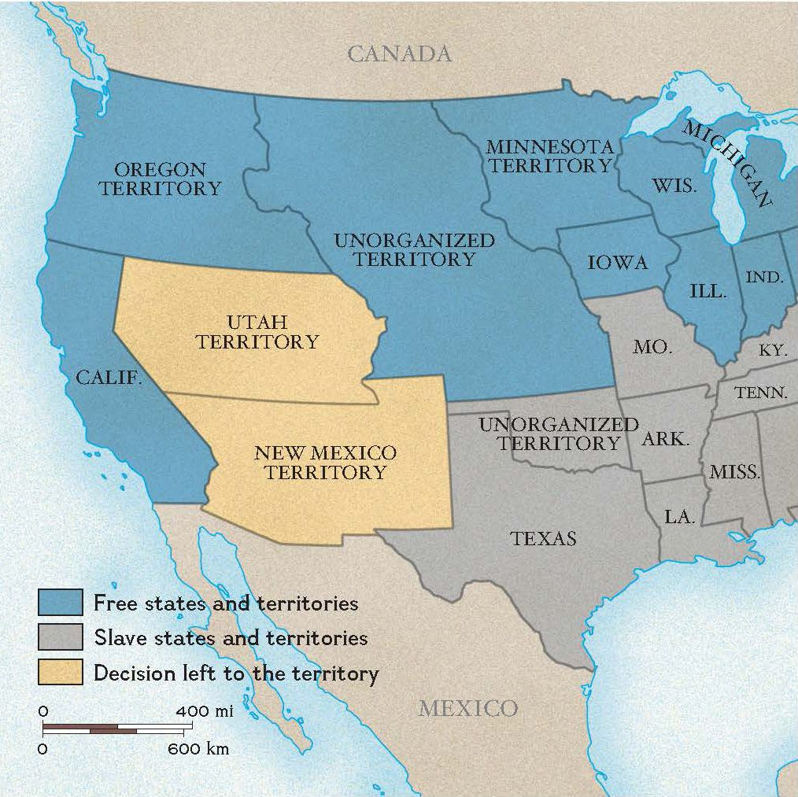
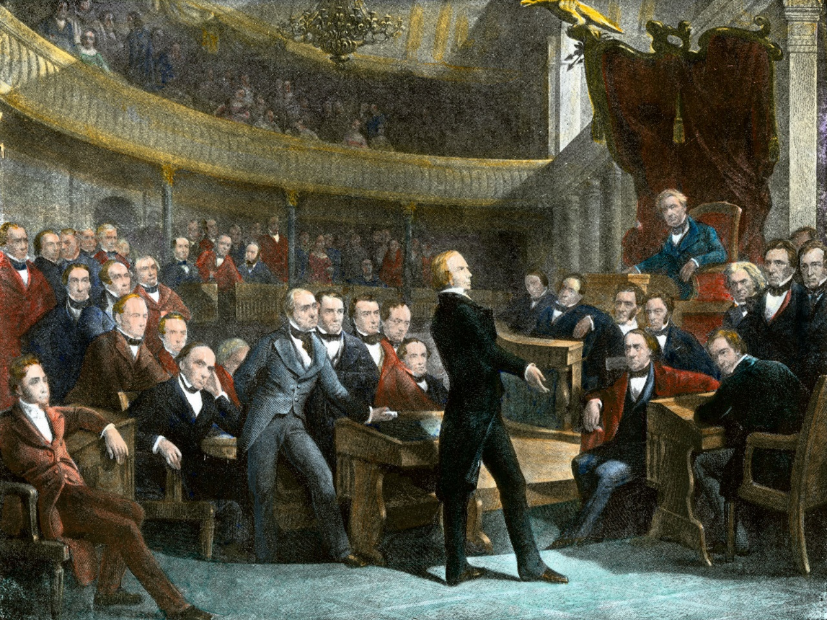
5A. 3/5th’s COMPROMISE
a. With the states now using POPULAR SOVEREIGNTY to decide whether a STATE is FREE OR SLAVE, now SOUTH and NORTH argued whether a SLAVE was counted as a person, if they count for SEATS in HOUSE OF REPRESENTTIVES.
- Each state gets a number of REPS in the HOUSE based on the STATES POPULATION!
b. NORTH said, “NO” if you are not freeing your SLAVES, then they should not count as a person.
c. SOUTH said, “YES” they are living in our STATE they should COUNT!
d. To make both sides HAPPY, they said SLAVES would count as 3/5th’s of a person towards the number of population.
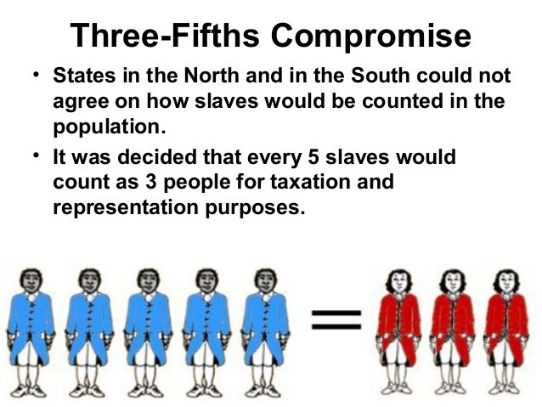
6. UNCLE TOMS CABIN
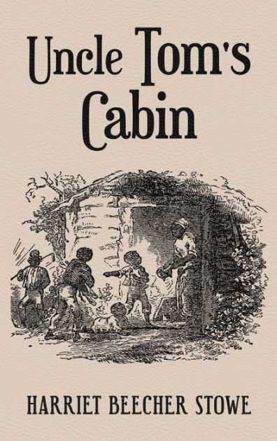
a. UNCLE TOMS CABIN is a book created by HARRIET BEECHER STOWE in 1852. The book shows the EVILS of SLAVERY and how bad the FUGITIVE SLAVE LAW ACT really was.
- TOM was a kind man, who was purchased by SIMON LEGREE,
- SIMON LEGREE asked TOM where the other runaway slaves were, TOM REFUSED!
- SIMON LEGREE whips him to death and shows everyone that slavery is EVIL!
b. UNCLE TOMS CABIN becomes the nations best seller, in 1 year 300,000 copies were sold! Millions were sold after they made the book in other languages.
c. NORTH LOVED UNCLE TOMS CABIN, SOUTH HATED the book! SOUTH said that it gave a FALSE picture of slave life.
d. UNCLE TOMS CABIN made many NORTH people become ABOLITIONISTS!
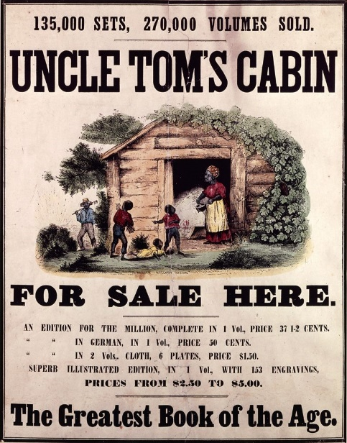

SECTION 2 – GROWING TENSIONS BETWEEN NORTH AND SOUTH
1. SLAVERY IN KANSAS & NEBRASKA TERRITORY
a. 1854, Senator STEPHEN DOUGHLAS created a new LAW to CONGRESS,
b. DOUGHLAS wanted to create the NORTHERN AREA of LOUISIANA or UNORGANIZED TERRITORY into 2 TERRITORIES: KANSAS & NEBRASKA TERRITORY.
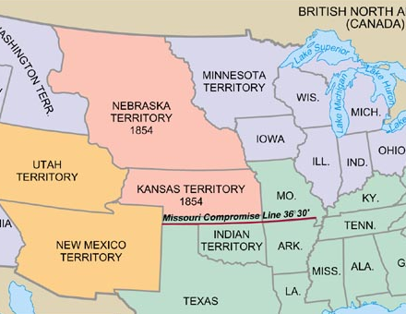
c. DOUGLAS knew by making these territories and not STATES, the people could decide FREE OR SLAVE TERRITORIES.
d. This was KNOWN as the KANSAS NEBRASKA ACT, it made NORTH AND SOUTH upset!
e. NORTH was mad because they said MISSOURI COMPROMISE they should be FREE TERRITORIES! And MISSOURI COMPROMISE said, “SLAVERY IS BANNED IN NEW TERRITORIES”
f. SOUTH was mad because they wanted it to be decided by VOTE, because there were SLAVE states around them!
2. KANSAS TERRITORY NORTH AND SOUTH
a. STEPHEN DOUGLAS hoped settlers could decide on SLAVERY peacefully, he was wrong. Both NORTH AND SOUTH wanted control of KANSAS.
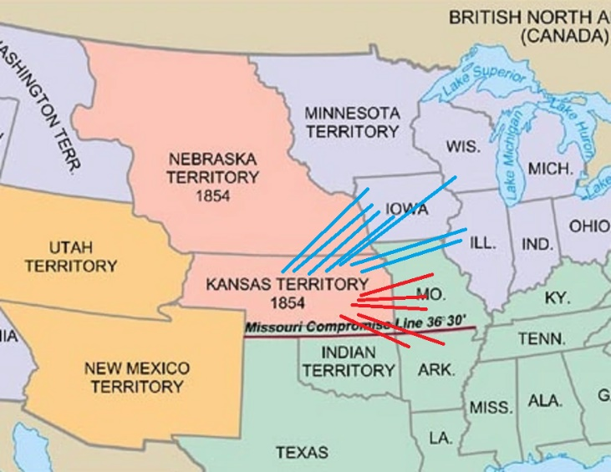
b. People flood from all areas of NORTH & SOUTH to KANSAS for CONTROL!
c. Kansas held an election in 1855, for STATE LAWMAKERS. People illegally flooded into KANSAS even though they were NOT LIVING THERE and voted MULTIPLE TIMES!
d. SOUTH won the ELECTION, NORTH said the election was rigged because 8,000 people voted, but the territory had 3,000 citizens!
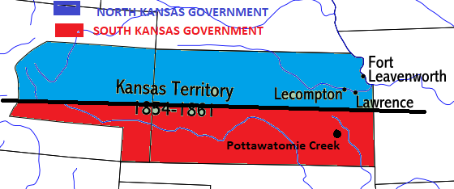
e. in KANSAS both NORTH and SOUTH set up GOVERNMENTS, it caused bloodshed called: BLEEDING KANSAS
3. BLEEDING KANSAS – “SACK OF LAWRENCE” DAY 1
a. BLOODSHED started by a PROSLAVE man “Franklin Coleman” shot an ABOLITION man “Charles Dow.” The Sheriff “Sam Jones” shows up to arrest someone, and arrests CHARLES DOW the man who was shot!
b. Eventually, the man Charles Dow got out of jail with the help of NORTH.
c. In LAWRENCE KANSAS, SHERIFF SAM JONES and his friends walk in to try to ARREST the NORTHERN KANSAS GOVERNMENT for getting Dow out of JAIL! JONES burned down a HOTEL, and a PRINTING PRESS and many ABOLITIONIST HOMES.
d. SAM JONES after the “SACK OF LAWRENCE” escaped and hid out in the SOUTHERN KANSAS TERRITORY
e. SHERRIF SAM JONES resigned because the SOUTH would not give him CHAINS and BALLS to arrest more!
SACK OF LAWRENCE SHERRIF SAM JONES
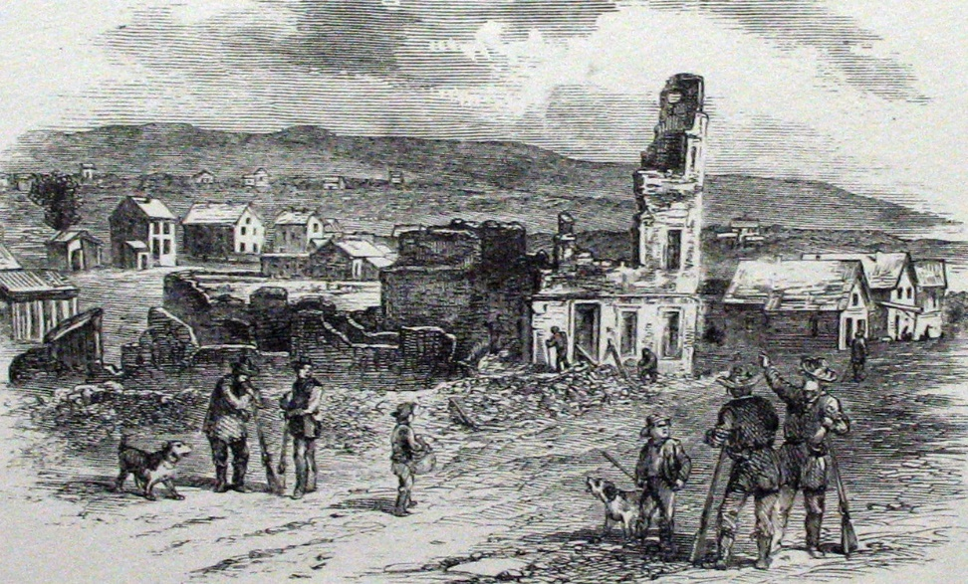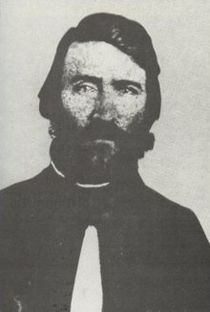
4. BLEEDING KANSAS – “BLOODSHED IN CONGRESS” DAY 2
a. In May of 1856, CHARLES SUMNER of Massachusetts spoke in CONGRESS to talk BAD about SLAVERY in KANSAS. He said that SLAVERY SUPPORTES were awful people.
b. CHARLES SUMNER also said that the SOUTH made a “CRIME AGAINST KANSAS” at LAWRENCE!
c. CHARLES SUMNER called out one SOUTHERN CONGRESSMAN, ANDREW BUTLER. SUMNER made BUTLER look very badly in public.
d. 2 DAYS after BULTERS HUMILITATION, BUTLERS cousin, PRESTON BROOKS walked up to CHARLES SUMNER and began beating him with a CANE on the SENATE floor. He was bloody and nearly DEAD!
e. SOUTHERNERS praised PRESTON BROOKS for beating CHARLES SUMNER nearly to DEATH! “HE GOT WHAT HE DESERVED”
PRESTON BROOKS BEATING CHARLES SUMNER WITH HIS CANE
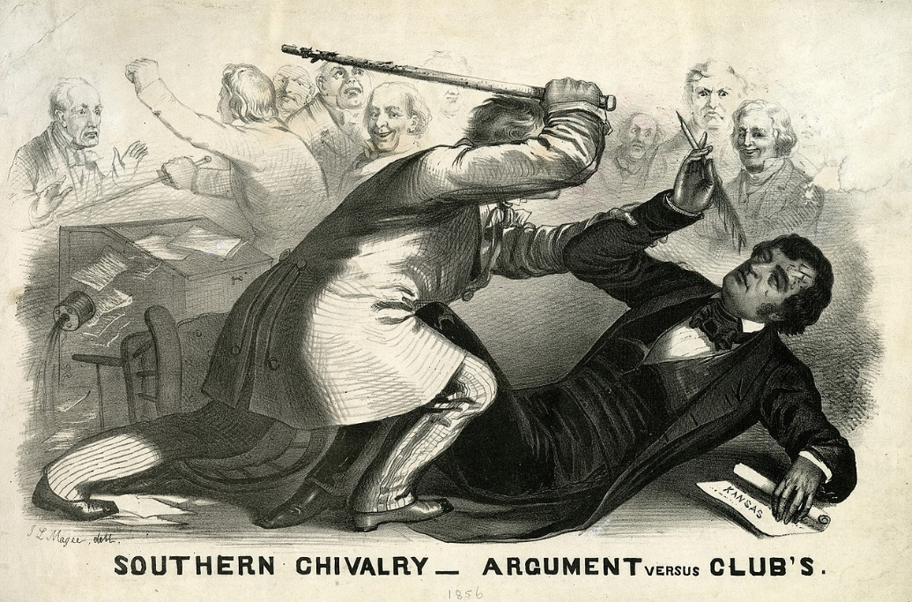
5. BLEEDING KANSAS – “JOHN BROWN BLOODSHED IN POTTAWOTTAMIE CREEK” DAY 3
a. JOHN BROWN a religious man who believed GOD sent him to EARTH to stop AMERICAN SLAVERY moved to KANSAS with his sons to help KANSAS become a FREE STATE.
b. JOHN BROWN often said, “I AM AN INSTRUMENT OF GOD” and “THESE MEN ARE ALL TALK NO ACTION! … ACTION!”
c. JOHN BROWN and sons snuck into POTTAWOTTOMIE and dragged 4 MEN and BOYS and killed them with BROADSWORDS!
d. JOHN BROW and sons ESCAPED, and a KANSAS CIVIL WAR began from 1857-1859.
e. JOHN BROWN and sons, returned to the NORTH, and started making plans and raising money for their next raid on SOUTHERN SLAVERY!
JOHN BROWN 1855-1856 JOHN BROWN 1859
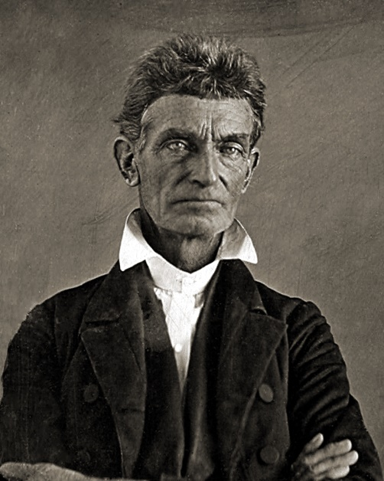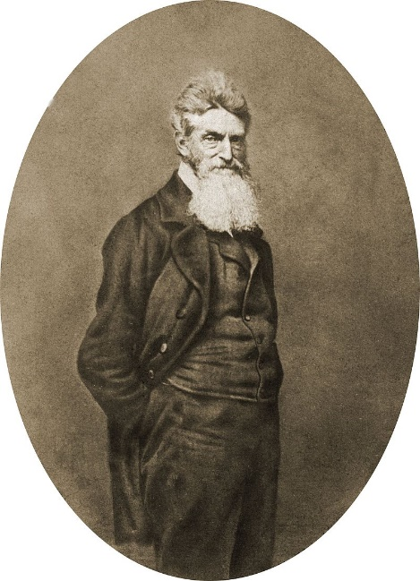

6. DREDD SCOTT VS. SANFORD COURT CASE
a. CONGRESS was arguing day and night over SLAVERY, a SUPREME COURT CASE divided the NORTH & SOUTH more.
b. a man named DREDD SCOTT, a SLAVE living in MISSOURI with his owner (Missouri SLAVE STATE). The OWNER and SCOTT moved to WISCONSIN TERRITORY (FREE Territory).
c. SCOTT and his OWNER moved back to MISSORI where the OWNER DIED!
d. ANTISLAVE LAWYERS helped DREDD SCOTT sue, SCOTTS lawyers said, he lived in a FREE AREA, so he should be FREE!
e. THE SUPREME COURT decided that because DREDD SCOTT was a SLAVE and not a CITIZEN, he could not SUE!
f. THE SUPREME COURT also decided that CONGRESS could not OUTLAW SLAVERY in ANY TERRITORY!
g. This decision made the MISSOURI COMPROMISE UNCONSTITUTIONAL
h. DREDD SCOTT decision made it where a ENSLAVED AFRICAN AMERICANS could not find FREEDOM ANYWHERE in USA.
7. NATIONAL REACTIONS TO DREDD SCOTT CASE DECISION
a. SOUTH loved the RESULT of the DREDD SCOTT vs. SANFORD CASE, SLAVERY was not LEGAL in ALL territories!
b. NORTH hated the RESULT, it made more people become ABOLITIONISTS.
c. A NORTHERNER named WILLIAM LLOYD GARRISON set up a ANTI-SLAVE NEWSPAPER called, “LIBERATOR”
c. GARRISON found a former SLAVE that ran away for his FREEDOM, his name was FREDRICK DOUGLAS, TOLD HIS STORY on how he escaped SLAVERY, risking going back into SLAVERY!
- FREDRICK DOUGLAS was born a SLAVE in Maryland, where he SECRETLY LEARNED THE ALPHABET and to READ. WHITE CHILDREN in his NEIGHBORHOOD TAUGHT HIM!
- FREDIRCK DOUGLAS original name was FREDRICK BAILEY, he married a woman after he escaped slavery, they changed their name to DOUGLAS while living in MASSACHUSETTS to hide the his identity.
- FREDRICK became a PREACHER where he learned to PUBLIC SPEAK!
- Eventually DOUGLAS becomes the LEADING ABOLITIONIST SPEAKER in the USA. He had MANY FOLLOWERS
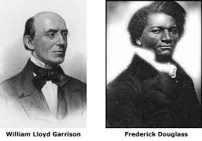
8. REPLUBLICAN PARTY FORMS – ELECTION OF 1856
a. There were only 2 POLITICAL PARTIES, WHIGS who stayed away from SLAVERY, and DEMOCRATS who FAVORED SLAVERY. Some DEMOCRATS HATED SLAVERY ALSO
b. NORTHERN WHIGS who HATED SLAVERY, & ANTI SLAVE DEMOCRATS created the REPUBLICAN PARTY
c. REPUBLICAN PARTY goal was to STOP the spread of SLAVERY into WEST
d. In 1856, REPUBLICANS ran for PRESIDENT, “JOHN C. FREEMONT” Creator of OREGON TRAIL and CALIFORNIA REVOLT! The Nation was not ready for an ANTI-SLAVE President.
e. FREMONT makes a GOOD CANDIDATE, Shows the REPUBLICANS are on the RISE
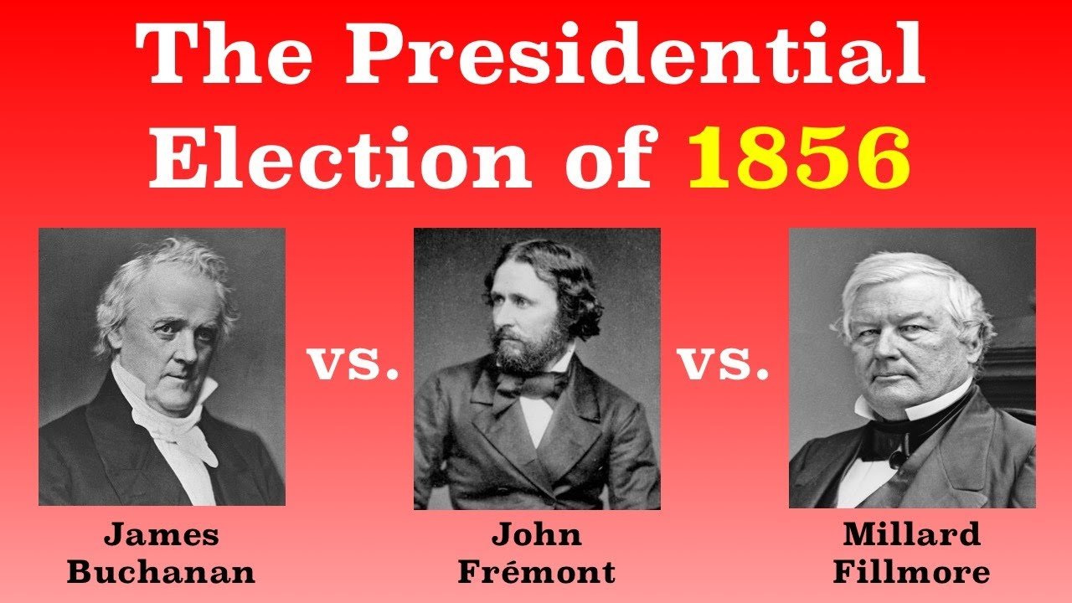
e. DEMOCRAT – JAMES BUCHANAN, northerner with Southern Principals, WINS THE ELECTION OF 1856
f. KNOW-NOTHING PARTY – Milliard Fillmore
g. ELECTION OF 1856 RESULTS
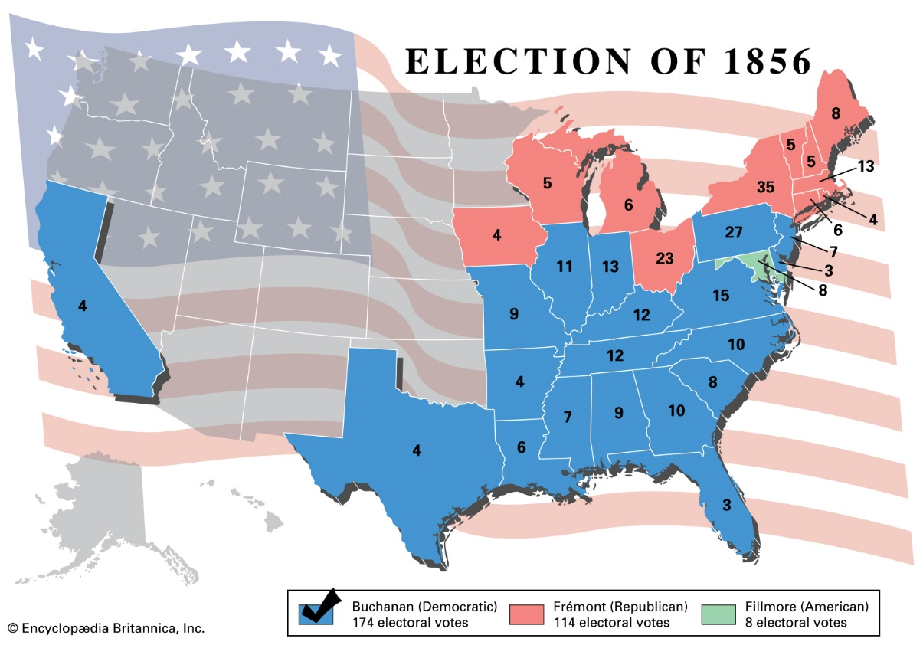
9. YOUNG ABRAHAM LINCOLN – LEARNING & JOB
a. YOUNG Lincoln lived in an ILLINOIS LOG CABIN, 1 Year in school and was SELF TAUGHT TO READ after that.
b. YOUNG LINCOLN’s mother died at 9 years old. His Sister died 10 years later giving birth. Father just a hard worker, remarried
c. YOUNG LINCOLN hated farm life, he loved reading writing and poetry and law. Became very close to STEPMOM
d. YOUNG LINCOLN helped build fences for his father earning money with an ax, he became a WRESTLER where he was the county CHAMP.
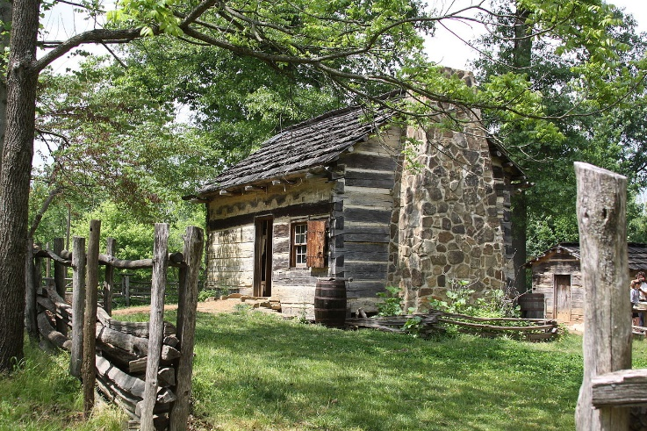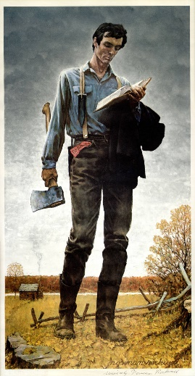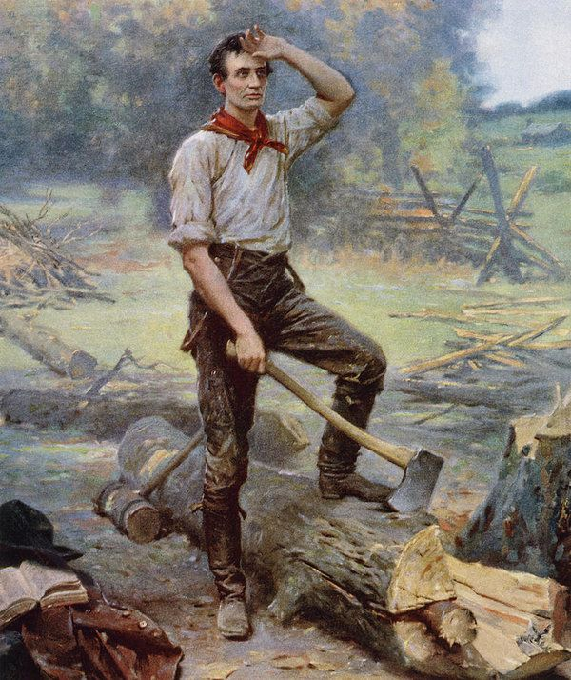
10. RISE OF ABRAHAM LINCOLN – MILITARY, POLITICS, LOVE LIFE, JOBS
a. LINCOLN created a GENERAL STORE in 1832, eventually sold his store and joined the ILLINOIS MILITIA.
b. LINCOLN had eventually become detached with his father for his lack of EDUCATION.
c. LINCOLN decided to go into politics and LAW and join the WHIG party in 1834
d. LINCOLN met a woman named ANN RUTLEDGE, but she died of TYPHOID FEVER during the relationship.
e. LINCOLN eventually met a woman named MARY TODD, a wealthy LAWYER, they moved to SPRINGFIELD where he became a LAWYER himself under MARY TODDS cousin, JOHN T. STUART
f. LINCOLN opens his OWN LAW PRACTICE where he became one of the best LAWYERS in ILLINOIS
g. in 1846 LINCOLN as a WHIG joined the Illinois HOUSE OF REPS for SANGAMON COUNTY, where he helped push CANALS.
h. In 1855-1856, LINCOLN was AGAINST PRESIDENT JAMES K. POLK’s desire for the MEXICAN AMERICAN WAR. Said we bullied MEXICO.
- LINCOLN in CONGRESS asked POLK to show exactly where BLOOD was SHED that started the war.
i. In 1858, LINCOLN stood up for DREDD SCOTT in the DREDD SCOTT vs. SANFORD Supreme Court Case
- LINCOLN said, “DREDD SCOTT should be FREE”
- LINCOLN said, “LETTING PEOPLE VOTE on slavery would continue to spread it in the USA”
j. LINCOLN stood up in 1858 and OPPOSED the KANSAS NEBRASKA ACT. LINCOLN ran for SENATE as a result in 1858.
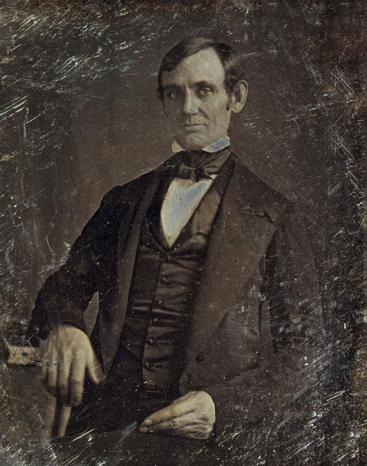
LINCOLN 1856 LINCOLN 1857 LINCOLN 1858
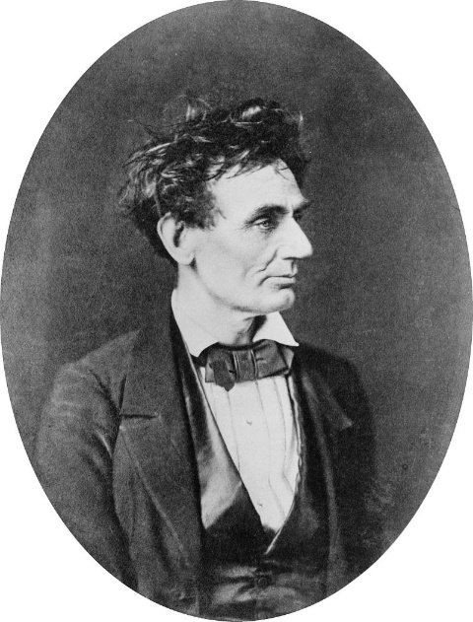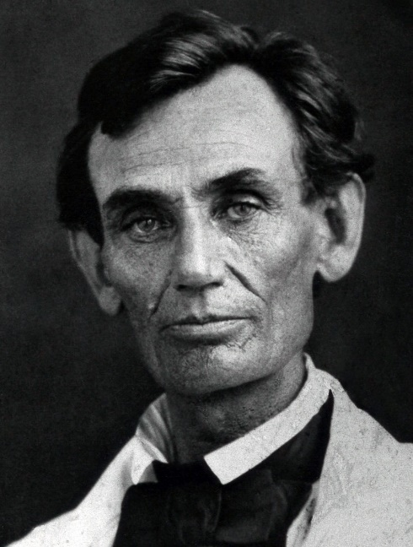
11. ABRAHAM LINCOLN RUNS FOR SENATE – “LINCOLN DOUGLAS DEBATES”
a. LINCOLN had been in politics a while, a GREAT LAWYER, and a GOOD POLITICIAN. He stood up for people.
b. 1858 LINCOLN decided to run for SENATE in ILLINOIS vs. STEPHEN DOUGLAS, the maker of the KANSAS NEBRASKA ACT.
c. STEPHEN DOUGLAS was the heavy favorite. LINCOLN challenged him to PUBLIC DEBATES!
d. The issue of SLAVERY in the WEST was the biggest question. DOUGLAS wanted SLAVERY to decided by VOTE (popular sovereignty). DOUGLAS however disliked SLAVERY just did not care if people voted on it.
e. LINCOLN wanted no SLAVERY in the new areas, he disliked it. LINCOLN was an ABOLITIONIST
- LINCOLN said in 1 of the 7 DEBATES, “There is no reason in the world why the negro is not entitled to NATURAL RIGHTS listed in the Declaration of Independence.”
f. Week after week, BOTH MEN SPOKE in large crowds in 7 DEBATES why they should be an ILLINOIS SENATOR.
g. NEWSPAPERS printed their words, more and more NORTHERNERS heard LINCOLNS words, however DOUGLAS beat him by a SLIM MARGIN. LINCOLN was now known throughout the COUNTRY! DOUGLAS & LINCOLN would meet again!
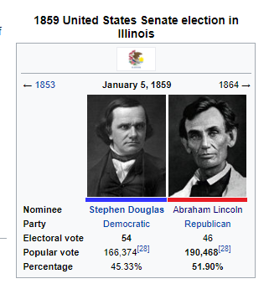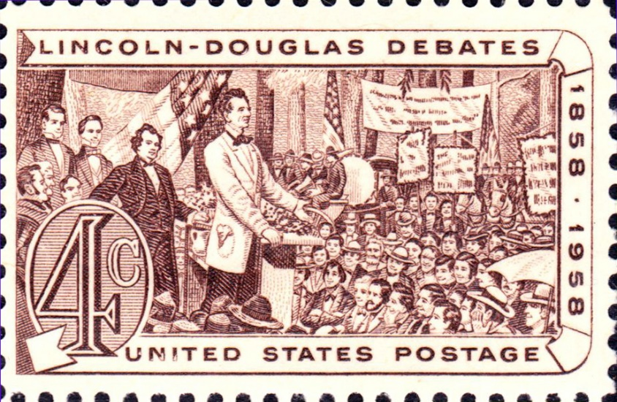
12. JOHN BROWNS RAID ON HARPERS FERRY VIRGINIA
a. In 1857, JOHN BROWN a RAIDICAL ABOLITIONIST was raising money with ABOLITIONIST and planning a plot to raid a ARSENAL in HARPERS FERRY VIRGINIA.
- ARSENAL is a place that has GUNS, CANNONS, AMMUNITION, GUN POWDER.
b. JOHN BROWN believed he was the new MOSES and wanted to FREE SLAVES.
c. In 1859, JOHN BROWN with his sons and 5 AFRICAN AMERICANS went to HARPERS FERRY ARESENAL and raided it in the night.
d. JOHN BROWN breaks into the ARMORY, takes HOSTAGES and begins to take GUNS out and hand them to SLAVES around the area, but many do not know how to shoot a gun.
e. UNITED STATES HIRE, ROBERT E. LEE to put down the REBELLION of JOHN BROWN at Harpers Ferry.
- At the time, ROBERT E. LEE was the best General in the United States from the area of VIRGINIA.
- ABRAHAM LINCOLN in 1861 asked Robert E. Lee to command the NORTHERN ARMY during the CIVIL WAR.
f. They surround JOHN BROWN, his sons, and followers in the ARMORY where ONLY ONE of JOHN BROWNS sons SURRIVED the SHOOTOUT
g. BROWN was captured after being shot himself. Put on Trial and was hung. Before being hung he kissed an AFRICAN AMERICAN baby as he was walking out of the COURTHOUSE
h. After he was hung, NORTHERN church bells sounded for him in mourning. THE SOUTH hated this and said the NORTH were defending a TRAITOR!
HARPERS FERRY ARMORY
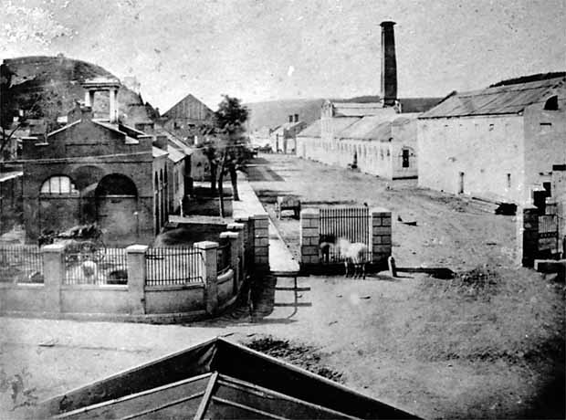
INSIDE THE ARMORY ENGINE ROOM WHERE THE TROOPS BROKE INTO TO ARREST JOHN BROWN
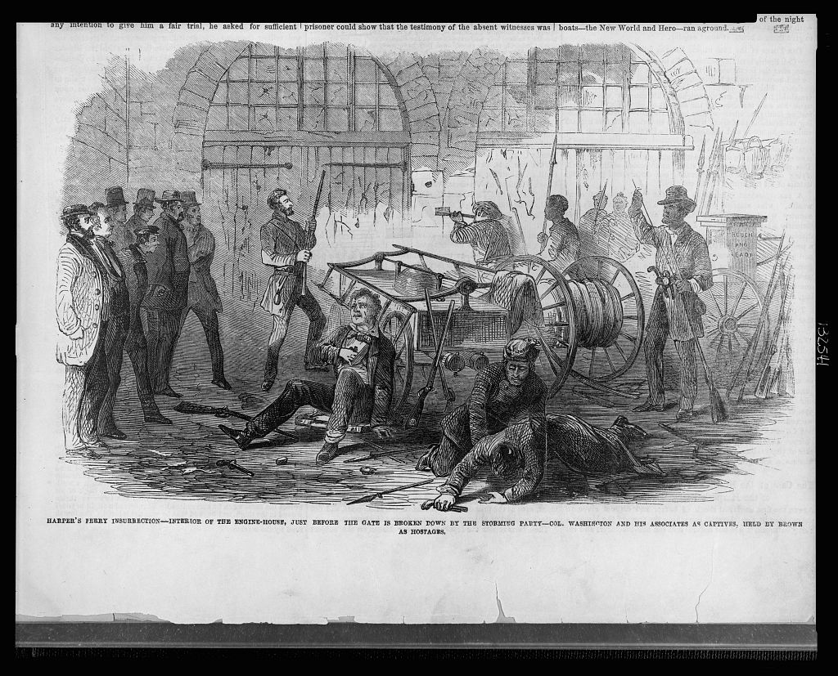
JOHN BROWN KISSING A BABY AFTER BEING SENTENCED TO DEATH
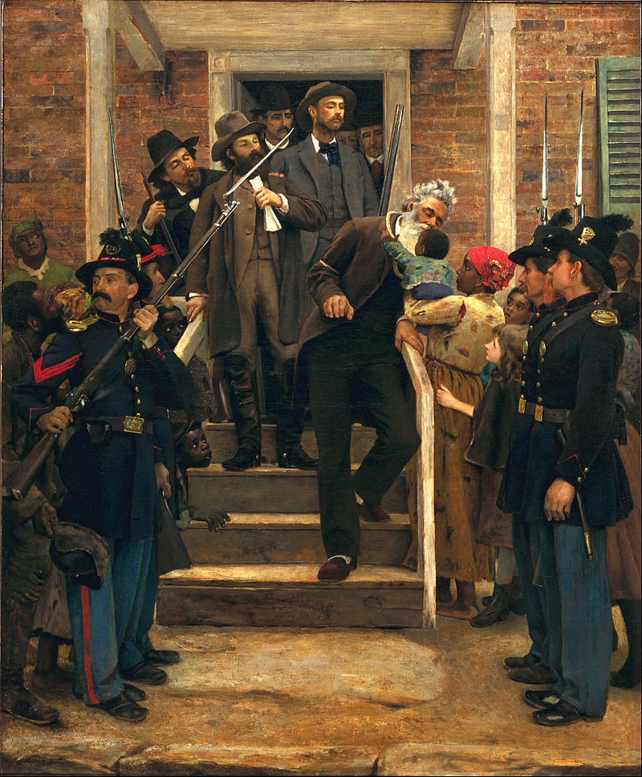
JOHN BROWN HANGIN
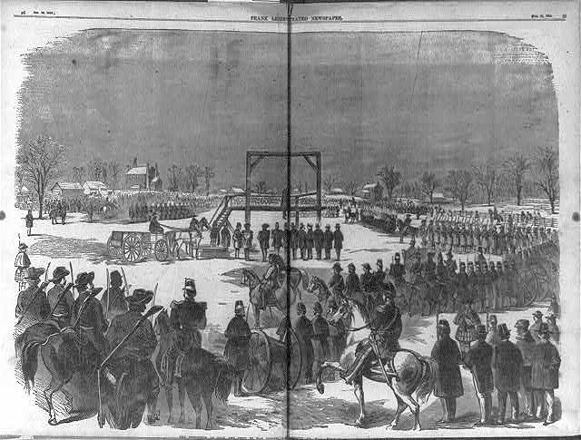

13. THE NATION OFFICIALLY DIVIDES WITH DISOLUTION
1. NORTHERN REACTIONS TO JOHN BROWNS RAID
a. The NORTH saw him as a HERO for trying to save slaves that were in HARPERS FERRY
b. They said he was a RELIGIOUS MAN trying to free people who SHOULD be FREE
c. After he was HUNG, they played CHURCH BELLS so that everyone knew he had SUPPORT and people were sad.
d. He becomes as MARTYR – “give up your life for your beliefs”
e. NORTHERNERS created a SONG about him where they praised him.
2. SOUTHERN REACTIONS TO JOHN BROWNS RAID
a. SOUTHERNERS viewed JOHN BROWN trying to free SLAVES as a act of TRAITOR.
b. SOUTH believed he got what he deserved.
c. SOUTH thought the NORTHERN support of JOHN BROWN was a slap in the face on their way of life.
d. SOUTH thought that NORTH wanted to officially END SLAVERY.

SECTION 3: DIVISON & THE OUTBREAK OF WAR
1. WHO SHOULD RUN IN ELECTION OF 1860 FOR PRESIDENT
a. The REPUBLICANS needed a new candidate for PRESIDENT, they had a strong showing in the previous election.
- 2 people EMERGE, WILLIAM SEWARD & ABRAHAM LINCOLN
- SEWARD was a FAMOUS US SENATOR
- LINCOLN became famous because of his DEBATES with STEPHEN DOUGLAS
- LINCOLN ends up beating SEWARD and is nominated to run for PRESIDENT for REPUBLICANS
b. DEMOCRATS needed a CANDIDATE for PRESIDENT, however they were SPLIT! SOUTHERNERS wanted all different.
- SOUTH DEMOCRATS wanted a CANDIDATE who supported SLAVERY in ALL new territories
- NORTH DEMOCRATS did not want SLAVERY in new territories
- DEMOCRATS split in two!
  - NORTH DEMOCRATS choose – STEPHEN DOUGLAS of Illinois
  - SOUTH DEMOCRATS choose – JOHN BRECKENRIDGE of Kentucky
c. Some did not like the SPLIT of the DEMOCRATS, so (WHIGS & KNOW NOTHINGS) created the CONSTITUTIONAL UNION PARTY, to keep the United States TOGETHER, that was their goal.
- The new political party choose – JOHN BELL of Tennessee
2. WHAT DID THE CANDIDATES of 1860 STAND FOR?
NORTH CANDIDATE
a. REPUBLICAN ABRAHAM LINCOLN – Did NOT want to end slavery at first! Wanted to keep USA TOGETHER! But disliked slavery
- LOVED BY ALL NORTHERNERS
- GREAT SPEAKER
- WANTED TO KEEP USA TOGETHER
- HATED SLAVERY BUT DID NOT WANT TO END IT IMMIDIATELY
SOUTH CANDIDATES
b. DEMOCRAT STEPHEN DOUGLAS – Pushed for NO SLAVERY in new Territories, Wanted USA to stay TOGETHER
- HATED BY MANY SOUTHERNERS,
- THREW TOMATOES AT HIM AT HIS SPEECHES BECAUSE HE WASN’T PRO SLAVERY
c. DEMOCRAT JOHN BRECKENRIDGE – Pushed for slavery in the NEW territories and preserve way of life in SOUTH
- MANY SOUTHERNERS LOVED HIM
- TOOK 2nd to ABRAHAM LINCOLN
- WAS THE VICE PRESIDENT BEFORE THE ELECTION?
d. CONSTITTUION PARTY – John Bell made no mention of SLAVERY, did not get much SOUTHERN support.
- MOST SAW HIM AS THE OLD MAN CANDIDATE
- WANTED TO KEEP USA TOGETHER
- DID NOT TALK ABOUT SLAVERY DURING CAMPAIGN
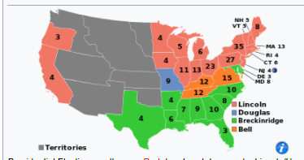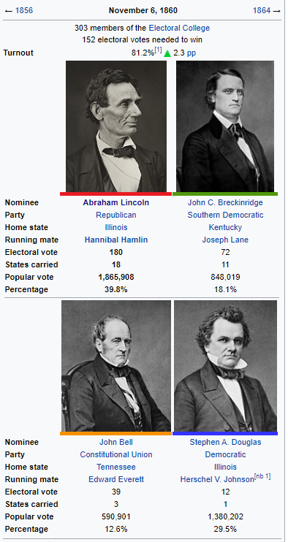

e. ABRAHAM LINCOLN wins the election because the DEMOCRATS had a split vote. LINCOLN wins the ELECTORAL VOTE but LINCOLN did NOT win the POPULAR VOTE.
3. A MOVE TOWARD CIVIL WAR
a. SOUTH said if LINCOLN becomes PRESIDENT, SOUTH states would SUCCEED or leave the USA.
b. on DECEMBER 20, 1860 – SOUTH CAROLINA becomes the first to leave the USA.
c. By FEB 1861 – ALABAMA, FLORIDA, GEORGIA, LOUISIANA, MISSISIPPI, and TEXAS leave as well,
- These STATES created their own country
- Country was called: CONFEDERATE STATES OF AMERICA (CONFEDERACY)
- Their President: JEFFERSON DAVIS
  - DAVIS went to school at WEST POINT to be an ARMY OFFICER
  - DAVIS was a WAR HERO from Mexican American War
  - DAVIS was SECRETARY of War for President FRANKLIN PIERCE
  - In his Inaugural Address he stated why SOUTH left the USA. “desire to preserve our own rights and promote our own welfare.”
  - Davis believed equality was only between white men
  - DAVIS Began assembling an ARMY to drive ALL NORTH SOLIDERS OUT OF SOUTH
d. SOUTHERN states said in the CONSITITUTION they had STATES rights to make their own choices. PRESIDENT ABRAHAM LINCOLN thought differently!
4. THE OUTBREAK OF WAR
a. On March 4, 1861 LINCOLN gave the oath of office. LINCOLN said, “No state …. can lawfully get out of the UNION. We are not enemies, but friends, countrymen. Though passion may have strained, it must not break our bonds of affection.”
b. LINCOLN said WAR will not happen unless the SOUTH starts it, also said he would enforce the FUGITITVE SLAVE ACT.
c. LINCOLN said that the SOUTH needed to accept the LAWS of the NORTH and accept his ELECTION under the CONSTITUTION.
d. LINCOLN had a difficult choices now:
- SEND TROOPS TO PROTECT FORTS IN SOUTH? (BAD CAUSE: Promotes War)
- LET SOUTH TAKE OVER FORTS in SOUTH? (BAD CAUSE: Promotes letting SOUTH leave the USA)
- DECLARE WAR ON SOUTH? (BAD CAUSE: It puts the USA IN CIVIL WAR)
- WHO SHOULD BE MY CABINET? (RISK: Chooses Edwin Stanton to be Sec. of WAR, HE WANTS WAR)
- WHO SHOULD BE MY NORTH GENERAL? (RISK: Asked Robert E. Lee, A SOUTHERNERER)

5. FIRST BATTLE OF CIVIL WAR – BATTLE OF FORT SUMTER – CHARLESTON SOUTH CAROLINA
a. One of the major strongholds of the NORTH was at CHARLESTON, SOUTH CAROLINA – Fort Sumter, it overlooked CHARLESTON HARBOR.
b. SOUTH PRESIDENT JEFFERSON DAVIS ordered South troops to take it!
c. LINCOLN learned that FOOD SUPPLIES at FORT SUMNTER were running low, HE told SOUTH he would SHIP FOOD ONLY! SOUTH DID NOT ALLOW IT!
d. April 11, 1861, SOUTH ordered FORT SUMNTER to Surrender, NORTH commander, Major Robert Anderson said “NO”
e. 2 DAYS SOUTH opened fire, NORTH ran out of ammunition, supplies and SURRENDERED the FORT. LINCOLN would NOT SEND THEM TROOPS or SUPPLIES
f. AFTER the BATTLE OF FORT SUMTER, VIRGINIA, NORTH CAROLINA, TENNESSEE and ARKANSAS joined the CONFEDERATE STATES OF AMERICA (CONFEDERACY)
f. SOUTH believed this was their FIGHT for SOUTHERN INDEPENDENCE and their way of life.
g. NORTH believed this war was a FIGHT to keep the USA together.
h. After much consideration the BORDER STATES (States in between NORTH and SOUTH) joined the North and did not leave the USA. – MISSOURI, KENTUCKY, WEST VIRGINIA, DELAWARE & MARYLAND.
SOUTH BOMBARDMENT OF FORT SUMTER MAJOR GENERAL ROBERT ANDERSON (NORTH)
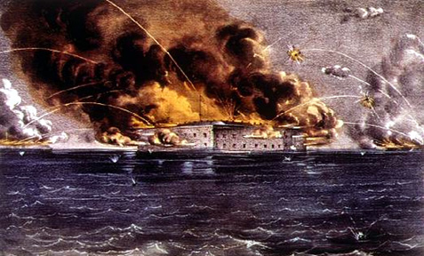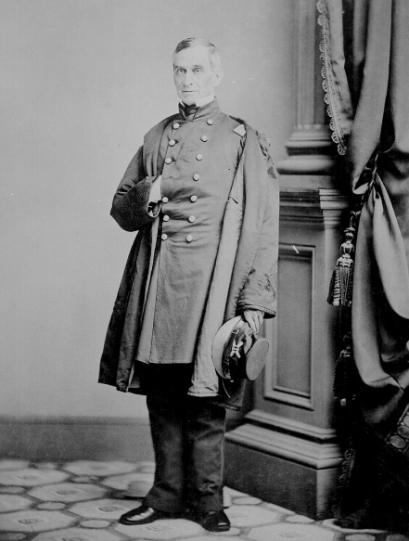
PICTURE AFTER BATTLE, SOUTH WINS
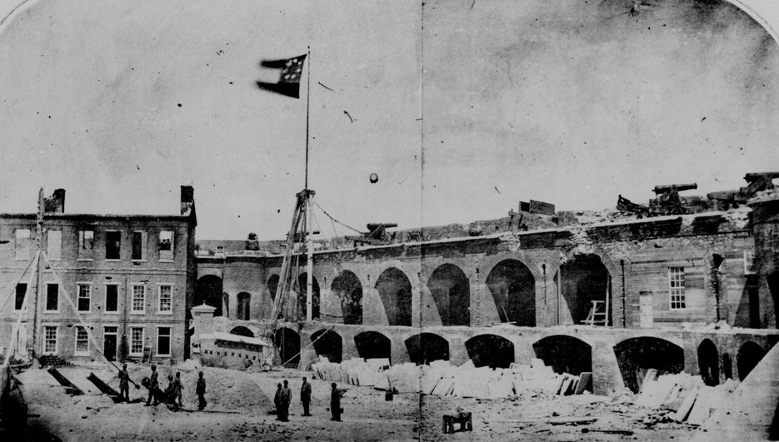

6. NORTH & SOUTH ADVANTAGES
  - NORTH (United States of America)
    - Fueled by industry and factories, mostly by immigrants that work for cheap labor to maximize their profits.
    - Had many railroads for easy transportation of products, soldiers, guns, ammo etc.
    - Had vast amounts of telegraph lines for easy communication, LINCOLN gave commands quickly
    - Banned slavery, so free African Americans fought for the NORTH
    - Large military, but bad leaders until Ulysses S. GRANT, large population with large cities.
    - President was Abraham Lincoln
    - Capitol city was Washington D.C.
    - Most people were abolitionists (People who were against slavery)
    - Had a strong NAVY
    - Had to fight in the SOUTH, didn’t know land as well.
    - Many soldiers had schooling
  - SOUTH (Confederate States of America)
    - Fueled by agriculture primarily cotton, so food was scarce!
    - Slavery was big, many slaves picked the cotton and they were treated like property
    - South had better Generals primarily Robert E. Lee
    - South was very spread out and technology was scarce.
    - Small military and small population
    - President was Jefferson Davis
    - Few railroads and few telegraph lines so transportation took longer and communication as well
    - Capitol was Richmond Virginia (106 miles from Washington D.C.)
    - In the 1860’s most people in the south lived on small farms and owned NO slaves.
    - South had to get INDIAN Territory on their side, MANY tribes fought for the south!
    - Was not a strong NAVY?
    - SOUTH had knowledge of the land! Most was fought in the SOUTH
    - Many soldiers were homeschooled and not as educated.

c. LINCOLN asked ROBERT E. LEE to be his UNION NORTH GENERAL. Lee respectfully declines because he is from the South,
- “Mr. President Lincoln, If VIRGINIA stands with the USA, so will I! But, if VIRGINIA leaves the USA, I must follow my NATIVE STATE with my sword and if need be…my life.”
- VIRGINIA joined the CONFEDERACY and so did ROBERT E. LEE, creating the “ARMY OF VIRGINIA” (SOUTH ARMY)
- LINCOLN struggles now at FINDING a good GENERAL for his “ARMY OF THE POTOMIC” (NORTH ARMY), HE CHOSE – WINFIELD SCOTT, the man who removed the NATIVE AMERICANS

SECTION 4: THE COURSE OF WAR
1. STRATEGIES OF THE UNION (NORTH) & CONFEDERATE (SOUTH)
a. NORTH STRATEGIES
- Wanted to create a NAVY BLOCKADE so SOUTH would not get goods from EUROPE
- CAPTURE the CAPITOL of SOUTH, RICHMOND – (Where SOUTH government was)
- CONTROL the MISSISSIPPI RIVER, no transportation of water and separate the SOUTH STATES
- GET the HELP of NATIVE AMERICANS – (Only got NORTHERN UPPER CREEKS)
- GENERAL WINFIELD SCOTT creates a plan to win the WAR called, “ANACONDA PLAN”
  - STRANGLE the SOUTH from MISSISSIPPI to BLOCKADING ALL PORTS
  - SCOTT most known for REMOVING THE INDIANS TO INDIAN TERRITORY, TRAIL OF TEARS
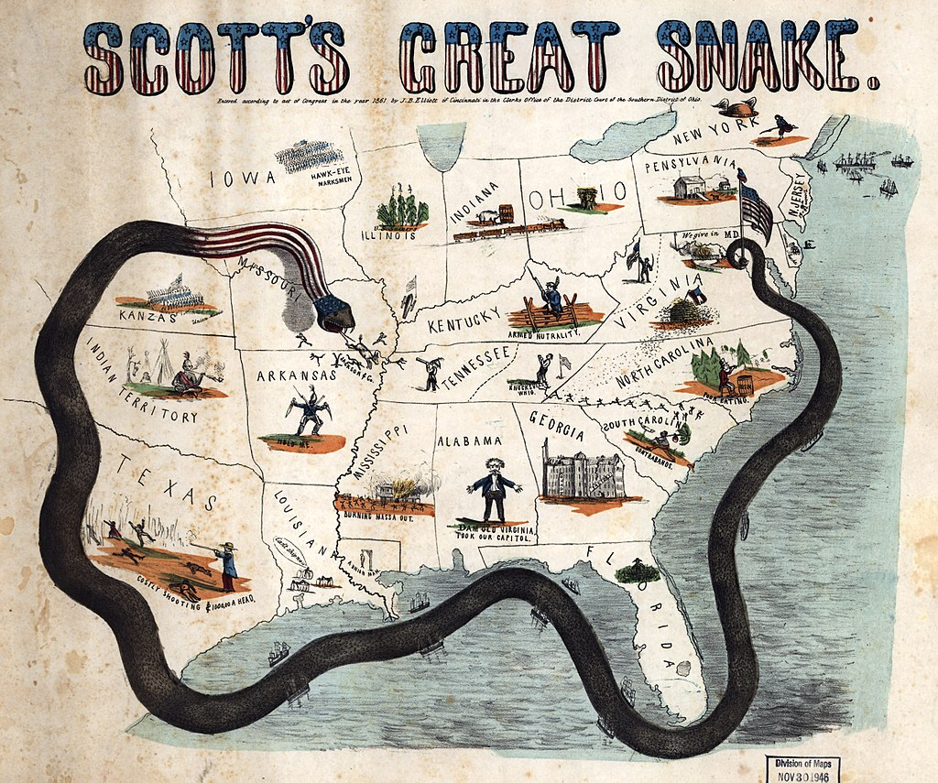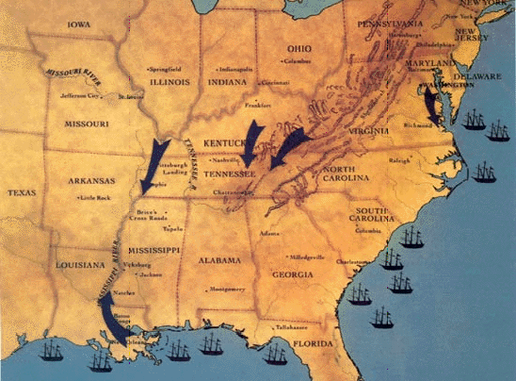
b. SOUTH STRATEGIES
- Fight a DEFENSIVE war and make it last a long time.
- Get HELP from EUROPE for food, supplies and manufacturing. TRADE COTTON for FOOD and GUNS
- Get HELP from NATIVES because they had a lot of FARMING and CATTLE in INDIAN TERRITORY.
2. EARLY BATTLES – FIRST BATTLE OF BULL RUN (NORTH NAME), “BATTLE OF MANASSAS” (SOUTH NAME)
JULY 21, 1861
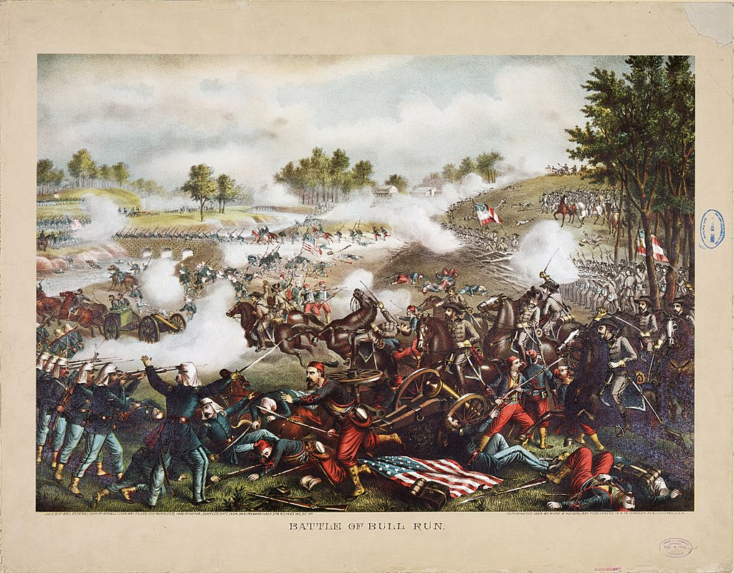
a. GENERAL WINFIELD SCOTT’s NORTH plan was to take out RICHMOND! With 18,000 UNTRAINED troops, He pushed forward in VIRGINIA to RICHMOND
b. ROBERT E LEE with 18,000 troops also STOOD their GROUND and waited and HURT the NORTHERN ARMY!
c. NORTH begins to push back the SOUTH, they begin to retreat, but one CONFEDERATE GENERAL keeps pushing and fighting, “THOMAS STONEWALL JACKSON”
- His men said, “LOOK, it is JACKSON standing like a STONEWALL”
- This pushed the CONFEDERATE ARMY to push forward and win the Battle of BULL RUN (MANASSAS)
- ROBERT E. LEE promotes JACKSON TO HIGH RANKING GENERAL for his bravery
c. BOTH SIDES had heavy losses, but SOUTH CONFEDERACY WINS!
d. FIRST BATTLE OF BULL RUN realizes that it was going to be a LONG BLOODY WAR.
e. ABRAHAM LINCOLN is not happy with his GENERAL WINFIELD SCOTT, Tells SCOTT to RETIRE!
NORTH GENERAL WINFEILED SCOTT THOMAS “STONEWALL” JACKSON SOUTH GENERAL ROBERT E. LEE
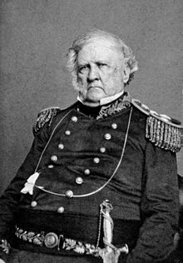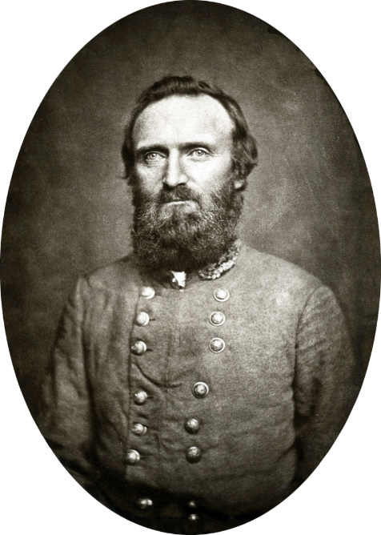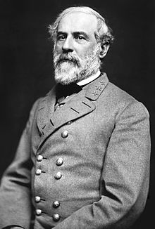
THOMAS “STONEWALL” JACKSON @ BATTLE OF BULL RUN
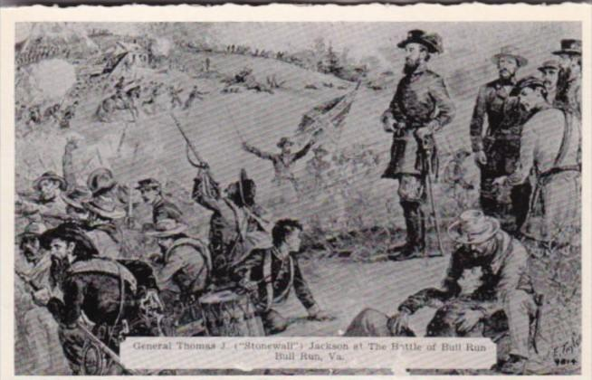
3. BUILDING THE NORTHERN “ARMY OF THE POTOMIC” – MCCLELAN FIRST BATTLE
a. ABRAHAM LINCOLN was furious with the LOSS at BULL RUN (MANASSAS) so he RETIRES GENERAL WINFIELD SCOTT.
b. LINCOLN asks for GENERAL GEORGE MCCLLENAN to meet with him and he offers him the job in Washington D.C.
- GEORGE MCCLLELAN was a war HERO from the MEXICAN AMERICAN WAR
c. GENERAL MCCLLENAN accepts the job and says WE WILL TAKE RICHMOND, but the men NEEDED LOTS OF TRAINING
MCCLELLAN ENTERING WASHINGTON NORTH GENERAL GEORGE MCCLELLAN
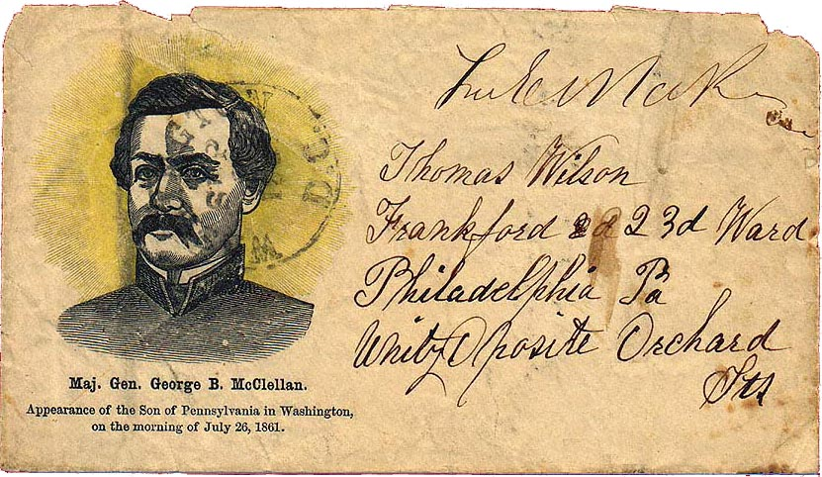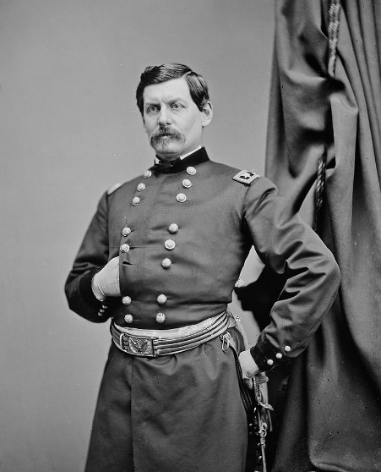
NORTHERN ARMY OF THE POTOMIC (LARGE ARMY IN WASHINGTON D.C.)
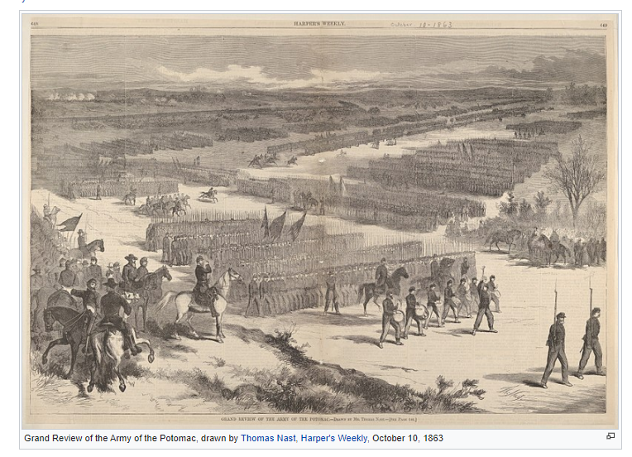
d. MCCLELLAN was known for transforming inexperienced recruits into BATTLE READY SOLDIERS, he trained and organized his men, also CREATING 48 forts to PROTECT WASHINGTON D.C.
e. THE ARMY OF THE POTOMIC grew from 48,000 to 168,000 under MCCLELLAN.
f. MCCLELLAN was a good General, but he was very CAUTIOUS, LINCOLN wanted a man that would GET THE WAR OVER.
g. MCCLELLAN trained the men literally 6 months with no fighting being done!,
- LINCOLN frustrated with his GENERAL said, “If MCCLELLAN does not want to use the army I would like to BORROW IT!”
- America would often joke NATIONALLY, “All quiet along the POTOMAC” meaning MCCLELLAN would not fight.
h. LINCOLN pushed MCCLELLAN to fight, so in 1862, he sailed on a ship just south of the SOUTH CAPITOL of RICHMOND
- MCCLELLAN landed on the VIRGINIA PENNINSULA, so it was nicknamed the PENNINSULA CAMPAIGN or BATTLE OF 7 DAYS
i. GENERAL LEE of the SOUTH met him there and AMBUSHED him! LEE sent STONEWALL JACKSON to MARCH TO ATTACK WASHINGTON D.C.
j. MCCLELLAN retreated and went back to DEFENED WASHINGTON D.C. – LINCLON was NOT HAPPY!
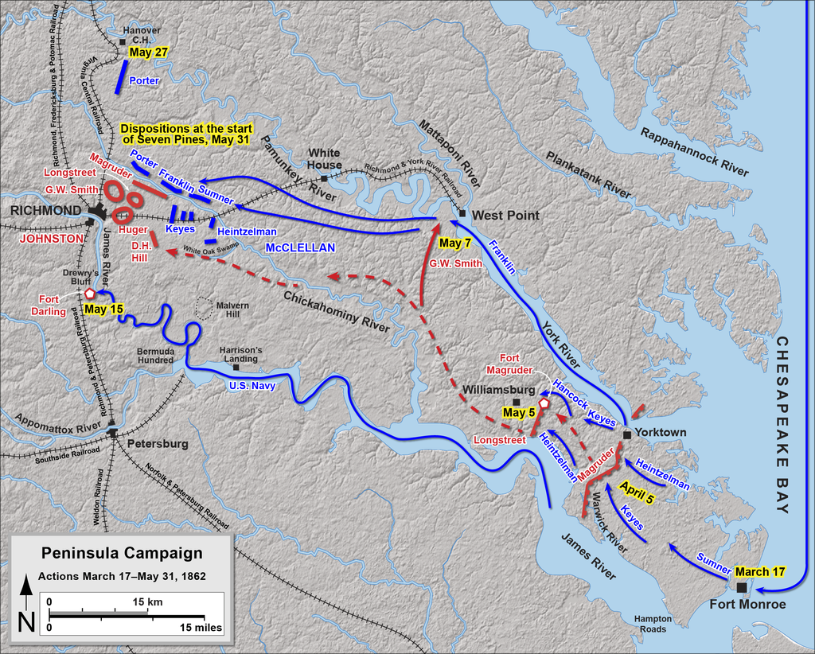
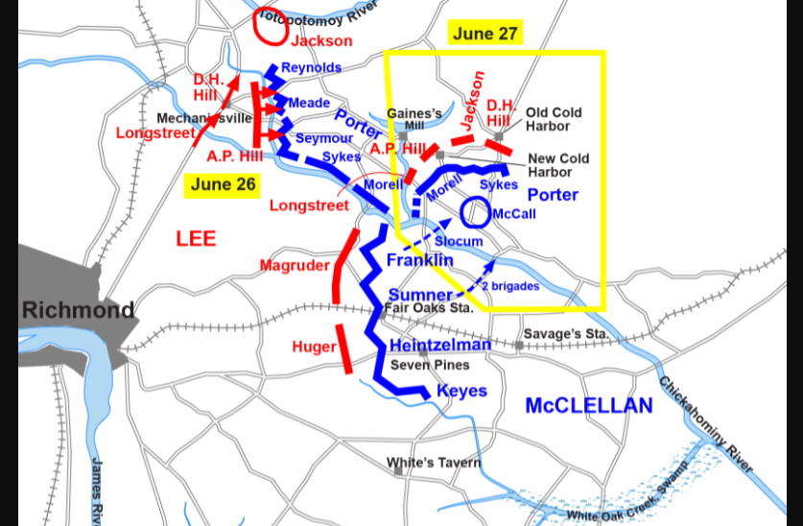

4. THE BLOCKADES AND IRONCLAD GUN BOATS
a. Early in the war, UNION BLOCKADED all SOUTH PORTS, so nothing would come in or out. SOUTH needed IMPORTS
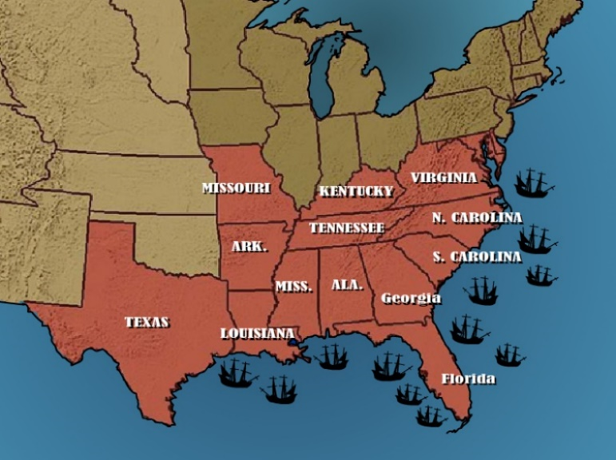
b. To break the BLOCKADE the SOUTH created IRONCLAD GUNBOATS! Ships made with IRON on the outside!
c. SOUTH took an OLD NORTH ship called, “MERRIMACK” and put IRON around it calling it, “VIRGINIA”
- The VIRGINIA took out 2 NORTH ships and HURT many more.
- NORTH Cannonballs bounced off the IRONCLAD GUNBOATS.
- The SOUTH had to SINK the VIRGINIA because the NORTH CAPTURED the City of NORFOLK.
d. Because of the VIRGINIA, the NORTH built 50 IRONCLADS for them to use against the SOUTH. These were used well into World War 1.
e. The NORTH GUNBOATS became much more effective than the SOUTH, NORTH had much more!
NORTHERN IRONCLAD
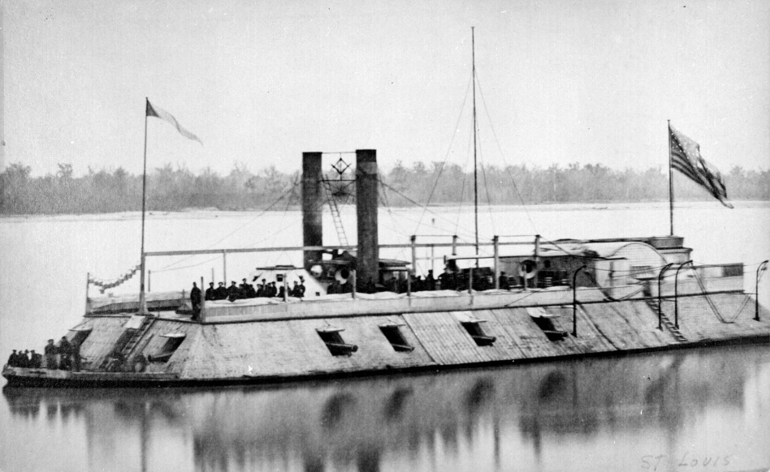
CSS VIRGINIA SOUTH GUNBOAT
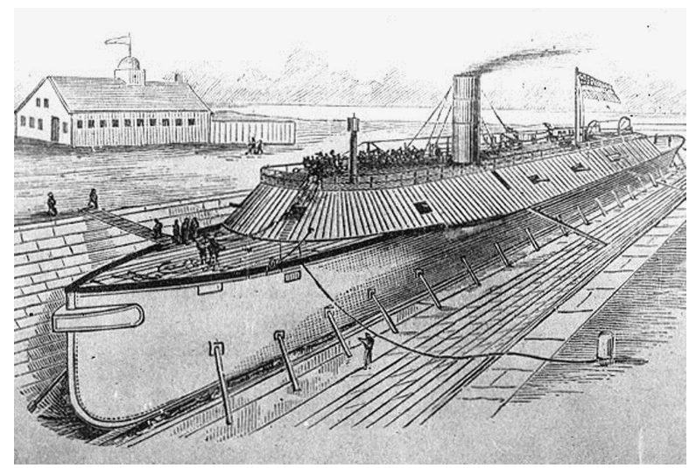

5. MCLELLAN’s SECOND CHANCE – BATTLE OF ANTIETAM – “BLOODIEST DAY IN AMERICAS ARMY HISTORY”
a. PRESIDENT LINLCON gave MCCLELLAN a 2nd chance at leading the ARMY OF THE POTOMIC
- MCCLELLAN led the army at the BATTLE OF ANTIETAM in SHARPSBURGH MARYLAND.
- NORTH names this BATTLE of ANTIETAM because it was near “ANTIETAM CREEK”.
- SOUTH names the BATTLE of ANTIETAM “BATTLE OF SHARSBURGH” because of the closest city.
b. To this day, the BATTLE OF ANTIETAM was the Bloodiest Day in American History.
c. There were 3 MAIN PARTS OF BATTLE OF ANTIETAM on September 17, 1862.
- 1ST PART: Union attack the Confederacy through a CORNFIELD,
  - Artillery FIRE came from both sides!
  - They fought HAND TO HAND BAYONETT in close range
  - They lit the CORNFIELD on FIRE hurting both sides!
  - CONFEDERATE GENERAL was Stonewall Jackson,
  - Not much Advancement, 13,000 total DEAD
VARIOUS PICTURES OF CORNFIELD TODAY TAKEN BY COACH D.
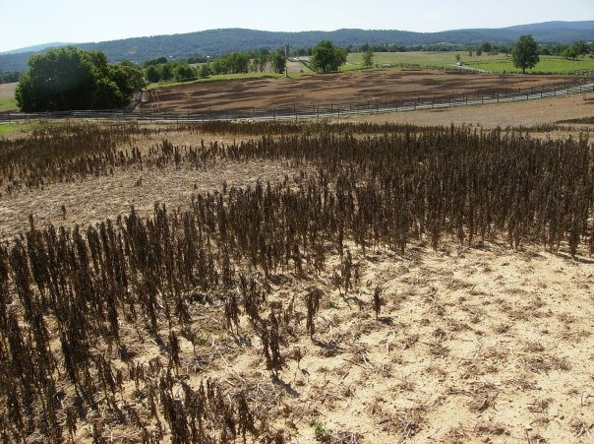
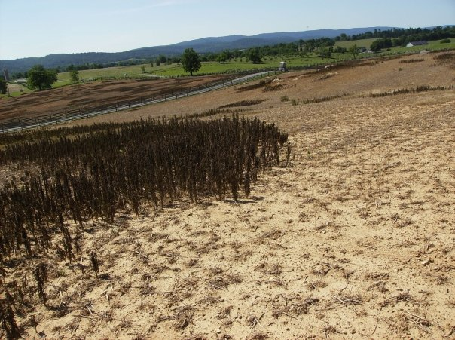
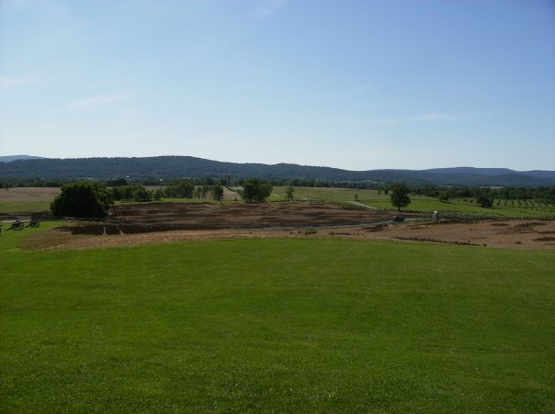
OLD CANNON FROM THE CORNFIELD
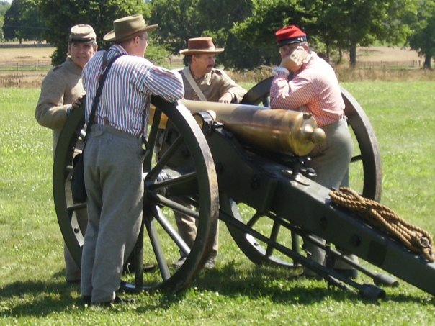
OLD CHURCH at BATTLE OF ANTIETAM, NORT HAND SOUTH BODIES PILED UP
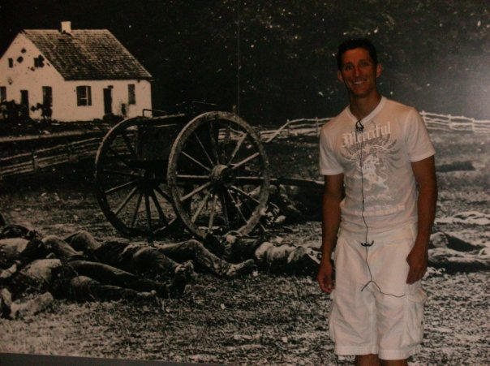
- 2nd PART OF BATTLE OF ANTIETAM – “BLOODY LANE”
  - There was a OLD ROAD used by wagons that transported goods. SOUTH used it as defensive place
  - They camped and waited on the ADVANCEMENT of the NORTH.
  - The ROAD was VERY OLD, and over time SUNK IN!
  - The NORTH advanced and jumped in the ROAD and HAND to HAND fighting began!
  - NORTH and SOUTH bodies piled up, you could not walk through the road.
  - There was were puddles of blood from both sides in the road like a small river, “BLOODY LANE”
COACH D GIVING LECTURE TO OTHER TEACHERS STANDING IN “BLOODY LANE”
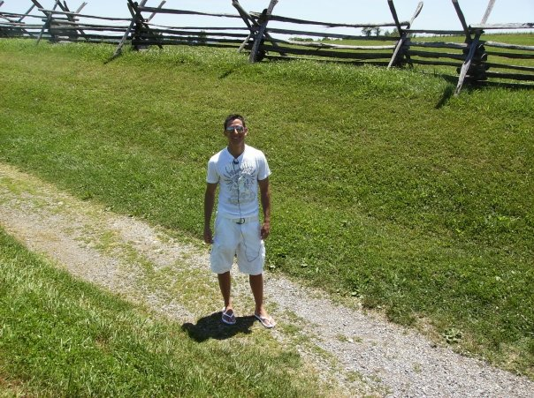
HOW DEEP BLOODY LANE WAS
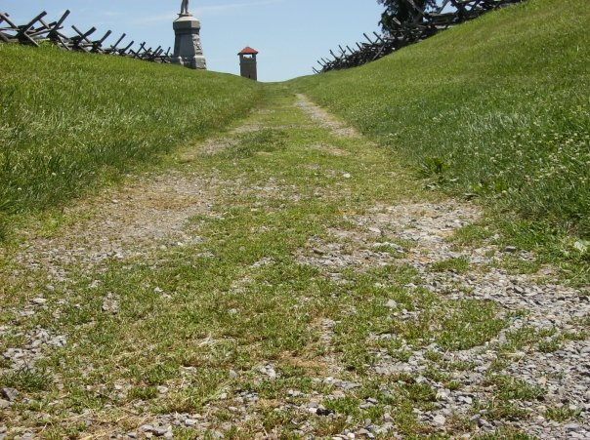

SOUTH SOLDIERS USED FENCES AND HILL ON SIDE OF LANE FOR COVER
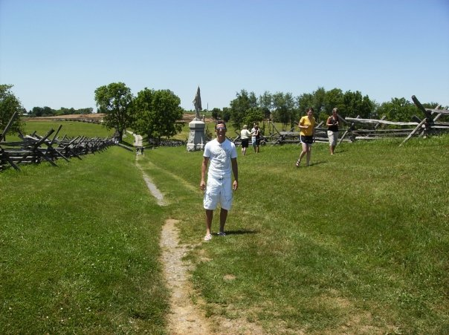
BLOODY LANE MONUMENT TODAY, YOU CAN CLIMB UP AND SEE DOWN INTO THE LANE
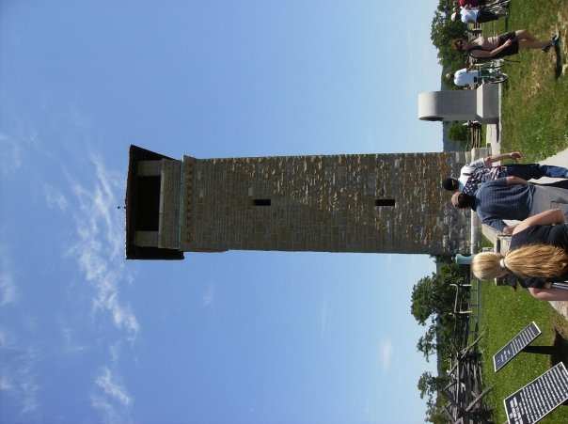

AFTERMATH OF BLOODY LANE
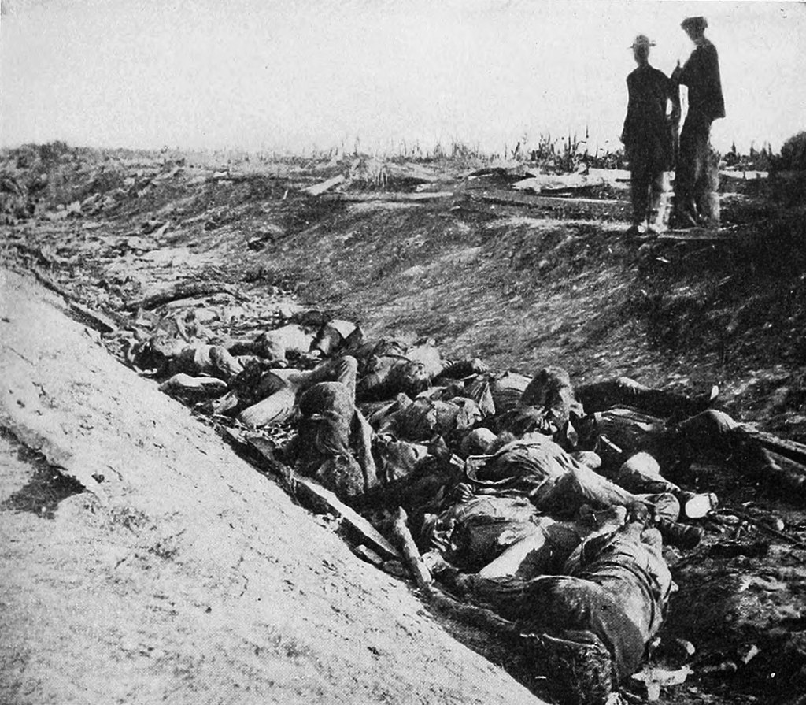

- 3rd PART OF BATTLE OF ANTIETAM – “BURNSIDES BRIDGE”
  - There was a BRIDGE where GENERAL BURNSIDE (NORTH) had his men CROSS!
  - BURNSIDE SENT WAVE AFTER WAVE! Most killed or wounded! AGGRESSIVE PUSH
  - GENERAL BURNSIDE and his men made it to the other side, but little advancement
PAINTING OF BURNSIDES BRIDGE BATTLE
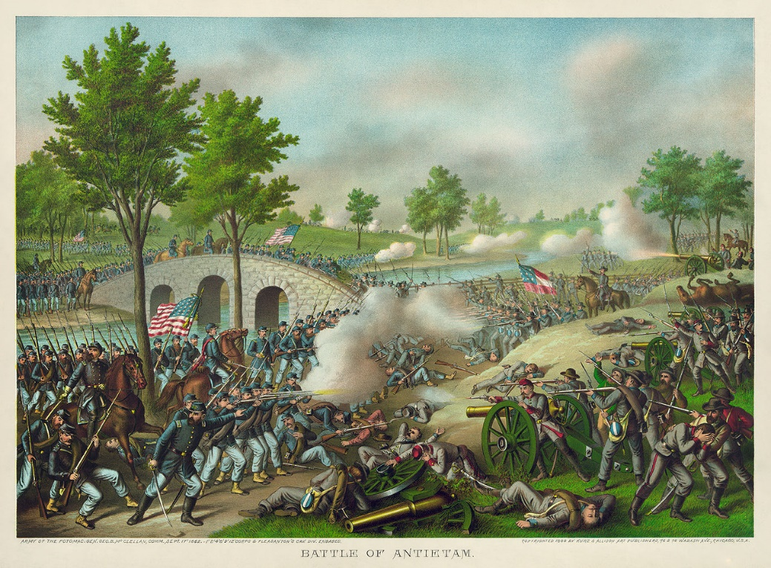
  - BURNSIDE made 3 major attempts, the SOUTH GENERAL LONGSTREET, held his own
  - BURNSIDES BRIDGE was heavy casualties on both sides.
  - After this it was the end of BATTLE OF ANTIETAM
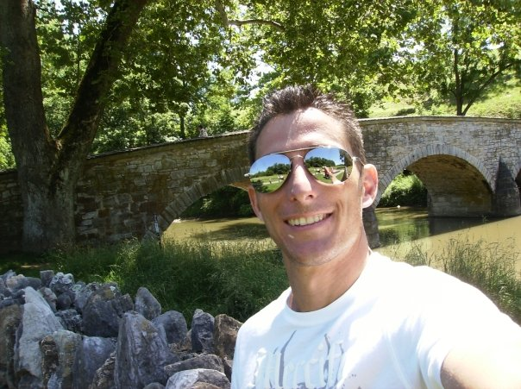
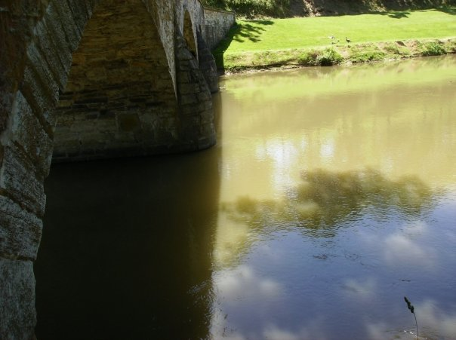

- RESULTS OF BATTLE OF ANTIETAM
  - ABRAHAM LINCOLN was not happy with MCCLELLAN and his CAUTIOUS FIGHTING
  - LINCOLN FIRES MCCLELLAN
  - ANTIETAM goes down in HISTORY as a TIE: 25,000 AMERICANS Dead or Missing in Action
  - This was a STRATEGIC WIN for the NORTH, The SOUTH ARMY was HURT!
  - 5 DAYS LATER, LINCOLN MAKES HIS, “EMANCIPATION PROCLIMATION”
IMAGE OF LINCOLN FIRING MCCLELLAN
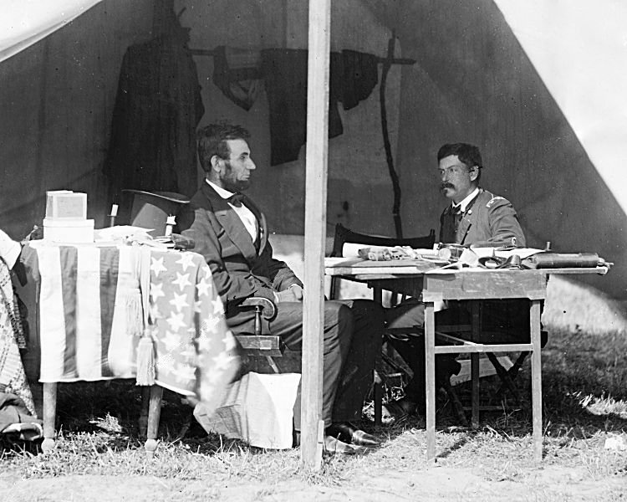

6. VICTORIES IN THE EAST FOR CONFEDERACY (SOUTH)
a. LINCOLN fires MCCLELLAN because his CAUTIOUS nature and not going to fight GENERAL ROBERT E. LEE
b. LINCOLN hires the AGGRESSIVE, GENERAL AMBROSE BURNSIDE
GENERAL AMBROSE BURNSIDE
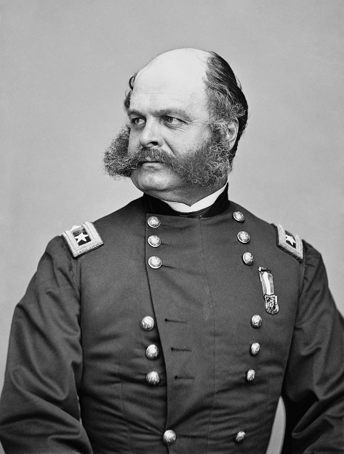
c. BURNSIDE brought a PHYSICAL and AGGRESSIVE nature to the ARMY OF THE POTOMIC
d. BURNSIDE told LINCOLN he would take RICHMOND, he pushed but lost two wars at FREDRICKSBURG and CHANSELORVILLE
BATTLE OF FREDRICKSBURG
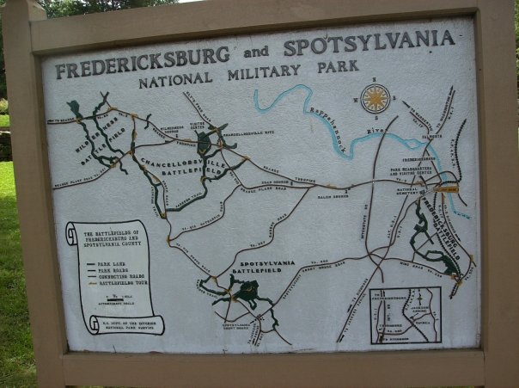
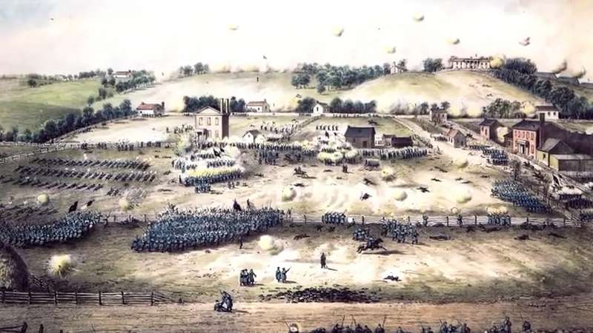
- BATTLE OF FREDRICKSBURG – MAY 3, 1863
  - One of NORTHS worst losses!
  - SOUTH GENERAL, Robert E. Lee and James LONGSTREET
  - 12,000 Dead for NORTH
  - 6,000 Dead for SOUTH
  - BURNSIDE had a HUGE FRONT attack! SOUTH had high ground though
  - BURNSIDES lack of preparation for the BATTLE gets him fired!
e. LINCOLN fires BURNSIDE because his lack of KNOWLEDGE on Battlefield preparation and Hires GENERAL JOSEPH HOOKER
GENERAL JOESEPH HOOKER
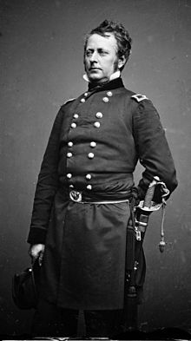
- BATTLE OF CHANCELORSVILLE – APRIL 30 to MAY 6, 1863
  - SOUTH VICTORY, General was Robert E. Lee and Stonewall Jackson
  - NORTH GENERAL, Joe Hooker
  - Battle lasted 3 days, NORTH lost but SOUTH had heavy losses
  - STONEWALL JACKSON was shot and killed at this BATTLE, Shot by his own MEN on ACCIDENT
  - GENERAL HOOKER in the battle found a opening, but did not PURSUE it!
  - HOOKER was not good at COMMUNICATION, changed his plans MID BATTLE!
  - LINCON chose to keep him anyways, but LINCOLN got in fights with his CABINET OVER IT!
BATTLE OF CHACELORSVILLE
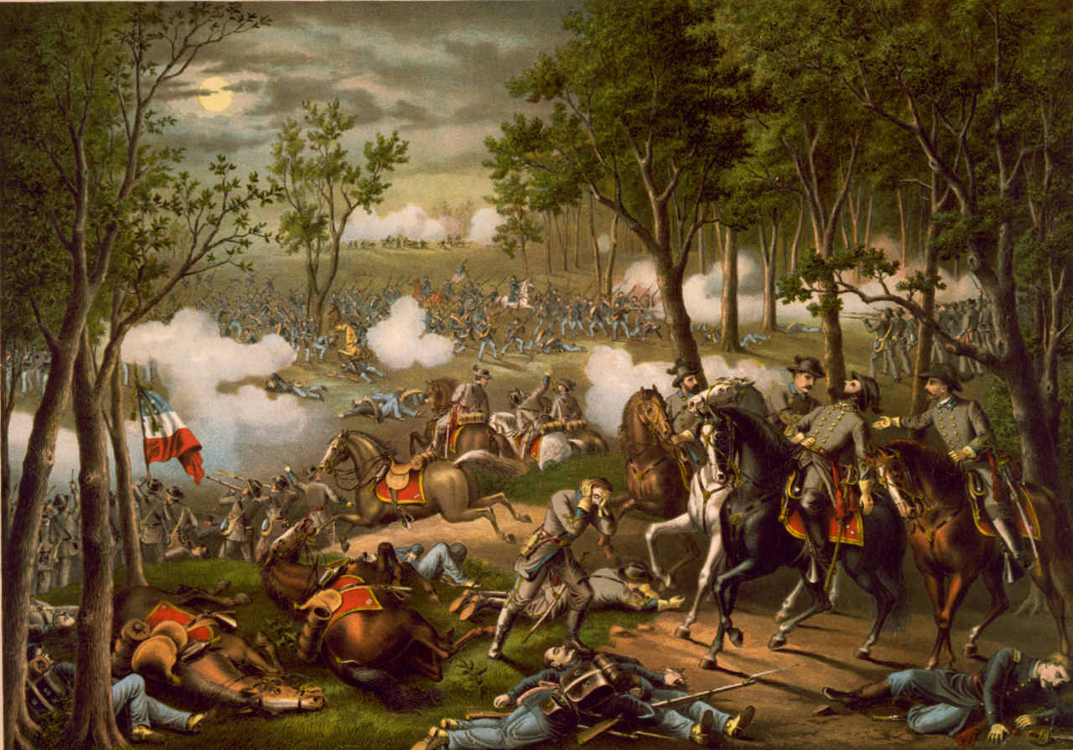
6. LINCOLNS EMANCIPATION PROCLIMATION
a. Lincoln wanted to find a way to HURT the south, 5 DAYS after CHANCELORVILLE he creates his “EMANCIPATION PROCLOMATION”
- Lincoln wanted the SLAVES free! But, also thought this as a MILITARY STRATEGY
  - 1. Slaves pick the COTTON – (Free them means no COTTON)
  - 2. Cotton is sold to Britain – (No COTTON means no MONEY)
  - 3. No Money (Can’t make war and pay soldiers and buy weapons)
- Lincoln knew this was a DO NO WRONG IDEA! He thought SLAVERY was WRONG!
- Jan 1, 1863.
- Emancipation Proclamation freed SLAVES in CONFEDERATE OCCUPIED SOUTH, not in LOYAL SLAVE STATES.
- Creating the PROCLOMATION showed EUROPE that USA STILL CONTROLLED SOUTH WITH LAWS!
- UNION Troops were now fighting to not just keep USA TOGETHER but to END SLAVERY
LINCOLN WRITING THE EMANCIPATION PROCLOMATION
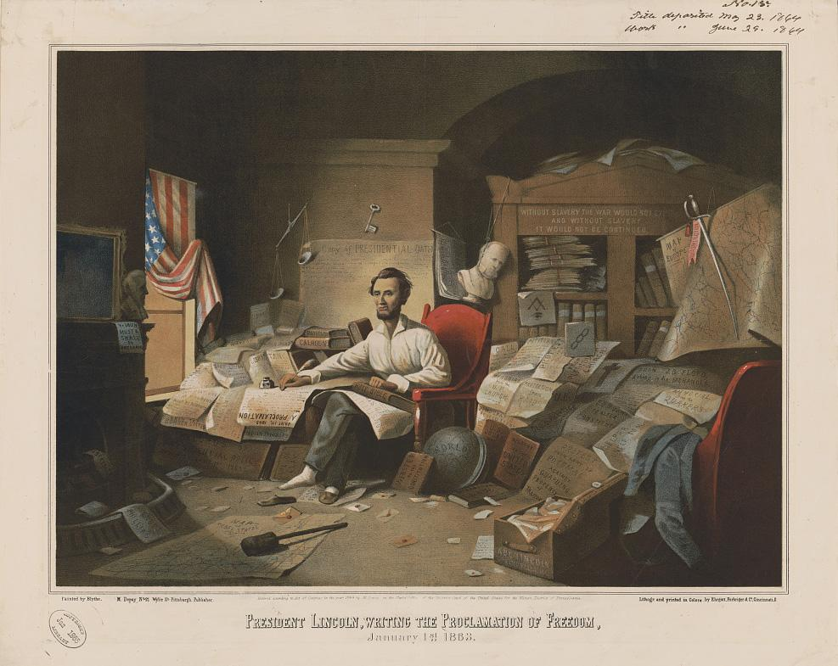
EMANCIPATION HAPPENS IN THE RED STATES NOT THE BLUE BECAUSE BLUE FAUGHT FOR THE NORTH
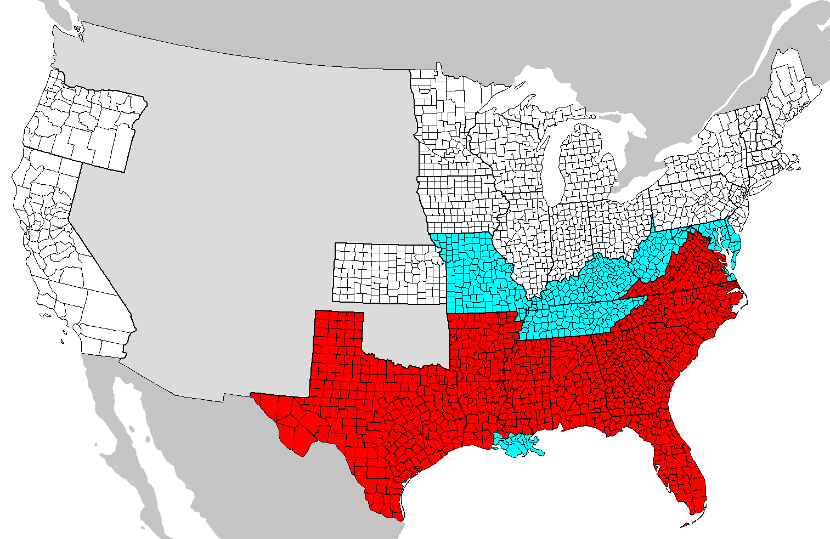
7. EFFECTS OF THE EMANCIPATION PROCLOMATION
a. Thousands of African Americans turn out to fight for the UNION
b. Many who get FREE from the PROCLOMATION join the ARMY to FIND THEIR FAMILIES
c. By 1863, 200,000 AFRICAN AMERICANS fought in the UNION army.
d. The most famous AFRICAN AMERICAN regiment is the 54th INFINTRY
- FREDRICK DOUGLAS recruited for this ALL BLACK INFANTRY.
- The 54th at ONE TIME REFUSED PAY because they did not get the same PAY as WHITE SOLDIERS!
- They VOLUNTEERED to Lead the ATTACK at FORT WAGNER where they all including the GENERAL DIED.
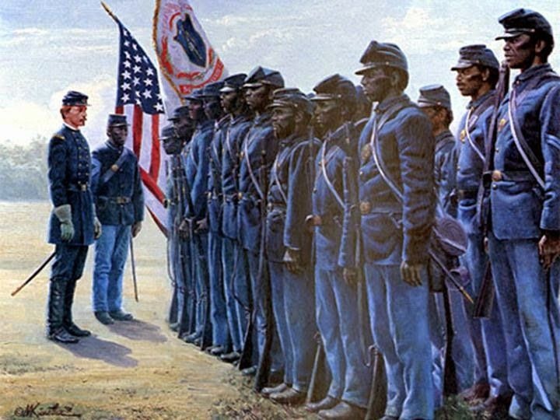
- Every one of the MEN received a MEDAL OF HONOR and a PLACE IN HISTORY
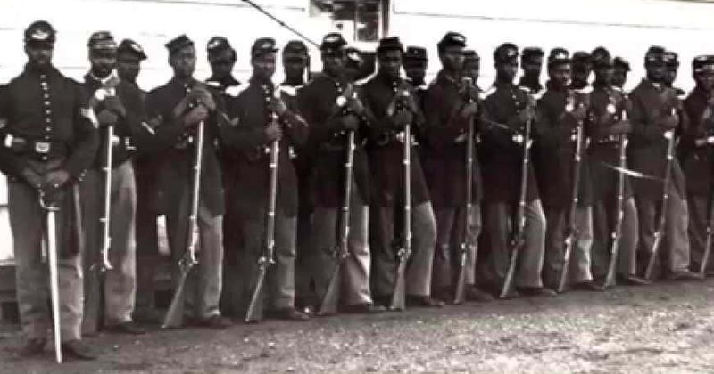

54th MASSACHUSSETTS INFANTRY AT FORT WAGNER
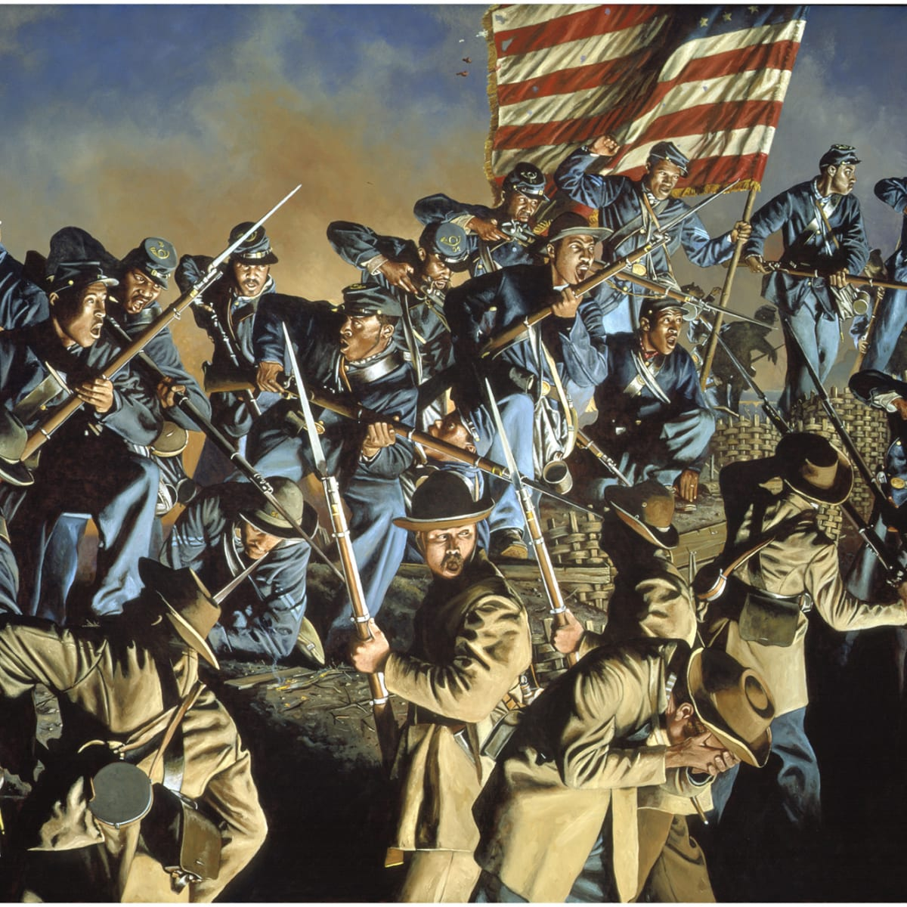
e. SECRETARY OF WAR EDWIN STANTON said, “These men proved themselves among the bravest of the brave.”
f. 1/4th of the SOUTHS SLAVES became RUNAWAYS to try and find UNION soldiers so they would be free.

8. HORRORS OF WAR – DRAFT, TECHNOLOGY, MEDICINES, TAXES, ECONMICS, WOMEN
a. AGE OF SOLDIERS
- SOUTH – Begins drafting kids at 17 years old because a lack of man power.
- NORTH & SOUTH – Most under the age of 21, because more Athletic and were fit.
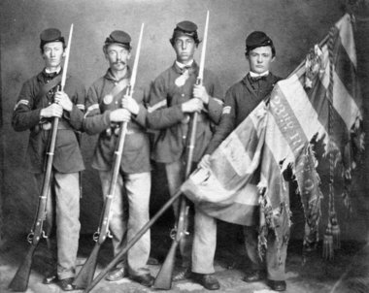

b. CONDITIONS & TECHNOLOGY
- Most soldiers fought in a OLD style in a LINE, But TECHNOLOGY was better!
- RIFLES shot faster, straighter because of GROOVES in ALL BARRELLS of GUNS and RELOADED QUICK
- SOLDEIRS ran in STRAIGHT LINES made it easy for CANNON FIRE
- BULLETTS now had CONES at the TIP like today called the, “MINIBALL”
STRAIGHT LINES IN WARFARE MINIBALL BULLETT
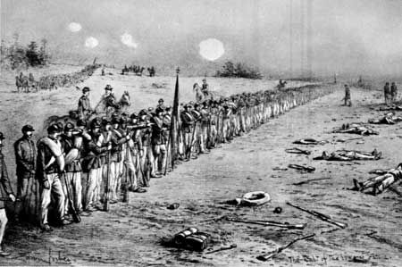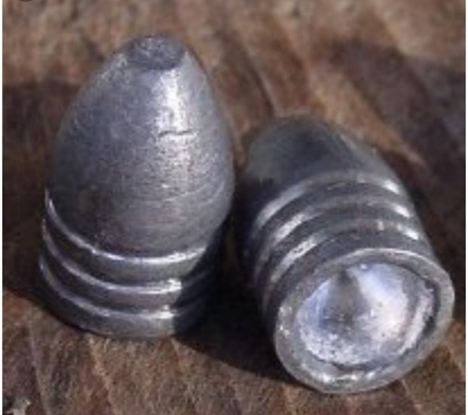
- IMPROVED CANNON mobility and RANGE, BOMBS could now fly almost a MILE with PROJECTILES
- First time BALOONS were used in WARFARE
LONG RANGE CANNONRY LONG RANGE BOMBS
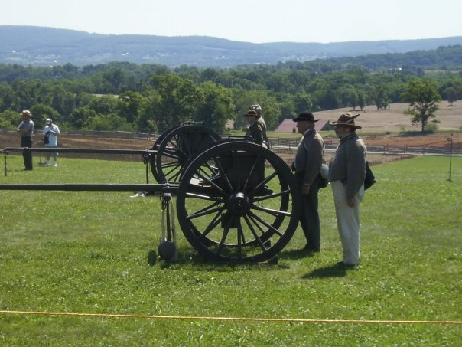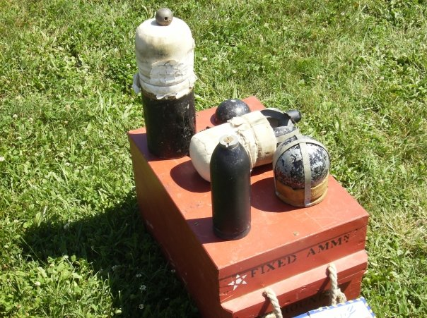
MORE PROJECTILES USED IN CIVIL WAR SHORT RIFLES USED IN CIVIL WAR
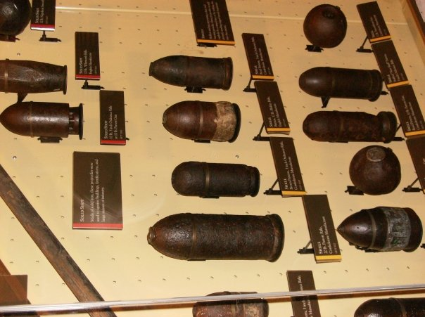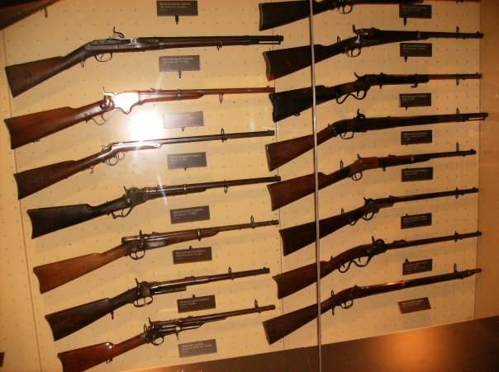
LONG RIFLES USED IN CIVIL WAR
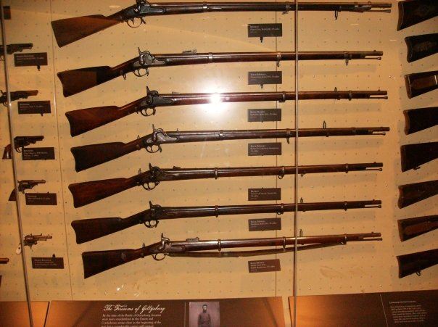
CONFEDERATE SOLDIER UNIFORM (“JOHNNY REB”) UNION SOLDIER UNIFORM (“BILLY YANK”)
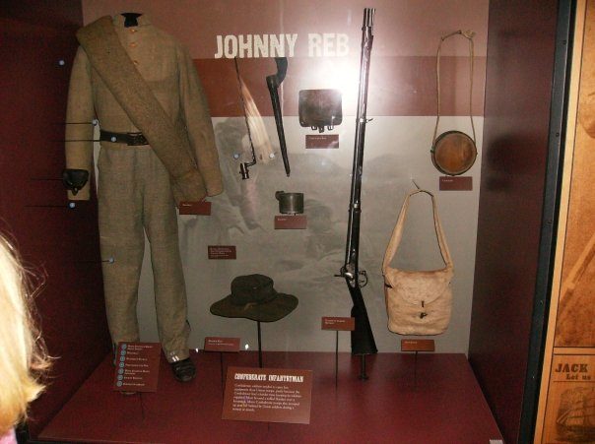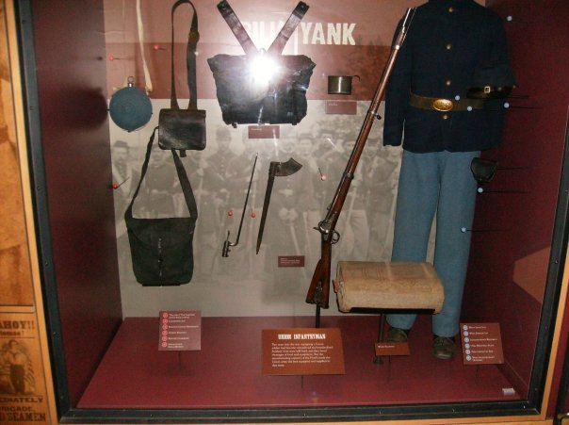
GUNBOATS
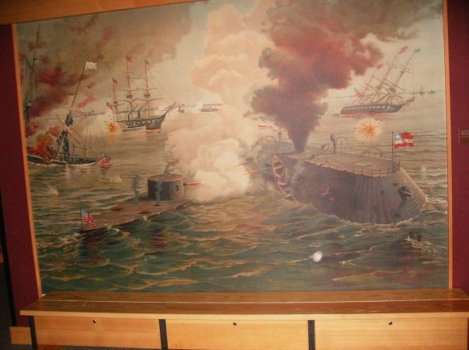
CIVIL WAR BALOONS FOR SCOUTING ENEMY
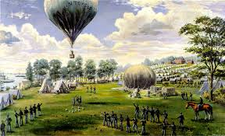
d. MEDICAL ADVANCES AND SHORTFALLS
- Sick and Wounded FACED HORROS, the possibility of AMBUTATION
  - AMPUTATION – Where you cut off someone’s arms or legs, so INFECTION does not occur.
- Doctors did not know how INFECTIONS cause disease and germs.
- A minor wound can turn into a HUGE ONE causing AMPUTATION.
- There was not much ANESTHESIA – Putting someone to sleep while surgery (WAS SOME LATER IN WAR)
- The MEDICAL TENTS were not sanitary at all. There was blood and GERMS everywhere
- PNEMONIA and MALARIA killed more men than GUNS DID!
- GANGREEN began to be a serious problem as well. It is an infection that people got in the HOSPITALS
- United States developed a GOOD system of carrying wounded off the BATTLEFIELD quickly
- They created HOSPITALS near the local BATTLE SITES
- DENTAL checks were done to make sure soldiers could use their FRONT teeth to tear into GUN POWDER packs.
- By the time of the CIVIL WAR end the UNION had 12,000 Doctors. CONFEDERACY had 3,000.
DOCTORS TOOLS IN CIVIL WAR
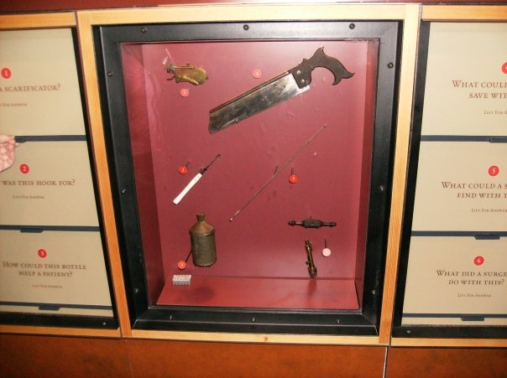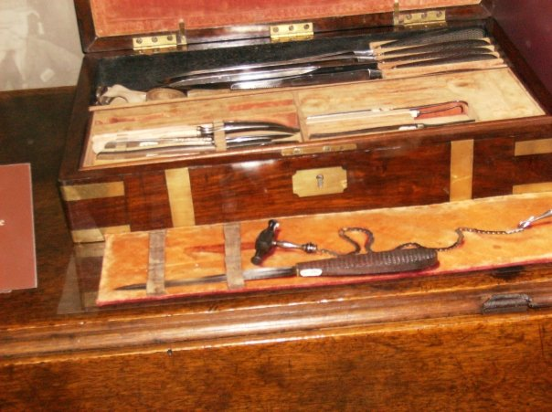
e. DRAFTS
- Supporters of war were called: COPPERHEADS, some did not like the way LINCOLN conducted the war
- NORTH DRAFT
  - LINCOLN created the first DRAFT in AMERICAN HISTORY in 1863.
  - The DRAFT was where all MEN ages 20-45 had to go to war if told by the GOVERNMENT.
  - DRAFTS led to RIOTS in major cities in the NORTH, worst one was in NEW YORK CITY. 74 people dead!
  - LINCOLN took away HABEAS CORPUS during this: Right to have a hearing before jail. HE JUST JAILED!
  - 14,000 people were arrested during the RIOTS of NEW YORK CITY
- SOUTH DRAFT
  - President JEFFERSON DAVIS said if you owned 20 slaves you were NOT IN THE DRAFT
  - By the end of the war, DAVIS put SLAVES in the army!
  - SOUTH states did not like the TAXES made to pay for the war!
  - DRAFT in south was not as bad as NORTH

DRAFT RIOTS IN NEW YORK CITY
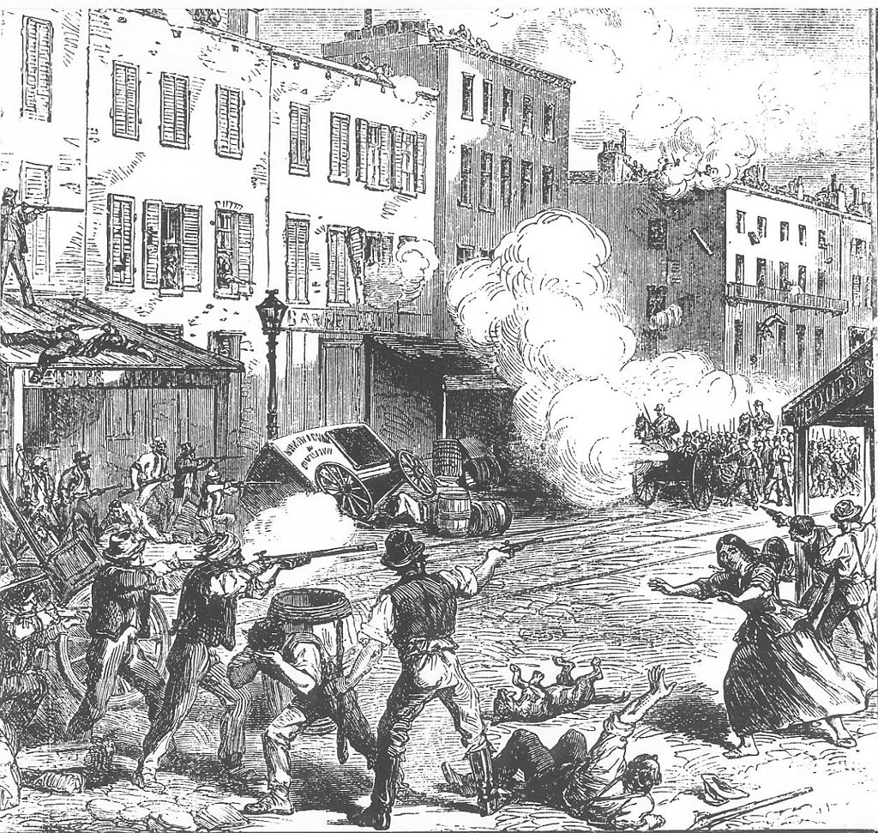
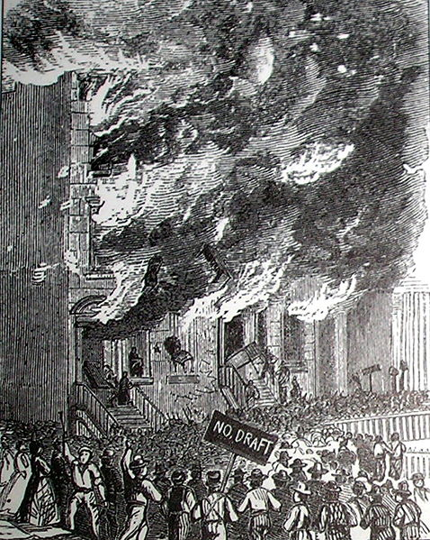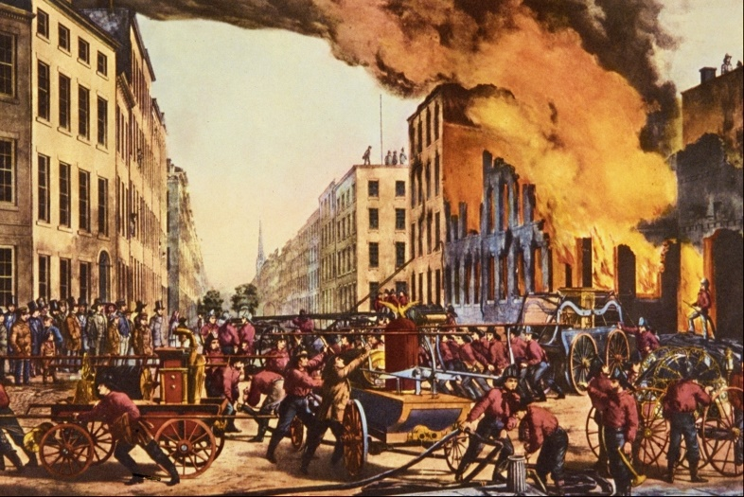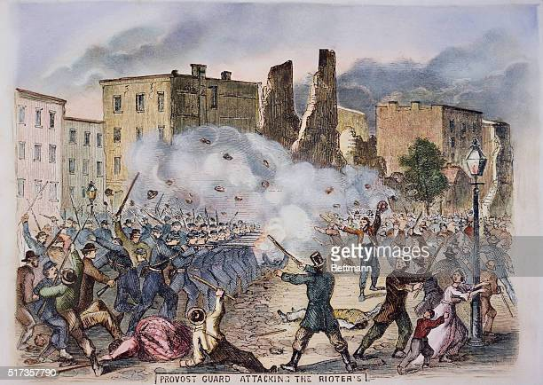

f. TAXES AND ECONOMICS
- The CIVIL WAR brought ECONOMIC chaos for both NORTH and SOUTH
- SOUTH did not have enough resources to trade and the UNION BLOCKADE hurt them
- NORTH & SOUTH imposed a HARD INOCOME TAX, Farmers had to turn over 1/10th of their crop to CONFED GOVT.
  - Also, AMERICA created the IRS (Internal Revenue Bureau) that oversee the TAXES
  - INCOME TAX – Tax on people’s earnings,
- SOUTH printed PAPER MONEY that led to INFLATION
  - INFLATION – Raise in prices but a decrease in the value of the money
- SOUTH PRESIDENT DAVIS stopped shipping COTTON to BRITAIN in hopes BRITAIN would back the SOUTH
  - BRITAIN turned on them and bought their COTTON from INDIA and EGYPT
- NORTH ECONOMY went up because the demand for: FOOD, CLOTHES, GUNS, BULLETS all went up during war.
g. WOMEN IN THE WAR
- Women in the NORTH and SOUTH played a HUGE roll! Women worked in MENS jobs when MEN went to war.
- Women had to raise the families on their own.
- Some women served as SPIES for the NORTH and SOUTH
- Many women accompanied their MEN in camps in the war.
- Some women in rare times dressed up as MEN to fight in the CIVIL WAR
- Women formed different AID societies and raised food and money with bedding, clothing, and medicines
- Women MOST of ALL worked as NURSES on both sides NORTH AND SOUTH
  - They did it so well, WOMEN become NURSES till even TODAY
  - Sojourner Truth, Doretha Dix, and Clara Barton were women who worked for the NORTH in ways.
    - CLARA BARTON – Established the American Red Cross
ROLES OF WOMEN IN THE CIVIL WAR (SERVERS)
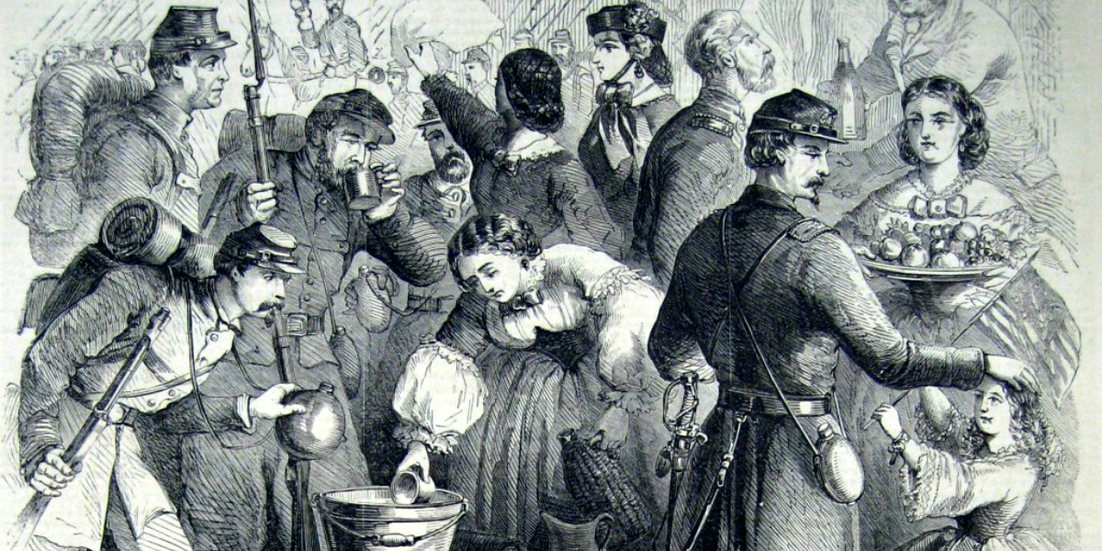
NURSES
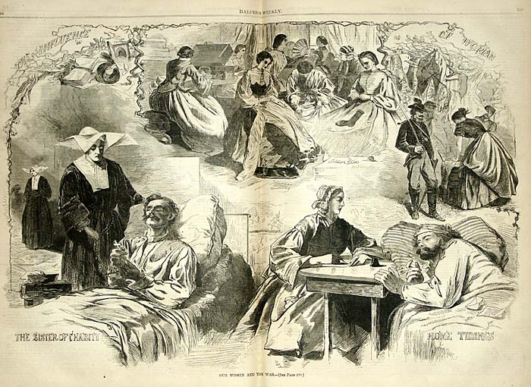
SEWING
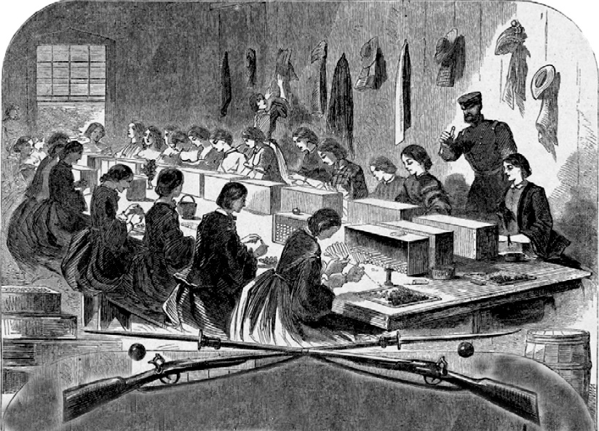
SECTION 6: “The Wars End”
1. A SUCCESSFUL UNION GENERAL – ULYSSEUS S. GRANT
a. After BIG LOSSES at Fredericksburg and Chancellorsville, the UNION (NORTH) had a General in the WEST that WON!
b. UNION WEST GENERAL U.S. GRANT commanded an attack at VICKSBURG & SHILOH
- BATTLE OF SHILOH – APRIL 6-7, 1862 – ULYSSEUS S. GRANT in TENNESSEE
  - GENERAL GRANT of the UNION NORTH ARMY IN THE WEST attacked on the TENNESEE RIVER with GUNBOATS
BATTLE OF SHILOH GUNBOATS BATTLE OF SHILOH HORNETS NEST SUNKEN ROAD
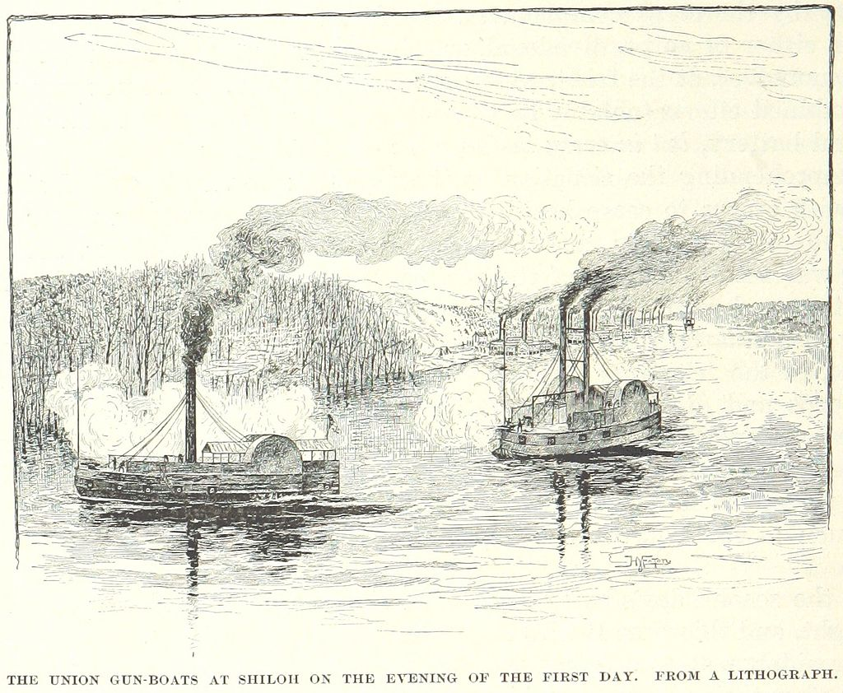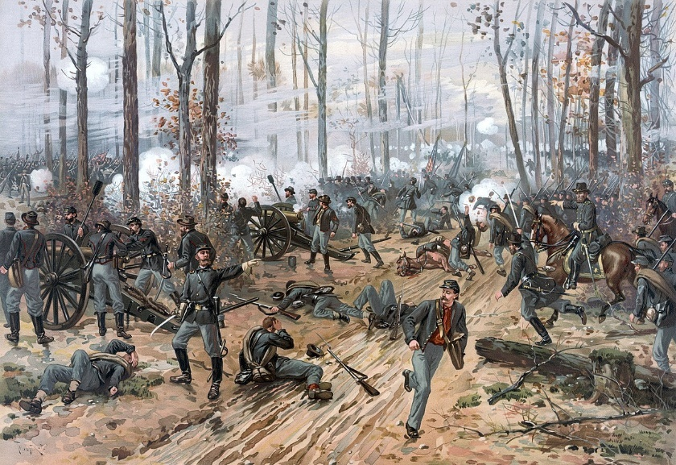
  - GRANT confused the CONFEDERATE ARMY in TENNESEE so badly their own GENERAL “ALBERT JOHNSTON” was shot in the leg and killed.
  - Lots of fighting was done along a place called, “HORNETS NEST.” A old sunken road.
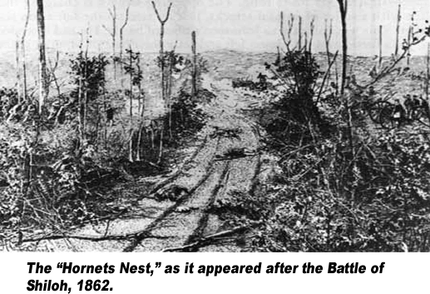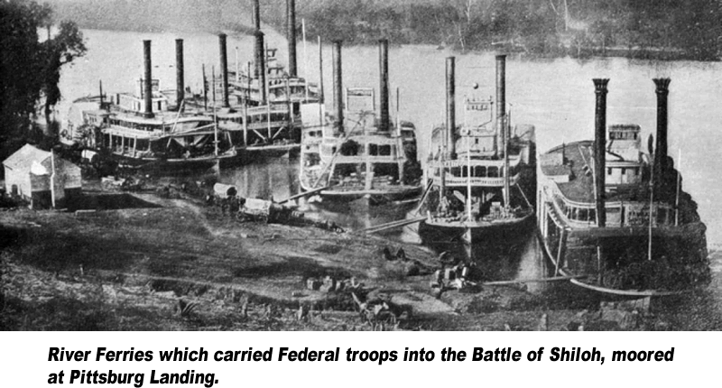
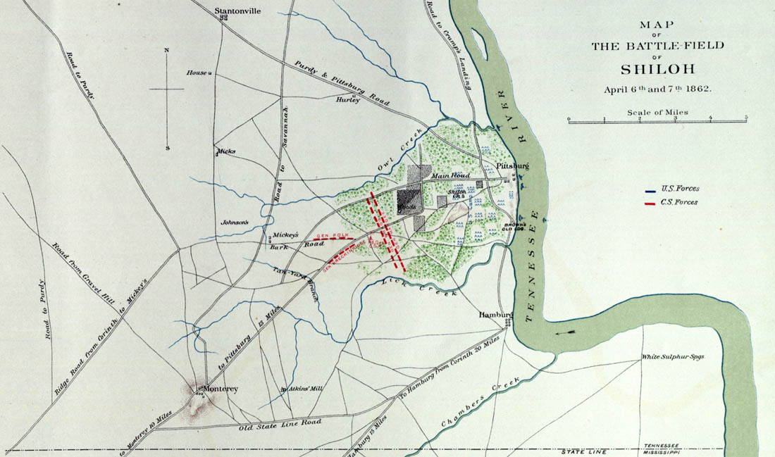
- GENERAL GRANT and his men defended at the SUNKEN ROAD “HORNETS NEST” and defeated the CONFED SOUTH @ SHILOH
- 13,000 UNION NORTH troops dead or wounded,
- 10,000 CONFEDERATE SOUTH troops dead or wounded.
- GENERAL GRANT proved he is a good leader !
c. GENERAL GRANT knew that the NORTH needed to take the MISSISSPPI RIVER, & TENNESEE RIVER but he had to take VICKSBURG to separate EAST AND WEST SOUTHERN STATES!
d. GRANT tried taking VICKSBURG one time before and failed in 1861, GRANT tried again in 1863 and WON
e. GRANTS plan was to ATTACK from the MISSISSIPPI RIVER and from the REAR coming from WEST.
f. The Battle of Vicksburg lasted 6 WEEKS, with BLOCKADES the SOUTH ran out of supplies at VICKSBURG and surrendered on July 4, 1863.
g. The WIN @ VICKSBURG made it where TEXAS, ARKANSAS, LOUSIANA could no longer supply SOUTH with SUPPLIES.
h. GENERAL GRANT became an INSTANT HERO in the UNITED STATES, and LINCOLN LOVED HIS AGGRESSIVE NATURE!
ULYSSEUS S. GRANT AS HEAD OF ARMY FAMOUS PICTURE AS PRESIDENT OF THE USA
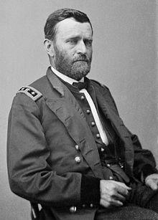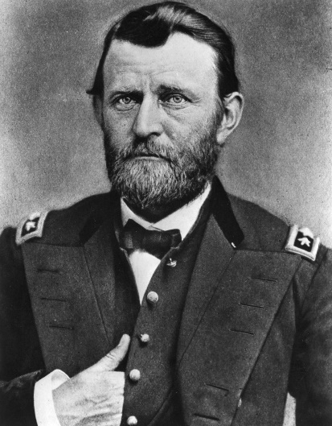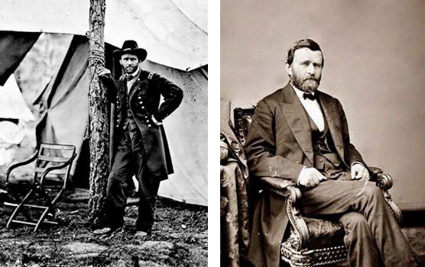
BATTLE OF VICKSBURG
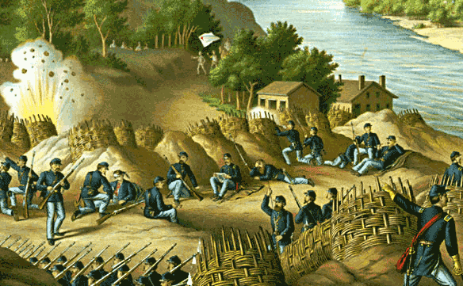
GRANT USING IRONCLAN GUNBOATS @ VICKSBURG
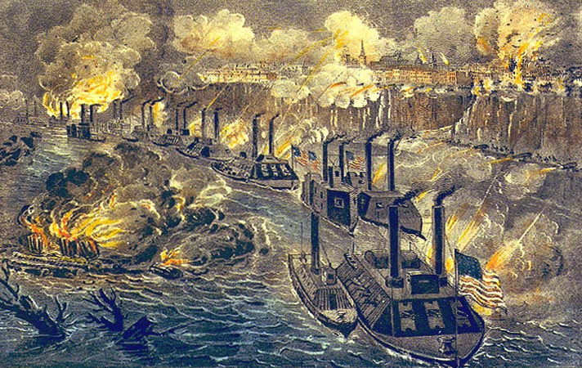
MAP OF UNION ATTACK @ VICKSBURG
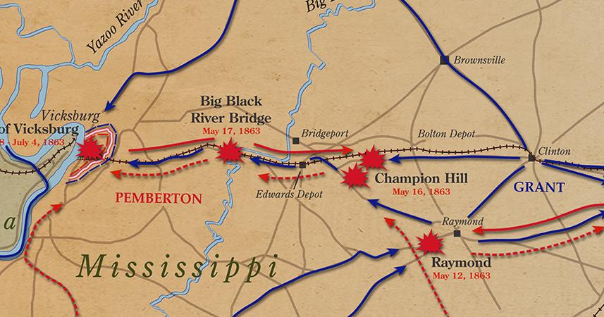
2. BATTLE OF GETTYSBURG
a. CONFEDERATE GENERAL ROBERT E. LEE thought he MIGHT can take WASHINGTON D.C., so he moved his troops to PENNSYLVANIA @ GETTYSBURG
b. LINCOLN PROMOTED ANOTHER GENERAL, GENERAL MEADE to command the ARMY OF POTOMIC @ GETTYSBURG.
ABRAHAM LINCOLN GENERAL GEORGE G. MEADE
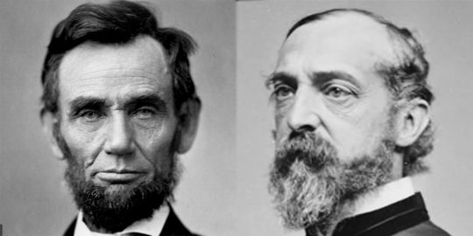
c. The Battle of GETTYSBURGH was on June 30. 1863. This Battle was a three-day battle! This battle was THE MOST SIGNIFICANT battle of the CIVIL WAR
d. The Battle of GETTYSBURGH is known as the TURNING POINT in the war for the NORTH
e. 1st day of BATTLE of GETTYSBURGH,
- GENERAL LEE of the CONFEDERATE SOUTH attacked the NORTH heavily in the TOWN OF GETTYSBURGH and drove them OUT OF THE TOWN!
- Both also fought at a place called, “CEMETARY HILL” it overlooks downtown GETTYSBURGH, both sides HEAVY losses – NORTH VICTORY
- 1st day VICTORY TO SOUTH
CEMETARY HILL GETTYSBURGH (NORTH ON TOP HILL, SOUTH ON BOTTOM) CEMETARY HILL TODAY MONUMENT
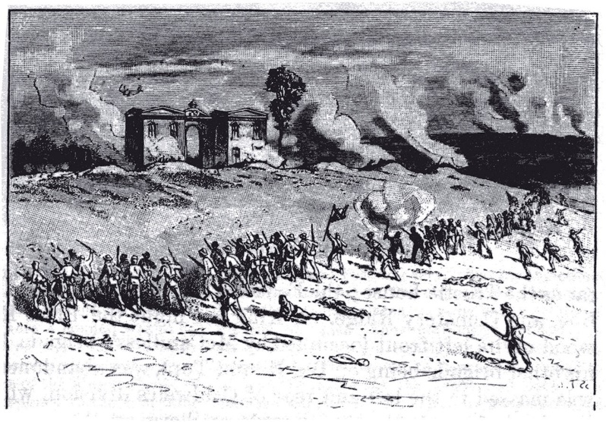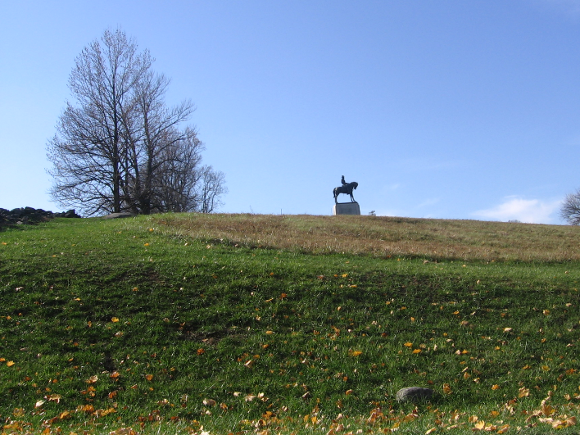
f. 2nd day of BATTLE of GETTYSBURGH,
- both armies were READY HEAVILY on a place called, “CULPS HILL”,
- NORTH on DEFENSE, SOUTH on OFFENSIVE. The NORTH held the SOUTH back
- Both also fought at a place called, “CEMETARY HILL” – NORTH VICTORY
- 2nd day VICTORY to NORTH
“CULPS HILL”, SOUTH on BOTTOM OF HILL NORTH ON TOP
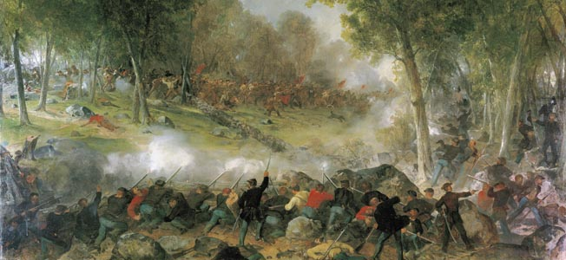
“CULPS HILL”
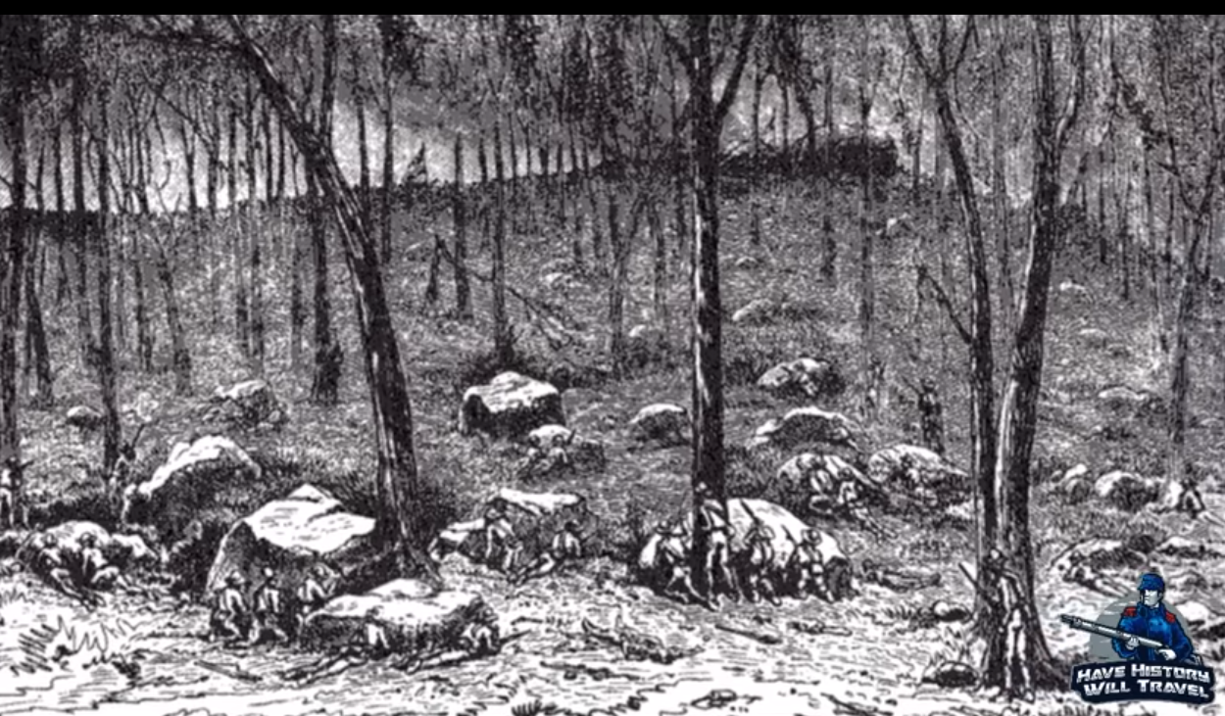
g. 3rd day of BATTLE of GETTYSBURGH
- Fighting resumed on “CULPS HILL” but CONFEDERATE SOUTH sent 12,500 men directly into Union LINE
  - This was known as, “PICKETS CHARGE”
  - CONFEDERATE SOUTH lost TONS of men!
  - PICKETTS CHARGE was one of the worst decisions for the SOUTH that devastated GENERAL LEE ARMY
  - The NORTH used RIFLES and CANNON fire to push the CHARGE back
  - GENERAL LEE of SOUTH retreated to VIRGINIA.
- Fighting resumed also on CEMETARY HILL - NORTH VICTORY
- 3rd day VICTORY to NORTH
GENERAL GEORGE PICKETT
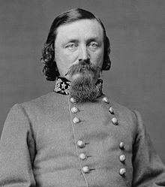
GENERAL GEORGE PICKETTS CHARGE 1 (SOUTH)
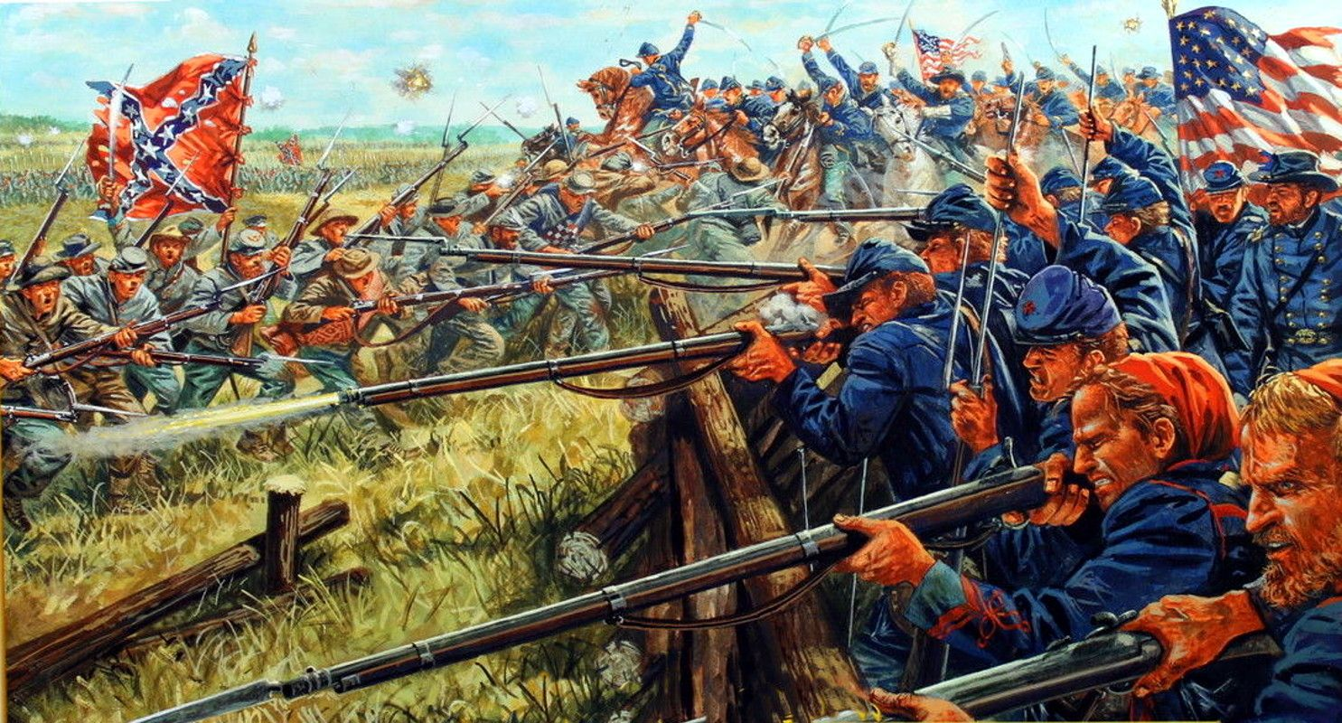
GENERAL GEORGE PICKETTS CHARGE 2 (SOUTH)
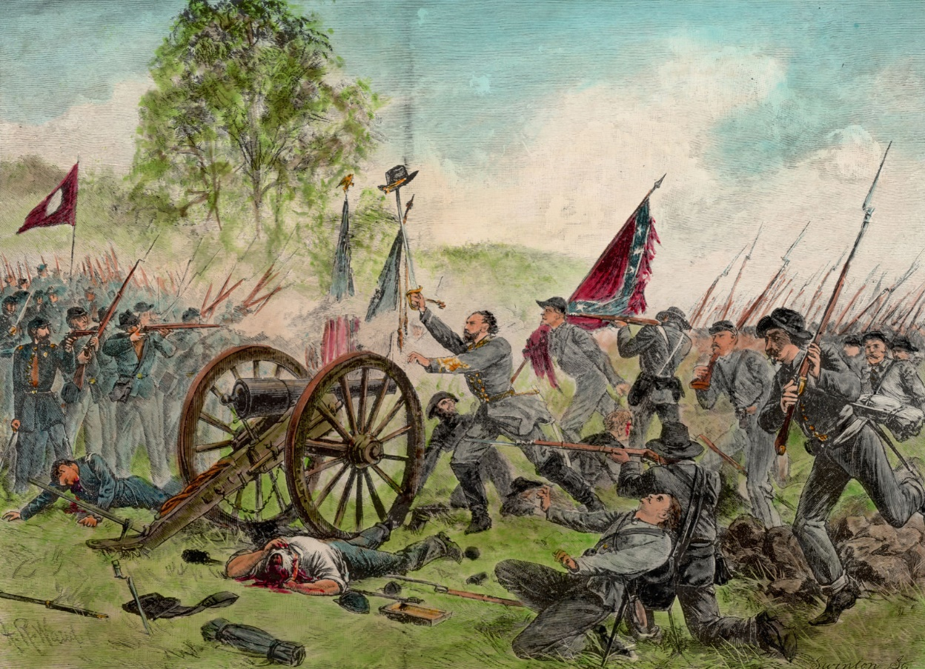
SOUTH GETTING READY FOR PICKETTS CHARGE
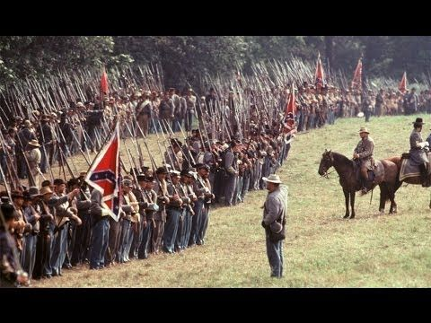
h. United States had heavy losses on both sides, between 46,000-51,000 AMERICAN LIVES
i. The NORTH WINS the BATTLE OF GETTYSBURGH. They create a CEMETARY THERE, 4 months later. LINCOLN gave the GETTYSBURGH ADDRESS @ the SOLDIERS NATIONAL CEMETARY OPENING
3. GETTYSBURGH ADDRESS – November 19, 1863
a. LINCOLN gave a speech on this day to give the MEMORY of the 50,000 soldiers that died at GETTYSBURGH
b. LINCOLNS GETTYSBURGH ADDRESS showed his leadership ability
c. LINCOLN stressed that all men are created EQUAL in his speech. His speech lasted 10 sentences and 3 minutes long!
- Most don’t know, but LINOCLN was sick during his speech with a small dose of SMALLPOX!
- The man that SPOKE before LINCOLN, “Edward Everett” spoke 2 HOURS about the BATTLE!
LINCOLN GIVING HIS GETTYSBURGH ADDRESS
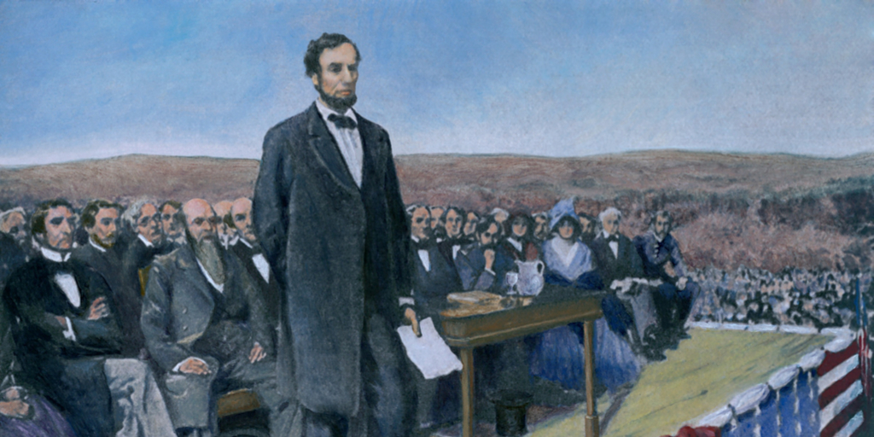
LINCOLN HAND WRITTEN COPY OF GETTYSBURGH ADDRESS
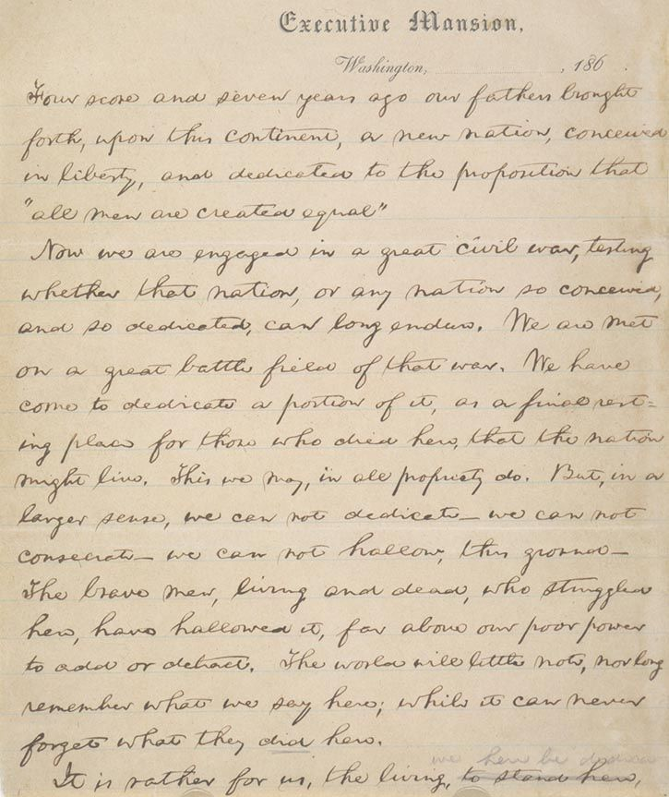

LINCOLN AFTER THE GETTYSBURGH ADDRESS
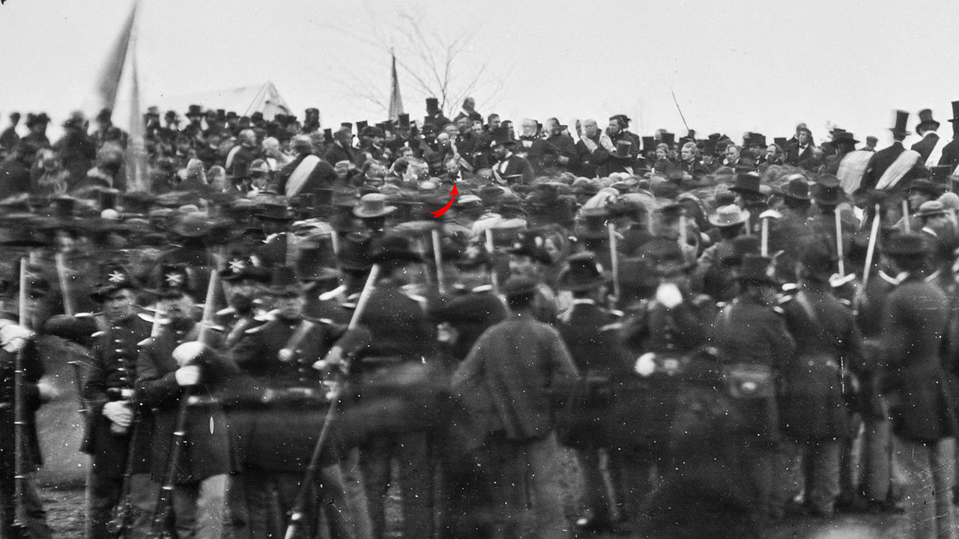
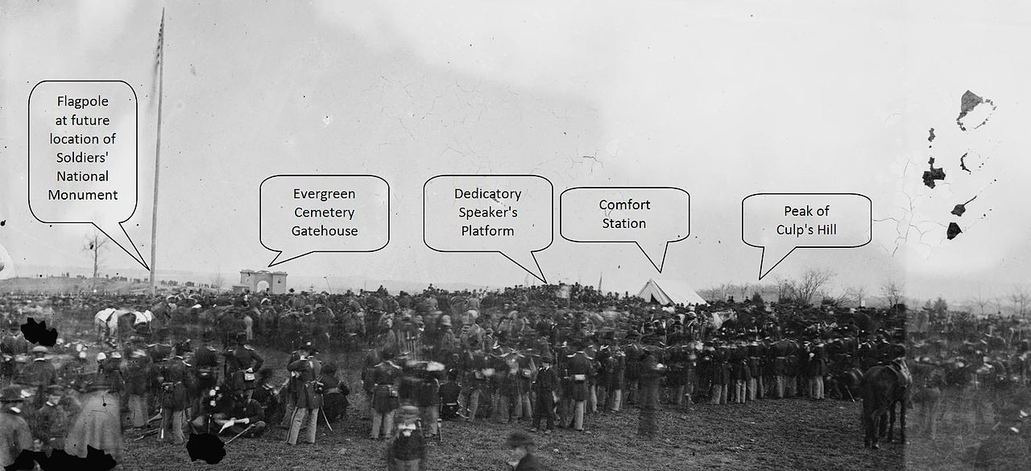

LINCOLNS FAMOUS GETTYSBURGH ADDRESS
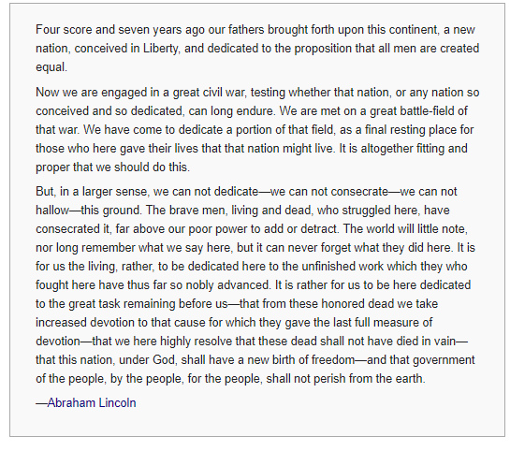
4. LINCOLN GETS HIS GENERAL – ULYSSEUS S. GRANT - “TOTAL WAR” - 1864
a. After a series of BAD generals or ones that LINCOLN were not happy with, he PROMOTES WEST GENERAL U.S. GRANT
- After GRANTS NEAR LOSS at the Battle of Shiloh LINCOLN said this about him,
  - “I can’t help but to like this man…. HE FIGHTS!”
- ULYSSEUS S. GRANT HISTORY
  - Graduated from West Point
  - Served in the Mexican American War under GENRAL ZACHARY TAYLOR
  - Grant forced to resign from army in 1854 for possibility of HEAVY DRINKING
  - Rejoined the Army during the CIVIL WAR
  - Elected as the 18th President of the United States
b. GRANTS plan to win the war was to DESTROY the SOUTHS ABILITY to FIGHT! He called this, “TOTAL WAR”
c. Told his OFFICERS and ARMY, DESTROY:
- BURN FOOD
- TEAR APART EQUIPTMENT (CANNONS, GUNS,
- KNOCK DOWN TELEGRAPH LINES,
- SHOOT CATTLE
- BURN COTTON FIELDS
- RAILROAD TRACKS,
- LOOT HOMES,
- FREE SLAVES
- BURN CITIES
d. GRANT put TWO men in charge of TOTAL WAR,
- GENERAL PHILLIP SHERIDAN (CALVARY COMMANDER OF ARMY OF POTOMIC)
  - Sheridan was told to go to the VIRGINIA Shenandoah Valley
  - In 8 BATTLES in VIRGINIA from AUGUST to OCTOBER 1864, burned 2,000 Barns full of WHEAT
  - This left SOUTHERN ARMY AND PEOPLE HUNGRY
  - GENERAL SHERIDAN Destruction of this area WON LINCOLN ANOTHER PRESIDENCY!
GENEARL PHILLIP SHERIDAN GENERAL WILLIAM TECUMSEH SHERMAN
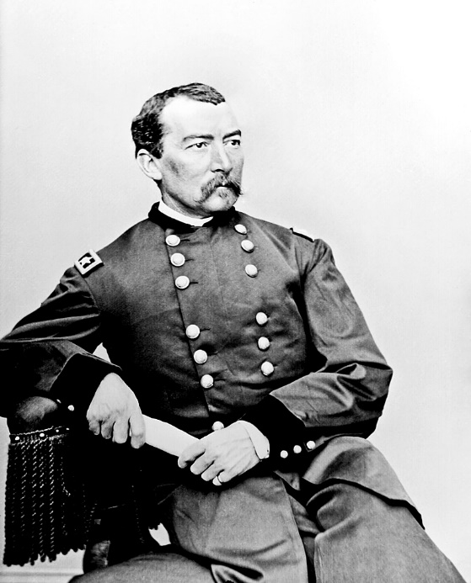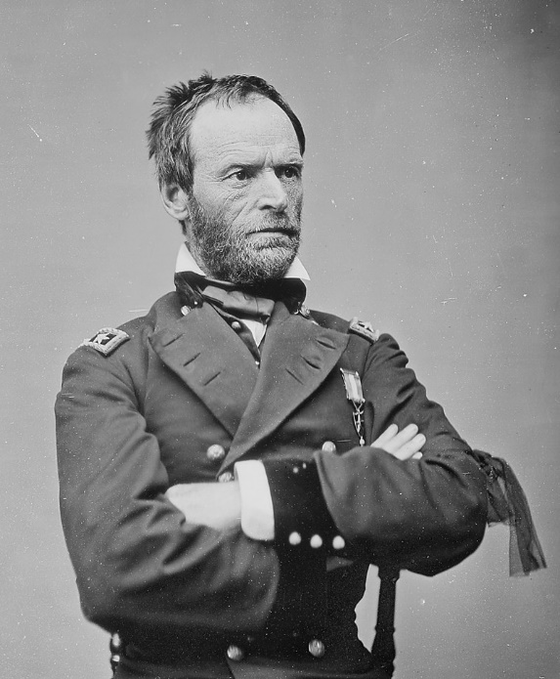
- GENERAL WILLIAM TECHUMSEH SHERMAN
  - Was also told by GRANT to DESTROY EVERYTHING!
  - Was ORDERED TO TAKE ATLANTA, GEORGIA! SHERAMN burns it to the GROUND
“I will make them so sick of war that generations would pass away before they would again appeal to it.” – General Sherman
  - He captured ATLANTA in September 1864, BURNED IT DOWN, then MARCHED TO ATLANTIC OCEAN.
  - GENERAL SHERAMN helped win LINCOLN RE-ELECTION in 1864

5. LINCOLN RE-ELECTION - ELECTION OF 1864 – LINCOLN vs. MCCLELAND
a. ABRAHAM LINCOLN is up for RE-ELECTION in 1864, his OPPONENT was GEORGE MCCLELAND his old GENERAL that he FIRED.
b. DEMOCRATS nominated MCCLELAND because he pushed to, “cessation of hostilities” or NEGOTIATE with the SOUTH CONFEDERACY to END the WAR
- ABRAHAM LINCOLNS party changed since 1860, the REPUBLICANS merged with the UNIONIST PARTY and the WAR DEMOCRATS to form, “NATIONAL UNION PARTY.”
- This new political party preached, KEEPING THE USA TOGETHER.
c. Many people in AMERICA were tired of WAR, families were dying, MCCLELAND had a good CAMPAIGN in the SPRING of 1864 against LINCOLN. Said, he could STOP THE FIGHTING!
d. At one time, people were losing FAITH in ABRAHAM LINCOLN on how he handled the CIVIL WAR, they didn’t like the DRAFTS. They did not like GRANT’S “TOTAL WAR”
e. LINCOLN and GRANT begin TOTAL WAR with SHERIDAN and SHERMAN, and their VICTORIES IN BATTLE begin to gain back the PEOPLES CONFIDENCE in LINCOLN.
f. SHERMAN and SHERIDANS “TOTAL WAR” secures LINCOLN a very HUGE WIN!
g. LINCOLNS re-election was the first time a PRESIDENT was re-elected since ANDREW JACKSON in 1832
h. LINCOLN chose ANDREW JOHNSON as his VICE PRESIDENT. LINCOLN is assassinated 2 months into his 2nd PRESIDENCY.
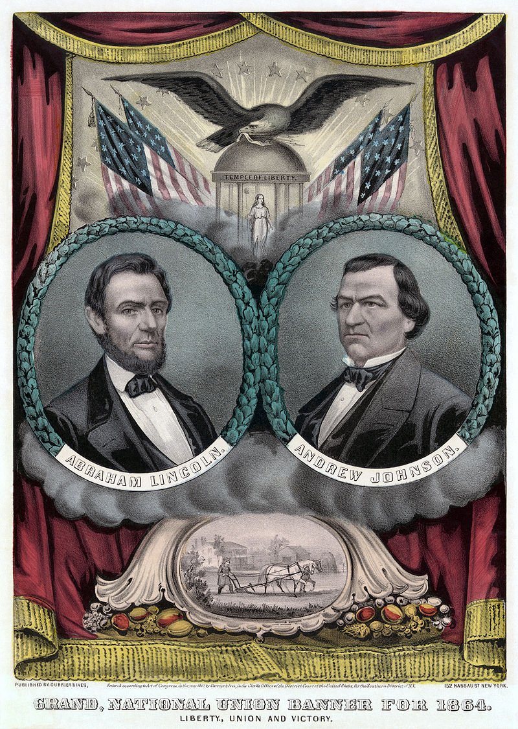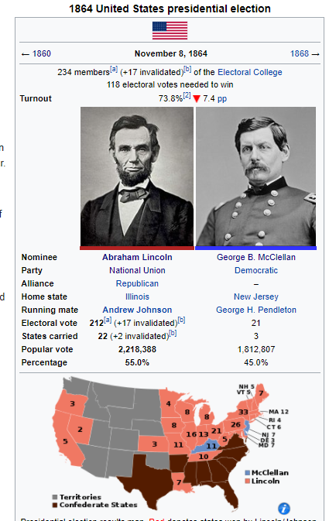
i. When LINCOLN was elected to a 2nd TERM as PRESIDENT, he had a famous 2nd INAGURAL ADDRESS. He had three speeches that became the most famous in AMERICAN HISTORY:
- 1st INAGURAL ADDRESS (1st PRESIDENCY ELECTION VICTORY)
  - Influenced the importance of keeping the NATION TOGETHER
  - Lincoln said, “Constitution states that no state can lawfully leave the United States”
- GETTYSBURGH ADDRESS (3 MONTHS AFTER BATTLE OF GETTYSBRUG)
  - Pushed that we needed to MAINTAIN the USA together, and lost will not be forgotten
  - Everyone and everything were based on FREEDOM and EQUALITY

- 2nd INAGURAH ADDRESS (2nd PRESIDENCY ELECTION VICTORY)
  - Focused on the issue of SLAVERY and that it was a violation of EQUALITY and WRONG
  - Said that the USA needed, “bind up the nations wounds.”

6. THE FINAL BATTLE – APPAMATOX COURTHOUSE & ROBERT E. LEE SURRENDERS – APRIL 9, 1865
a. GENERAL U.S. GRANT began to pursue GENERAL ROBERT E. LEE into the state of VIRGINIA. GRANTS goal was to take the SOUTH CAPITOL at RICHMOND.
b. GENERAL GRANT pushed his men in SPRING and SUMMER of 1864 very hard into many battles in VIRGINIA losing 60,000 men in just 1 of those MONTHS.
c. GENERAL GRANT knew that he could get REINFORCEMENTS and SUPPLIES very quickly, the SOUTH could not because of TOTAL WAR.
d. 1864, GRANT pushed an area called, PETERSBURG near RICHMOND. 9 months later he won PETERSBURG and RICHMOND on the same day on April 2, 1865
e. ROBERT E. LEE retreated to a place called, “APPOMATOX COURT HOUSE” with his VERY SMALL ARMY.
f. LEE knew that if he kept fighting his men would be SLAUGTHERED, so he SURRENDERED to GRANT.
g. ROBERT E. LEE and his 28,000 troops SURRENDERS to GRANT on April 9, 1865
- GRANT was generous to ROBERT E. LEE during the surrender.
- GRANT TOLD his MEN “Do NOT CHEER, the war is over the REBELS are once again our brothers”
- GRANT said, “Each officer and man will be allowed to return to his home, not to be disturbed by the USA Authorities”
- GRANTS TERMS OF SURRENDER:
  - Confederate officers can keep their pistols and swords
  - Soldiers can keep their horses to take them home to plow their fields, THEY WERE PARDONEDED
  - Confederate troops would be given food
  - Official documents were signed in the home of “Wilmer McLean” at 1:00 PM
h. Many soldiers earned MEDALS of HONOR, PARADES and CELEBRATIONS began for returning VETERANS on both sides.
LEE SURRENDERING TO GRANT IN WILMER MCLEAN HOUSE
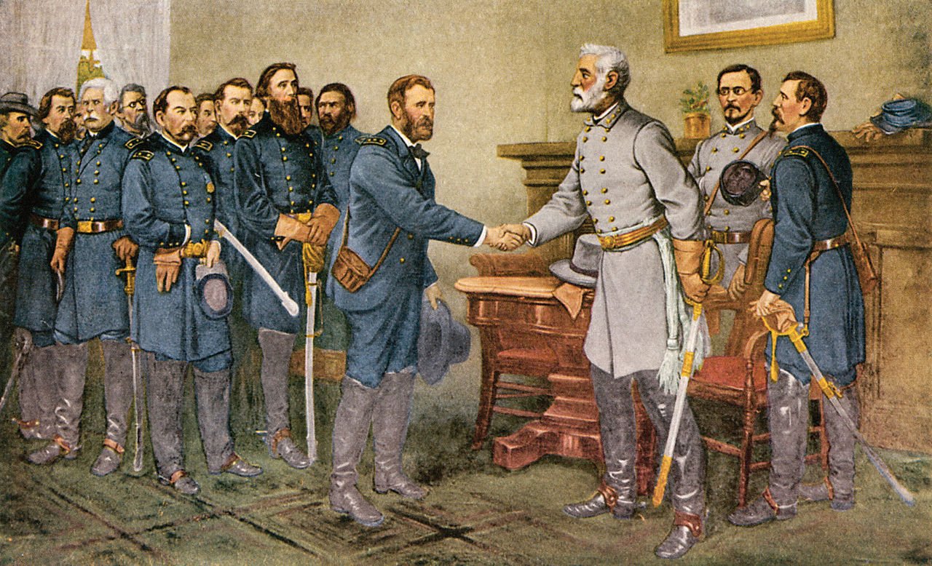
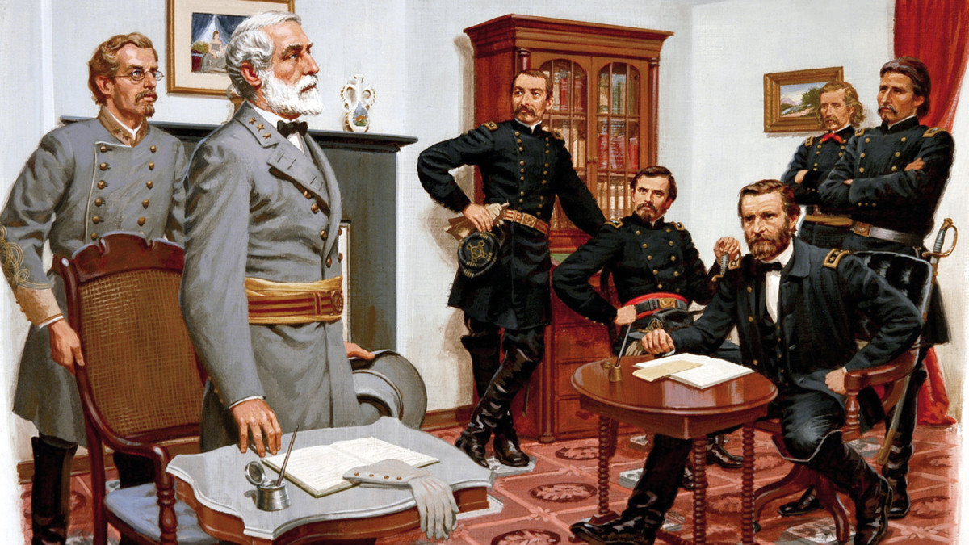
SOUTH GENERAL ROBERT E. LEE RETREAT LEADING TO SURRENDER
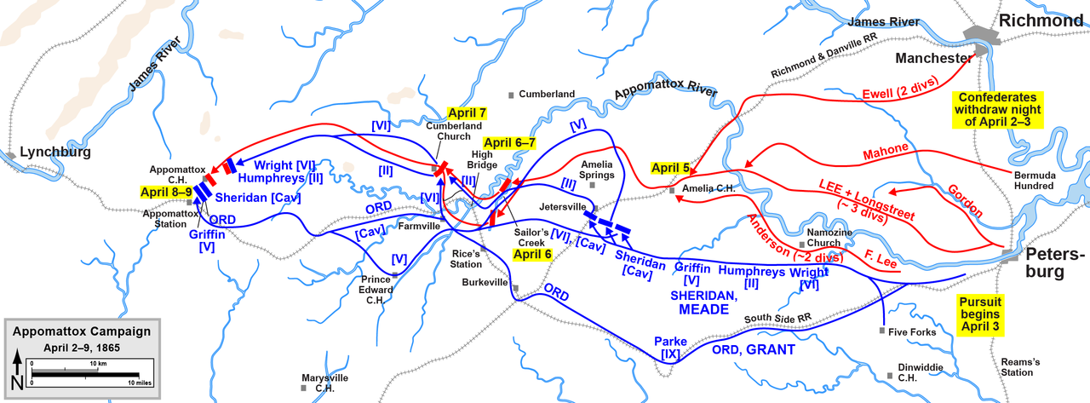
APPOMATOX COURTHOUSE THEN IN 1865
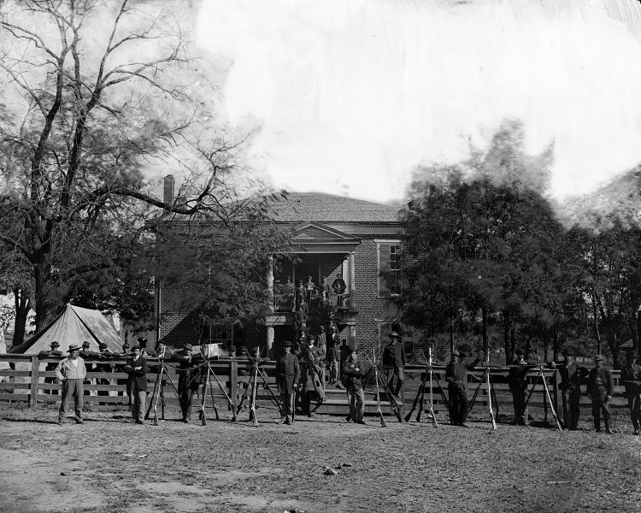
ROOM TODAY WHERE IT WAS SIGNED TODAY APPAMOTOX COURTHOUSE TODAY
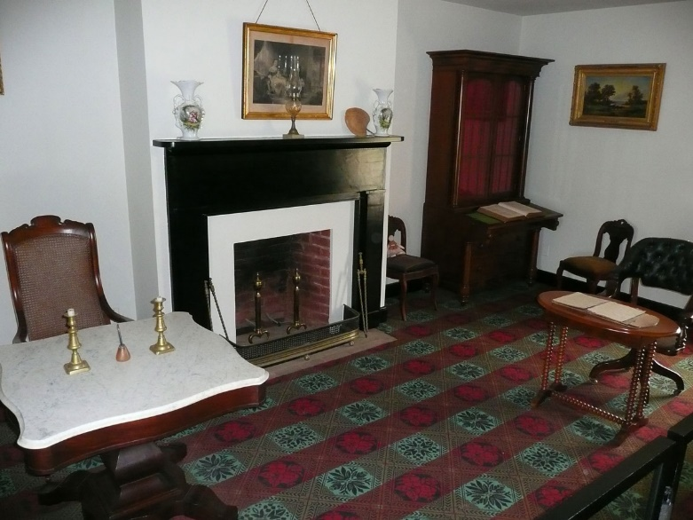 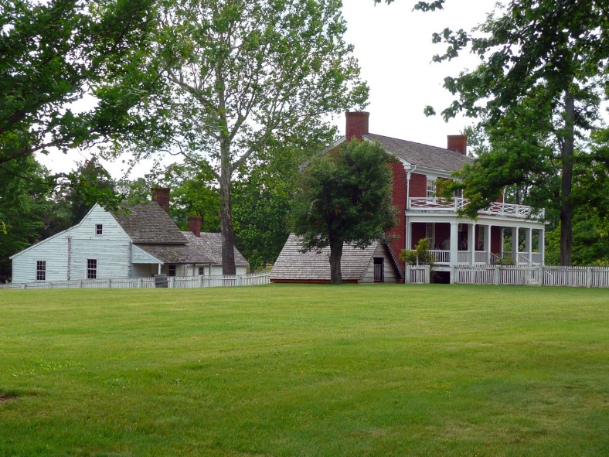
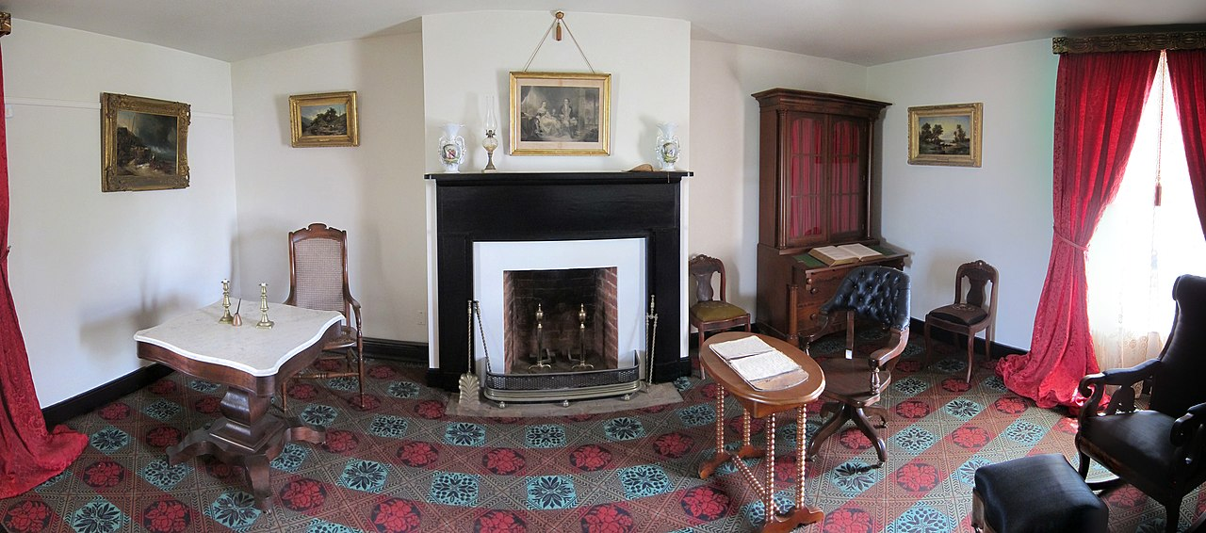
FLAG THAT ROBERT E. LEE USED TO SURRENDER TO GRANT
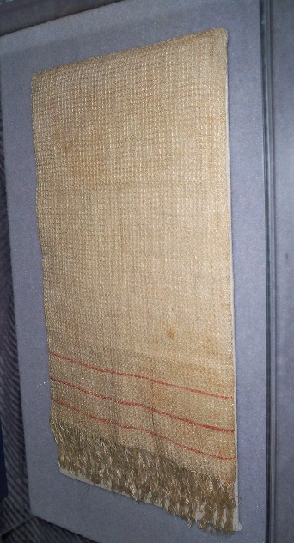
7. CIVIL WAR AFTERMATH
a. Cost of the CIVIL WAR was immense in AMERICAN LIVES, 360,000 NORTH, 250,000 SOUTH
b. The MONEY cost of the war was 20 BILLION
c. Before the war, people said, “THESE UNITED STATES” after the war they said, “THE UNITED STATES”
d. After the CIVIL WAR the power of the FEDERAL GOVERNMENT GREW.
e. At the end of the CIVIL WAR, MILLIONS of AFRICAN AMERICANS got their freedom. EQUAL and FREE.
- 4 MILLION of these were now called, “FREEDMEN”
  - There was no LEGAL SYSTEM to protect these free African Americans.
f. The CIVIL WAR made AMERICA a stronger FREER NATION.
g. Some SOUTH did not want the WAR to END, and HATED ABRAHAM LINCOLN and the NORTH
h. 800,000 UNION soldiers came back home and needed JOBS, it was hard for many of them at first.
i. Much of the FIGHTING was only on the SOUTH, few BATTLES in the NORTH. SOUTH had to REUBILD.
j. Many NORTH did not know how to bring the SOUTH back into the USA. They argued over it.
k. SOUTHERNERS had it hard, EVERYTHING was burned, tore up, and destroyed. CONFEDERATE MONEY was TRASH.
- Major SOUTH cities had been leveled to ashes: ATLANTA, RICHMOND, and COLUMBIA
- FORESTS, BARNS, CROPS, and 2/3rds of SOUTH RAILROADS destroyed
- MULES and HORSES died by the 1,000’s
l. SOUTH banks closed, many people LOST their SAVINGS in the SOUTH
m. Many CONFEDERATE politicians were not allowed in the new GOVERNMENT.
CONFDERATE CAPITOL RICHMOND VIRGINIA AFTER CIVIL WAR
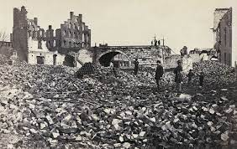
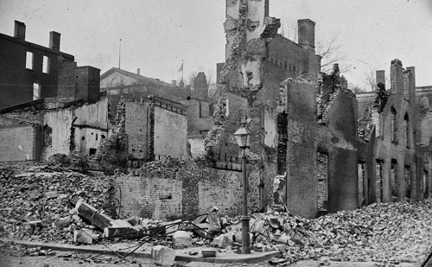
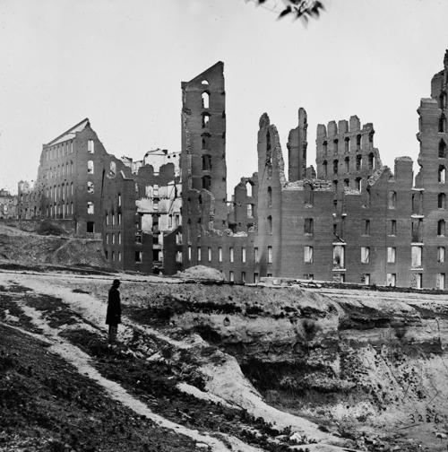
COLUMBIA AFTER CIVIL WAR
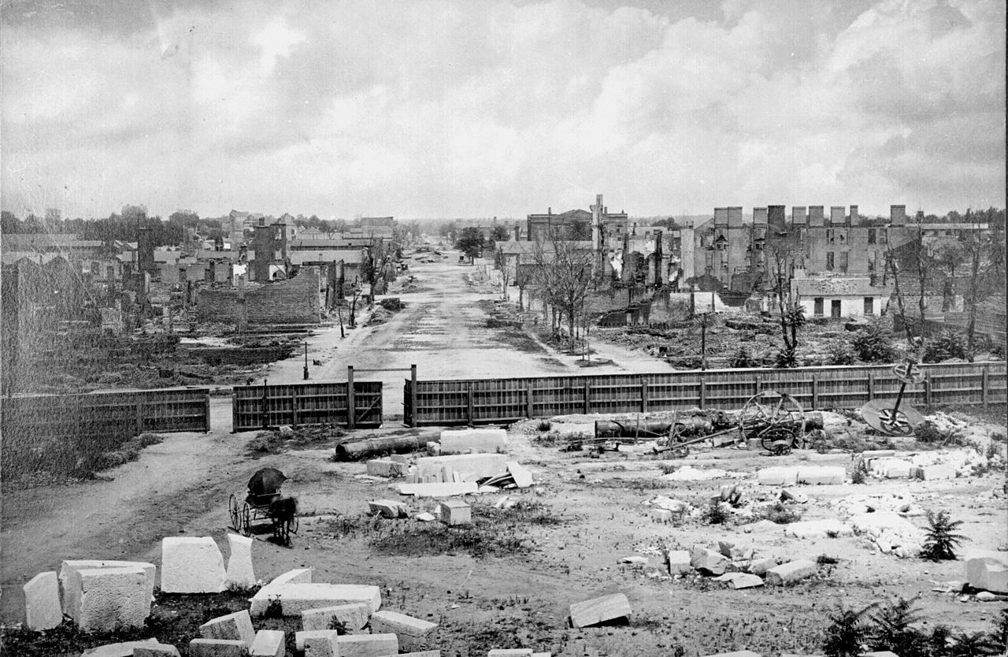
CIVIL WAR AFTERMATH ATLANTA
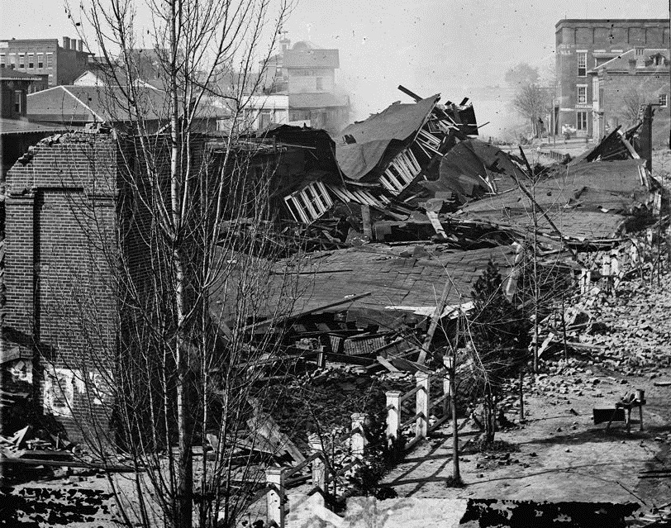
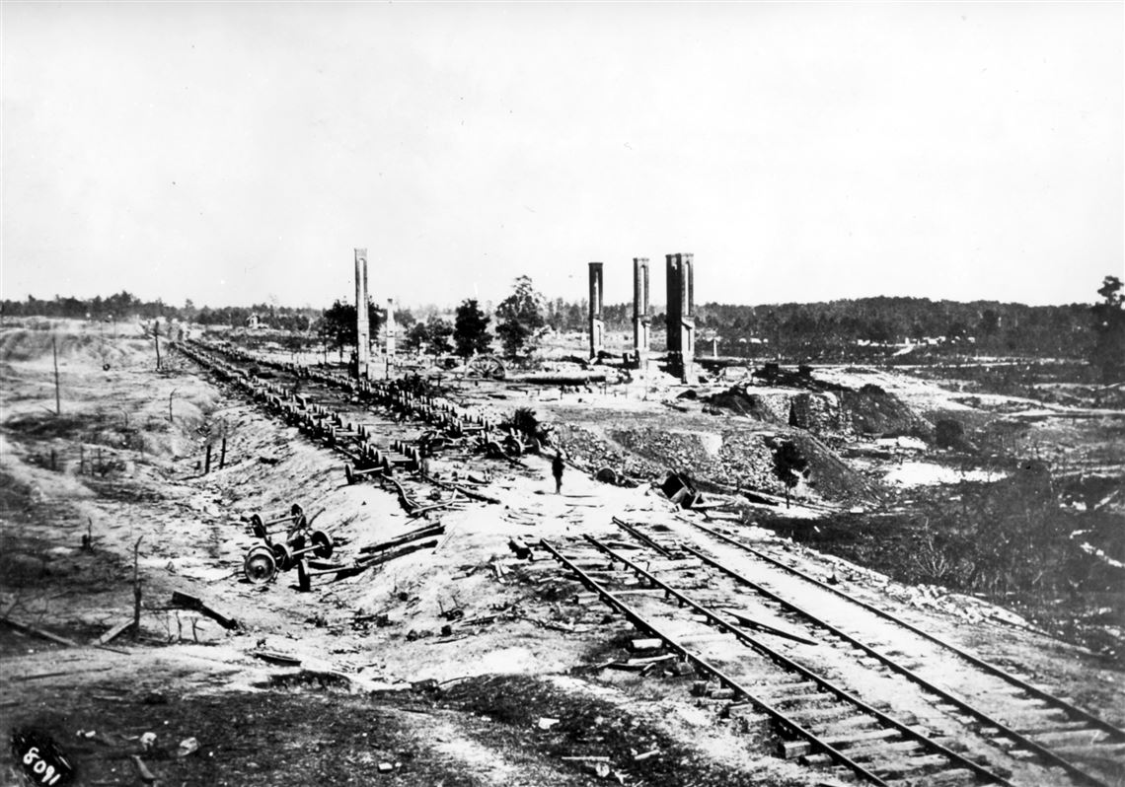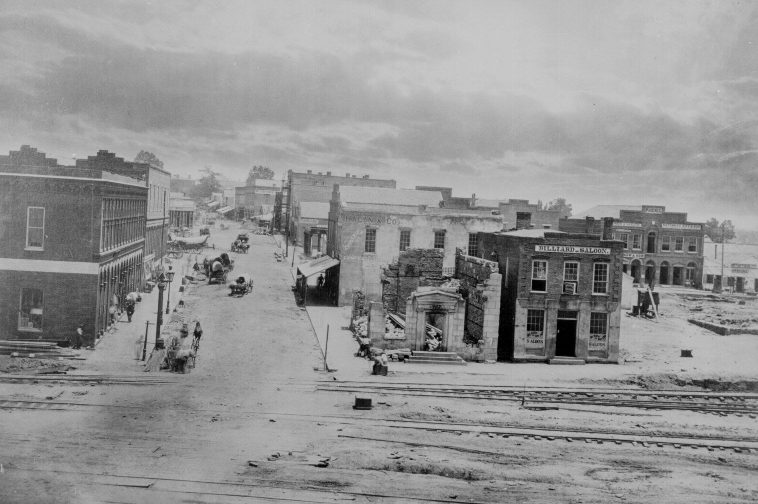

TOPIC 9 CHAPTER 15: RECONSTRUCTION
SECTION 1: LINCOLNS PLAN AFTER WAR
1. LINCOLNS “RECONSTRUCTION” PLAN
a. The ERA after CIVIL WAR is called, “RECONSTRUCTION” It is the physical, political, and social rebuilding of SOUTH
b. LINCOLN wanted an easy way for SOUTH to rejoin the USA. “FASTER the BETTER” – LINCOLN
c. LINCOLNS 10% PLAN
- SOUTH states could form GOVERNMENTS when 10% of its voters swore an OATHE to the USA.
- VOTERS elect members of each states CONGRESS.
- LINCOLN gave AMNESTY – or a GOVERNMENT PARDON to anyone except who pledged allegiance to USA. However CONFEDERATE LEADERS did not get this.
- All SOUTH would have their private property protected.
- All new GOVERNMENTS MUST BAN SLAVERY
d. LINCOLNS FREEDMENS BUREAU
- This was to help former SLAVES get on their feet, over 4 MILLION needed help
- This bill gave FOOD, CLOTHING, and MEDICAL to former slaves. It helped POOR WHITES as well.
- This bill set up schools for African Americans, many teachers were WOMEN from the NORTH
  - Grandparents and Grandchildren often went to the same schools to get educated
  - Freedmen Bureau created COLLEGES for African Americans like HOWARD, MOREHOUSE, FISK College.
  - By 1870 African Americans were teaching in classrooms in the SOUTH
- Some NORTHERNERS wanted a HARSH PUNISHMENT for SOUTH, they were called, “RADICAL REPUBLICANS”
  - These RADICAL REPUBLICANS take charge after LINCOLNS DEATH and change the USA till EVEN TODAY!
FREEDMENS BUREAU, SOLDIERS PROTECTING AFRICAN AMERICANS
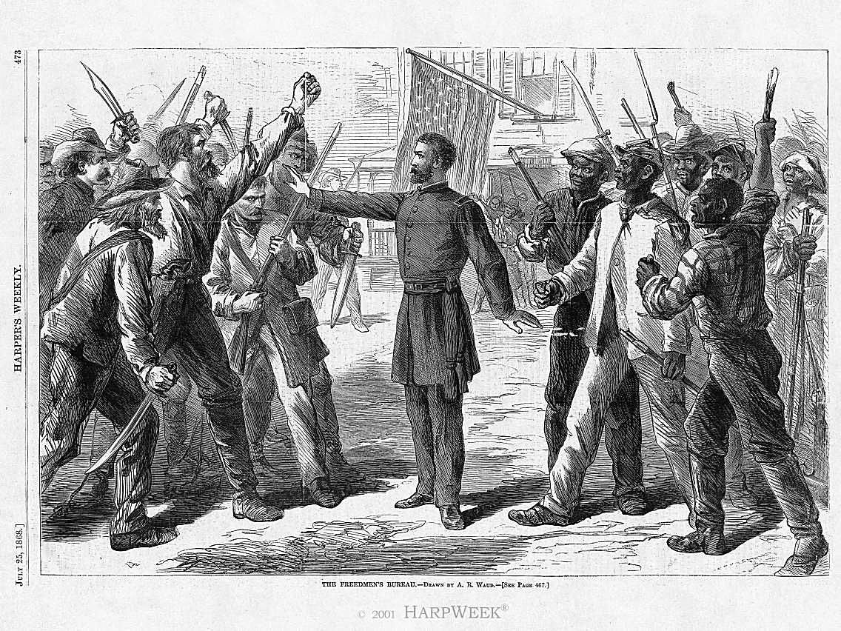
e. LINCOLNS 13th AMENDMENT – JANUARY 31, 1865
- This is a CHANGE to the CONSTITUTION, 13th AMENDMENT ABOLISHED SLAVERY in the United States
- 13th AMENDMENT BACKSTROY
  - LINCOLNS EMANCIPATION PROCLIMATION
    - FREED SLAVES only IN THE SOUTHERN CONFEDERATE STATES with SLAVERY.
    - This also DID NOT apply to the BORDER STATES of: Kentucky, Missouri, West Virginia, Delaware and Maryland
    - Each STATE taken over by NORTH, it was then a FREE STATE
    - To make SLAVERY ILLEGAL EVERYWHERE it took a CHANGE TO THE CONSTITITION “AMENDMENT”
BORDER STATES – EMANCIPATION PROCLOMATION DID NOT APPLY
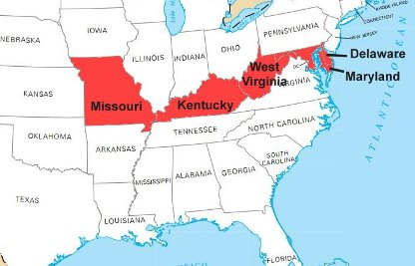
  - BATTLE OVER AMENDMENT
    - After LINCOLN re-election, 13th AMENDMENT was TOP GOAL
    - LINCOLN invited people to his OFFICE to DISCUSS it!
    - In his office, LINCOLN pushed the BORDER STATES to also get on BOARD to FREE ALL!
    - LINCOLN told his CABINET in his office at a meeting this,
- “I leave it to you to determine how it shall be done but remember that I am the PRESIDENT OF THE UNITED STATES, clothed with IMMENSE POWER, and I EXPECT you to procure those VOTES.”
– ABRAHAM LINCOLN
    - LINCOLN was basically telling them, GET THE VOTES TO PASS THIS OR ILL DO IT MYSELF!
    - LINCOLNS supporters get the votes needed to PASS the AMENDEMENT, 119 (YES) to 56 (NO)
    - AMENDMENT Passed on JAN 31, 1865
    - SIGNED or “RATIFIED” by 27 out of 36 States on December 18, 1865
      - Secretary of State WILLIAM SEWARD put it VALID IN CONSTITUTION on Dec. 18, 1865
        - SEWARD APPLIED it to ALL STATES regardless if STATE signed or NOT
      - LINCOLN would never see it OFFICIALLY signed he was assonated on April 14, 1865 by JOHN WILKES BOOTH in FORDS THEATRE

