Chapter 14 HOW DID THE NATION PROCEED FROM WORLD WAR II TO THE BABY BOOM?
(This workbook chapter does not start with a vocabulary section.)

I. COMPLETE. Fill in the blanks with the correct word or words.
1. World War II began in _________________(year).
2. America entered it in December, _____________.
3. The Oklahoma National Guard changed its original insignia because it resembled the insignia of
the __________________________.
4. The Germans called the men of the 45th Division the______________________.
5. Bill Mauldin drew characters who helped make the 45th famous. Their names were ___________________.
6. The U.S. Navy’s only inland base was located at_______________________.
7. General Clarence L. Tinker was a member of the ______________________ Tribe.
8. The only man in the army during World War II who rose from civilian status to the rank of general was Lt. Gen. ____________________________.

II. MAP. Using a wall map, a roadmap, or an atlas, locate these seven military installation sites which were active during World War II: Midwest City; Muskogee; Lawton; Clinton; Norman; Miami; El Reno. Draw a box around the list on the left and use it for your key.
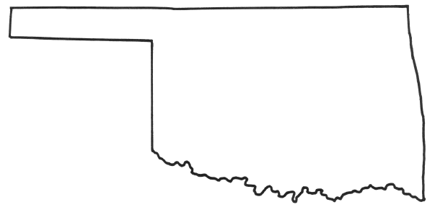

Midwest City
Muskogee
Lawton
Clinton-Sherman (Burns Flat)
Norman
Miami
El Reno

III. TRUE or FALSE and FILL IN THE BLANK
____ 1. Military communication for the 45th was not broken by the Germans because communication was in Indian languages.
____ 2. In Oklahoma, there were several training facilities for the Army and Air Force but none for the Navy.
____ 3. Some Prisoners of War were imprisoned in Oklahoma.
___ 4. Roy Turner’s construction programs created jobs.
5. The name of the airplane that dropped the atomic bomb on Hiroshima was_______________.
continued on next page
6. The number of Oklahomans killed in World War II was_____________.
7. Educational benefits for veterans were called the _______________________________.
8. The governor who improved the state’s image nationwide and left a surplus in the state treasury was ___________________.
9. A news article called Robert S. Kerr the “uncrowned king of the _____________________.”
10. The first bull to sire offspring worth $2 million belonged to the _______________ Ranch.

IV. IDENTIFY. Circle the 3 words or phrases on the right that are about the names on the left.

1. ROY J. TURNER rancher, war hero, highways, 4-H, senator

2. GEORGE W. MCLAURIN separate table, Chickasha, OU, ECSU, law school

3. MAURICE AHEARN fire, OSU, sacrifice, reward, dormitory, ECSU

4. TOM ANGLIN governor, senator, congressman, gunplay, Scott

5. POLIO Infantile Paralysis, tuberculosis, iron lung,
Crippled Children’s Hospital, influenza, aging

6. ENOLA GAY Hiroshima, Tokyo, atom bomb, hydrogen bomb, neutron bomb, surrender

