CHAPTER 7: CREATING THE CONSTIUTION
SECTION 1: GOVERNING A NEW NATION
- GOVERNMENT BY THE STATES
  - When America was created with the Declaration of Independence. The first order of business was to create a new government. Each of the 13 states wrote their own state government Constitutions and the nation had one government that looked over it all.
  - The biggest problem is the colonists did not like the governors who were appointed by the British King. They wanted people to be voted into offices.
  - The Governor would be elected, then the Governor of a state would bring in key officials to advise him.
  - Even though people got to vote people into office, most states still did not let AFRICAN AMERICANS and WOMEN vote. White males could vote if they were 21 years old, some states males had to own certain amounts of property.
  - VIRGINIA was the first state to give their people a BILL OF RIGHTS with their State Constitutions (Basic rights like freedom of speech, religion, press.)
- ARTICLES OF CONFEDERATION
  - During the American Revolution the first government was set up was called, “THE ARTICLE OF CONFEDERATION”
    - Coach Dick calls it, “ARTICLES OF CRUDATION” because it was horrible and rushed
  - The Articles of Confederation did not have 3 branches of government like we do today, it only had 1 branch of government – THE LEGISLATIVE (CONGRESS).
  - 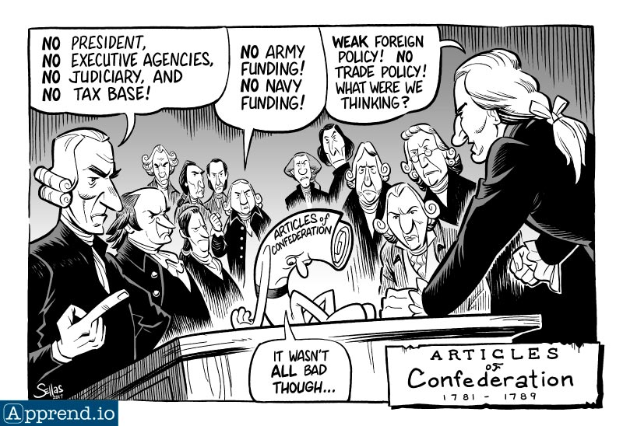
  - The people who created the Articles of Confederation did not want to give the Congress to much power. Most of the power was left with each state.
  - ARTICLES OF CONFEDERATION could not regulate trade or collect taxes. The government had to ask the states for money it needed.
- SETTLING OF WESTERN LANDS AFTER AMERICAN REVOLUTION
  - The Articles of Confederation had to be passed by all 13 states. But some states would not vote on the Articles until they decided on a vast land that they received from the British after the American Revolution. This land was called, “THE NORTHWEST TERRITORY”
    - NOTHWEST TERRITORY – (OHIO, MICHIGAN, WISCONSIN, ILLINOIS, MINNESOTA, IOWA, INDIANA)
  - LAND ORDINANCE OF 1785
    - This was a system that divided lands into SMALL TOWNS that were 6 miles on each side. Creating grids of squares,
    - In these 6 miles, it would be divided up into 1 mile on each side.
    - This set the beginning of what we have today
    - This paved the way for the NORTHWEST ORDIANCE for people to move west.
  - NORTHWEST ORDINANCE OF 1787
    - Investors were eager to buy the land in the Northwest Territory; they knew people would move there.
    - Congress created the Northwest Ordinance of 1787 to give rights to citizens of that area that moved there.
      - Basic Rights like freedom of Speech, Religion, Press,
      - This Ordinance also banned slavery in those areas.
    - Congress gave steps for these new territories to become a state in the United States:
      - Once territory population hit 5,000 people you could have a State Congress
      - When population hit 60,000 people then that territory could send an application to become a state
      - Everyone in your territory had to have rights and ban slavery.
  - 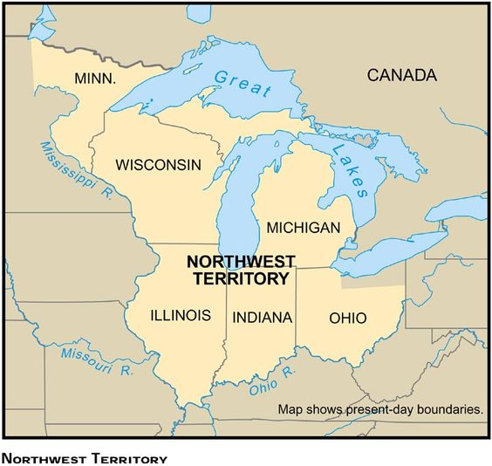
- GROWING PROBLEMS UNDER THE ARTICLES OF CONFEDERATION
  - ECONOMIC ISSUES
    - Under the Articles of Confederation each state had its own trade policy. Each State tried to help their own farmers and manufacturers in their own states by taxing only goods coming from other states. THIS HURT TRADE BETWEEN STATES.
    - It also was bad because there was no such thing as a UNITED STATES DOLLAR, each state had its own Currency. There was no national currency!
    - Under the AoC, Congress DID NOT HAVE THE POWER TO TAX! So, Congress could not run the Government.
  - FOREIGN AFFAIRS ISSUES
    - Congress had no money to make an army. So, America looked weak and other countries took advantage.
    - Britain did not remove all their troops from NORTHWEST TERRITORY like Treaty of Paris promised.
    - Spanish did not let our ships down the Mississippi River like Treaty of Paris promised.
      - Farmers had to drag their crops in wagons over the Appalachian Mountains as a result.
  - REBELLION ISSUES – “SHAYS REBELLION”
    - In the 1780’s a severe Economic Depression happened in America.
      - (DEPRESSION - where business activity slows down, unemployment occurs)
    - The depression hit farmers in MASSACHUSETTS the worst, crop prices dropped, and many farmers could not pay their taxes. MASSACHUSETTS began to take peoples farms away to get back their taxes.
    - One farmer who was a war captain from the American Revolution named, “DANIEL SHAY” led 1,000 farmers on a uprising when they tried to take farms away.
    - Shay and his men were met in Boston by a militia that anticipated his every move. Shay wanted to take the armory in Boston and get guns. The militia shot 2 shots and made them scatter where the Rebellion stopped. 2 were dead, 20 wounded.
    - 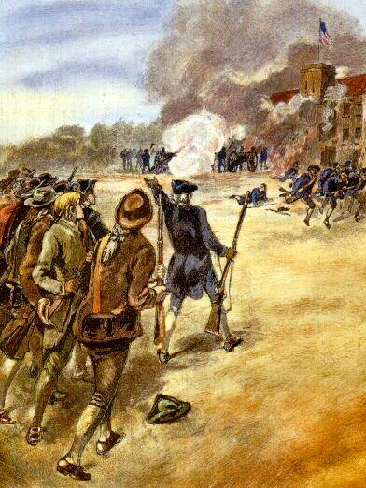
  - RESULT OF DANIEL SHAYS REBELLION
    - Shays was hidden out by Ethan Allen, the hero of FORT TICONDEROGA. Eventually was pardoned by the new Boston Governor, “JOHN HANCOCK”
    - Daniel Shays took control of the Courthouse in Boston, only a militia could be organized. No regular army.
    - The rebellion proved that a stronger Congress was needed, and an army was needed.
    - Congress asked the states to send delegates to Philadelphia in 1787, to revise or change the Articles of Confederation
SECTION 2 : THE CONSTITUTONAL CONVENTION
      - THE CONSTITUTONAL CONVENTION BEGINS
        - When the delegates began to show up in Philadelphia statehouse, they were there to CHANGE THE ARTICLES OF CONFEDERATION. It was the summer of 1787, hot and muggy. Most of the meetings were secret. Guards stood outside keeping the public out.
        - 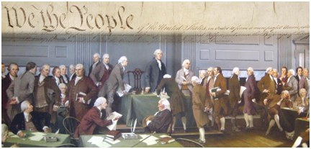
        - Many delegates expressed that just changing them was not enough. And they needed to be trashed completely.
        - Delegates were free to speak their minds, 55 delegates from 12 states, Rhode Island did not attend.
          - The Key Delegates included were:
            - George Washington = Named President of the Constitutional Convention.
            - Ben Franklin = Was old and dying at the time and could only attend certain meetings.
            - Alexander Hamilton = Was one of the war heroes of the American Revolution under Washington.
            - James Madison = GREAT NOT TAKER and becomes the FATHER OF OUR CONSTITUTION.
        - THE VIRGINIA PLAN
          - Edmond Randolph on the 3rd day of the Convention proposed for a Strong Central Government with representatives. James Madison was the man who came up with the plan.
            - VIRGINIA PLAN (POPULATION PLAN)
              - CREARED THREE BRANCHES OF GOVERNMENT
                - LEGISLATIVE – CONGRESS (MAKES LAWS)
                - EXECUTIVE – PRESIDENT (ENFORCES LAWS)
                - JUDICIAL – SUPREME COURT & LOWER COURT SYSTEM (REVIEWS LAWS)
              - CREATED HOUSE OF REPS & SENATE – 2 HOUSE SYSTEM (BICAMERAL)
                - SENATE (UPPER HOUSE)
                - HOUSE OF REPRESENTATIVES (LOWER HOUSE)
                - Number of Delegates in each state would be determined by population that state had.
          - The Virginia Plan did not please everyone in the Constitutional Convention. The Smaller states were upset because they would have a much smaller say than the larger states in Congress.

      - THE GREAT COMPROMISE
        - The Virginia Plan did great things, Created the HOUSE and the SENATE. But the issue was… States that were larger, got more representation. The smaller states would not get as many seats in Congress because they were small. They were very upset about it. A COMPROMISE had to be made.
        - NEW JERSEY PLAN
          - Proposed by William Patterson of NEW JERSEY, where instead of two houses there was just 1 based on EQUAL REPRESENTATION. It did not pass, another Compromise had to be made or the Convention would fail.
        - GREAT COMPROMISE
          - Roger Sherman came up with a way to please both the LARGE and SMALL states on POPULATION.
            - The number of delegates in the HOUSE OF REPRESENTATIVES would be based on STATE POPULATION.
              - Representatives were elected to a two-year term.
            - The number of delegates in the SENATE would be EQUAL, SMALL and LARGE states would get (2) each
              - Senators would be elected to a six-year term.
              - Vice-President would be the leader of the Senate
        - 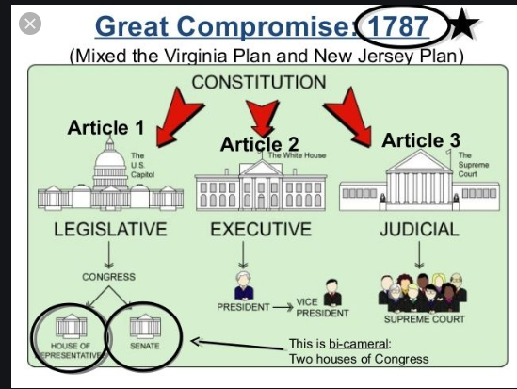
        - 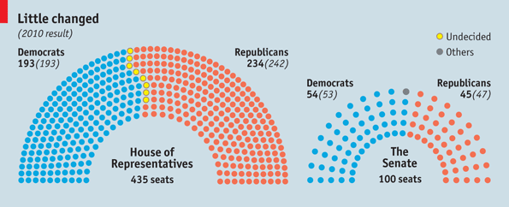
        - 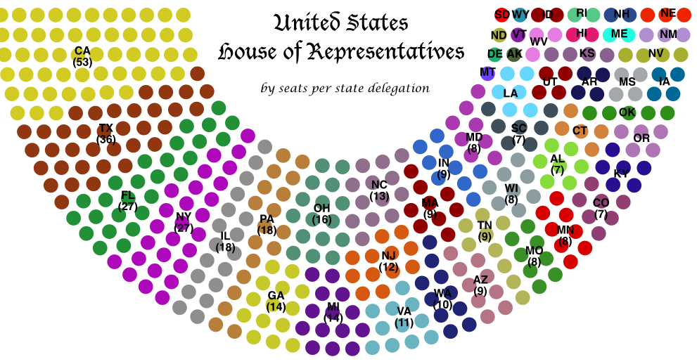
        - 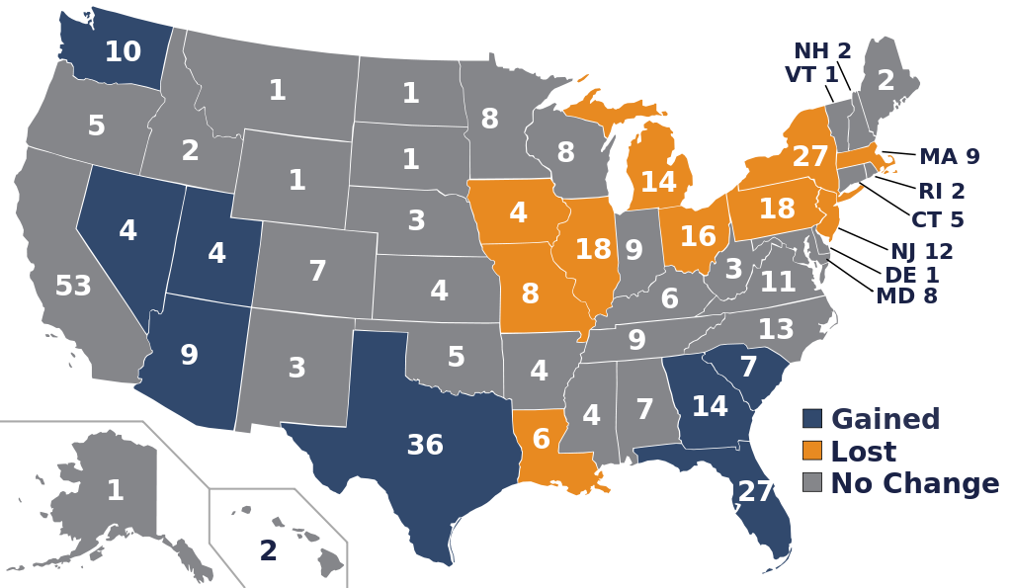
        - DEBATE OVER SLAVERY
          - The Large states were happy with the Compromise, so was the Smaller states. The Small states in the South said they should get more seats in the HOUSE OF REPRESENTATIVES because they tried including their slaves as people.
          - The North said that they were not free so they cannot be included in the number of people for their state.
          - Again, the Smaller states and the South argued over the issues of population in the House of Representatives. Once again, a Compromise had to be made.
          - THREE FIFTHS COMPROMISE
              - This was a Compromise to please the Smaller states and the Southern states where every slave was counted as 3/5ths of a person when counting overall population of a state. Example is 500 slaves would only count as 300 people.
              - 3/5 Compromise was a good thing for the South, but a bad thing for African Americans.
              - Many people wanted to ban the selling and buying of slaves after this. So they agreed the Slave trade could only exist for another 20 years. After 1808 it had to stop.
        - A NEW CONSTITUTION
          - The delegates created the beginnings of the United States Constitution. A delegate named Gouverneur Morris created the PREAMBLE,
            - “We the people of the United States, in order to form a more perfect union, establish justice, insure domestic tranquility, provide for the common defense, promote the general welfare, and secure the blessings of liberty to ourselves and our posterity, do ordain and establish this Constitution for the United States of America. “
          - The United States decided 9 of the 13 states had to ratify:
            - Ratify – Means approve and sign a document.
SECTION 3: DEBATING THE CONSTITUION
- FEDERALIST VS. ANTIFEDERISISTS
  - FEDERALISTS – This was a group of men that favored a strong CENTRAL GOVERNMENT and approved of the Constitution (CONGRESS)
    - These men were: James Madison, Alexander Hamilton, and John Jay. They published the FEDERALIST PAPERS.
      - FEDERALIST PAPERS – 85 newspaper essays in support of the Constitution.
  - ANTI-FEDERALISTS – Were against the Constitution, they said it lacked a Bill of Rights. It weakened the States. They did not like the idea that the President could get elected again …and again… and again
    - These men were: George Mason and Patrick Henry
- RATIFICATION DEBATE
  - The FEDERALISTS and ANTI-FEDERALISTS said that there were no CHECKS AND BALANCES to make sure no one branch of government has too much power.
  - 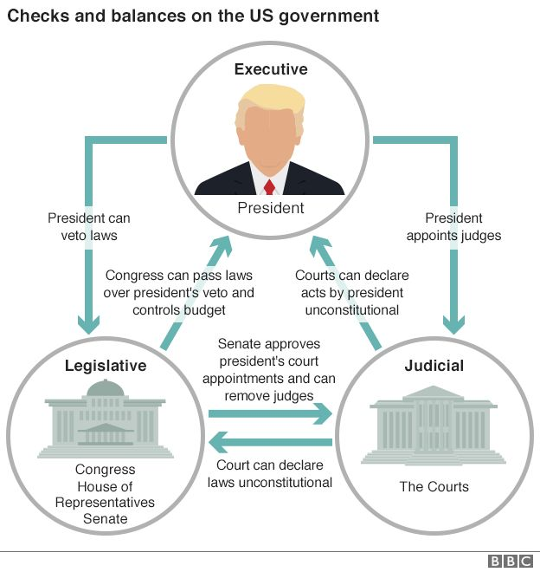
    - They began talking about a way to CHANGE THE CONSITUTION CALLED AMENDMENTS
      - AMENDMENTS – Changes to the Constitution
      - FIRST 10 AMENDEMTNS – “Bill of Rights”
        - Bill of Rights – List of rights that you have as a USA Citizen.
        - 1st Amendment – Freedom of religion, speech, and press
        - 2nd Amendment – Right to Bear Arms
        - 3rd Amendment – No troops in their houses if they don’t want to
        - 4th Amendment – Illegal search and seizure
        - 5th – 8th Amendment – Trial by jury, Innocent until proven guilty
        - 9th and 10th – Limit the United States Government
  - After the 9th state signed the CONSITUTION. They decided to make GEORGE WASHINGTON PRESIDENT AND JOHN ADAMS VICE PRESIDENT.

