CHAPTER 8: LAUNCHING A NEW NATION
SECTION 1: WASHINGTON TAKES OFFICE
- THE FIRST PRESIDENT
  - During the Constitutional Convention, the delegates unanimously made GEORGE WASHINGTON the first President of the United States.
  - They voted for the first VICE PRESIDENT, “JOHN ADAMS”
  - 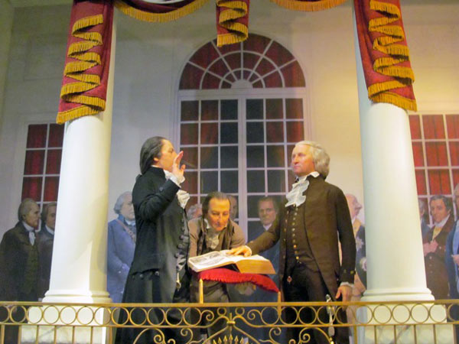
  - April 1789 George Washington traveled to NEW YORK CITY to begin his job as PRESIDENT.
  - At the first AMERICAN INAUGURATION (swearing in the President and he takes the oath of office) he added the words, “SO HELP ME GOD” at the end of his swearing in. Today all PRESIDENTS have done the same.
  - EXECUTIVE BRANCH
    - The first job of GEORGE WASHINGTON was to put the GOVERNMENT in place. He was set up 3 departments: TREASURY, STATE, & WAR. He would then appoint an Attorney General
    - Each of the 3 departments had a secretary to oversee it.
      - SECRETARY OF TREASURY – ALEXANDER HAMILTON
PRESIDENTIAL CABINET
      - SECRETARY OF STATE – THOMAS JEFFERSON
      - SECRETARY OF WAR – HENRY KNOX
      - ATTORNEY GENERAL – EDMOND RANDOLPH
  - JUDICIARY BRANCH
    - Judiciary Act of 1789 created a Supreme Court and 6 Judges. There were 3 Circuit Courts and 13 District Courts.
    - JOHN JAY becomes the first CHIEF JUSTICE OF THE SUPREME COURT
- NATIONS FIRST ECONOMIC CRISIS
  - After the American Revolution, America was in grave debt. They owed 52 MILLION dollars in the form of bonds.
    - BOND – is a certificate given by a country or government to another promising to pay that money back with INTEREST.
      - INTEREST – An extra amount of money that had to be paid like a fee.
    - SPECULATORS – People who sold their bonds for less money than they were worth making the value of the BOND lower.
  - America was so in debt that they did not even have enough money to move George Washington from Virginia to New York.
  - ALEXANDER HAMILTON’S FINANCIAL PLAN
  - 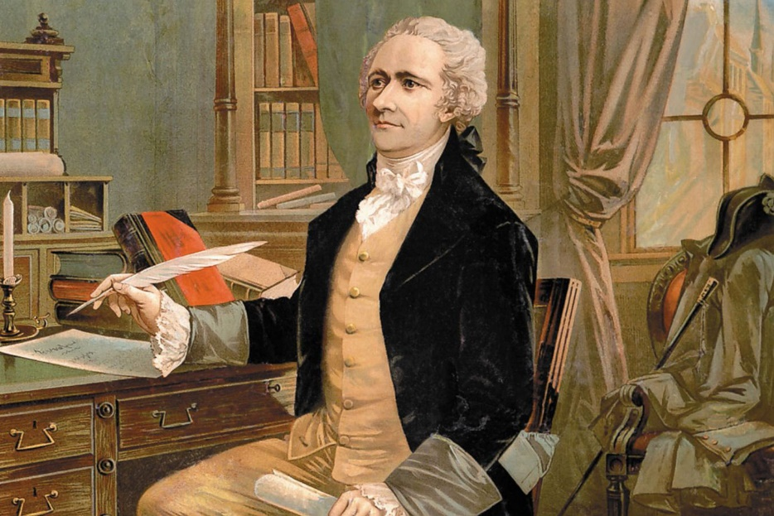
    - This was a 3 stage plan to get America out of debt.
      - USA would agree to pay back all debt owed to other countries, and state debts.
      - USA would create a national bank for depositing govt. money to keep good track.
      - USA would create a HIGH tariff on goods coming into the country to generate revenue.
    - PAYING THE DEBT STEP 1
      - After paying for the debt, the USA would create a national capital between Maryland and Virginia calling it, “WASHINGTON D.C. (DISTRICT OF COLUMBIA)
    - CREATING A NATIONAL BANK STEP 2
      - Created the Bank of the United States. The bank could issue paper money. However, THOMAS JEFFERSON, the SECRETARY OF STATE claimed creating a bank was UNCONSITITONAL
        - UNCONSITITUAL – Against what the Constitution says.
      - Thomas Jefferson, “No where does it say you can create a bank in the CONSTITUION”
        - He believed if it doesn’t say, we don’t do it… a STRICT INTERPRETATION.
      - Alexander Hamilton “It Kind of says it therefore we can make a Bank.”
        - Hamilton believed you could stretch what the CONSTITUION SAYS, or a LOOSE INTERPRETATION.
    - MAKING A HIGH TARRIFF STEP 3
      - USA would create a HIGH TARRIF – Tax on Imports coming into USA.
        - The tariff did help generate money for the USA however it hurt some of the farmers in the south. Eventually making them upset for rebellion.
- THE WISKEY REBELLION
  - Also known as the “WISKEY INSURRECTION.” This was the first tax made by the new government to generate money for debt from the American Revolution.
  - It was a tax not just on WISKEY but every AMERICAN SPIRIT (LIQUORS). WISKEY was the most popular.
  - Farmers in Pennsylvania revolted because they could not afford the things to make WISKEY like : wheat, rye, barley,
  - Farmers refused to pay the tax from 1791-1794. Over 600 protested and began to revolt in PENNSYLVANIA.
  - GEORGE WASHINGTON ordered 13,000 troops from 4 states to take down the Rebellion. It was swift and quick.
  - This proved that the new government proved to be strong in putting down revolts against governments laws.
  - 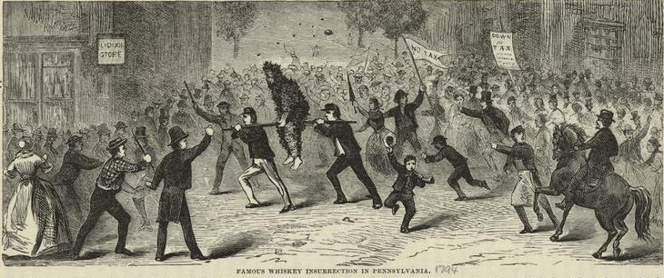
  - 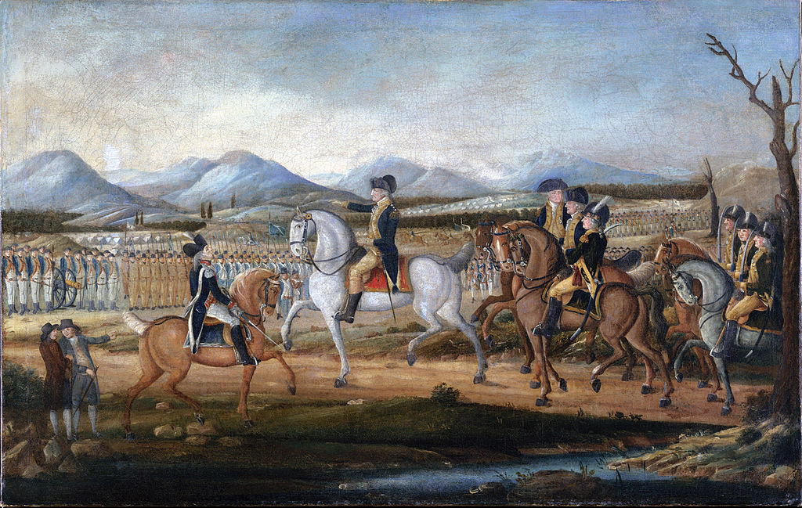

SECTION 2: THE BIRTH OF POLITICS
      - POLITICAL PARTIES EMERGE
        - When the Founding Fathers created the Constitution, they believed everyone would work together for the sake of the Countries. They did not think POLITICAL PARTIES would emerge.
        - Political Parties are also called, “FACTIONS” and James Madison and George Washington were very much against them
          - “Factions will tear the United States apart” – GEORGE WASHINGTON AS HE LEFT OFFICE AS PRESIDENT.
        - Two men create political parties:
          - Alexander Hamilton created “THE FEDERALISTS”
            - Believed the healthy and educated should lead the United States
            - Favored a strong Congress
            - Encouraged manufacturing, and trade with other countries
            - Believed in a LOOSE INTERPRETATION of the Constitution
            - Wanted alliance with the British
            - Wanted a National Bank
            - Wanted Tariffs to get out of debt and taxing people
          - Thomas Jefferson created, “THE DEMOCRATIC-REPUBLICANS”
            - Believed people should have the power
            - Favored strong State Governments
            - Encouraged farming and agriculture
            - Believed in a STRICT INTERPRETATION of the Constitution
            - Wanted an alliance with France
            - Opposed a National Bank
            - Opposed a Tariff for debt and taxing the people
        - 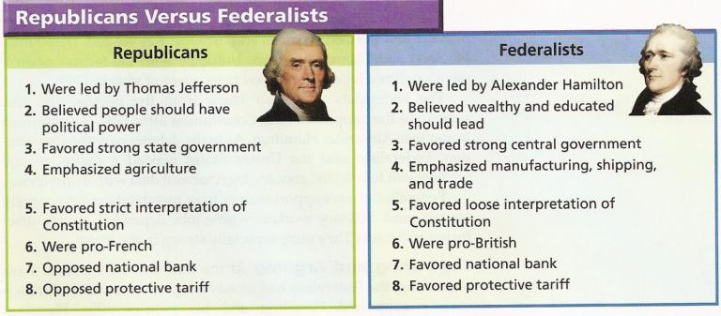
        - When CABINET meetings happened with GEORGE WASHINGTON, HAMILTON and JEFFERSON would disagree and argue and grow apart. GEORGE WASHIGNTON tended to agree with HAMILTON, because of this Eventually, Thomas Jefferson decides to leave as SECRETARY OF STATE in 1793.
        - George Washington becomes very hated in the UNITED STATES. Sometimes he had torches at his own doorstep threatening to burn down his home.
        - After 8 years as President, WASHINGTON decides to leave as PRESIDENT.
          - He could have chosen to stay, there was no term limit.
          - Because he left, most Presidents did the same after 8 years or 2-year terms. 22nd AMENDEMENT
      - THE ELECTION OF 1796: JOHN ADAMS vs. THOMAS JEFFERSON
        - This election was between the VICE PRESIDENT – JOHN ADAMS and FORMER SECRETARY OF STATE – THOMAS JEFFERSON.
        - Both were good friends with different opinions on the Constitution.
          - JOHN ADAMS – FEDERALIST (VICE PRESIDENT)
          - THOMAS JEFFERSON – REPUBLICAN (SECRETARY OF STATE)
        - One of them would be President, the other would become VICE PRESIDENT. 2nd Place in voting for PRESIDENT became VICE.
        - JOHN ADAMS defeated THOMAS JEFFERSON and became the 2nd PRESIDENT OF THE USA.
        - Their friendship was demolished as a result of their differences in REPUBLICAN AND FEDERALIST.

SECTION 3: TROUBLES AT HOME & ABROAD
            - CONFLICTS IN THE NW TERRITORY
              - After the American Revolution, FRANCE AND BRITAIN agreed to leave and go home with their soldiers. BRITAIN was still around and staying and giving guns and ammunition to Native Americans.
              - BRITIAIN did this in hopes that America would not move toward the MISSISSIPPI RIVER and into the NORTH WEST TERRITORY
              - America wanted to move further out into the OHIO RIVER VALLEY. They battled with Native Americans who did not want to give up their lands.
            - THE FRENCH REVOLUTION
              - Began in 1789, because France wanted the same thing America had… a DEMOCRACY
              - The King of France would not allow it, so the FRENCH CUT HIS HEAD OFF!
              - 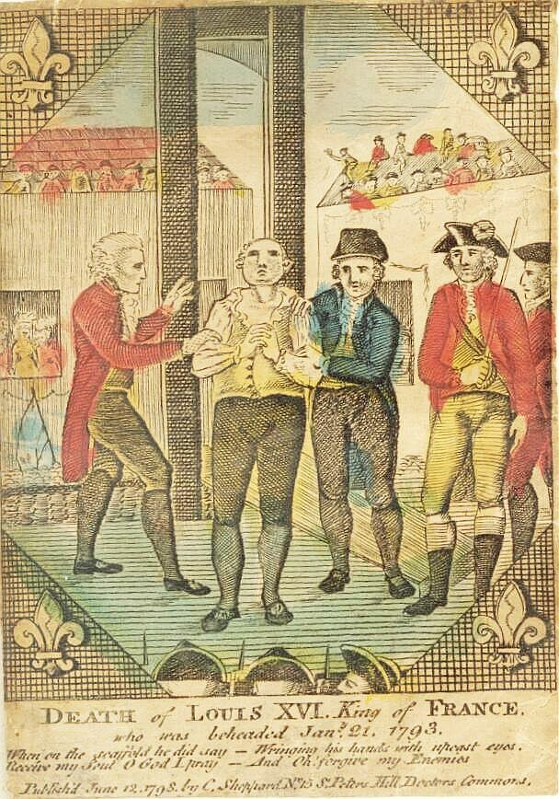
              - 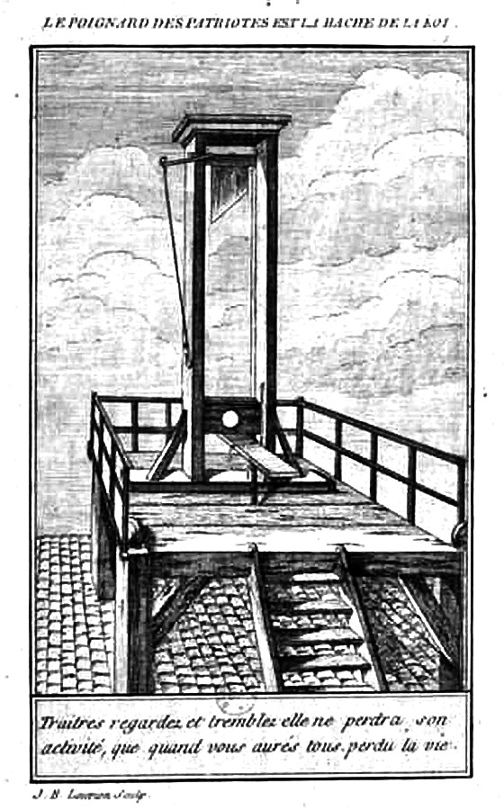
              - 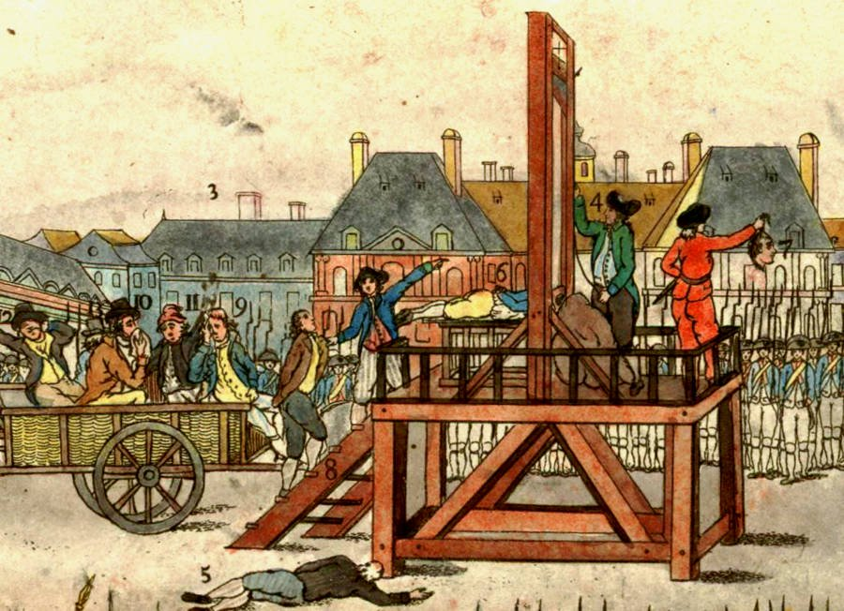
              - France asked GEORGE WASHINGTON for help in creating a new GOVERNMENT. GEORGE WASHINGTON TOLD THEM, “NO!”
              - This started many USA Citizens to HATE GEORGE WASHIGNTON.
              - Washington wanted to stay NEUTRAL in all BRITISH AND FRENCH CONFILCTS.
  - Washington said he would not trade with just one country…. but both!
- France began creating a new government slowly, however they could never get anything going. Their REVOLUTION continued with the conquering of lands throughout EUROPE with their new GENERAL, NAPOLEON BEUNOPART
- NAPOLEON BONEAPART
  - Hero of the French Revolution conquered much of EUROPE with the largest army seen in the world.
  - Every war he would win he wrote home letters saying I am creating new lands for France, you create the Government.
  - Napoleon eventually returned to France seeing that Government is not set up and they make him THE EMPEROR of FRANCE!
3. BRITISH IN THE FRENCH REVOLUTION
  - Britain and France were at War with Napoleon, both wanted the support of America. We stayed Neutral and sent ships to both countries. Problem is, neither wanted us to give supplies.
  - AMERICA was allies with both FRANCE AND BRITAIN, who should they support?
    - Tensions change when BRITAIN begins seizing AMERICAN SAILORS and putting them in the BRITISH NAVY called, “IMPRESSMENT”
    - Alexander Hamilton urged GEORGE WASHINGTON to keep friends with the BRITISH. Said trade with them was essential.
- JOHN JAY’s TREATY
  - WASHINGTON sent over John Jay to make good terms with Britain in 1795 and he came bac with a Treaty that was not all that great:
    - America would pay debts owed to Britain
    - Britain would pay for the ships they took and attacked illegally.
    - Britain agreed to remove troops from NW Territory.
    - Britain would agree to stop giving guns to Native Americans in NW Territory.
    - Britain said, “We will not allow trade with France.”
    - Britain said, “If you trade with France, we will impress your sailors.”
  - This treaty angered THOMAS JEFFERSONS REPUBLICANS.
  - ALEXANDER HAMILTONS FEDERALISTS liked the treaty because it kept the peace.
- WASHINGTON RETIRES FROM PUBLIC LIFE
  - Because of JOHN JAYS treaty and staying NEUTRAL between FRANCE AND GREAT BRITAIN. GEORGE WASHINGTON was well hated by the public.
  - He was also upset about the division between FEDERALISTS AND REPUBLICANS. “FACTIONS will be the downfall of America” – GEORGE WASHINGTON
  - WASHIGNTON stressed staying out of EUROPEAN affairs.
  - REASONS FOR LEAVING OFFICICE AFTER 8 YEARS:
    - USA Now had a functional federal government
    - Economy was improving because of the tariffs under Hamilton’s plan.
    - Washington avoided war
    - British had been forced to leave their forts in the NW Territory, and now safe for settlement.

SECTION 4 : THE PRESIDENCY OF JOHN ADAMS
      - TROUBLES WITH FRANCE
        - The JOHN JAY Treaty made tensions with France because Britain said we could not trade with France. France began now attacking AMERICAN MERCHANT SHIPS as well!
        - THE XYZ AFFAIR
          - To keep the peace with FRANCE, John Adams sends 3 Delegates to FRANCE to negotiate peace. He sends: Charles Pinkney, John Marshall, & Elbridge Gerry.
          - When the 3 men arrive in France expecting to talk to Lord Talleyrand, the French PRIME MINISTER. Talleyrand said he would not talk to them until he gave them $250,000 to fund the French Revolution & another 10 million dollars to lend them for other things.
          - Charles Pinkney yells out, “NO! NO! NO! We will not give you a sixpence!” (Less than a penny).
          - 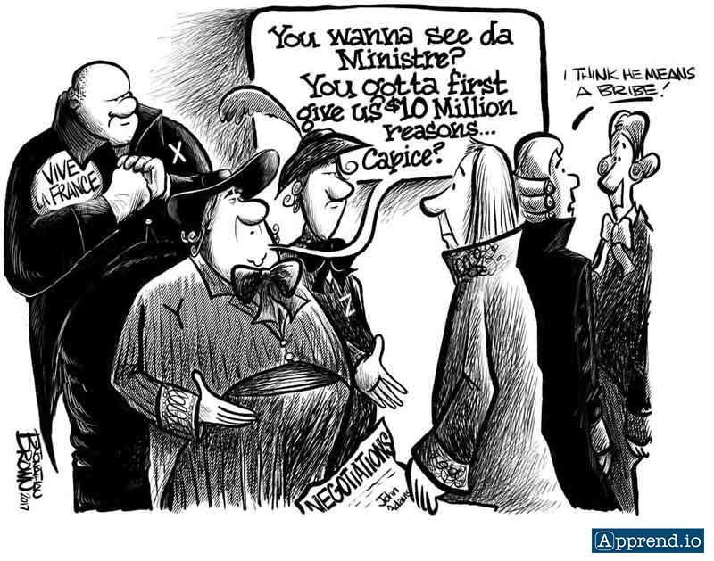
          - When this information got out to the public. The public was mad because France demanded money.
          - John Adams kept the names of the 3 delegates secret in the papers, naming them, “X,Y, & Z.”
          - The public outcry for war was HUGE. FEDERALISTS demanded war with FRANCE.
          - John Adams did not want war, he wanted to keep GEORGE WASHINGTONS promise of NEUTRALITY.
          - Instead of war, JOHN ADAMS asks CONGRESS to increase the Army and Navy along our own borders.
          - In 1800, Napoleon Buonaparte agreed to stop attacking American ships. JOHN ADAMS avoided war.
      - THE ALIEN AND SEDITION ACTS
        - The idea of war SPLIT the FEDERALISTS and REPUBLICANS, FEDERALISTS did not want to help FRANCE. REPUBLICANS wanted to support the FRENCH.
        - The biggest problem that happened, is the FEDERALISTS gained PRESIDENT JOHN ADAMS on their side.
        - JOHN ADAMS & FEDERALISTS asked Congress “ALIEN ACTS.”
          - This law allowed people to become US Citizens after 14 years. Before it was only 5 years.
          - The Alien Act allowed the President to deport people who he felt were dangerous to America.
        - JOHN ADAMS & FEDERALIST asked CONGRESS to pass a 2nd law, “SEDITION ACTS”
          - The Sedition Acts targeted the REPUBLCANS, it limited FREE SPEECH! It made it a crime to for anyone to write or say something bad about the government or the President.

      - STATES RIGHTS & ELECTION OF 1800
        - The REPUBLICANS felt that the SEDITION ACTS were unconstitutional. It pushed for them to run in the Election of 1800, they chose VICE PRESIDENT, THOMAS JEFFERSON.
        - Thomas Jefferson defeated John Adams in the ELECTION OF 1800, Jefferson called it the, “REVOLUTION OF 1800.”
        - 2 States tried to strike down the SEDITION ACTS during JOHN ADAMS PRESIDENCY. The 2 states were KENTUCKY AND VIRGINIA, They said that they have “STATES RIGHTS.”
          - This is the idea that STATES have the authority to overrule the FEDERAL GOVERNMENT LAW. But, it did not work.

