Chapter 11: THE NORTH AND SOUTH TAKE DIFFERENT PATHS
SECTION 1 : THE INDUSTRIAL REVOLUTION
- A REVOLUTION IN TECHNOLOGY ENGLAND
  - Industrial Revolution – Slowly, machines take the place of many hand tools. Much of the power once used by horses and people begin to be replaced. First by flowing water and then steam engines.
  - 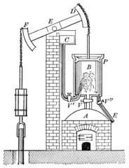
  - The Industrial Revolution begins in Great Britain (England)
  - The people created clothes on “spinning wheels” it took to long. Richard Arkwright invented a water spinning machine that made things faster for weaving.
  - Factories begin to pop up on the edge of rivers. Many of these were outside cities at first.
  - Richard Arkwright found a way to make factories in cities that allowed women and children even ages 7 or 8 to work in factories.
    - Problem was, children were dying in factories getting limbs caught in machines. Child labor began.
  - The factories pumped out more cotton made goods and created “capitalists” or people who invest money into businesses for profit.
- THE AMERICAN INDUSTRIAL REVOLUTION
  - In 1789 Richard Arkwright’s Apprentice, Samuel Slater decided to leave England and head to the New York City.
  - Samuel Slater knew Arkwright’s machine designs.
  - Samuel Slater joined forces with a guy in New York named Moses Brown, he had a factory in Rhode Island.
  - Slater and Moses created a factory based on Arkwright’s Spinning Wheel Machine. Cotton was on the rise in America now.
- AMERICAN INDUSTRY GROWS
  - Samuel Slaters mills marked the beginning of American Industrialization.
  - Another man also had knowledge of Machines, Francs Cabot Lowell. He opened a factory in Massachusetts. He made a small town around his factory for his people to live.
  - The factory was staffed with girls from the nearby town called, “Lowell’s Girls” many women gained an education.
  - Lowell created, “mass production” or rapid manufacture of large numbers.
- THE REVOLUTION TAKES HOLD
  - Mass production started in other industries such as guns, clocks, and of course cotton products.
  - Most of these factories had poor conditions and long hours. More and more children started working from 10-15 years old with pay.
  - There was little fresh air, many workers get injured or died on the job. Businesses gave dead workers no pay or their families.
SECTION 2: THE NORTH TRANSFORMED
- NORTHERN CITIES
  - New York City was the largest population and had the most industry.
  - With the growth of factories, URBANIZATION happened.
    - URBANIZATION – Where people move from the country areas of farming to work in cities and factories.
  - Immigrants begin to move into the United States to work in these factories. German & Irish were the two largest.
  - URBANIZATION caused problems: filthy streets, bad sewage, lack of clean water, disease spread, citywide fires.
  - 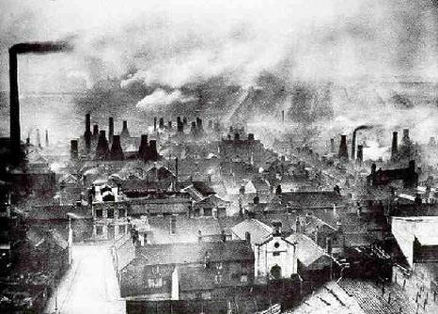
- THE GROWTH OF NORTHERN INDUSTRY
  - Industrial Revolution created new things: Telegraph Lines, Railroads, Steamboats, Combines,
    - TELEGRAPH
      - a device that used electric signals to send messages quickly over long distances using telephone pole like lines.
      - MORESE CODE – Created by Samuel Morse that had a code for every word or letter sent by Telegraph line. Used a series of dots and dashes.
    - COMBINE
      - Cyrus McCormick created a machine that cut wheat and separated the grain from the wheat. Eventually this helped create the Combine.
    - SEWING MACHINE
      - Created by Elias Howe in 1846 that made and produced threading cloth quickly. This helped expand the cloth making industry.
    - STEAMBOATS AND CLIPPER SHIPS
      - 1807 Robert Fulton used a steam engine to power a boat. He helped revolutionize ship building and it moved from river boats to Clipper Ships. Clipper ships were faster than Paddle boats.
      - Steam Engine boats helped produced massive ships to haul cargo across the oceans.
    - RAILROADS
      - Of all forms of transportation, Railroads was the biggest influence. They could be built anywhere.
      - Peter Cooper built the first Locomotive.
      - 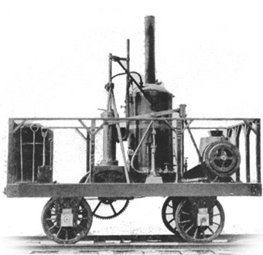
      - Most of the railroads were built in the north. Very few in the south and west.
- A NEW WAVE OF IMMIGRANTS
  - With Steam Engine ships being built, Immigrants begin to move to America: German, Irish, English, Dutch. They all face hardships
  - IRISH IMMIGRATION
    - The Irish always had one major crop, the potato. In 1845 they had a widespread FAMINE or lack of water and starvation.
    - Many of the Irish boarded ships to America landing in New York City’s Ellis Island.
    - 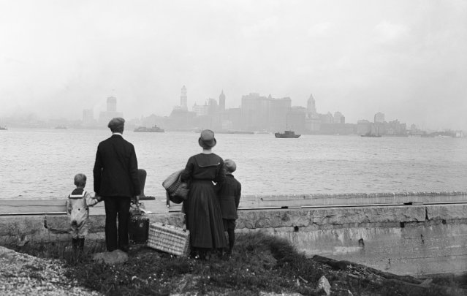
    - Irish would get off the boat, and the Military would be there with Bread and water asking them to join Americans Military with the promise of food and housing.
    - In the end, most of the Irish Immigrants begin to work in the factories and laying railroad tracks.
  - GERMAN IMMIGRATION
    - Many of the Germans that came to America did not have to deal with some of the same things as Irish. They however had to deal with harsh rulers and kings.
    - Most of the Germans ended up moving west and becoming farmers in corn, wheat, and other agriculture things.
  - HATRED TOWARD IMMIGRATION
    - Irish immigrants begin to take American jobs because they will work harder, for less pay than the average American.
    - As a result, some Americans become NATIVISTS: people who believe America was made only for natural born Americans.
    - NATIVISTS opposed Irish heavily because they not only took jobs, but they were Roman Catholic.
    - NATIVISTS vs. IRISH had gangs and fought in the streets of New York.
    - NATIVISTS even created a secret order group called, NO-NOTHINGS PARTY. They even ran for President at one time. Then it collapsed when they lost.
  - HATRED TOWARD AFRICAN AMERICANS IN THE NORTH
    - African Americans in the North faced DISCRIMINATION or the denial of equal rights and treatment.
    - Slavery began ending in the north in early 1800’s but African Americans that were free could not vote.
    - African Americans could not work in factories with whites.
    - African Americans faced SEGREGATION or separation of whites and blacks in some schools and public places in the North.
    - White newspapers often said that free African Americans were inferior.
    - African Americans created their own newspaper called Freedoms Journal created by John Russwurm.
      - John Russwurm was one of the first African Americans to graduate college in America
SECTION 3: THE PLANTATION SOUTH
- THE COTTON KINGDOM
  - When The North became Urbanization, the south stayed RURAL or people who stay in the country side.
  - The best thing to happen to the south was the COTTON GIN created by Eli Whitney in 1793. This invention took the pointy seeds out of the cotton fast.
  - 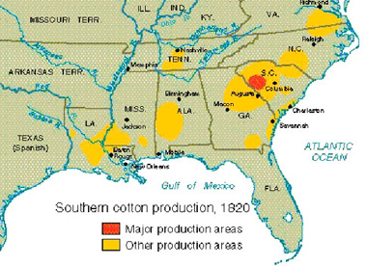
  - With the invention of the COTTON GIN people wanted more cotton. Which demanded more SLAVE LABOR.
  - 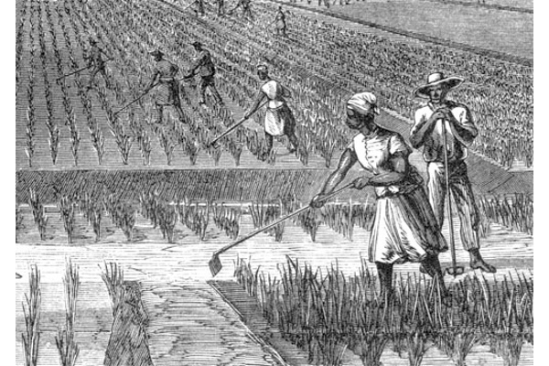
  - Large farms with SLAVES started popping up along the Atlantic Ocean and Gulf of Mexico called PLANTATIONS. People with plantations educated their kids with tutors. Owned lots of slaves! RICH!
  - 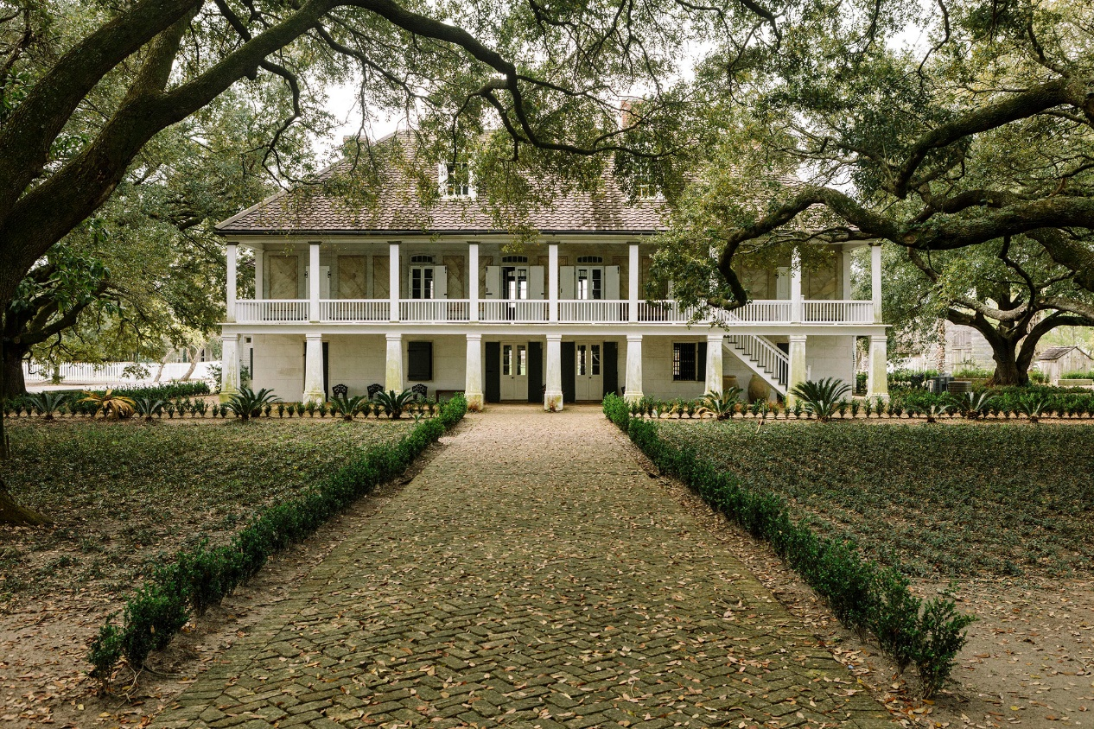
  - Cotton became the greatest CASH CROP for the SOUTH and the UNITED STATES. Britain bought tons of it.
  - 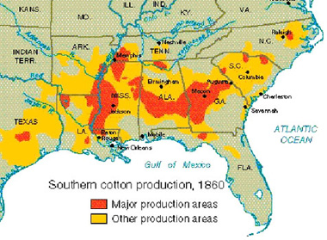
  - SOUTH would have SLAVES pick the Cotton. Sell the Cotton to the NORTH, NORTH factories would make clothes, Clothes would be sold to Americans and the world.
  - Most more than half of people in the south did not own slaves! Most were average working everyday farmers.
  - In 1790 the number of slaves were now up to nearly 700,000! 1860 it was up to 4 million! The price of slaves also went higher in price by 20x
  - Northern and Southerners had a different view on slavery. Northerners who did not like Slavery were called, “ABOLITIONISTS.” Southern people said that these African enslaved would always have a job.
- AFRICAN AMERICANS IN THE SOUTH
  - Not all African Americans in the south were slaves. About 6% of them were free! Most of them bought their freedom
  - Many free men could not have certain jobs, vote, go to school, testify in court, and couldn’t travel.
  - African American Families were split apart, sold based on the size and strength of a man.
  - 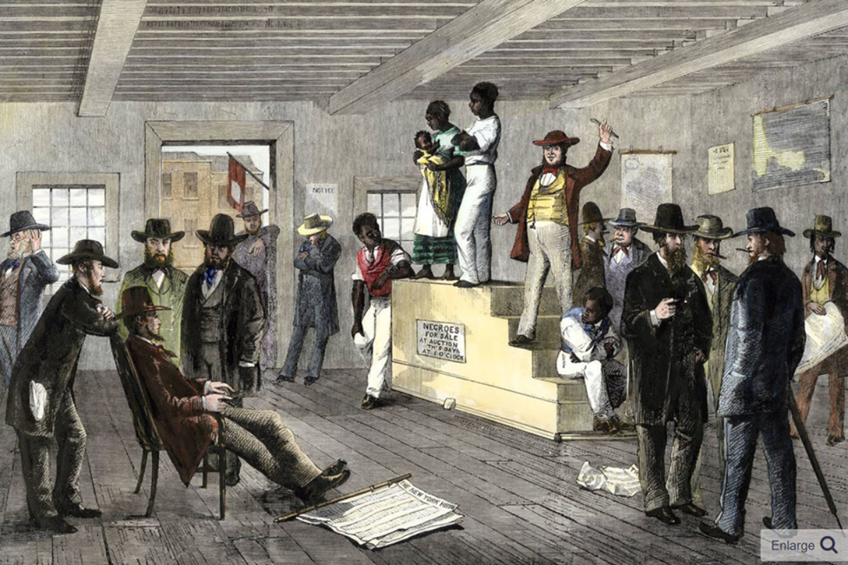
  - Many free African Americans sometimes ended up back into slavery because someone thought they ran away from their owners.
  - Some African American men changed the way the south ways. Norbert Rilleux changed the sugar industry in the south and made it faster to make and sell. Henry Blair made a seed planting device that made crop sowing faster and easier.
  - If you were enslaved you faced hardship laws called, “SLAVE CODES” these controlled your everyday life and took away ALL rights.

  - 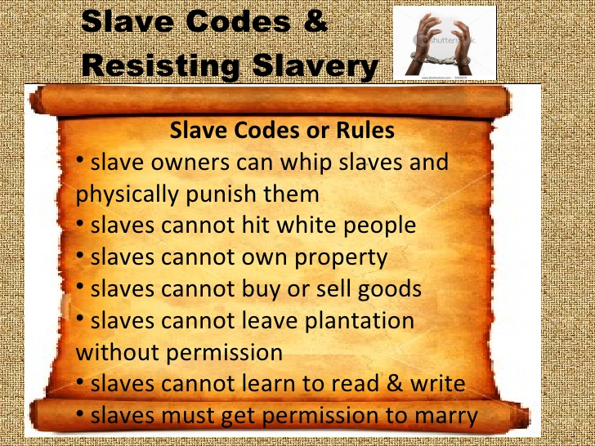
  - Most slaves did heavy labor. If they refused, some slaves were whipped if they did not do as their owners pleased. Some were close friends of their slave owners and worked as servants in the home.
  - The one thing slaves had to their advantage is the owners saw them as property not a person. So they took interest in their property.
  - Many African American slaves found hope in the Bible. Many of them learned to read and write by using the Bible.
  - If a slave learned to read and write on a plantation, that person would teach others.
  - Slave owners did not want their slaves to read and write because they could organize uprisings and revolutions against them.
  - The most famous slave that revolted was Nat Turner in 1831. He and others killed about 60 whites and went on the run for 6 weeks in Virginia until he was caught and hung.
  - 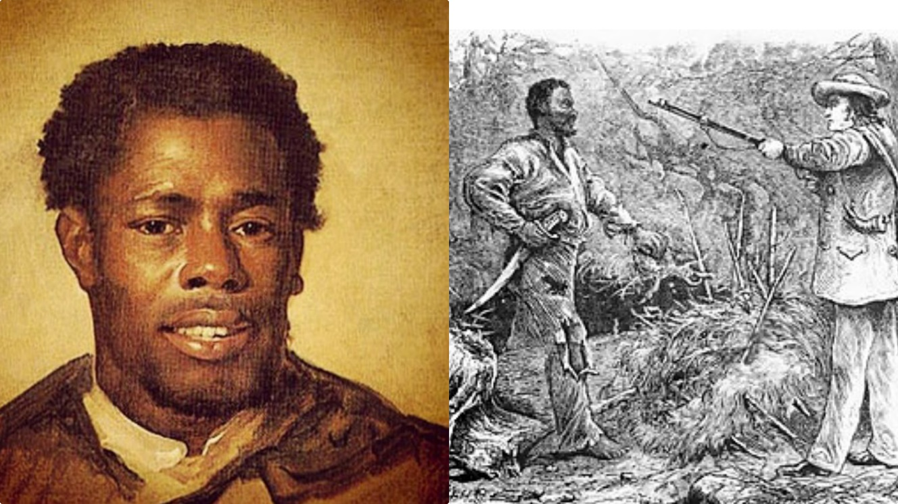
  - Nat Turner and his followers made the southerners have even stricter laws on slaves running away.
SECTION 4: THE CHALLENGES OF GROWTH
- MOVING WEST
  - By the 1750’s IRISH and GERMAN immigrants come to America and settled with Americans. This takes up more land. American people begin to have the idea of moving west.
  - The most famous early pioneer was Daniel Boone, Boone and about 30 men created a new road west called the Wilderness Road. It crossed the Appalachian Mountains to Kentucky.
  - 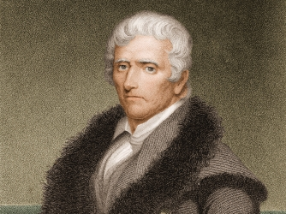
  - 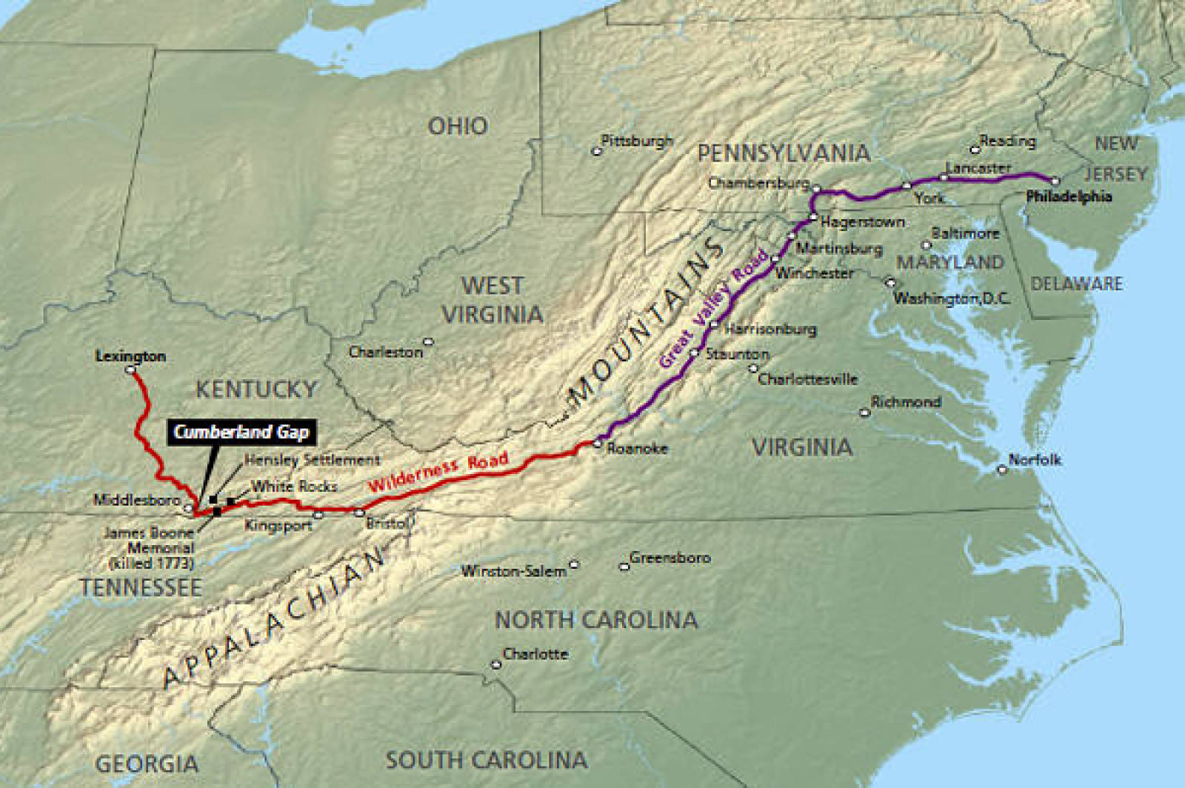
  - The more people going west, made more states to be created in the United States
  - Kentucky (1792), Tennessee (1796), Ohio (1803), Louisiana (1812), Indiana (1816), Mississippi (1817), Illinois (1818), & Alabama (1819)
  - The problem with settlers moving into these places, the roads were terrible for wagons
- ROADS AND TURNPIKES
  - America began to create turnpikes (toll roads) throughout the west to help people get around and transport goods faster.
  - The first long distance turnpike was called the Philadelphia Lancaster Turnpike, this was the first long distance STONE ROAD
  - 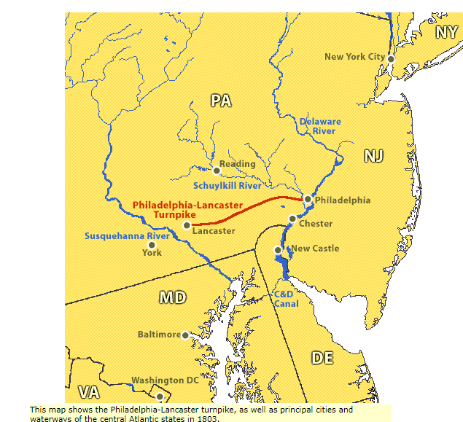
  - Some roads were called corduroy roads or sawed-off logs laid side by side. These roads were tough on horses’ feet, sometimes they slipped through logs.
  - The National Road was the first federally funded road in 1811. Went from Maryland to Illinois.
  - 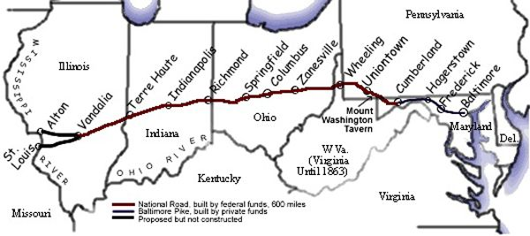
- CANALS
  - The fastest and cheapest way to ship goods was by a CANAL. A channel that is dug across land and filled with water.
  - In New York in 1816, Gov. DeWitt Clinton proposed a Canal called Clintons Ditch from Hudson River to Lake Erie. Called the ERIE CANAL
  - 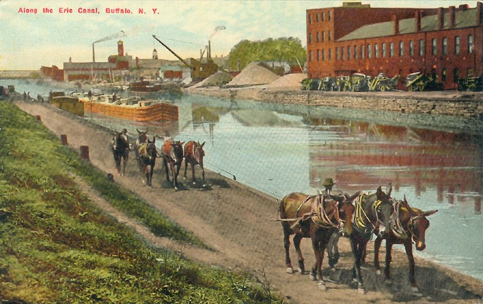
  - Clinton had to build Locks or things that block the water off to make it raise and lower based on how big a ship was.
  - This CANAL made New York City the richest city in the country. This became known as the ERIE CANAL.
  - 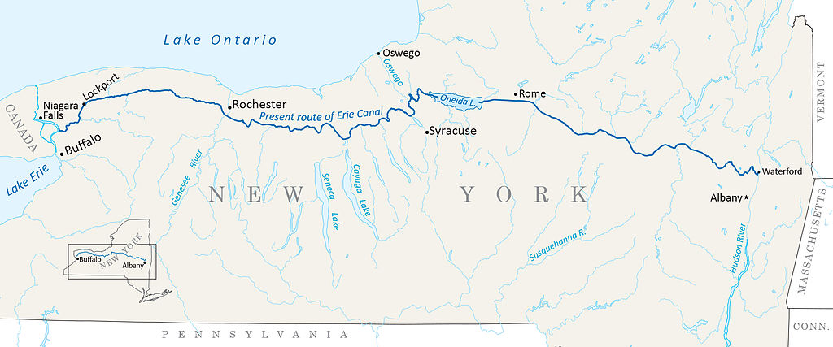
  - 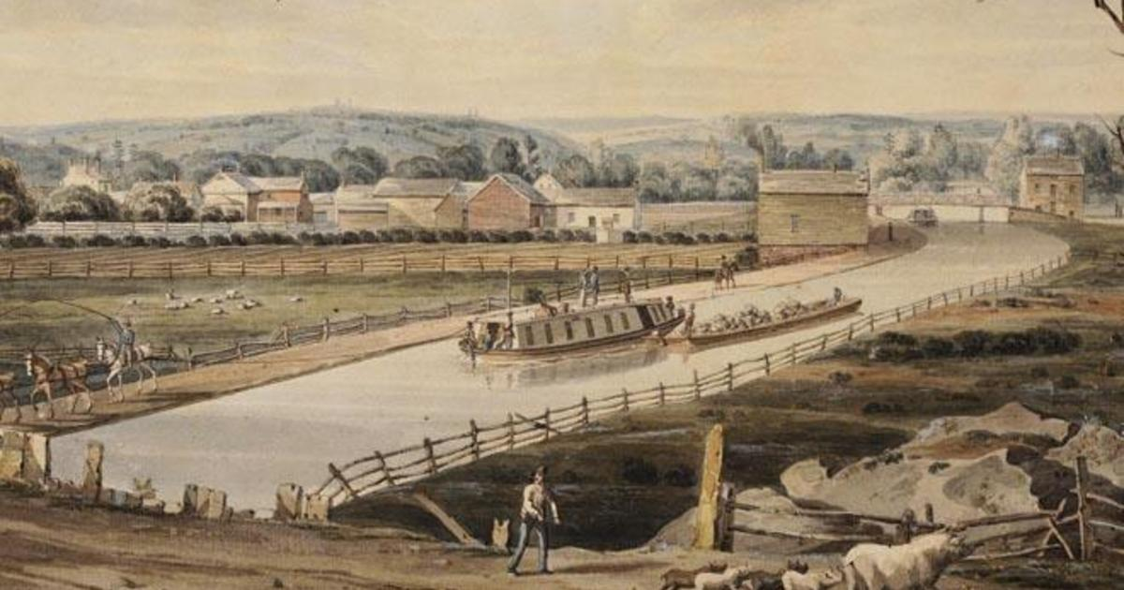
- THE EXTENSION OF SLAVERY
  - With more states popping up in the west, it made the United States stronger. But the new issue was are these states going to be slave states or free states?
  - Missouri wanted to become a state. But there was a total of 22 states before Missouri, 11 free and 11 slave. Missouri wanted to be a slave state.
  - The Missouri Compromise allowed 2 new states instead of one. In the North it would be Maine as a free state. In the South it would be Missouri as a slave state.
    - In the Missouri Compromise any new states above Missouri would be free states, anything below Missouri would be slave states.

