CHAPTER 12 : AN AGE OF REFORM
SECTION 1 : IMPROVING SOCIETY
- THE FORMING SPIRIT
  - Under Andrew Jacksons Presidency, he pushed for more democracy. He pushed for other social changes around everyday life called, “Social Reform”
  - White men were now being able to vote, Political Parties now chose their Presidential candidates differently. Some pushed for women’s rights as well. But, they did not get voting until 1919.
  - Religious feelings also began again in the early 1800’s, “THE SECOND GREAT AWAKENING” pushed people to have free will and express themselves how they wish.
    - The most important preacher during 2nd GREAT AWAKENING was Charles Finney, he created “REVIVALS” or huge outdoor religious meetings. Finney believed REVIVALS could get to even the worst sinners and convert them back to Christ.
    - 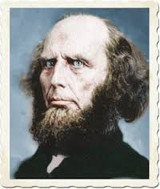CHARLES FINNEY
  - Some people began to think if they improved their lives they could improve society as well. People want a more PERFECT SOCIETY or a UTOPIAN SOCIETY (perfect city)
  - Robert Owen founded the first UTOPIAN COMMUNITY in Indiana called, “NEW HARMONY” but it was not HARMONY at all. People argued, and colony dissolved after 2 years.
  - 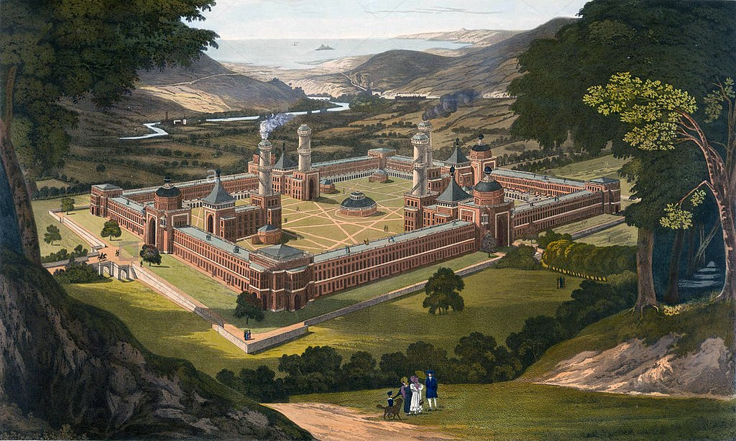
- SOCIAL REFORMERS AT WORK
  - Social Reform continued, one of the largest reforms was, “TEMPERANCE MOVEMENT” or an effort to end alcohol abuse.
  - 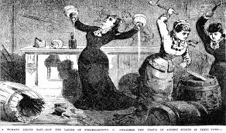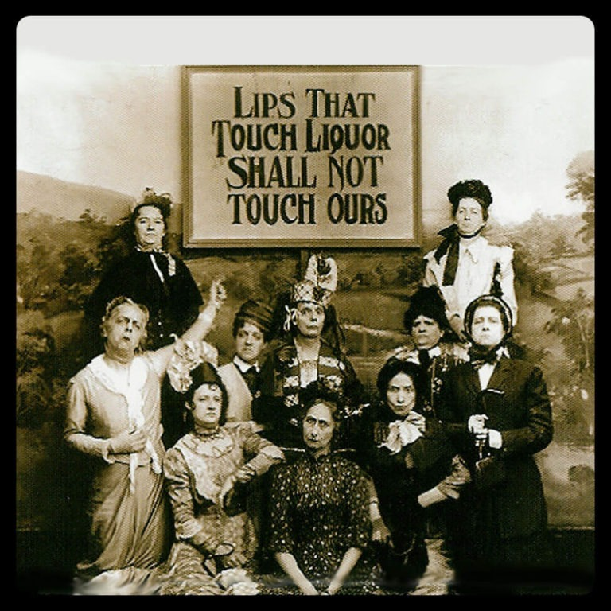
  - Whiskey was cheaper than milk! So people drank it because it was also safer than water.
  - Men would get off work, drink Whiskey, and sometimes take abuse home to the wife and kids.
  - Women pushed for this TEMPERANCE of ALCOHOL!
  - One time in our History before World War 2, 1920-1933 America did PROHIBITION or banned ALCOHOL in America.
  - 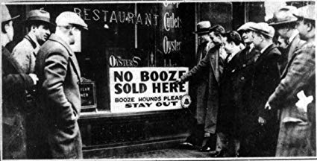
  - America also did PRISON REFORMS, PRISONS were hot, and people who were in debt and couldn’t pay.
  - PRISON REFORER, DORTHEA DIX convinced Massachusetts to build nicer prisons where people in debt were not sent to jail. Chains and cages were used on prisoners.
  - 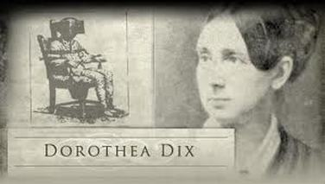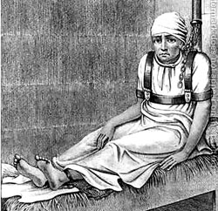
  - Doretha Dix also helped MENTAL INSTITUIONS, She pushed to create ASYLUMS for people with MENTAL ILLNESS. These new ASYLUMS provided treatment not punishments with chains.
- EDUCATION REFORM
  - Education was another area of concern; the first schools were for religion. But, now they were public schools that were supported by USA taxes.
  - Many Americans could not read or write, so this reform was needed. They said Americans cannot vote if they can’t read or write. We must educate.
  - HORACE MANN of Massachusetts took the lead in his state, he became the state board in 1837 creating colleges to train teachers, salaries for teachers, and a good long school year like we have today to educate the young to get them ready to vote.
  - 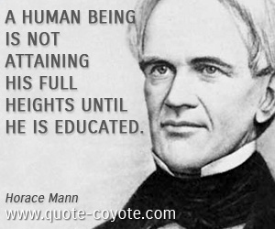
  - Public Education did little for African Americans. South had SLAVE CODES, so kids and slaves could not learn to read or write.
  - African Americans in North had to open their own schools or go to Private schools like Harvard.
SECTION 2 : THE FIGHT AGAINST SLAVERY
- ROOTS OF THE ANTISLAVERY MOVEMENT
  - Some founding fathers did not like Slavery: Ben Franklin, Alexander Hamilton. They believed it took away the principle of the Declaration of Independence.
  - Slavery ended in the North in 1780 when Pennsylvania became the first state to ban it. 1804 every North state banned it.
  - The first ANTI-SLAVE society was called, “AMERICAN COLONIZATION SOCIETY”, they recommended slaves to be transported to Liberia a colony in West Africa.
- GROWING OPPOSITION TO SLAVERY
  - More and more people become ABOLITIONISTS in the NORTH or people who wanted to abolish or end slavery.
  - The most powerful early ABOLITIONIST was WILLIAM LLOYD GARRISON. He did not want violence to end slavery.
  - GARRISON created an anti-slave or ABOLITIONISTS newspaper called, “LIBERATOR”
  - 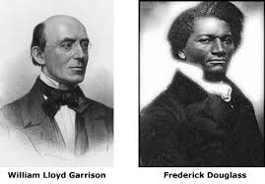
  - Fredrick Douglas was the most powerful of African American ABOLITIONITS. He was born into slavery, he broke the law learning how to read. He escaped to the North for freedom. GARRISON told him to tell his story, Douglas risked telling his story maybe going back into slavery.
  - Fredrick Douglas made his own ABOLITIONIST newspaper called, NORTH STAR.
  - 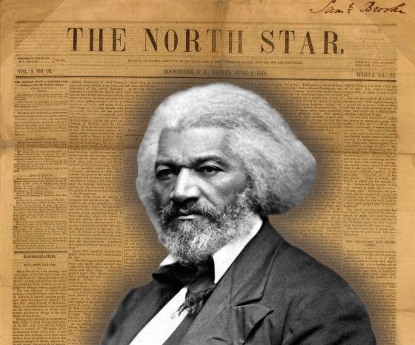
  - A former President became an ABOLITIONIST. John Quincy Adams became a speaker for a group of Africans that were stuck in America after they overthrew their slave ships called, “AMISTAD”
  - The 73-year-old John Q. Adams was able to speak 9 hours to the Supreme Court to get the Africans their freedom back to Africa.
  - 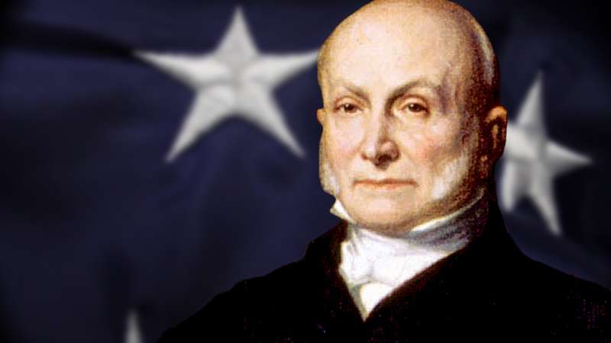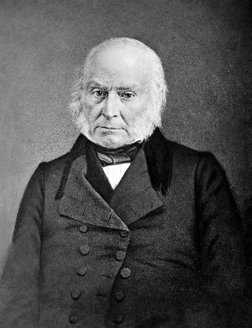
- THE UNDERGROUND RAILROAD
  - A few ABOLITIONISTS created a series of roads helping slaves escape to their freedom. This became known as the UNDERGROUND RAILROAD. However, this was not a REAL RAILROAD!
  - Helping slaves escape was illegal and dangerous. You could be shot by slave owners or attacked by dogs.
  - The people helping the slaves were called, “CONDUCTORS” the lead was HARRIET TUBMAN, escaped herself, then she escorted more than 300 on the Railroad.
  - HARRIET TUBMAN’s nickname was “Black Moses” slave owners offered $40,000 for her capture!
  - Another great CONDUCTOR was Levi Coffin assisting 3,000 fugitive slaves.
  - Over 50,000 slaves earned their freedom on the UNDERGROUND RAILROAD.
  - 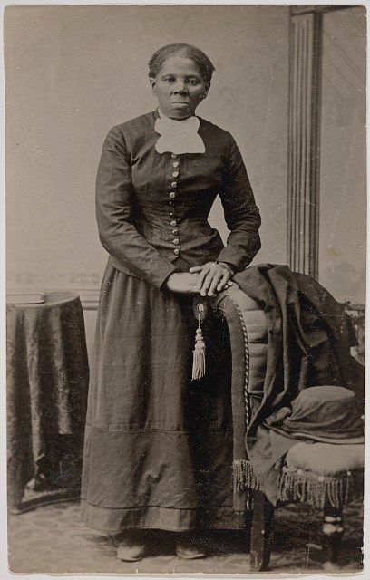HARRIET TUBMAN
  - 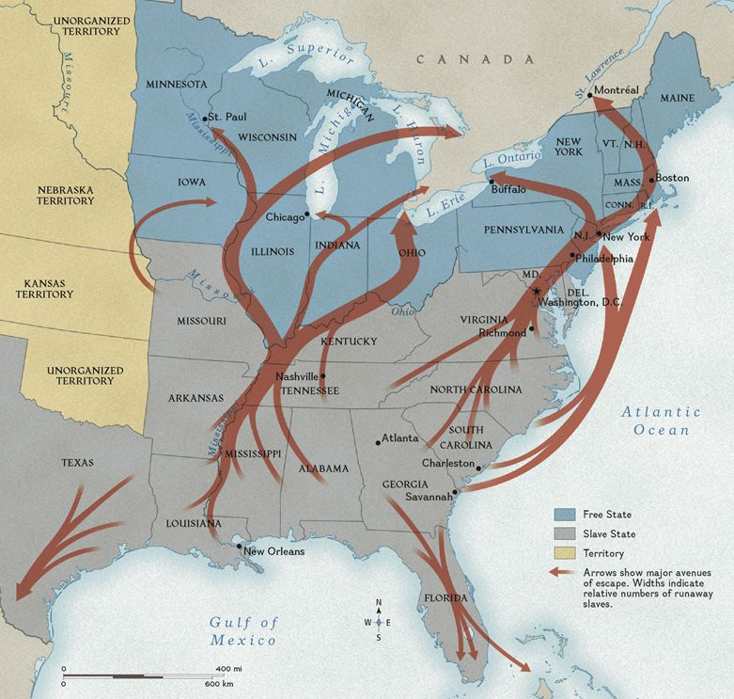
  - 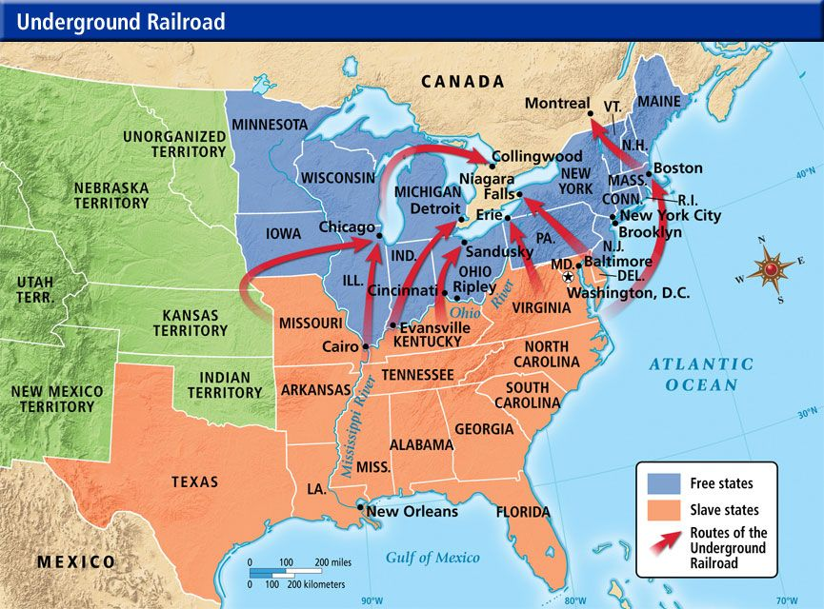
- OPPOSING ABOLITION
  - ABOLITIONISTS faced powerful obstacles in the north as well as the south, Some North Profited from slavery, North Textile Factories needed the production of cotton!
  - Some northerners that ran factories attacked ABOLITIONISTS that had meetings. WILLIAM LLOYD GARRISON was one time dragged in the street and beaten up!
  - The South began a new law called the GAG RULE, if you talked about ABOLITION you should be thrown in jail. JOHN QUINCY ADAMS pushed for the removal of the law.

SECTION 3 : A CALL FOR WOMENS RIGHTS
- THE STRUGGLE BEGINS
  - Women in the 1800’s had basically no rights. No vote, no juries, no public offices. Americans believed women should raise the kids and stay in the home.
  - ABOLITION helped push women’s rights. They began to demand rights too. One women, SOJOURNER TRUTH, an African American woman born into slavery, could not read or write. But, her words inspired crowds of women for their rights.
  - 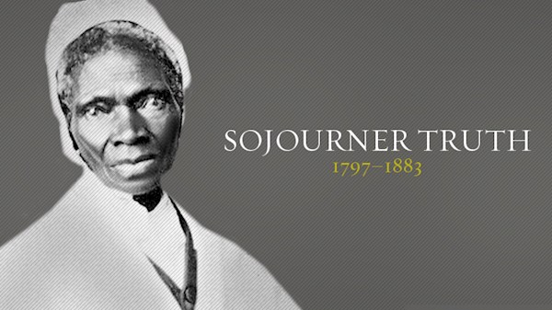
  - Another woman, a QUAKER named LUCRETIA MOTT spent years in ABOLITION movement. MOTT was a great public speaker for women’s rights most were not very good speakers.
  - 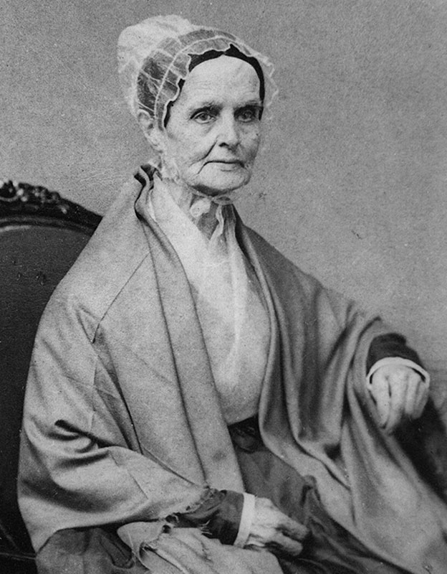LUCRETIA MOTT
  - In 1840, LUCRETIA MOTT traveled to London to go to a ANTI-SLAVE convention. She met, ELIZABETH CADY STANTON, STANTON was on her honeymoon! Both women were told they could not attend the meetings.
  - 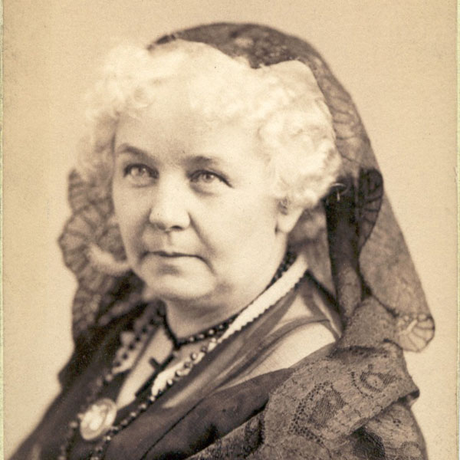ELIZABETH CADY STANTON
  - Both women agreed they would create their own meeting in America
  - STANTON and MOTT created a CONVENTION in SENECA FALLS NEW YORK. There they spoke before 300 men and women. (SENECA FALLS CONVENTION)
  - Stanton wrote a DECLARATION OF SENTIMENTS for women. That demanded equal rights for women. Her DECLARATION OF SENTIMENTS was very similar to the DECLARATION OF INDEPENDENCE.
  - Stanton pushed for SUFFRAGE, or a push for women’s rights and RIGHT TO VOTE
  - Fredrick Douglas strongly supported Stanton and her SUFFRAGE MOVEMENT.
- NEW OPPORTUNITIES FOR WOMEN
  - The Seneca Falls Convention began women’s SUFFRAGE and rights. This began the WOMENS RIGHTS MOVEMENT. Or effort to improve political, legal, economic, and rights for women in society.
  - SUSAN B. ANTHONY becomes a lead in the WOMENS RIGHTS MOVEMENT, she allies with STANTON!
  - 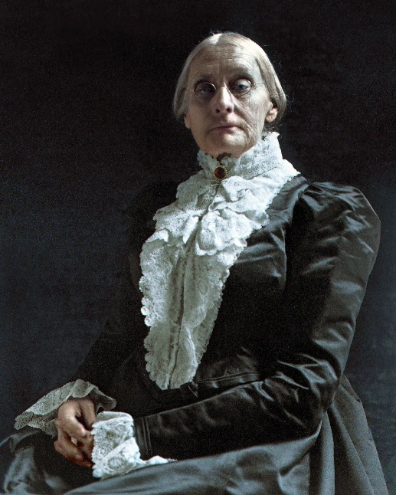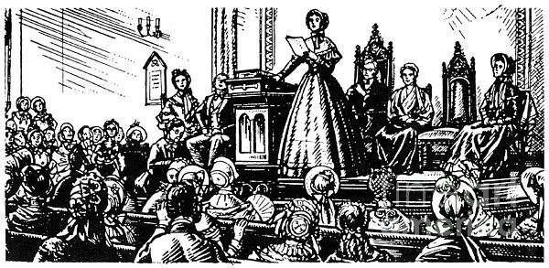
  - SUSAN B. ANTONLY and STANTON together create the National Woman Suffrage Association of 1869.
  - ANTHONY and STANTON push to make women get educated. If women are educated they are smart enough to vote.
  - Women begin to learn Latin, Geometry, and Chemistry,
  - Emma Willard started a school for daughters of lawyers in 1821 called the TROY FEMALE SEMINARY.
  - Mary Lyon created another in 1837 for women called MOUNT HOLYOKE the first college for women in America.
SECTION 4: AMERICAN LITERATURE AND ARTS
- AN AMERICAN CULTURE DEVELOPS
  - Most American writers and painters learned from EUROPEAN STYLES.
  - Washington Irving & James Fennimore Cooper developed the AMERICAN THEMES.
    - James Fennimore Cooper wrote –
      - “The Legend of Sleepy Hollow” & “Rip Van Winkle”
      - “The Last of the Mochicans”
      - Cooper created popular characters who wanted to move westward like “Bumppo”
      - Cooper helped American writing and literature become popular in Europe.
    - 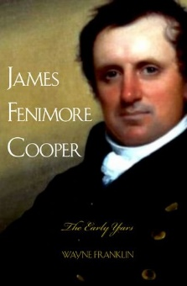
  - By early 1800’s ROMANTICISM took root in America. ROMANTICISM writers wrote about nature, emotions and imagination.
  - ROMANTICISM in America moved toward, TRANSCEDIENTALISM or a movement that sought to explore the relationship between humans and nature through emotions.
  - TRANSEDENTALISM people wanted people to seek beauty, goodness and truth in their souls.
  - 2 men were leading Transcendentalists: RALPH WALDO EMERSON & HENRY DAVID THOREAU
    - Ralph Waldo Emerson –
      - leading Transcendentalist, He had popular speeches and essays.
      - Emerson stressed Individualism or importance in every individual. “TRUST THYSELF” he taught.
      - 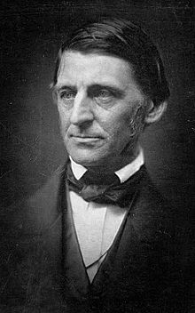
    - Henry David Thoreau –
      - Spent 2 years living in the woods to understand Emerson’s ideas. He meditated on nature.
      - Thoreau believed that individuals must judge right and wrong for themselves. He spent a night in jail for refusing to pay a tax that supported slavery.
      - Thoreau encouraged CIVIL DISOBEDIENCE or the idea that people should peacefully disobey unjust and unfair laws if they feel it.
      - 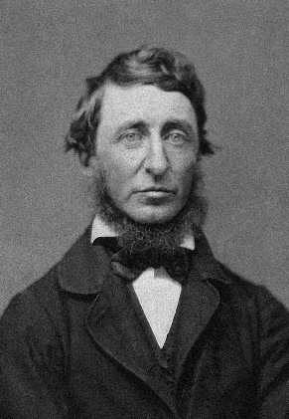
- FLOWERING OF AMERICAN LITERATURE
  - HERMAN MELVILLE AND NATHAN HAWTHORNE were fascinated wit h psychology and extreme emotions.
    - HERMAN MELVILLE
      - Created a novel called, “MOBY DICK” (1851) –
    - NATHAN HAWTHORNE
      - Created a novel called, “THE SCARLET LETTER” (1850) –
  - LOUISA MAY ALCOTT showed a new view of New England life with her growing up with 3 sisters. She wrote a novel about it.
    - Created a novel called, “Little Women” (1868)
- ART AND MUSIC
  - PAINTINGS
    - HUDSON RIVER SCHOOL – painted pictures of the Hudson River Valley
      - Thomas Cole & Caleb Bingham – painted beauty and nature, and view of the River
      - George Catlin – Painted the real life look of Native Americans and how they interact.
  - SONGS
    - Many songs pop up to the tune of “YANKEE DOODLE”
    - Most popular American songwriter in 1800’s was STEPHEN FOSTER, “Camptown Races” and “Old Folks at Home”

