Chapter 5 – The Road to Revolution 1745-1776
- SECTION 1: TROUBLE ON THE FRONTIER
1. COMPETEING EMPIRES FOR NORTH AMERICA
  - Three major powers of the world were competing or the New World in North America.
    - France –
      - They colonized the Mississippi River area, Canada and New Orleans. They called the area that they colonized, “Louisiana”
      - Their number one thing they wanted to do was establish a fur trade with the Native Americans. Fur was extremely popular and expensive in Paris, France.
      - France had a great relationship with the Native Americans because they traded guns with them for fur amongst other items that Native Americans did not have.
    - England –
      - They colonized the 13 original colonies on the Eastern coast of present-day America.
      - Their major cash crop was tabaco and cotton. Both crops England did not really have and needed it.
      - England did not have a good relationship with the Native Americans because they were invaded their lands and kept pushing them west.
    - Spain –
      - They colonized the Caribbean area called the “West Indes.”
      - They then moved into present day Mexico and into the American Southwest of Texas, New Mexico, California, Arizona, Kansas and Oklahoma.
      - Spain’s main goal at first was to find Gold but changed to try to convert Native Americans to Christianity by creating missions (churches) around the present-day American Southwest. This created bigger cities eventually on the west coast.
      - The relationship with Native Americans and Spain weakened over time because many Natives did not want to change their old ways and traditions and customs they had for religion.
- PREQUEL OF “THE FRENCH AND INDIAN WAR” (AMERICAN) OR “SEVEN YEARS WAR” (EUROPE)
  - France was colonizing and building forts in the area right next to the English colonies. They would build them between Lake Erie and the Ohio River Valley.
  - This news upset the Virginia colony there in the English Colonies. They also claimed the Ohio River Valley
  - The governor of Virginia sent soldiers to tell the French to leave the Ohio River Valley. The leader of the soldiers was 21-year-old George Washington.
  - Washington’s men were mainly militia (a military group made of civilians trained as soldiers)
  - Washington told the French to leave, but French did not listen.
  - One year later, Virginia governor ordered Washington to go back and build a fort near the Ohio River Valley. The French beat him to it, there was already a fort there called, “FORT DUQUESNE.”
  - Washington attacked and defeated a small French regiment. He then made a fort of his own called, “FORT NECESSITY”
    - Fort Necessity was a very small fort that did very little for cover. It was a bundle of sticks put together in a hurry.
    - Washington heard that the French heard about his attack and was looking for revenge. Washington was greatly outnumbered.
    - Washington was forced to surrender to the French. He was demoted because of the surrender.
  - This proved that the French would never leave the Ohio River without a fight
- THE ALBANY CONGRESS
  - With war about to possibly begin, the colonies and England called a meeting with the British Government in Albany, New York.
  - Britain wanted the colonies to cooperate in protecting them from the French and defending them, The British invited a nearby tribe as well: “The Iroquois”
    - The British and the colonies wanted the Iroquois to be their ally. However, they refused.
    - The reason for their refusal is because the French treated them great and traded with them. The British and Colonies brought them disease and took their lands.
  - The colonial leaders came up with a plan called, “ALBANY PLAN OF UNION” made by Benjamin Franklin.
    - This plan made it where each colony would send a representative and speak for their colony and stay in New York.
    - These people would oversee the following things for the colonies: creating armies, and making taxes, and trying to get Native American allies.
    - THE COLONIES TURNED IT DOWN! They wanted to control their own taxes and armies.
  - Because of turning down the Albany Plan of Union. BEN FRANKLIN created something in his newspaper THE PENNSYLVANIA GAZZETTE describing the colonies. HE DREW A PICTURE OF A SNAKE, CHOPPED UP WITH COLONIES ABREVATIONS ON IT. IT SAID, “JOIN OR DIE”
    - What Ben Franklin meant: “JOIN OR DIE”:
      - Each colony had their own currency.
      - Each colony had control of their own army.
      - Each colony had their own Native American policy.
- FRENCH AND INDIAN WAR or SEVEN YEARS WAR
  - BRITISH ATTACKS FORT DEQUESNE (FRENCH WIN)
    - After George Washington surrendered at FORT NECESSITY, the British decided to demote him under a better commander. Washington was young, and it was his first assignment.
    - He was now under the command of GENERAL EDWARD BRADDOCK in Virginia.
    - GENERAL BRADDOCK was ordered to drive the FRENCH out of the Ohio River Valley,
    - In the Ohio River Valley, the French had a fort there called, “FORT DEQUESNE”
    - Braddock’s attitude was cocky, and he had a lot of pride. He felt he would win every battle no matter what. His knowledge was military warfare in Europe, not in the colonies.
    - BRADDOCK had never fought against Native Americans before. BRADDOCK also did not respect any of his RED COAT SOLDIERS that were from the colonies.
    - The colonial soldiers & BEN FRANKLIN himself warned him of Native American tactics called, “GUERRILLA WARFARE” (HIT AND RUN, HIDE BEHIND BUSHES AND TREES). He ignored all of them.
    - BRADDOCK was ambushed by French and Native Americans on a his way to FORT DEQUESNE.
    - He lost half his men, and BRADDOCK WAS SHOT AND KILLED AS WELL!
    - The last person to surrender was George Washington. However, the French said he broke the rules of war by firing and killing a French officer. They made Washington sign a letter saying he killed the man even thought he did not do it. Washington was demoted again as his punishment and you do not hear about him again for about 20 years in History until the American Revolution.
  - MORE BRITISH DEFEATS & FIGHTING OVERSEAS , SPAIN ENTERS THE WAR
    - The British lost many other battles because the British Red Coat army was not used to fighting in colonial America.
    - In 1755 the Massachusetts Governor failed to take a FORT ONTARIO.
    - The Native Americans defeated the British at LAKE GEORGE as well. This defeat made the Iroquois decide to side with the French
    - The official beginning of the war started in 1756. Britain declared war on France in the new world.
    - The French and British were fighting not only in the colonies but also in Europe.
    - The Seven Years War is what Europe calls the “FRENCH AND INDIAN WAR”
    - SPAIN’s KING CHARLES III offered to help his French King Cousin “LOUIS XV”. So he did, however Spain does very little in the war.
  - BRITISH BEGIN TO WIN AND END WAR
    - Britain changed its “PRIME MINISTER” – (Leader of their country other than the King, more like a President) William Pitt.
    - He made sure he put Generals who were good in charge, he selected JAMES WOLFE as Britain’s top General. With Pitt in command, the war changed.
    - 1758 Britain took FORT DUQUESNE that BRADDOCK AND WASHINGTON could not. Renamed it to FORT PITT, a city was built around it, you know it now as PITTSBURGH.
    - A victory at LOUISBOURG also in 1758 led to the Iroquois requesting to join the BRITISH side not the FRENCH.
    - British General WOLFE attacked the Capital of NEW FRANCE, QUEBEC and took it down.
    - After losing QUEBEC, France could not longer defend North America and Canada. 1760 the British took MONTREAL, the other major French city.
    - BRITISH NAVY ended up capturing HAVANNA a HUGE Spanish trading area. They keep it till the end.
    - The French lost the war and signed a surrender called, “TREATY OF PARIS”
        - TREATY OF PARIS
          - Ended the French and Indian War
          - Britain got all lands EAST of MISSIPPI RIVER
          - Britain gained CANADA
          - SPAIN gave up FLORIDA to British to get back HAVANNA.
          - SPAIN got all FRENCH lands WEST of MISSISSIPPI RIVER (LOUISIANA)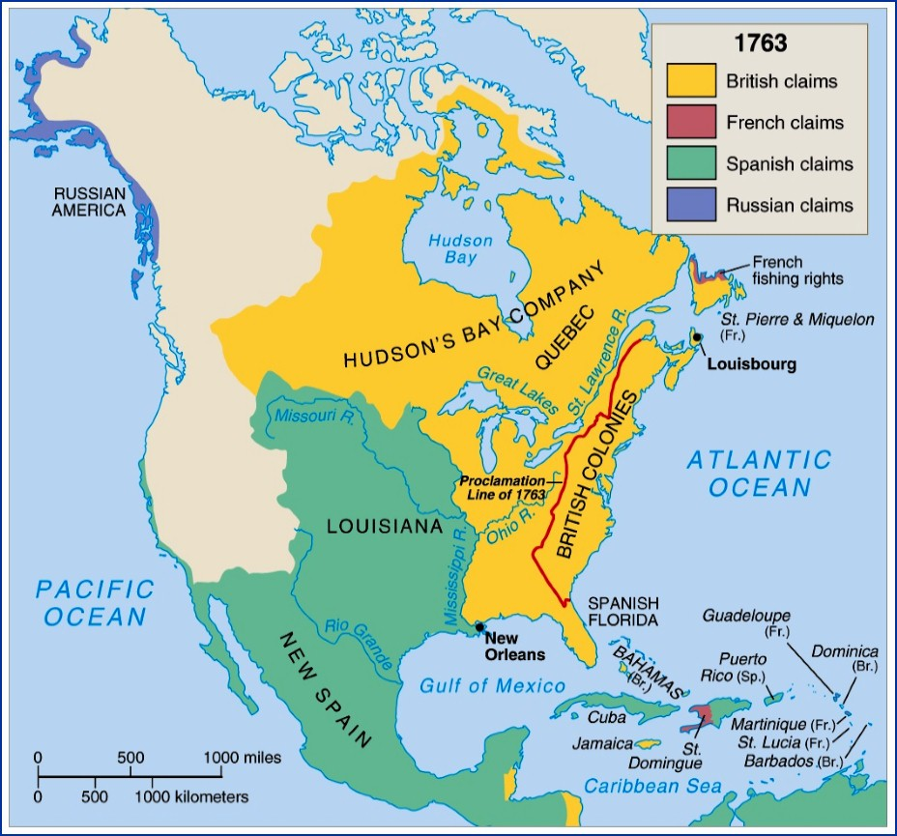

SECTION 2 : THE COLONISTS RESIST TIGHTER CONTROL
- CONFLITCT WITH NATIVE AMERICANS
  - 1763 Britain controlled most of North America EAST of MISSISSIPPI RIVER.
  - Bad thing is that the Native Americans were living in the place that used to be FRENCH lands just WEST of the APPALACHIAN MOUNTAINS.
  - The Native Americans are desperate to keep their lands and they will do whatever it takes to stop Colonials from invading their lands for farming.
  - PONTIACS WAR
    - On the last day of the French and Indian War, a OTTAWA leader named PONTIAC attacked 12 British forts. He allied with other Western Native American Tribes.
    - PONTIAC and his allies killed over 2,000 colonists. British colonists reacted killing innocent Native Americans.
    - PONTIAC was defeated by the British and the colonists in 1764.
  - PROCLOMATION OF 1763
    - Because of PONTIAC and other Natives fighting, the English King, (KING GEORGE III) PROCLAIMED that no colonists could go over an imaginary line across (APPALACHIAN MOUNTAINS)
    - King George 3rd did this to protect the colonists from Native Americans and vice versa.
    - Colonists wanted to move west with all the new land that Britain received from the FRENCH AND INDIAN WAR in the TREATY OF PARIS.
    - Colonists ignored it and still went passed the line, but it resulted in Native American’s attacking Colonists.
- BRITISH RULE LEADS TO CONFLICT
  - Colonists were proud of their effort in the FRENCH AND INDIAN WAR. They thought they contributed just as much as the BRITISH.
  - Colonists died in the war, but BRITIAN supplied the GUNS, GUN POWDER, BOATS, BOMBS, CANNONS, and UNIFORMS.
  - Because of the FRENCH AND INDIAN WAR and helping the Colonists, KING GEORGE III & BRITIAN WAS BROKE AND IN DEBT!
  - The British had to keep troops in North American Colonies to keep peace, and fight off Native Americans, and make sure FRANCE would not return.
  - Only way to get out DEBT, Tax the colonists for protecting them during the FRENCH AND INDIAN WAR.
- THE BEGINNING OF THE TAXES
  - King George III decided to tax the colonists on goods that HE KNEW the colonists had to have.
  - THE SUGAR ACT –
    - The one thing that everyone in the colonies loved was TEA! However, no one was going to drink tea without Sugar it would taste like DIRTY SMELLY FISHY POO WATER.
    - The Sugar Act is also a tax on something else the colonists loved, MOLASES. This made RUM and colonists loveeeed their RUM.
    - Because of the tax on Molasses and Sugar it made many people in the colonies began to smuggle their goods in from other places. This was highly illegal, people like JOHN HANCOCK were huge smugglers.
  - The QUARTERING ACT –
    - The word QUARTERS means your home or your Living QUARTERS.
    - Picture yourself having to let some stranger into your home, use your phone, sleep in your bed, and tell you to cook his or her food. This is what happened in the colonies and if you did not play by the rules. It was illegal!
    - The King needed a place for his soldiers to sleep, He did not want to spend money on HOTELS for them, so the colonists were FORCED to let SOLDIERS live in their houses.
    - These soldiers had to have their laundry done, feed them, Sleep in their beds, allow them baths, and treat them extremely well.
    - Sometimes soldiers would take advantage of women while living there if the man was not home.
    - King George said that this had to be done because the soldiers were protecting them from Natives and French.
  - THE STAMP ACT
    - Visualize every time you texted someone you were charged $2.00 to send or receive. This is basically what happened in the colonies in 1765.
    - Everyone in the colonies would send letters every day. Colonists wrote letters like you text your friends.
    - King George III told Parliament to tax the following things that the colonists needed to send a letter with: Newspapers, Wills, Licenses, Insurance Policies, Land Deeds, Contracts, Paper and of course … STAMPS.
    - Colonists would pay this money, but they were not happy with it. They loved to contact their loved ones that they did not live near.
    - Virginia House of Burgesses (Virginia Government) tried to enforce this law in Virginia, a man named PATRICK HENRY stood up in the meetings and said the law was not fair.
    - Many other colonies started a BOYCOTT (refusal to buy the taxed goods).
    - Colonists begin to make flags called, “DON’T TREAD ON ME” this is called the GADSEN FLAG.
    - 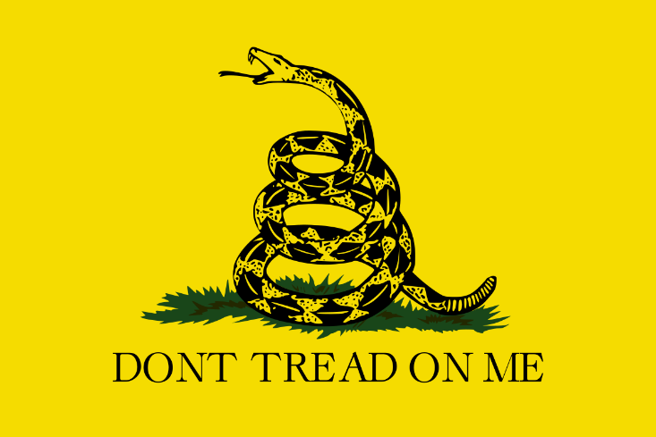
    - The colonists created a STAMP ACT CONGRESS. These people in the Congress created a petition (Request to the Government) to ask Parliament and King George to get rid of the STAMP ACT and the SUGAR ACT because they are things they love so much. The Petition and protests worked. But it was not the end.
    - 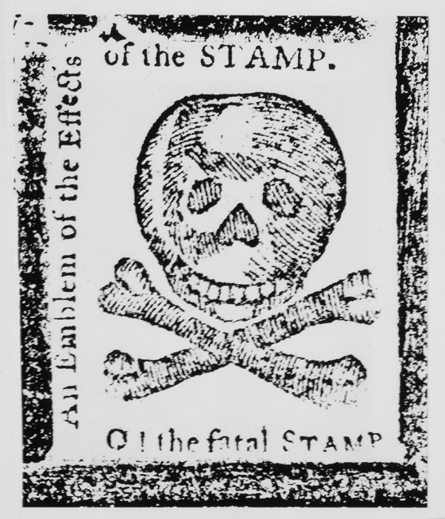
  - DECLARATORY ACT -
    - This act allowed Parliament to have total authority over the colonies. The problem was, Parliament was 3,000 miles overseas. The colonists had no one in Parliament, “TAXATION WITHOUT REPRESENATION”
  - TOWNSHEND ACTS –
    - This idea came up from a guy in England Parliament named “Charles Townshend”
    - Parliament tried taxing the colonists in a way that would not make the mad. So, they taxed goods only coming INTO the colonies.
    - Parliament would tax the following items that came in: paper, paint, lead, glass, and tea.
    - Townshend Acts also Allowed a WRIT OF ASSISTANCE (soldiers can now search homes and people without court orders or tell you what they were searching for)
  - TEA ACT –
    - 1773 the British Parliament passed a tax that would help the LARGEST company in Britain make more money. It was “BRITISH EASH INDIA COMPANY”.
      - The EAST INDIA TRADE COMPANY sold the following things from the country of India : Indian Tea, Indigo, silk, salt, opium, cotton,
    - The British East India Trade Company made some bad business deals that resulted in them about to be Bankrupt, so Britain bailed them out by making the “TEA ACT” which allowed the EAST INDIA COMPANY the access to send their tea directly to COLONIES without going to BRITAIN. Normally they would have to send Indian Tea to Britain then to the colonies.
    - Doing this made the colonials mad because they sold DUTCH TEA, by smuggling it illegally. So, colonials now were forced to buy BRITISH EAST INDIA TEA. British EAST INDIA TEA became a MONOPOLY
      - Monopoly – where someone corners a market and has total control of the price.
- BOSTON MASSACRE – EVENING OF MARCH 5, 1770
  - Colonists protested the STAMP ACT and the SUGAR ACT. They were furious about SOLDIERS living in their homes. This resulted in bloodshed for the colonists.
  - On March 5 1770, Parliament realized the BOYCOTT on goods was hurting BRITAIN merchants (TRADERS) . So, they lifted the Townshend duties except one…. TEA.
  - On the same day of March 5, 1770, a mob began to form outside “BOSTON CUSTOMS HOUSE” place where you buy STAMPS, PAPER, LEAD, INK to send letters.
  - Soldiers guarded the Customs House, the colonist began throwing things at them: snowballs with rocks in them, clubs (Small bats for beating rope), Oyster Shells, and Buckets of Feces.
  - The crowd taunted the Sentry (Group of Soldiers) yelling, “FIRE, FIRE” small children calling them, “LOBSTERS.”
  - The group fired into the crowd after a young solider by the name of, “PRIVATE HUGH MONTGOMERY” was struck with a bat to the head. Montgomery dropped his gun and it went off.
  - The rest of the soldiers fired their weapons as well.
  - RESULT – 6 Colonists wounded, 5 Dead, 1 of the Dead African American “CRISPUS ATTUCKS”
  - Two men witnessed the account, “SAMUEL ADAMS & PAUL REVERE”
    - SAMUEL ADAMS – Owner of a pub (bar) in Boston and the cousin of JOHN ADAMS (2nd President of the United States) (1st Ever Vice President)
    - LEADER AND CREATED THE “SONS OF LIBERTY”
      - Group that pushed the beginnings of the American Revolution
      - 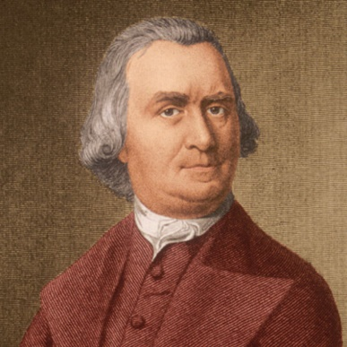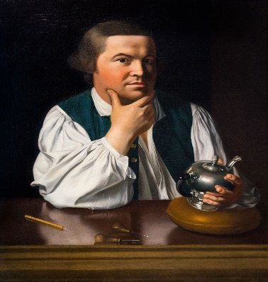
    - PAUL REVERE – Owned his own Silversmith shop and was a casual dentist. He was also a semi-artist.
      - He was a member of the SONS OF LIBERTY
      - Drew the famous picture of SOLDIERS shooting into a crowd the next morning in a newspaper publishing that went VIRAL!
  - 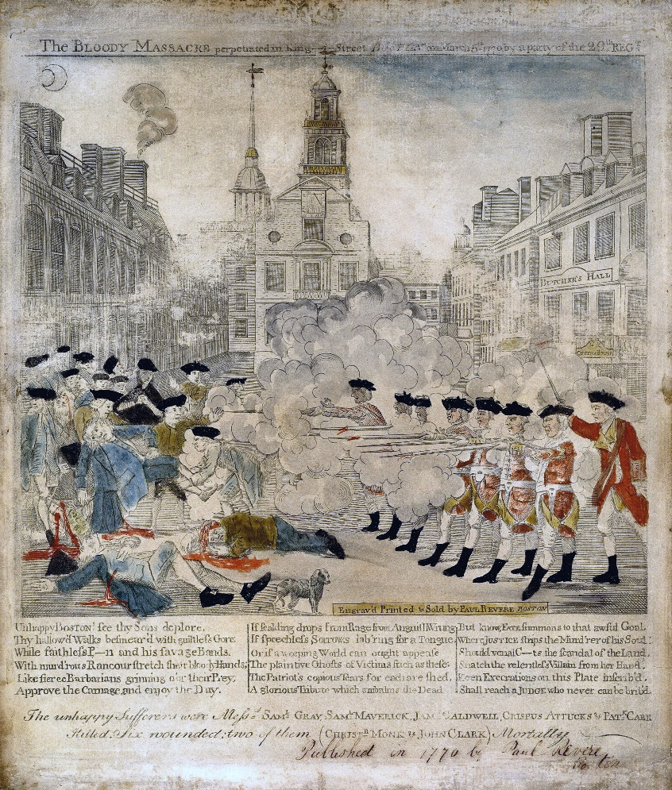
- BOSTON MASSACRE TRIAL
  - As a result of the soldiers firing into the crowd and killing 5 but wounding 6, Boston Governor Thomas Hutchinson arrested the 9 soldiers mainly to make the colonists happy.
  - No one in the colonies would be the lawyer for the soldiers, one man decided just to listen to them. His name was John Adams, he becomes their lawyer after seeing a gash above Private Hugh Montgomery’s eye where he was hit with a bat and was knocked to the ground.
  - The Captain of the soldiers was Thomas Preston, he told the soldiers “DON’T FIRE MEN”
  - Multiple eye witnesses said that Captain Preston was in front of the men. But, many of the SONS of LIBERTY said he was behind yelling FIRE FIRE FIRE. It came out to be not true.
  - John Adams won the case for the soldiers and proved that they were defending themselves against colonial attacks.
  - Only two soldiers were convicted (GUILTY) and their only punishment was to have their thumbs branded
  - 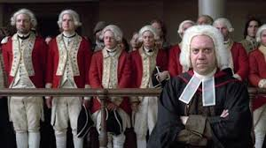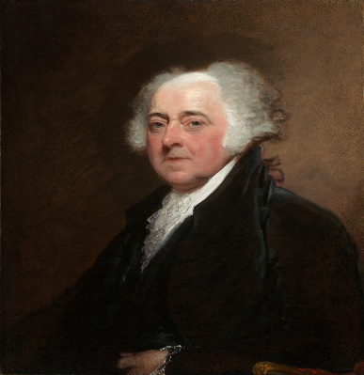
  - As a result of John Adams winning the case, EVERYONE hated him in the colonies, and no one would ask him to be his lawyer. His own Cousin, SAMUEL ADAMS even does not talk to him.
- COMMITTEES OF CORRESPONDENCE
  - After the Boston Massacre, leader of the SONS of LIBERTY “SAMUEL ADAMS” created a group that informed everyone in the 13 colonies about what was going on in Boston. It started in Boston and spread to other colonies because Colonists did not like the taxes, and the killings.
  - They wrote letters to each other and published pamphlets.
SECTION 3 – FROM PROTEST TO REBELLION
- BOSTON TEA PARTY – DECEMBER 16 1773
  - Soon after the Committees of Correspondence was made, SAMUEL ADAMS group “SONS OF LIBERTY” grew large! They begin meeting in his pub basement called a cellar.
  - The Sons of Liberty did not like the British East India Tea Company putting a high price on Tea, so they decided to create an event to prevent them from coming to Boston.
  - The Sons of Liberty decided they would dress up like MOHAWK Indians go to Boston Harbor and start to scare and threaten people (Merchants) who wanted to buy British East India Tea.
  - One man was tarred and feathered and poured scolding hot tea down his throat because he was a tax collector for Britain Tea.
  - The Sons of Liberty also threatened ship captains carrying the ships, many of them did not even land in other colonies like New York, Philadelphia, in fear that they would be tarred and feathered or stolen from.
  - Governor Hutchinson demanded that the team arriving in Boston to be unloaded. The Sons of Liberty dressed as the MOHWAK Indians boarded the boats and dumped 342 cases of tea into Boston Harbor! Destroying 90,000 pounds worth of tea. This was worth thousands of dollars. Calling this the Boston Tea Party.
  - 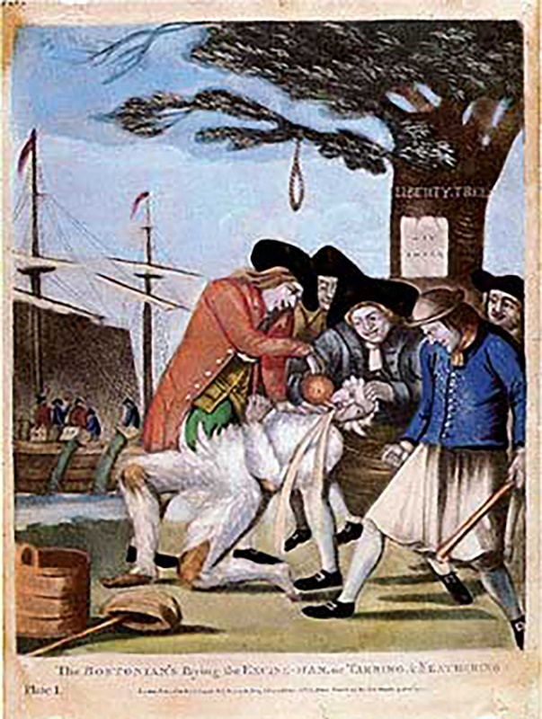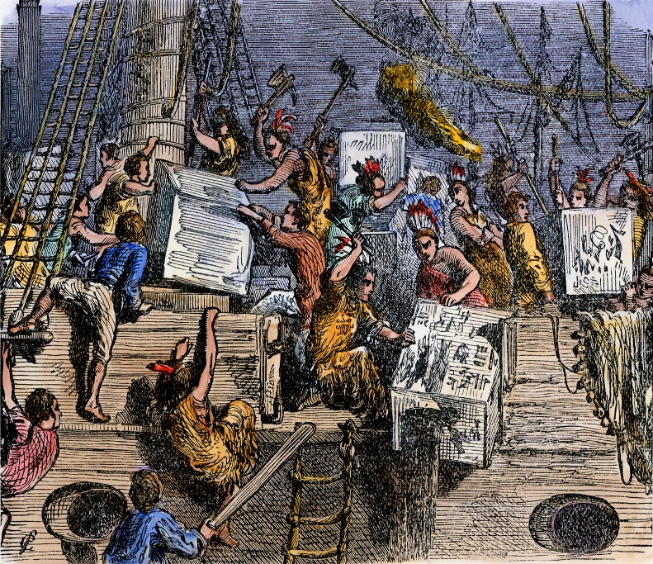
  - 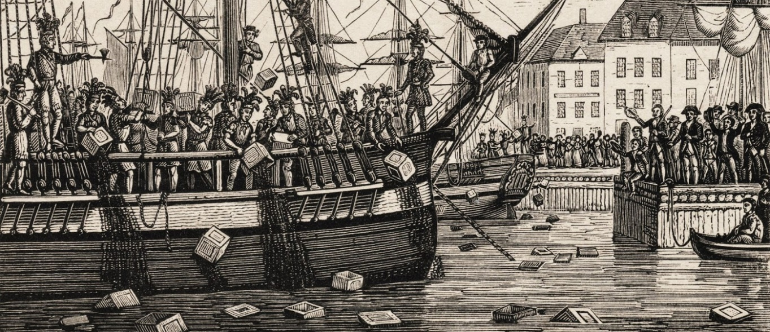
- RESULT OF THE BOSTON TEA PARTY
“THE INTOLLERABLE ACTS” (COLONISTS) AKA “COERCIVE ACTS” (BRITAIN)
  - The Boston Tea Party made the King and Parliament very angry. King George III decided to punish the colonists of Boston with 5 new laws for their actions. The laws are called the “INTOLLERABLE ACTS” because the colonists could barley “tolerate” them. He asked the new MASSACHUSETTS GOVERNOR THOMAS GAGE TO ENFORCE THEM.
    - Intolerable Act #1 - “BOSTON PORT ACT”
      - King George III shut down and closed Boston Harbor, nothing came in or out of it until the colonists paid for the dumped tea.
          - 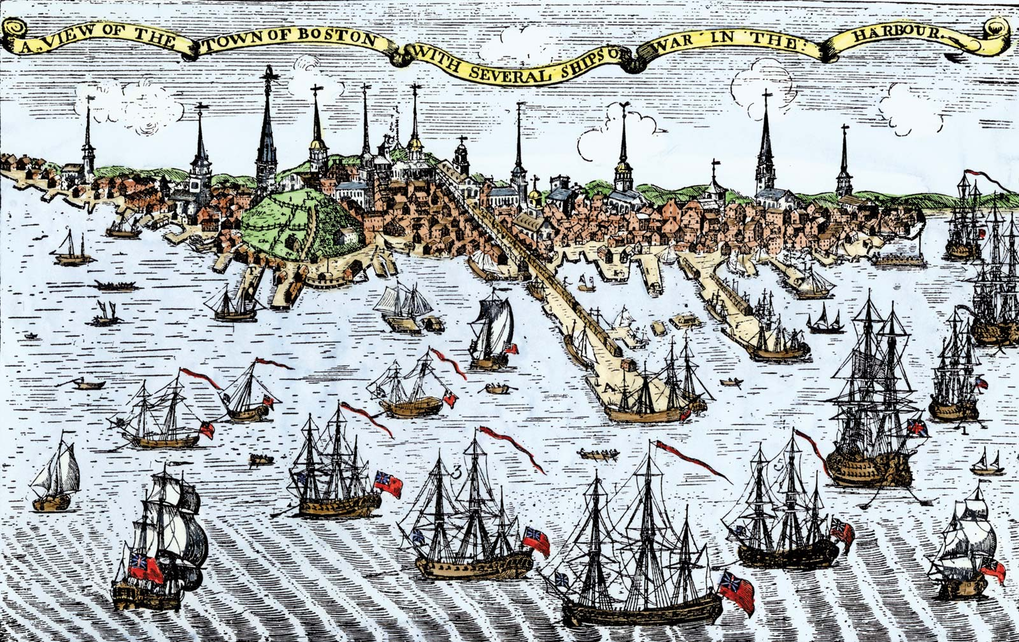
    - Intolerable Act #2 – “MASSACHUSETTS GOVERNMENT ACT”
      - This act changed the government of the colony of Massachusetts. It gave more power to the governor (who was appointed by Great Britain) and took away power from the colonists. Many of the government officials that used to be elected by the people would now be appointed by the governor. The act also said that only one town meeting a year could be held.
    - Intolerable Act #3 – “ADMINISTRATION OF JUSTICE ACT”
      - This act allowed the governor to move trials against government officials to Great Britain. The colonists felt that this act gave too much protection to government officials. Witnesses would have to travel all the way to Britain to testify against an official, making it nearly impossible to convict. Some colonists called this the "Murder Act" as they thought it would allow officials to get away with murder.
    - Intolerable Act #4 – “QUARTERING ACT”
      - This act expanded upon the original Quartering Act of 1765. It said that the colonies had to provide barracks for British soldiers. In the case where barracks weren't available, the soldiers could be housed in other buildings such as barns, hotels, and homes.
    - Intolerable Act #5 – “QUEBEC ACT”
      - The Quebec Act expanded the British Canadian territory south into the Ohio Valley. It also made the Quebec Province a Catholic province. This angered colonists who wanted to move into that area. Now they cannot move west.
- RESULT OF THE INTOLERABLE ACTS – “FIRST CONTINENTAL CONGRESS” OCTOBER 24, 1774
  - Some Historians say that the Intolerable Acts began to unite the colonies. Many of the other 12 colonies began giving food and supplies to the colony of Massachusetts.
  - The colonies decided to come together on what to do next, they called it the “FIRST CONTINETNAL CONGRESS”
    - This meeting took place in Philadelphia at a place called CARPENTERS HALL where 12 out of 13 colonies sent delegates (representatives) Georgia did not send.
  - LIST OF FIRST CONTINENTAL CONGRESS DELEGATES
New Hampshire: | John Sullivan, Nathaniel Folsom
Massachusetts Bay: | John Adams, Samuel Adams, Thomas Cushing, Robert Treat Paine
Rhode Island: | Stephen Hopkins, Samuel Ward
Connecticut: | Eliphalet Dyer, Roger Sherman, Silas Deane
New York: | Isaac Low, John Alsop, John Jay, Philip Livingston, James Duane, William Floyd, Henry Wisner, Simon Boerum
New Jersey: | James Kinsey, William Livingston, Stephen Crane, Richard Smith, John De Hart
Pennsylvania: | Joseph Galloway, John Dickinson, Charles Humphreys, Thomas Miffin, Edward Biddle, John Morton, George Ross
Delaware: | Caesar Rodney, Thomas McKean, George Read
Maryland: | Matthew Tilghman, Thomas Johnson, William Paca, Samuel Chase, Robert Goldsborough
Virginia: | Peyton Randolph, Richard Henry Lee, George Washington, Patrick Henry, Richard Bland, Benjamin Harrison, Edmund Pendleton
North Carolina: | William Hooper, Joseph Hewes, Richard Caswell
South Carolina: | Henry Middleton, Thomas Lynch, Jr., Christopher Gadsden, John Rutledge, Edward Rutledge
  - First Continental Congress Delegates from Massachusetts tried to declare Independence. But, all the other colonies just asked England to get rid of the Intolerable Acts. The British would not budge though.

- SHOT HEARD ROUND THE WORLD “BATTLE OF LEXINGTON AND CONCORD”
  - PREVIEW OF THE FIRST BATTLE OF THE AMERICAN REVOULTION
  - THE MAN WHO FINANCED THE REVOLUTION - JOHN HANCOCK
  - 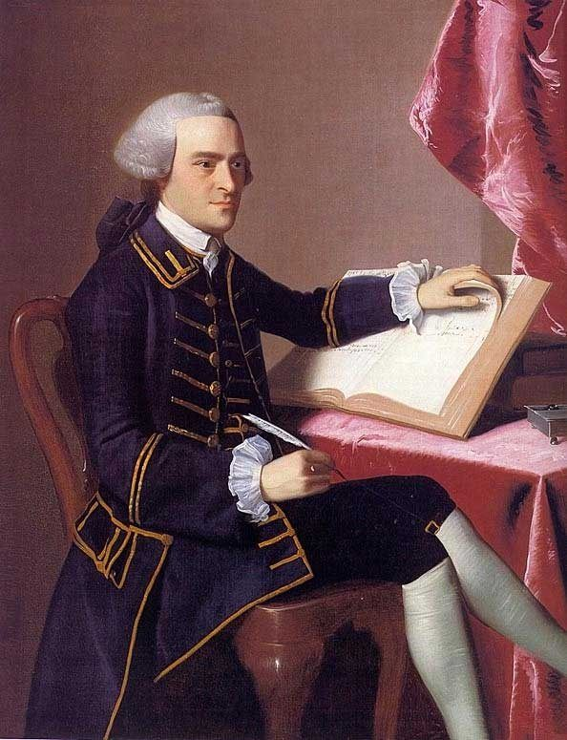
    - One thing that most do not know is that there was a REALLY RICH man in the colonies who was also elected as a Governor of Massachusetts was JOHN HANCOCK. He was a graduate of HARVARD and inherited his Uncles wealth. JOHN HANCOCK always had lots of paperwork in his business transactions. He sold and traded goods on a regular basis to make his money.
    - When taxes hit hard like the STAMP ACT, JOHN HANCOCK began finding ways to save money sometimes by evading the BRITISH taxes and not paying fees (smuggling). The BRITISH called him out on this when his ship “THE LIBERTY” pulled up to BOSTON HARBOR. They called him a cheat.
    - When the new BRITISH GOVERNOR comes “THOMAS GAGE”, he creates the INTOLLERABLE ACTS. HANCOCK did not like the BRITISH not letting him and the Colonies hold meetings.
    - JOHN HANCOCK also was not happy about how BRITAIN handled the BOSTON MASSACRE; he became vocal about it.
    - Shortly after THOMAS GAGE arrived in BOSTON, he removed JOHN HANCOCK from his GOVERNOR POSITION in Boston.
    - JOHN HANCOCK then reached out to leader of the SONS OF LIBERTY, SAMUEL ADAMS. Asked what he needed to do to help him have an idea to fight back against the BRITISH.
      - Samuel Adams said this, “We need money, we have men to fight at minutes notice.”
        - MINUTEMEN – Citizens willing to fight at MINUTES notice. (MILITIA)
        - MILITIA – Volunteers in a army that are normally not as trained as regular soldiers.
      - JOHN HANCOCK gave money to Samuel Adams to buy guns, cannons, gunpowder, bullets, and bombs. Enough for a small army!
      - The Problem was they had no place to store ALL THESE WEAPONS… John Hancock said, “I have a old house out at LEXINGTON perfect to store them!”
(Lexington is like 20 Miles outside of BOSTON).
    - 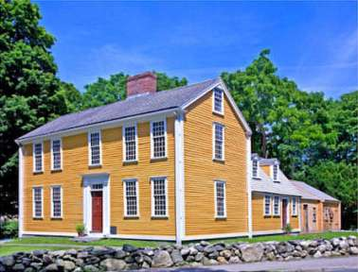
    - They needed a plan to make sure the guns were safe in LEXINGTON, so they came up with an idea to make it where a signal would be made if the SOLIDERS were planning to do something.
    - Their plan was made by Dr. JOSEPH WARREN, he made it where two colonists would hang a light in the OLD NORTH CHURCH, If there was one light, then they BRITISH were marching on land, if there were two lit, then they would be coming by sea. This also told two other men to ride off and warn the people of LEXINGTON to hide the guns or move them to a different location. The two men were PAUL REVERE and WILIAM DAWES.
      - PAUL REVERE – famous for being the first one to arrive at LEXINGTON alerting everyone that they BRITISH are coming. However, he was captured and arrested and then let go by the soldiers. During the war Paul Revere served American by printing Americas first money. He also was the lead man in the BOSTON TEA PARTY. After the war he created his own hardware store and copper mill. The Navy used his copper to put large sheets of copper under their boats. He died at age 83 of natural causes
      - WILLIAM DAWES – He as a leather tanner and lived outside of Boston so he was not very well known by the BRITISH. He did not get captured but was thrown from his horse and injured where he hobbled back to LEXINGTON on foot. During the war he served as a QUARTERMASTER (Ship navigation and uniform making) in the Navy. After the war he lived a quiet life dying peacefully at age 53.
        - 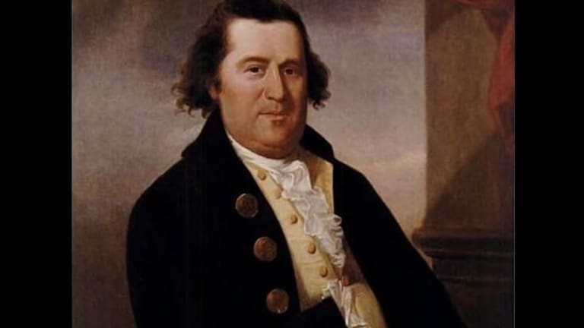
      - SAMUEL PRESCOTT – Met up with Dawes and Revere on the way to LEXINGTON. He was the man who single handedly made it to CONCORD without being caught. If he would not have made it others would not be alarmed and ready for combat. Many HISTORIANS credit his ride the most important of the three rides. Little is known after this event about PRESCOTT. Many say that he served as a doctor in the American Revolution and was eventually captured and put on a prison ship where he died there.
      - 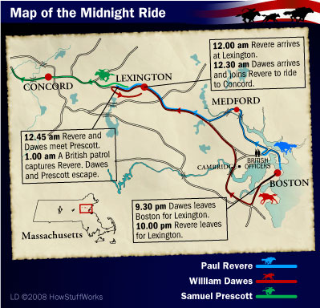
      - GOV. THOMAS GAGE learned of the Stockpile of weapons and ordered a unit of 700 men to go and disarm them and avoid a fight. The soldiers began to MARCH FROM BOSTON 20 miles to LEXINGTON.
      - SKIRMISH @ LEXINGTON -
        - When arriving at LEXINGTON in early morning, The soldiers noticed they were about to go toe to toe with 77 COLONIAL MINUTEMEN. These men came storming out of Buckman Tavern.
        - Captain JOHN PARKER who was dying of tuberculosis commanded the MINUTEMEN. He was a veteran of the FRENCH AND INIAN WAR to stand out in the open without cover fire, he yelled the words as the soldiers approached, “STAND YOUR GROUND MEN, DON’T FIRE UNLESS FIRED UPON, BUT IF THEY MEAN TO HAVE A WAR LET IT BEGIN HERE!”
        - Today we do not know who fired the first shot, but there are two sides of the story. This was not the SHOT HEARD ROUND THE WORLD THOUGH. A shot fired and everyone began firing this was a small fight, where many of the MINUTEMEN dispersed. The Soldiers could not find the guns because they had already been relocated to the town of CONCORD 5 miles away from LEXINGTON. This was because of PAUL REVERE’s warning that they were coming.
        - 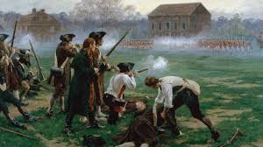
        - When the smoke cleared 8 MINUTEMEN lay dead and 9 wounded, only one BRITISH REDCOAT SOLIDER was injured.
        - The British REDCOAT soldiers rounded up what little guns they had and burned them to the ground, True story the fire that they made got out of control and burned some of the town of LEXINGTON, the smoke and fires was so high it could be seen from CONCORD forcing some MINIUTEMEN to begin moving toward LEXINGTON.
          - BATTLE OF CONCORD (SHOT HEARD ROUND THE WORLD)
        - They both met an area just outside the city of CONCORD called, “CONCORDS NORTH BRIDGE” This is where British fired upon the MINUTEMEN and the colonials answered with 400 men shooting at 700 soldiers. This was the “SHOT HEARD ROUND THE WORLD”
        - 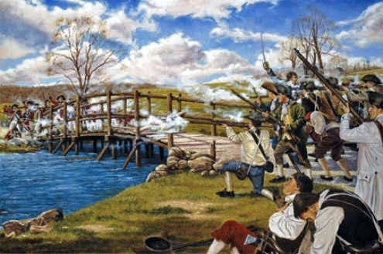
        - The soldiers eventually overtake the MINUTEMEN and finding little guns and weapons they decided to return the BOSTON on the 20-mile journey back.
          - ROAD BACK TO BOSTON – BLOODSHED
        - The 20 mile journey for the soldiers back to BOSTON was the worst of the entire battle. They were carrying wounded, and relaxing on the journey. They did not know what they were about to face.
        - The MINUTEMN from CONCORD were hiding behind trees firing at the soldiers but hitting little. They continued to follow them down their road a few miles where MORE MINUTEMEN SHOWED UP!
        - 2,000 MINUTEMEN from around the 20 mile area had grabbed their guns and began to start shoot at soldiers. They began chasing them 5 miles down the road until they reached MORE REDCOAT SOLIDER reinforcements.
        - 4,000 colonists fired on them from houses, behind fences, and trees. 300 soldiers were killed.
        - Eventually the soldiers get back to Boston but with casualties and wounded and now, THE AMERICAN REVOLUTION IS ABOUT TO BEGIN.
        - 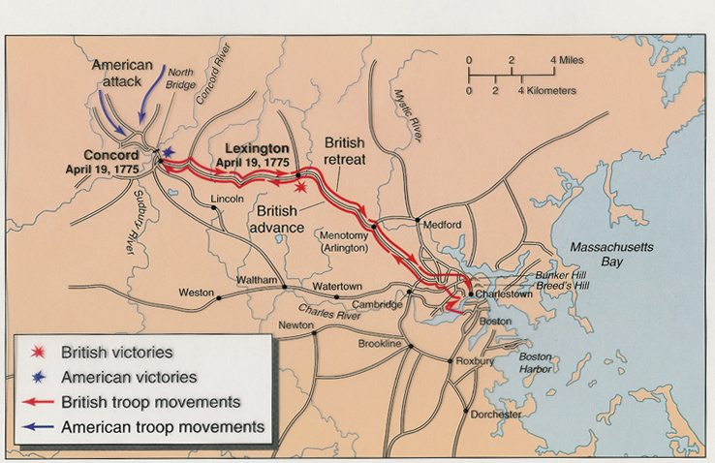

SECTION 4: THE WAR BEGINS
- SECOND CONTINENTAL CONGRESS
  - After the Battle of Lexington and Concord many of the 13 colonies remained loyal to the King, they were called “LOYALISTS”
    - Loyalists were usually large land owners and merchants that worked with Britain.
    - Many African Americans sided with the British to try to earn their freedom.
  - Those who pushed for Independence mainly the colony of MASSACHUSETTS. These kids were called, “PATRIOTS”
  - The colonies knew there was a crisis going on after the Battle of Lexington and Concord, so they called for a ALL colony meeting in PHILIDALPHIA in May of 1776.
  - The delegates included: Thomas Jefferson, John Hancock, and Ben Franklin.
  - Everyone agreed that they needed an ARMY for a just in case purpose. So, they created one making GEORGE WASHINGTON their General. They called this the “CONTINENTAL ARMY.”
  - 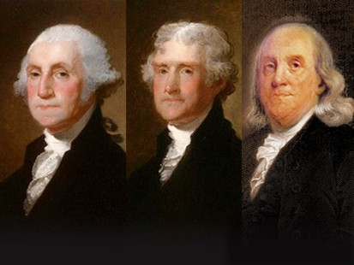
  - JOHN HANCOCK offered to also making paper money during this meeting.
  - OLIVE BRANCH PETITION
    - During the Second Continental Congress, the majority of the 13 colonies DID NOT vote on Independence. Instead they voted to try and send a letter to the King saying they wanted peace and to apologize for the Battle of Lexington and Concord.
    - This letter sent to the king asking for forgiveness was called the “OLIVE BRANCH PETITION”
    - For 6 months the 13 colonies waited on a response with, “THE COLONIES WERE IN OPEN REBELLION” and King George III sent 20,000 troops to the colonies.
- BATTLE OF FORT TICONDEROGA
  - On the same day as the 2nd CONTINENTAL CONGRESS, General George Washington was short on supplies because the CONTINENTAL CONGRESS did not have the money to finance them.
  - GEORGE WASHINGTON selected a man from VERMONT named ETHAN ALLEN. ALLEN was the leader of a group of 83 MILIIA called, “GREEN MOUNTAIN BOYS” They were great fighters but not well trained.
  - ETHAN ALLEN with the help of BENEDICT ARNOLD AND HENRY KNOX was told to attack FORT TICONDEROGA because of the following things:
    - It had great strategic positioning in Northern New York on the border of CANADA
    - It had some of the greatest cannons in the colonies there that GEORGE WASHINGTON needed for the war. The 2 largest cannons they carried from NEW YORK to BOSTON were called, “FREEDOM” and “INDEPENDENCE”
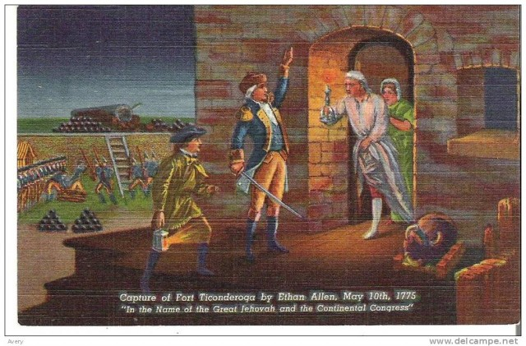
  - 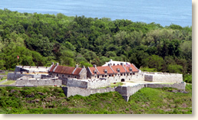
  - Ethan Allen’s plan was to take the fort in the middle of the night, he and his 83 MILITIA went up to the front gate where he saw a sleeping guard, knocked him clean out. They then began going to small areas where troops slept called BUNKERS. One by one every soldiers surrendered
  - The picture above shows ETHAN ALLEN knocking on the door of the commander of FORT TICONDEROGA. His wife or mistress was with him in their pajamas where he ordered the surrender of the fort. ETHAN ALLEN took the fort without a shot being fired. ETHAN ALLEN SAID , ". . . the Captain came immediately to the door, with his breeches in his hand, when I ordered him to deliver me the fort instantly."
  - HENRY KNOX – This man was in charge of artillery for the entire CONTINENTAL ARMY. His job was to deliver these cannons from FORT TICONDEROGA GEORGE WASHINGTON to fight with. 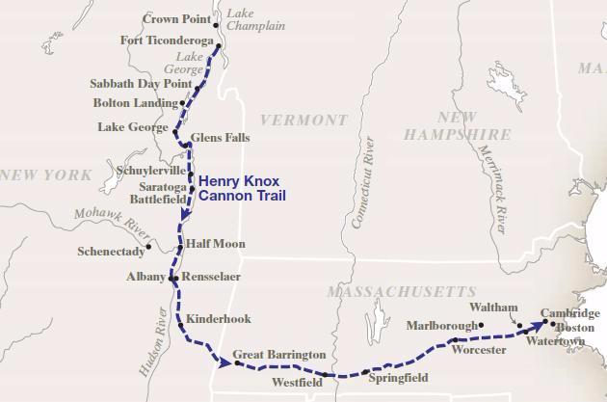to
3 . OTHER EARLY BATTLES
- In May of 1775, thousands of troops show up in Boston for the BRITISH INCLUDING GENERAL HENRY CLINTON, A MEAN GENERAL. Some of the generals included the best GENERALS that BRITISH had to offer and were ruthless:
- MAJOR GENERALS OF BRITISH
  - General Thomas Gage
    - GOV. OF MASSACHUSETTS & 2nd in COMMAND UNTIL 1775, THEN BACK TO ENGLAND
  - General William Howe
    - REPLACED GAGE NEW 2nd in COMMAND UNTIL RESIGNATION IN 1778
  - General Henry Clinton
    - ARRIVED in 1778 AS THE TOP PERSON IN CHARGE, BROUGHT 20,000 Troops
    - Was in Charge of turning BENEDICT ARNOLD to the BRITISH SIDE
    - Made NEW YORK the BRITISH BASE
    - 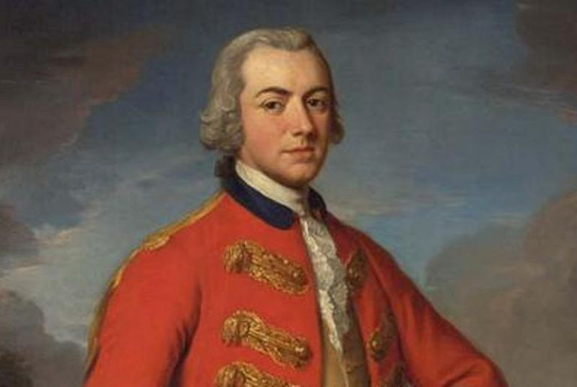
- OTHER NOTABLE BRITISH GENERALS
  - GENERAL JOHN BURGOYNE
    - Lost at the Battle of Saratoga to the Americans, It was the turning point in the war.
    - He also was in charge of taking and gaining control of the Hudson River
  - GENERAL CHARLES CORNWALLIS
    - The most famous British General in the American Revolution.
    - Served directly under HOWE and CLINTON in New York and Philadelphia
    - Ordered to take out the Southern Colonies with the surrender at Charlestown
    - Lost the last major Battle of the American Revolution at the Battle of Yorktown
- BATTLE OF BUNKER HILL AKA BREEDS HILL
  - With the British General Henry Clinton arriving with 20,000 men. Boston was now under siege. The people of Boston were ready to defend themselves with MILITIA and MINUTEMEN, but there was only one problem. Supplies were limited.
  - British camped about 7,000 men in the city of Boston, of these about 1,600 were camped at a nearby HILL called BREEDS HILL.
  - This HILL overlooked the city of Boston and was a great strategic point. The Americans felt they could take it and keep it. The Americans arrived at BREEDS HILL before the BRITISH!
  - GENERAL WILIAM HOWE ordered his men to re-take the HILL, THE BATTLE OF BUNKER HILL BEGAN.
  - ISRALE PUTNUM – This was the man who became the leader of the Americans at BUNKER HILL (BREEDS HILL)
  - 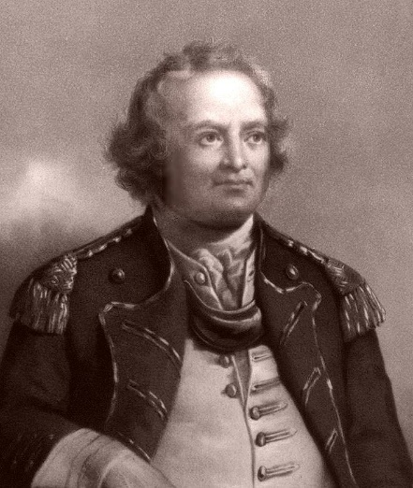
    - PUTNAM knew the Americans were short on one major thing. Gunpowder! So, he ordered the Americans not to fire until the British got really close to make every shot count!
    - “DON’T FIRE MEN, DON’T FIRE UNTIL YOU SEE THE WHITE IN THEIR EYES” – ISRAEL PUTNAM
    - The British marched up BUNKER BREEDS HILL 2 times, the AMERICANS won both! The 3rd time, they ran out of Gunpowder and the British won the battle. The Americans retreated.
  - WHY IS THIS IMPORTANT? – This proved that Americans could stand toe to toe with British Redcoat forces
  - 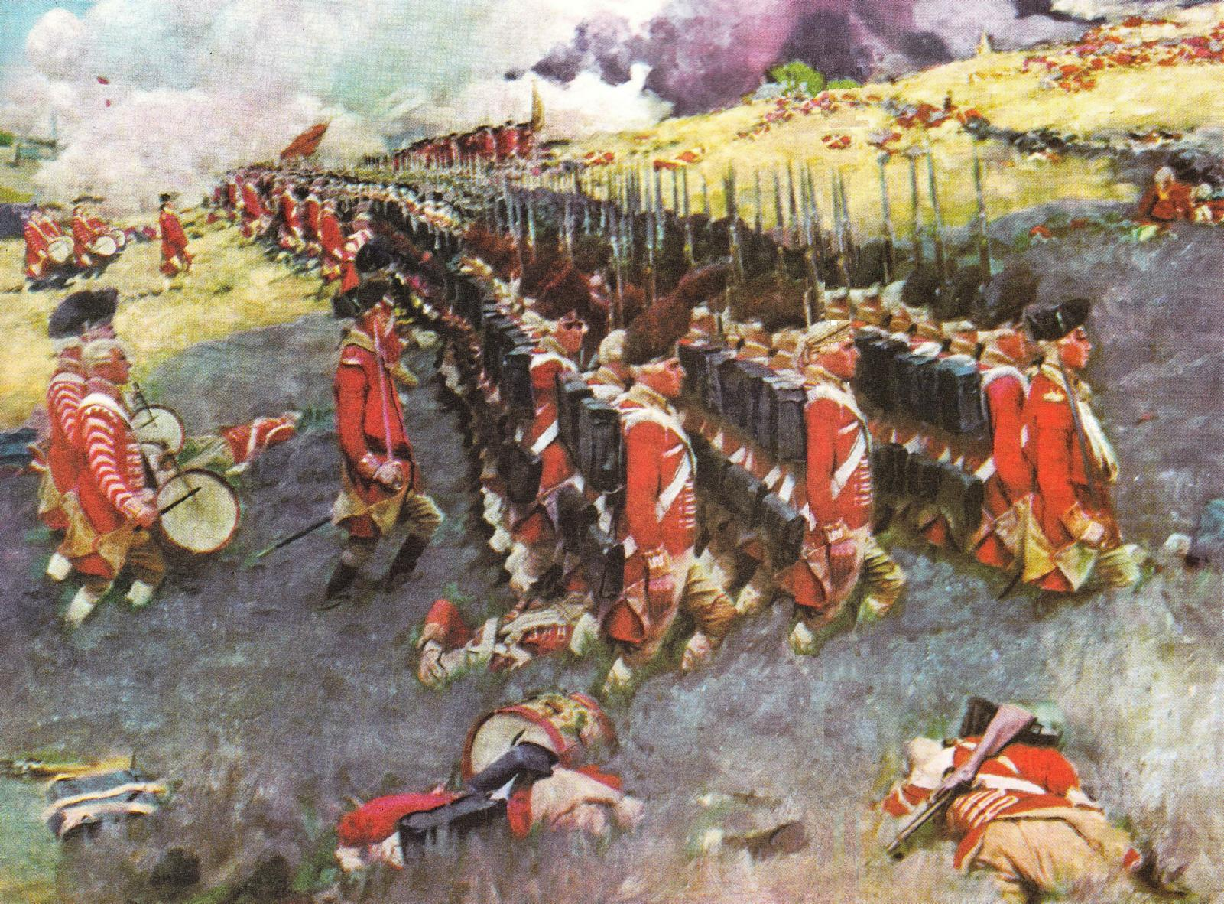
  - 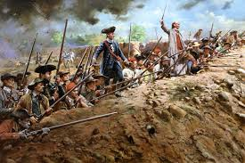
  - 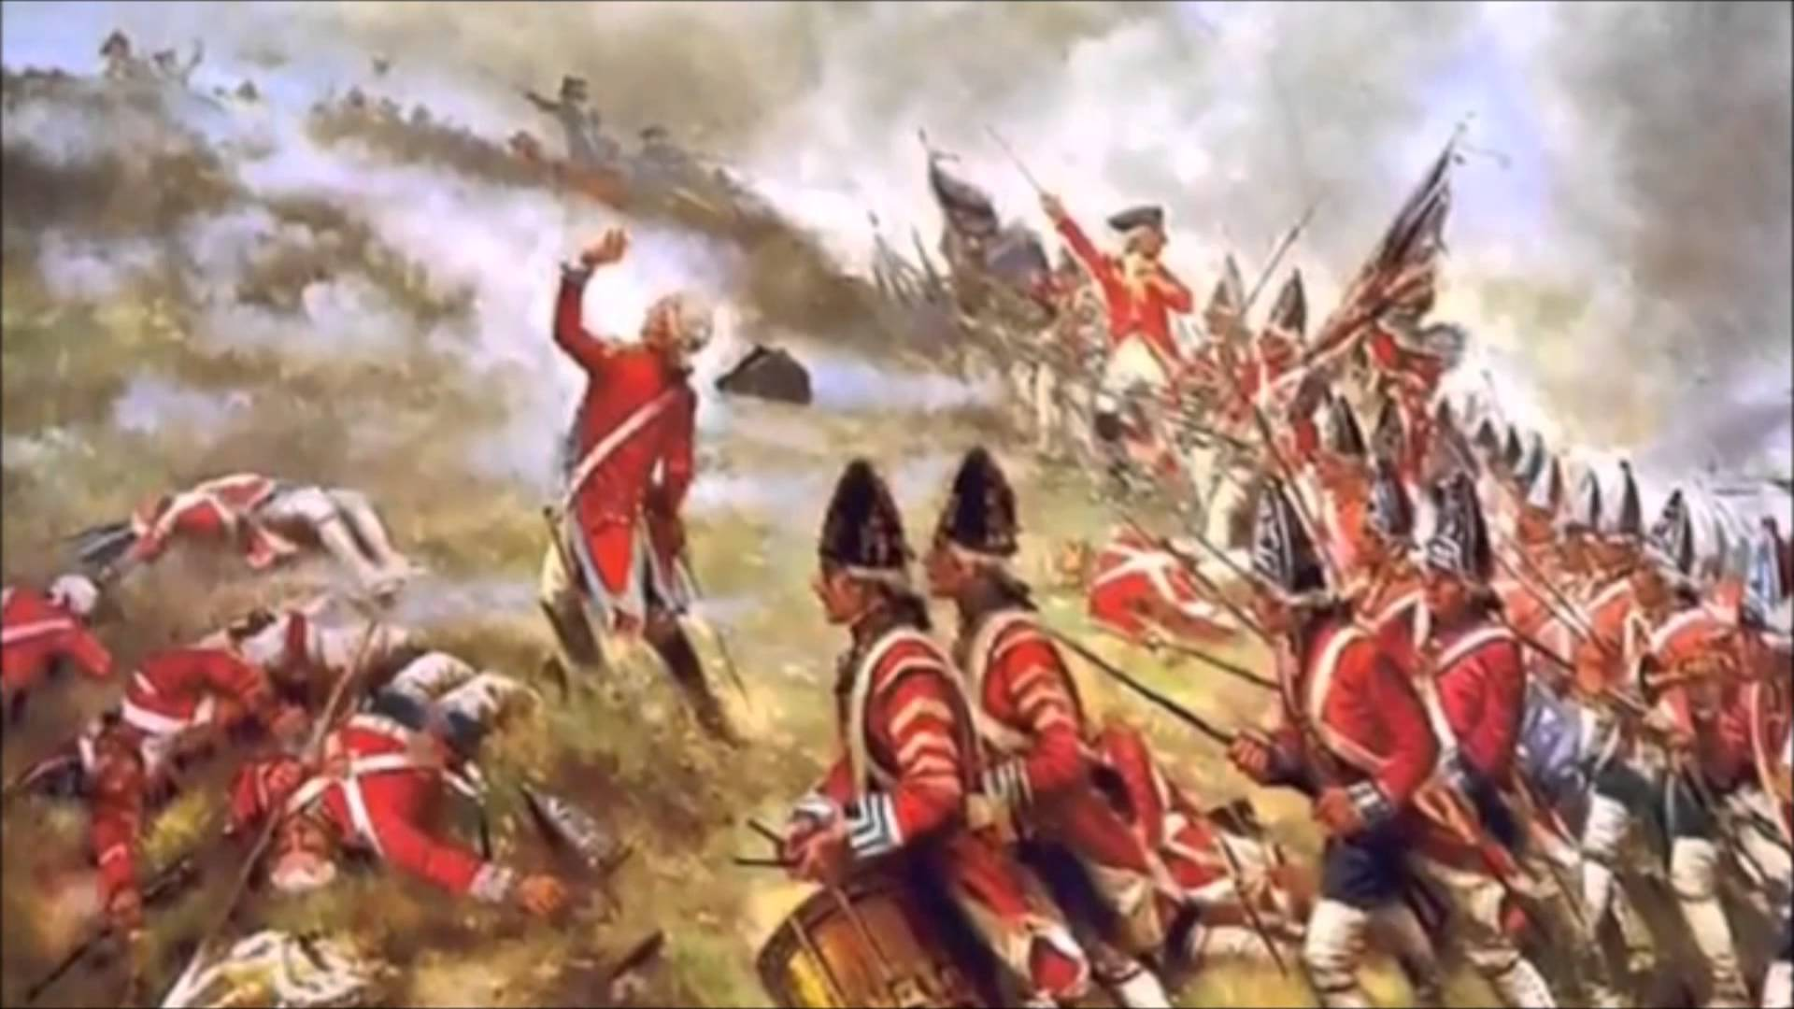
  - Boston was taken by British forces, but thousands of Americans were around Boston. George Washington arrived in Boston with the cannons that he got from HENRY KNOX and ETHAN ALLEN at Fort Ticonderoga. He used them to RETAKE BOSTON. WASHINGTON put cannons on a high hill and fired.
  - The BRITISH never re-take Boston. They moved to New York, New Jersey, and Philadelphia.
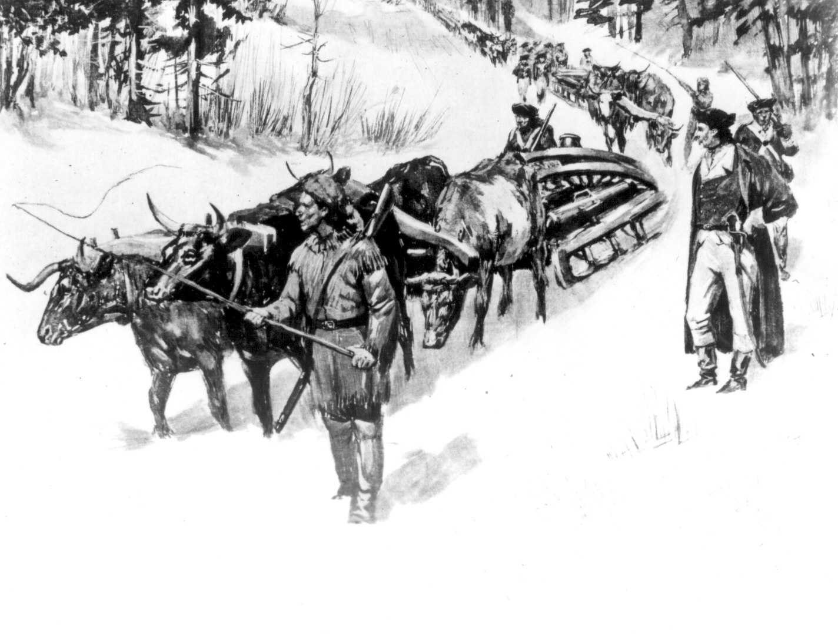
  - Washington won the Battle of Boston; however, he knew FIGHTING was far from over. BRITAIN still had these advantages over the Americans:
    - BRITISH had more fire power: guns, ammo, gunpowder.
    - BRITISH had a superior NAVY one of the best in the world.
    - BRITISH had better GENERALS with smarter tactics.
    - BRITISH blocked BOSTON harbor from anything going in and out of the Harbor.
    - BRITISH hired MERCENARIES (German Hessians) to fight for them. Hired Soldiers
  - QUEBEC INVASION WENT WRONG
    - Washington begins training his army outside of Boston to get them ready for combat. Most of them were volunteers or MILITIA.
    - Another army was moving North to CANADA led by RICHARD MONTGOMERY, Another led by BENEDICT ARNOLD moving north through MAINE.
        - BENEDICT ARNOLDS men had little supplies, they were eating candles, wood bark and shoe leather for food.
        - ARNOLD was not happy that he was not getting the supplies needed, he thought he was the best commander in the army.
    - These 2 wanted to take and invade QUEBEC, a major city for the British.
    - When reaching QUEBEC, the Americans were beat big time. Not to mention they attacked in a huge snowstorm. MONTGOMERY was killed and BENEDICT ARNOLD was shot in the leg. The Americans retreated leaving CANADA to the British

