Chapter 6 : The American Revolution
SECTION 1 : A Nation Declares Independence
- A CALL FOR INDEPENDENCE
  - PATRIOTS – this is a person who wants independence and break away from British completely. At first only 1/3rd of the CONTINENTAL CONGRESS wanted independence.
  - LOYALISTS – People loyal to Great Britain, were scared that if they joined the REBEL side than they would lose their lands and rights.
- THOMAS PAINE’S “COMMON SENSE”
  - This was a 50-page small pamphlet made in Philadelphia. It laid out WHY the colonists should be independent. Thomas Paine was the writer and he called KING GEORGE III, “A ROYAL BRUTE”
  - This pamphlet sold 500,000 copies! Made Thomas Paine wanted to be arrested. It was so powerful that GEORGE WASHINGTON carried a copy in his coat during the war.
  - 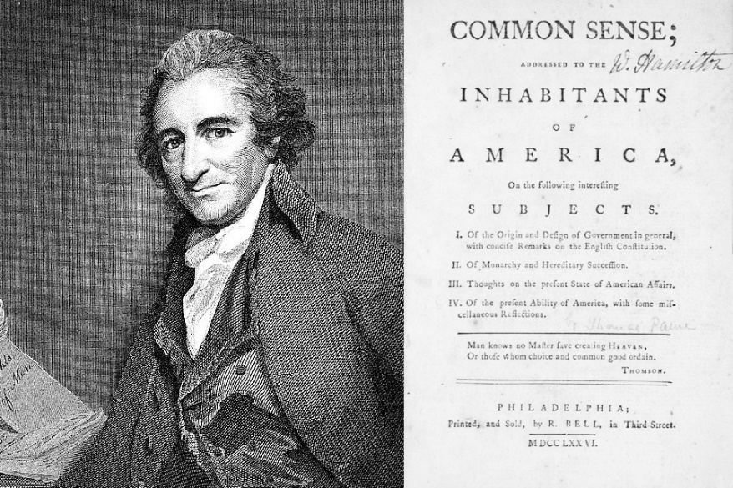
- VIRGINIA RESOLUTION – RICHARD HENRY LEE
  - After Paine’s Pamphlet, “COMMON SENSE” it sparked a cry for Independence throughout many colonies. One of the VIRGINIA.
  - A Virginia Delegate, “RICHARD HENRY LEE” came up with a RESOLUTION (opinion for a vote) that they colonies, “THESE COLONIES SHOULD AND OUGHT TO BE, FREE AND INDEPENDENT STATES.”
  - Before the vote, the CONTINENTAL CONGRESS appointed 5 men to come up with a planned statement on the reasons for Independence. You know this as the “DECLARATION OF INDEPENDENCE”
    - These 5 Men Were:
      - VIRGINIA – Thomas Jefferson (Great Writer, Bad with Talking & Quiet)
        - Originally Thomas Jefferson did not want to write the Declaration of Independence
      - CONNECTICUIT – Roger Sherman (Was on the Committee to help, but not a lot known)
        - Only man to sign all 4 popular documents in American History. Popular with people.
      - PENNSYLVANIA – Benjamin Franklin (Good delegate, Great writer and editor. Helped add and remove things in the Declaration of Independence.)
        - Benjamin Franklin takes out the issue of Slavery in the Declaration of Independence.
      - MASSACHUSETTS – John Adams (Originally was asked to write the Declaration of Independence, turned it down because he said he is opinionated and unpopular. Asked Thomas Jefferson to write it.)
      - NEW YORK – Robert Livingston (Helped in editing the Declaration of Independence and negotiated the LOUISIANA PURCHASE with France for Thomas Jefferson in 1804)
      - 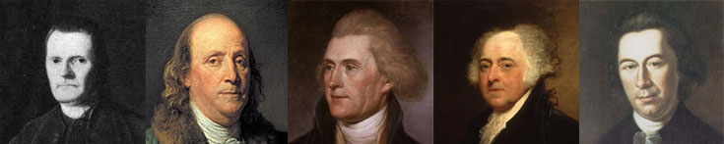
Sherman Franklin Jefferson Adams Livingston
- THE DECLARATION OF INDEPENDENCE – JULY 4, 1776
  - PREAMBLE – (INTRODUCTION TO THE DECLARATION OF INDEPENDECNE)
    - “We hold these truths to be self-evident, that all men are created equal, that they are endowed by their Creator with certain unalienable rights, that among these are Life, Liberty and the Pursuit of happiness.”
  - NATURAL RIGHTS - (RIGHTS GUARANTEED TO CITIZENS)
    - Thomas Jefferson writes a line in the Declaration of independence, “CERTAIN UNALIENABLE RIGHTS” this means rights that CANNOT be taken away and are granted from GOD himself.
    - This is the idea taken from JOHN LOCKE’s ideas of NATURAL RIGHTS
  - LIST OF GRIEVENCES – (LIST OF REASONS & COMPLAINTS WHY COLONISTS WANT INDEPENDENCE)
    - One of the Complaints (GRIEVENCES) is that KING GEORGE III ignored their rights as English Citizens and their petitions to change things.
    - Another complaint was that the colonies had “TAXATION WITHOUT REPRESENTATION” this means the King made taxes on them, and they had no one to speak for them in ENGLAND on their behalf.
  - DISSOLVING THE BONDS – (CONCLUSION TO DECLARATION)
    - The ending statement says that the colonies are to be, “FREE AND INDEPENDENT STATES.”
    - All political and government connection with Great Britain would be no more.
  - IMPACT OF THE DECLARATION OF INDEPENDECE
    - It united the 13 colonies as one “UNITED STATES OF AMERICA”
    - Ben Franklin said it best, “We must all hang together or assuredly we shall all hang separately”
    - Today this document is one of the world’s most important documents.
SECTION 2: A CRITICAL TIME
      - BATTLE OF LONG ISLAND, NEW YORK
        - 1776 fighting went from Massachusetts area, to New York.
        - A large fleet of ships arrived at New York with a new commander, “GENERAL WILLIAM HOWE”
        - George Washington was ready for him, but he was no match for the BRITISH and General Howe.
        - HOWE had 34,000 troops under his command, 10,000 sailors. Washington had 20,000 MILITIA.
        - HOWE drove Washington out of Brooklyn, then Washington abandoned New York and fled to hide.
        - HOWE created New York as the new HEADQUARTERS for the BRITISH.
          - NATHAN HALE – This man becomes an American hero. He volunteers to be a spy for the Americans, go into the HEADQUARTESR of the British at New York and try and steal BRITISH battle plans. He was recognized by a LOYALIST named, ROBERT ROGERS (QUEENS British Rangers.)
          - ROGERS took Hale to William Howe and interrogated him. Eventually taking him to a tree outside his HOUSE he was staying and hung him.
          - HALES final famous words, “I ONLY REGRET THAT I HAVE BUT ONE LIFE TO LOSE FOR MY COUNTRY”
          - 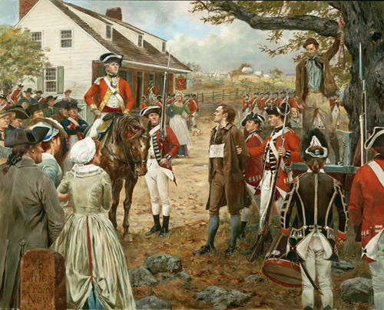
      - SUPRISES FOR THE BRITISH
        - The loss of New York and Nathan Hale was devastating news to Washington and his men. Their lack of supplies were frustrating. Congress could not fund the army very well. Many men wanted to quit, So Washington had to think of a plan
        - Washington asked author Thomas Paine to write another pamphlet to raise the spirits of the men. Paine wrote, “THE CRISIS”
            - Paine’s Crisis – urged Americans to support the army, even in hard times.
            - “These are the times that try men’s souls. The summer soldier and the sunshine patriot will, in this crisis shrink from the service of his country. But he that stands it now deserves the love and thinks of men and women.
            - Washington read it out loud to his men, and the men cheered. Washington knew his men’s spirits were high, it was time for an attack.
      - CROSSING THE DELAWARE RIVER – CHRISTMAS EVE
          - Washington knew he could not beat the British, so he kept running.
          - Washington also learned that they were was a nearby fort at NEW JERSEY occupying a small force of HESSIANS (German Mercenaries or HIRED GUNS by the British) and they were not ready.
          - Washington decided he would cross the Delaware River and attack NEW JERSEY
          - In December on Christmas is where he decided he had to get his army across it to safety. It was cold, and icy.
          - On Christmas, 2,400 men crossed the icy river in small boats.
          - Many soldiers had no shoes, no gloves, no socks, the cold water on their faces.
          - Washington crossed with cannons and horses. On the banks of the Delaware River, they were walking in snow without shoes and socks.
      - 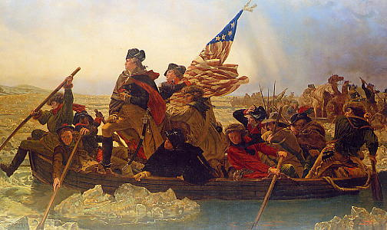
      - Washington had to go back 3-4 times to pick up his men. He planned on having 3 major crossings but only got 1 done. He was so far behind schedule he nearly stopped a planned attack on New Jersey.
- AN AMERICAN VICTORY
  - THE BATTLE OF TRENTON NEW JERSEY
  - With Washington crossing the Delaware River in the late night. Most of the HESSIANS (German Mercenaries or Hired Guns by British) that were protecting New Jersey were drinking and celebrating Christmas!
  - Washington ordered a tricky move. He told his men to light their campfires outside of Trenton so the British that were following them would see them lit. At the same time, they moved to attack TRENTON NEW JERSEY. It was a complete success! By the time the British saw them not there in the morning. It was too late.

- SARATOGA: A TURNING POINT IN THE WAR FOR AMERICA
  - PREVIEW TO THE BATTLE OF SARATOGA “BURGOYNES PLAN”
  - British General John Burgoyne came up with a plan that he hoped would end the war. His goal was to cut off NEW ENGLAND from the rest of the colonies His plan was this :
    - 1 – Take 8,000 men in 3 directions and take the areas of Lake Champlain, Lake George, and Upper Hudson River.
    - 2 – Take a smaller force toward Albany, New York
    - 3 – General Howe would march North and take lower New York City.
- British General Howe ran into trouble, King George III ordered General Howe to take Philadelphia instead of New York!
- The Americans cut off Burgoyne’s men from General Howe where he could not meet up with them.
- BATTLE OF SARATOGA
  - General Burgoyne knew he had to meet back up and defeat the Americans and drive them out. So first he went and recaptured FORT TICONDEROGA. Then moved slowly through the woods and started lacking supplies.
  - The American commander around New York City was GENERAL HORATIO GATES and he had 6,000 men
  - 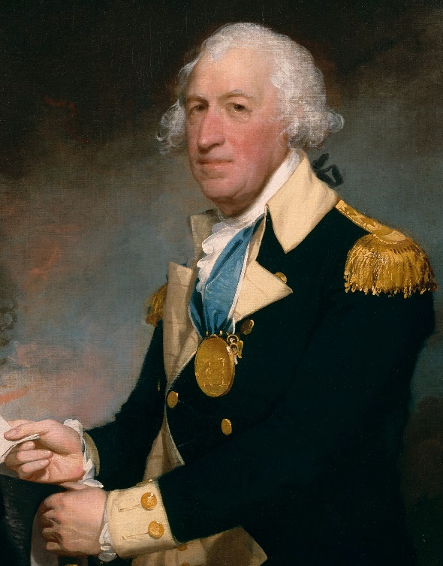General Gates
  - General Gates heard that Burgoyne was low on supplies and was marching toward New York City, so he took his men to a village called, SARATOGA outside of New York City. There he surrounded the British and gave them heavy casualties.
  - Burgoyne had no choice but to Surrender to General Gates on October 17,1777. This was the turning point in the war for the Americans
  - The win at Saratoga ended the British hopes that the war would end fast. It also lifted the Patriots spirits and encouraged the French to join our side.
- HELP FROM OVERSEAS
  - Soon after the Battle of Saratoga win for America, FRANCE was thinking about joining our side and becoming an ally (ALLIANCE – a formal agreement between two powers to work together for a common goal ). This was an agreement with King Louis 14th
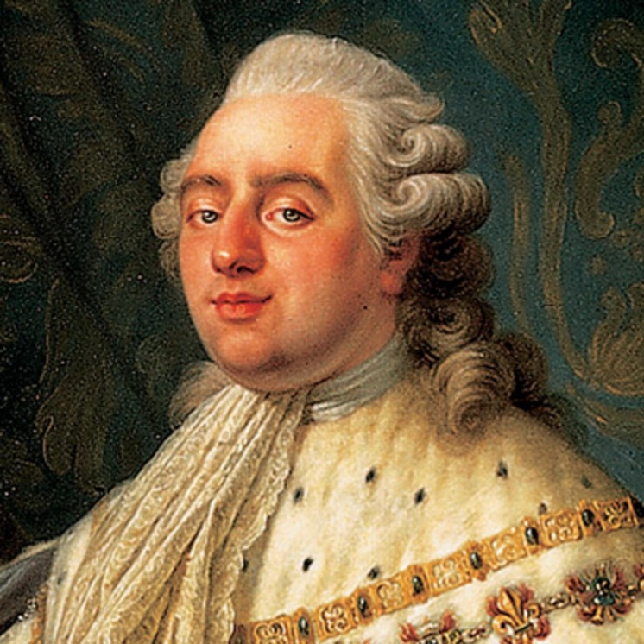
    - Two men were already over in Paris, France trying to get KING LOUIS to join.
    - The two delegates to FRANCE – A DELEGATE IS SOMEONE TRYING TO REPRESENT SOMETHING. LIKE A COUNTRY
            - John Adams & Benjamin Franklin
          - John Adams – Very eager to get the French to join, but way to pushy. No many of the French like him. Is eventually removed from France and moved to Netherlands to ask for a loan of money for the war.
          - Benjamin Franklin – Very likable because of his many experiments and makes friends with everyone. Was one of the big reasons FRANCE joins the United States in the American Revolution.
        - Before the FRENCH even joined, they secretly supplied money and arms to the Americans. France even sent over some volunteer commanders to help train the MILITIA
            - A French Noble - MARQUIS DE LAFAYETTE
              - He was an expert in training MILITA and becomes one of George Washington’s best friends and a high-ranking officer for the American forces. He gets wounded in battle and Washington tells the surgeons “TREAT HIM AS THOUGH HE WAS MY SON”
              - 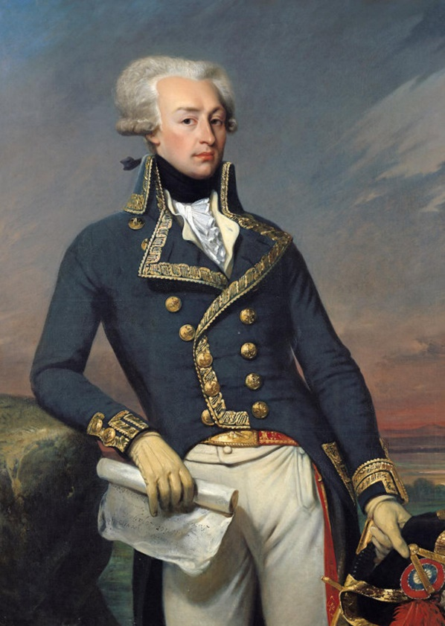
            - A Polish Engineer - THADDEUS KOSCIUSKO
              - Was an expert in creating FORTIFICATIONS, he was the one who helped design and make West Point (ARMY UNIVERSITY), He brought with him CASIMIR PULASKI who trained cavalry.
            - A Prussian Military General (German General) – BARON VON STEUBEN
              - Served in the Prussian Army which was considered one of the best in the world.
              - He was a General in the Prussian Army and was demoted for discovering that he was homosexual.
              - He trained the Continental Army basic tactics and gave them the art of the BAYONET.
              - 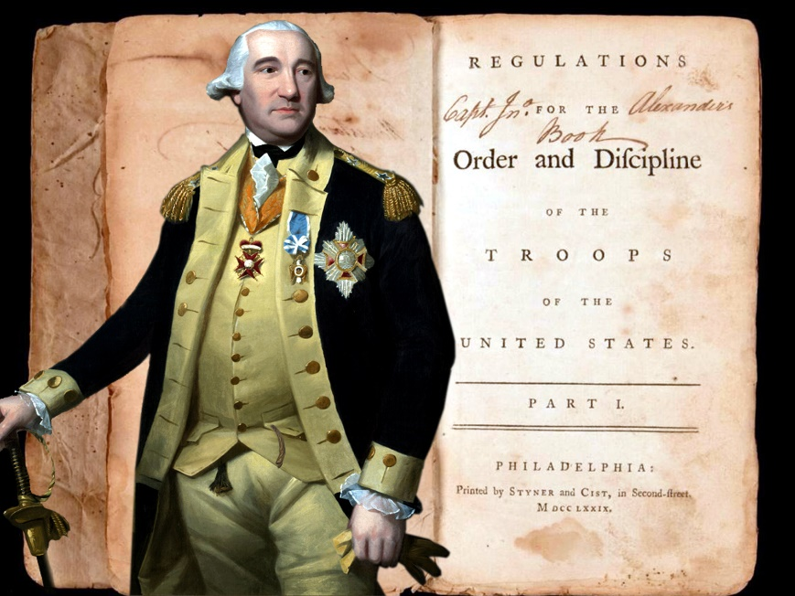
            - Leader of the French Army – JEAN BAPTISE ROCHAMBEAU
              - Commander of the French forces in the American Revolution.
              - Biggest contribution was during the Battle of Yorktown helping and communicating with General George Washington.
              - He was a general for France during the French Revolution, but was arrested and was supposed to be put to death but escaped because the leader was executed at the time.
              - 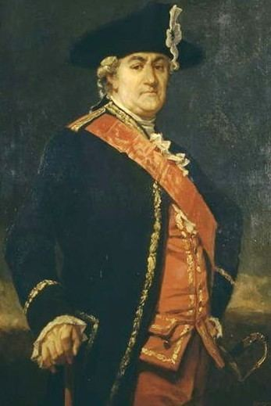

- VALLEY FORGE
  - General Washington knew that his army of MILITIA and volunteers were not ready to fight. They were under supplied and out matched for the British. He decided to hide and create a camp at a place called, VALLEY FORGE in PENNSYLVANIA.
  - This VALLEY FORGE was a tent made camp, some with sticks, some with log cabins. The men were without socks and gloves. Many of them got frostbite on their feet.
  - At the camp, food was scarce, men had to eat watery soup and dry crackers.
  - At VALLEY FORGE, women volunteered to help and came to the camp bringing goods, began washing clothes, knitting, and gave medicine to the sick.
  - BARON VON STUEBEN trained the CONTINEINTAL ARMY that made them a fighting force. BARON VON STUEBEN oversaw teaching the men how to fight like soldiers not like MILITIA.
    - STUEBEN created a pamphlet that AMERICAN ARMY still uses today to teach our current soldiers how to fight. STUEBEN taught the men discipline.

SECTION 3: THE WAR WIDENS
      - AFRICAN AMERICANS IN THE WAR
        - From the beginning, African Americans took part in the war in some way. For them it meant DANGER and OPPORTUNITY.
        - The British offered Freedom to slaves who ran away from their masters and joined the British army. Thousands join the British as a result. However, they served as cooks, blacksmiths and servants.
        - George Washington at first refused African Americans, but he changed his policy when the British let them join.
        - 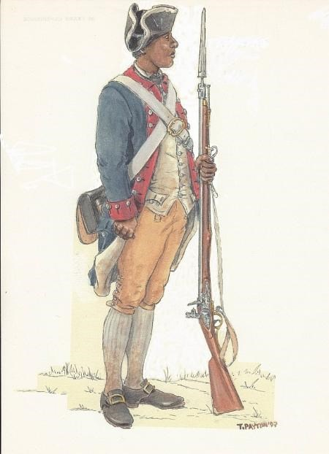
          - Many slaves served in the South rather than in the North. Many served on rag tag groups using Guerilla Warfare tactics taking out British soldiers and supply lines.
        - During the war in 1780 PENNSYLVANIA ended slavery.
      - THE WAR AT HOME
        - Many men ENLISTED – or signed up for duty in the CONTENTAL ARMY, Enlistments were 1 year.
        - WOMEN - took part in the war, they took up farming for their husbands, or ran their businesses. Some women went to military camps with their husbands.
            - DEBORAH SAMPSON- joined the army dressed as a man! When wounded she tended to her own wounds, so she would not be discovered. She used the name “TIMOTHY THAYER” She was eventually discovered after a year and half of fighting.
            - MARY LUDWIG HAYS nicknamed “MOLLY PITCHER” – volunteered to give soldiers water while fighting. Her husband was on a cannon next to her, he was wounded she dropped her bucket and took his role in loading the cannon.
            - 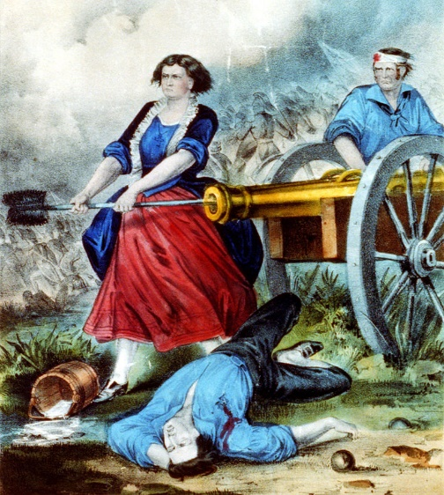
          - FINANCIAL BURDENS – Congress had limited resources. They had no taxes, so they printed “CONTINENTALS” or paper money. The more they printed the less the money was worth. By the end of the war, a CONTINETNAL was worth nearly nothing.
            - To make money Congress sent Ben Franklin to France to make and alliance. They sent John Adams to NETHERLANDS to create a loan. Both were successful.
      - FIGHTING IN THE WEST
        - Most of the war was fought in the 13 colonies. However, some of it was fought in the Frontier or where everyone did not live (FURTHER WEST)
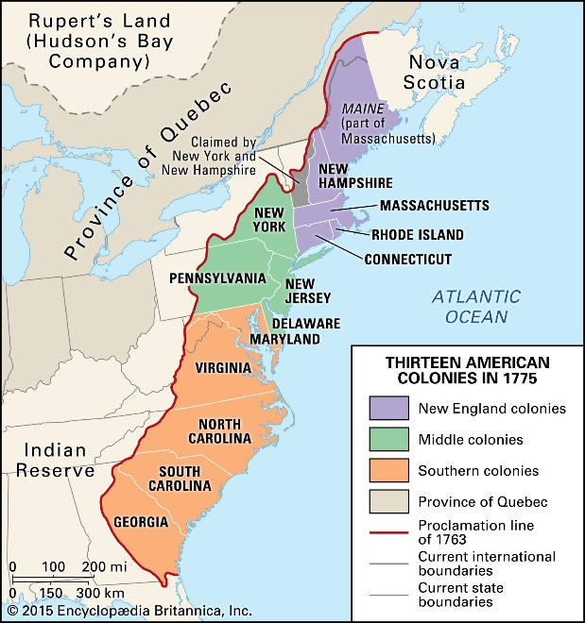
        - NATIVE AMERICANS had to take sides when the fighting came to the FRONTIER. Americans tried to keep NATIVES out of the war. NATIVES joined the British fearing they would lose more land with an American Victory.
          - Many Native Americans split tribes over which side to join. Many decided to leave and move further west. Sometimes Native Americans just had many raids on British and American camps.
          - The Biggest thing that hurt people dying including Native Americans was the SMALLPOX EPIDEMIC. SMALLPOX killed 130,000 whites and Natives and over 8,000 soldiers. George Washington at Valley Forge saved his army by infecting his men early (LIKE A FLU SHOT) so they would become immune to the disease.
        - Hoping to defend the Frontier, The Americans sent GEORGE ROGERS CLARK to go and attack BRITISH forts along the Ohio River Valley into the Frontier.
        - The Americans got unofficial help from SPAIN, Spain controlled LOUISIANA, and they wanted back FLORIDA. Spain began helping America long before declaring war on Britain in 1779.
        - Spain asked LOUISIANA GOVERNOR BERNANRDO DE GALVEZ to give money, guns, and ammo to GEORGE ROGERS CLARK. They also allowed American ships to be in NEW ORLEANS.
      - THE WAR AT SEA
        - Congress created a continental army at the 2nd CONTINENTAL CONGRESS but lacked a navy. They created one in 1775.
        - Problem was American shipyards could only make a few warships. These few warships began to use HIT AND RUN tactics.
        - The most famous battle was off the coast of ENGLAND in 1779, The BONHOMME RICHARD commanded by JOHN PAUL JONES. In the middle of the battle after about to lose he said, “I NOT YET BEGUN TO FIGHT.” JONES wins the battle with the help of PRIVATEERS – armed civilian ships to attack enemy ships. Some of them were PIRATES.
SECTION 4: WINNING INDEPENDENCE
            - In 1778 the British started to aim to take over the southern colonies. They wanted to earn the populations respect and take over cities then move north.
            - British hired GENERAL LORD CHARLES CORNWALLIS to win the south campaign.
              - Cornwallis was an expert in British warfare and was one of the better Generals that Britain had.
              - 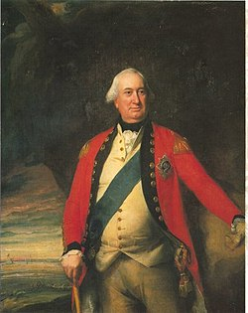
            - Cornwallis took control of the South Carolina capitol of Charlestown. He won many battles for the British and moved into North Carolina.
            - The Americans knew if Cornwallis made it to the Northern Colonies the British would win the war. So they began attacking Cornwallis in guerrilla warfare tactics.
              - The Americans asked South Carolina man, “FRANCIS MARION nicknamed the SWAMP FOX” to attack British Generals, Cornwallis’s supply wagons, in the south.
              - Marion’s men would move through swamps so they British never found them.
            - BENEDICT ARNOLD – A man who was in General George Washington’s inner circle. However, he was wounded in battle in his leg which left him gimp for the remainder of his life. Arnold was not happy with his command, he wanted more in the Continental Army.
              - George Washington gave command to Nathaniel Greene not BENEDICT ARNOLD Making BENEDICT ARNOLD mad. ARNOLD also fell in love with a woman in Pennsylvania who was a LOYALIST. And he married her, she began to turn him to the British side.
              - ARNOLD was also put on TRIAL for looting and taking money that he was not supposed to in war. His name was cleared but was still tarnished.
              - After back and forth deciding whether to be a PATRIOT or a LOYALIST he decided he would join the BRITISH side.
              - He met with GENERAL CLINTON the head of the BRITISH army and he wanted a position as a BRITISH officer, and command of an army. CLINTON agreed on some terms but not many.
              - ARNOLD was given command as a PATRIOT of a Important FORT CALLED WEST POINT (ARMY UNIVERSITY TODAY)
                - WEST POINT was a very good strategic point for the Americans, ARNOLD’s plan was to surrender and give the fort to the BRITISH.
                - With the use of AMERICAN spies, ARNOLD was discovered by WASHINGTON and was nearly arrested. He fled WEST POINT at the last second using a boat to cross a river to the BRITISH side.
                - FOREVER, BENEDICT ARNOLD WAS KNOWN AS AN AMERICAN TRAITOR
                - 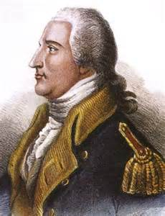BENEDICT ARNOLD
            - LAST MAJOR BATTLE : BATTLE OF YORKTOWN
              - PREVIEW: BATTLE OF COWPENS
                - Battle of Cowpens was a Battle where General Nathanael Greene split his army and flanked the BRITISH
                - He also told his MILIITA to get on the front and fire 3 shots and retreat making the BRITISH think they were surrendering.
                - The BRITISH charged after the 3 shots and met the AMERICANS charging at the same time with CAVALRY! The Americans won this HUGE battle based on strategy.
              - GEORGE WASHINGTON’s SPIES
                - Washington had a series of colonists send letters with invisible ink to each other
                - He also had various codes in letters for people to only know.
                - Washington would have women hang colored clothes based on where the British were at in cities like New York City, Boston, and Philadelphia.
                - By doing this Washington knew where the British was and was one step ahead of them.
                - ONE OF GEORGE WASHINGTONS SPIES Discovered that GENERAL CORNWALLIS was short on supplies and had moved his army to a place called Yorktown, Virginia.
              - BATTLE OF YORKTOWN
                - Washington heard that CORNWALLIS was there at YORKTOWN trapped like a rat in a cage.
                - CORNWALLIS was waiting on his BRITISH ships to pick him up and take him to a island on the other side.
                - 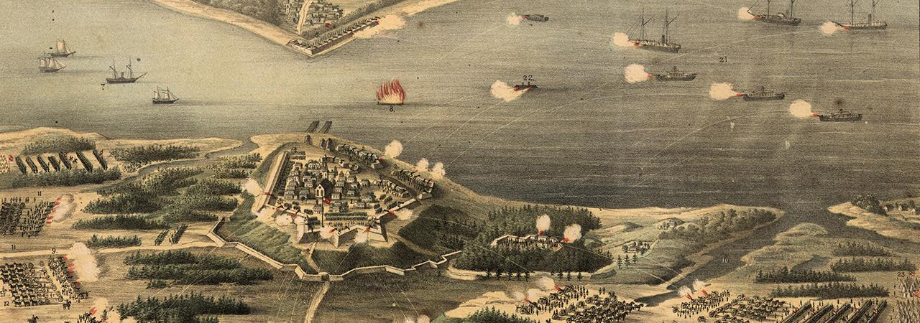
                - 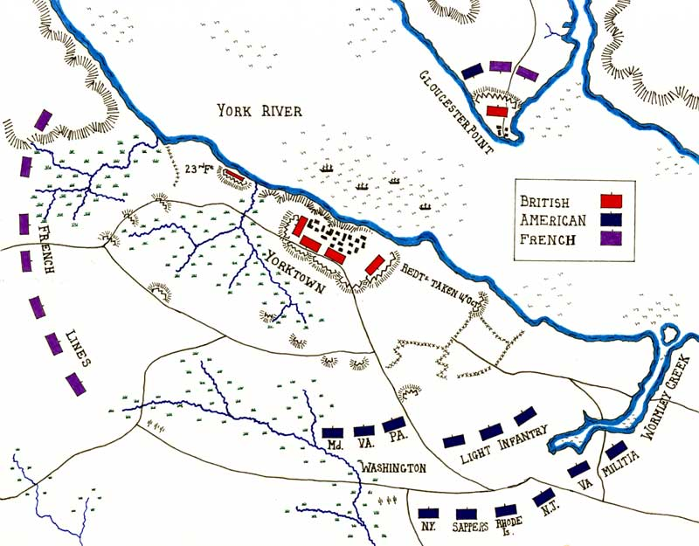
                - BRITISH GENERAL CORNWALLIS moved his troops to Yorktown to resupply. On the other side was a Peninsula called Gloucester Point. There was a British Fort there with plenty of men and supplies. CORNWALLIS just had to wait to be picked up.
                - WASHINGTON found out about CORNWALLIS being at YORKTOWN and ordered every single troop he had to that location. He arrived in the middle of the night.
                - Arriving with Washington at Yorktown,
                - 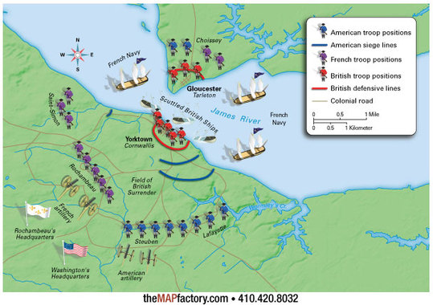
                - Every night, the American forces made baskets and put dirt in them and used them for barricades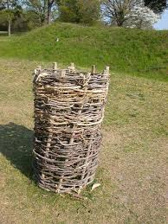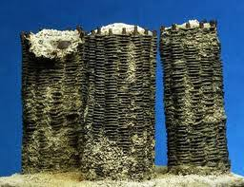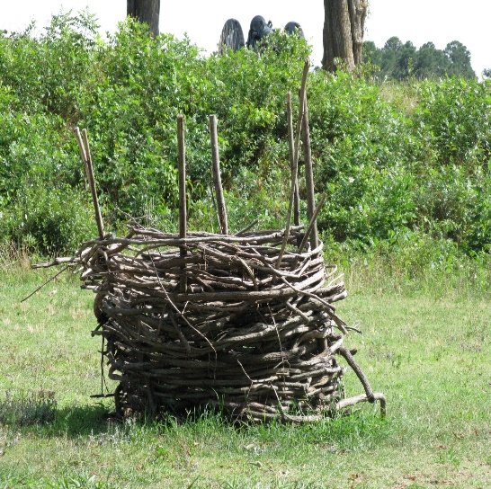

                - They used these BASKETS to put cannons behind as well. GEORGE WASHINGTON wanted the first shot!

                - 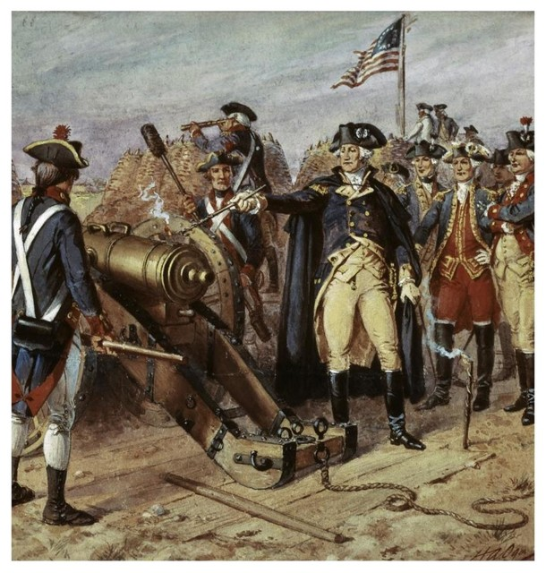
                - Washington’s advancements made it easy at Yorktown because it was somewhat cloudy over the 3 week siege
                - Washington and the French attacked a series of small dugouts called, “REDOUBTS” 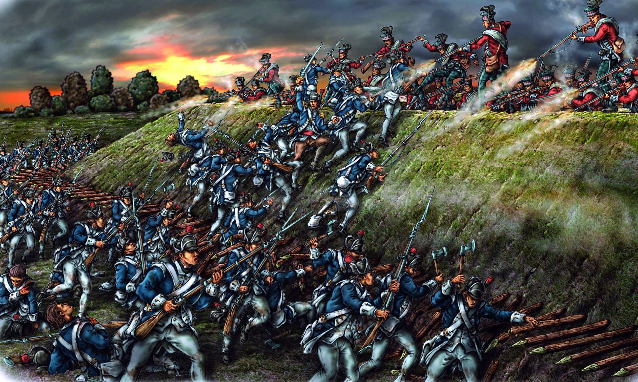
                - 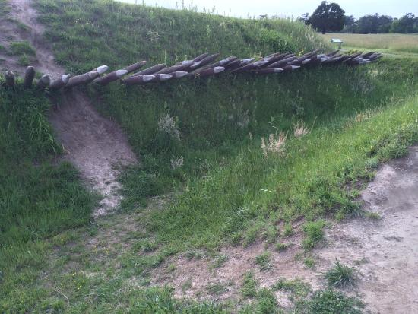
                - 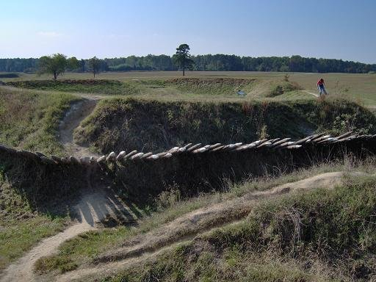
                - Washington and his men had the challenge of taking on #9 Redoubts and #10 Redoubts to reach Yorktown City.
                - The British fleet began to show up to try and pick up CORNWALLIS, however they were delayed because of a storm that was in the CHESAPEAKE BAY. This was HUGE FOR HISTORY. The delay allowed the French to show up and block CORNWALLIS from going across the Bay.
                - 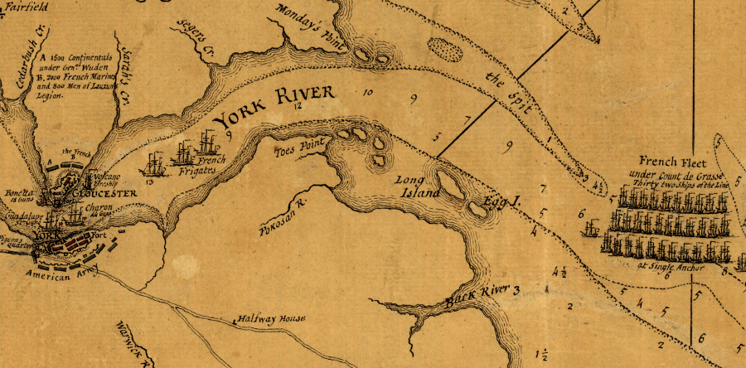
                - The French fleet won a large Battle in the Bay to block off the York River allowing CORNWALLLIS to be picked up
                - After 3 weeks of fighting CORNWALLIS had to surrender his men. However, he gave his sword to his assistant to surrender. He would not do it himself.
                - The British and Americans lied up in two facing columns. The British soldiers one by one walked down the walk way dropping their guns on the ground.
                - 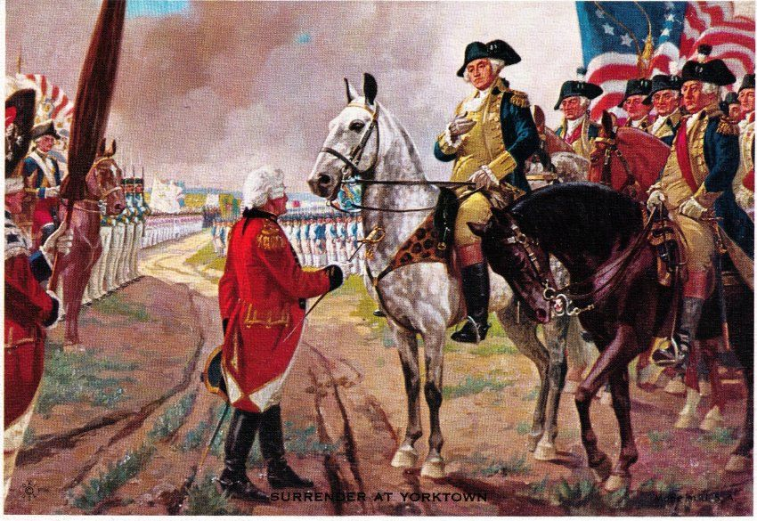
                - 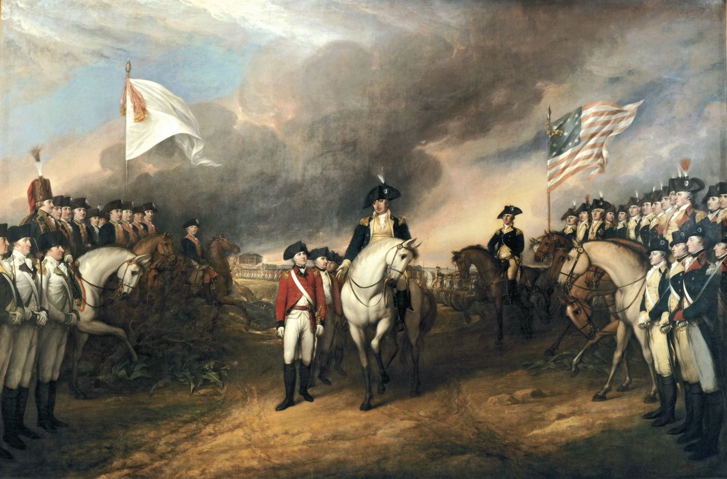

                - The end of the Battle happened on October 9, 1781. It was the last major battle of the American Revolution
            - MAKING PEACE WITH GREAT BRITAIN
              - News of the loss at Yorktown and Cornwallis surrender went through all of Europe. King GEORGE III did not want to surrender. The King wanted to keep fighting, but PARLAIMENT voted to stop fighting because Britain was still in debt.
              - Fighting went on for another few years, but the Battle of Yorktown sealed the British fate.
              - Peace talks began in Paris in 1782 with Benjamin Franklin at the helm. John Adams and John Jay went to Paris to help with the finalization.
                - JOHN JAY –
- Founding father of the United States of America,
- negotiated the Treaty of Paris, Governor of NY and
- Americas first Chief Justice of the Supreme Court.
- John Jay Was a co-author of the Federalist papers.
- John Jay Was the President of the 2nd Continental Congress in American Revolution
- 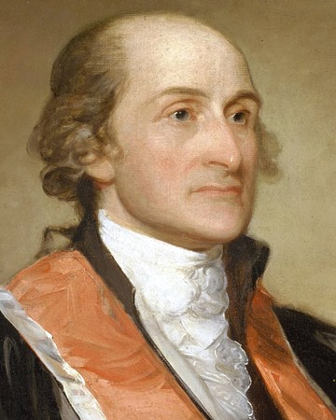
        - TREATY OF PARIS
          - This is the Treaty that ended the American Revolution. Negotiated by Ben Franklin, John Adams and John Jay.
          - At first, the peace negotiations did not go well because Britain did not want to recognize American independence. New people in British Parliament were elected and they were pro-American.
          - Many of these new elected officials in Parliament saw it as a trade opportunity to get Britain out of debt.
          - TERMS OF THE TREATY – BRITAIN & AMERICA
1. Great Britain would recognize American independence as a sovereign nation
2. Great Britain would give all land in the “NW Territory” (Illinois, Minnesota, Michigan, Ohio, Wisconsin, Indiana, Iowa) and other lands EAST OF THE MISSISSIPPI RIVER
3. Opened up the Mississippi River for the use of Navigation for both America and Great Britain.
4. America no longer owed Great Britain money. Their credit was cleared.
5. Made fair treatment for LOYALISTS who remained loyal to Great Britain during the war.
6. Allowed America to fish in areas of British Canada.
v. TERMS OF THE TREATY – BRITAIN & SPAIN
1. Great Britain would return Florida back to Spain for losing in the war.
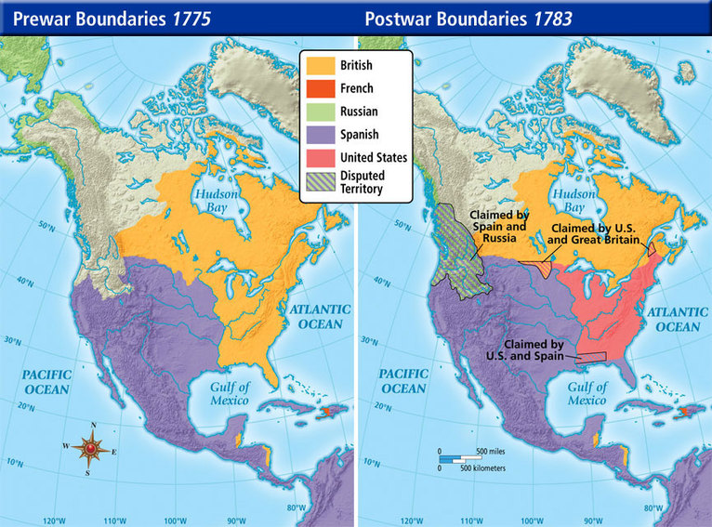

  - WASHINGTONG’S FAREWELL
    - On December 4, 1783 Washington met with his officers and had a meal in Fraunces Tavern in NY City. Washington told his men that he wished to retire to his plantation in Virginia called, Mount Vernon.
- IMPACT OF THE REVOLUTION
  - Created 13 Independent states
  - The American Revolution inspired other countries to rebel against their king as well (FRENCH REVOLUTION)
- WHY DID AMERICA WIN THE WAR?
  - AMERICAN PATRIOTIC SPIRIT - fighting to create a new nation.
  - GEOGRAPHY – Colonists were fighting in the forests, and swamps, they knew their surroundings.
  - SKILLED LEADERSHIP - George Washington never gave up in the war. He faced criticism and hardships.
  - HELP FROM OTHERS – American might never have won without the French Navy and Officers. Baron Von Stueben from Prussia to train the army. America also received money from the Netherlands.

