The Coming of War 1931-1942
Section 1 Study Guide -
What was the main cause of World War II? The Treaty of Versailles that ended WWI
Communism – started by Karl Marx, Revolution starts it all! Where the government owns everything and everything is dispersed evenly among the citizens. Everyone has the same wealth, land, food, houses but different jobs. No job is greater than the other. Everyone is working together, so no social classes exist because everyone is the same.
Fascism - a governmental system led by a dictator having complete power, forcibly suppressing opposition and criticism, regimenting all industry, commerce, etc., and emphasizing an aggressive nationalism and often racism.
Democracy – government by the people; a form of government in which the supreme power is vested in the people
Constitutional Monarchy - is a form of government in which a king or queen acts as Head of State. The ability to make and pass legislation resides with an elected Parliament, not with the Monarch.
Anti-Semitism – hatred or prejudice against the Jewish people
- Totalitarianism – created by Vladimir Lenin continued and made worse by Stalin
  - A theory of government where a single party or leader controls the following: economy, social, cultural, media, propaganda, youth programs, police and spies.
  - An example of a Totalitarian leader is : Joseph Stalin, Adolf Hitler, and Benito Mussolini
- Joseph Stalin – Soviet Union – Communist Party – Communism - (1917 Soviet Union - First Totalitarian Country)
  - Took over as dictator of Soviet Union after Lenin’s death in 1924.
  - Killed many innocent people to make Soviet Union an industrial power.
  - Used fear to stay in power, killed members of the Communist Party including high ranking officers in the Soviet Union’s Red Army. Called this “The Great Terror”
  - Stalin used “Propaganda “to stay in power – The use of art, movies, youth programs, posters, radio, and censorship to get people to believe in what you are doing. It is designed to MISLEAD the public in politics.
- Benito Mussolini – Italy – “IL DUCE” – Totalitarian Fascist Party – Fascism
  - Italy did not get land from Austria-Hungary in WW1, made them very upset.
  - Economic depression hits Italy, veterans cannot find jobs.
  - 1919 Benito Mussolini creates, “Fascist Party” or a conservative organization that trumpeted NATIONALISM
  - Mussolini promises to make Italy great once again through radio and speeches, gains many followers called, “Black Shirts”
  - “Black Shirts” fought in streets against socialists and communists in Italy.
  - 1922, Mussolini’s Black Shirts “Marched on Rome” to take over the government Italy King Victor, asked Mussolini to help him form a government as Prime Minister. Mussolini accepted but wanted to create Italy into a Totalitarian government with him as , “IL DUCE” or “the leader”
  - As Prime Minister or “IL DUCE”, Mussolini controlled the army, took over the press, outlawed political parties, and organized youth groups, and put down ALL strikes.
  - In 1935 Mussolini then focused on expanding the Italian empire by moving into Africa to Ethiopia
- Adolf Hitler (RISE TO POWER) - Germany– Leader of Nazi Party, - Author of Mein Kampf (“My Struggle”)
  - Grew up in Austria, as a failing artist. Got rejected from art school.
  - Declined during WWI to join the Austrian army so joined the German army instead.
  - WWI Hitler was gassed in the trenches leaving him partially blinded and blistered in the face.
  - Joined the Nationalist Socialist German Workers Party or NAZI after WWI. Becomes leader and a courageous speaker.
  - Hitler idolized Benito Mussolini because of what he was doing in Italy and Napoleon Bonaparte because of how great of a conqueror he was for France.
  - As leader Hitler tried to overthrow the Weimar Republic democracy government. The event was called the, “Beer Hall Putsch” Hitler tried to do the same thing Benito Mussolini did, however he failed and was thrown in jail.
  - While in jail Hitler wrote his autobiography, Mein Kampf which laid out everything he wanted to do as dictator including genocide of the Jews called the HOLOCAUST. BECAME GERMANY’S BEST SELLING BOOK
  - Once out of prison Hitler re-organized the Nazi Party, and began many speeches of how to get Germany out of the depression and that Germany would rise as a great nation.
  - Hitler would often speak of how Germany was cheated in WWI with the Treaty of Versailles how it was unfair.
  - People support made the Weimar Republic give Hitler a position in the government, “Chancellor” given to him by President Hindenburg who was 85 years old. Who beat out Hitler for Presidency a few years before.
  - As Chancellor Hitler gained more public support and the Nazi party gained seats in the Reichstag (German Parliament)
  - Hitler ordered his secret police the “SS or Schutzstaffel“to round up his enemies, anti-Nazi, rival political leaders, and people against the new German regime he was creating and execute them. EVENT CALLED: “NIGHT OF THE LONG KNIVES” by doing this Hitler had no one to stop him from becoming dictator.
  - President Hindenburg dies, and full authority now went to Adolf Hitler, because the Nazi party abolished the term, “Presidency” right before his death. The SS and Hitler then pushed the title “Fuhrer” for Hitler and succeeded.
  - Hitler 1933-36 focused on 2 things, focused on REBUILDING ECONOMY, & RISING THE ARMY NAVY AND AIR FORCE
  - Hitler disobeyed the Treaty of Versailles, and re-gained territories in RHINELAND, SAAR, & ALSACE LORRAINE, and SUDETENLAND.
  - 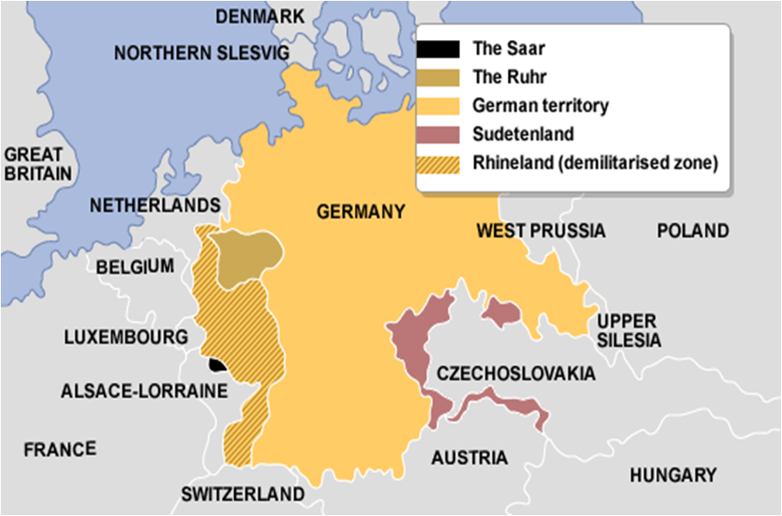
1
3
4
4
3
2
1
2
  - In 1938, Hitler brought Austria into his empire or “REICH” This EVENT CALLED : ANSCHLUSS
  - ALL new lands were given to Hitler because of “APPEASEMENT”, Neville Chamberlain; British Prime Minister appeased Hitler and gave him the land at their “MUNICH PACT” conference in Munich Germany.
- General & Prime Minister Hideki Tojo - Japan – Constitutional Monarchy – Dominated by Military – Invaded China and SE Asia – Bombed Pearl Harbor – RISE TO POWER
  - 1920’s democracy was pushed and the military was decreased, all men got the right to vote, legalized trade, and allowed political parties. – ALL OF THIS ENDED BECAUSE OF THE GREAT DEPRESSION. THEY BLAMED THE LEADERS
  - Military leaders argued that expansion would solve their economic problems
  - The military then began to take control of the country and attacked NE China “Manchuria” renaming it Manchukuo
  - Japan took control of the regions natural resources and invaded the Capitol city of China, Nanjing – EVENT NAMED: “Rape of Nanjing”
  - Japan becomes the region’s economic leader. But, had much trade with the United States such as oil, iron ore, fuel, steel, and rubber. They needed the oil to fuel their military campaign of SE Asia.
  - Japan does not like the United States in the Philippines and Guam. They resented the fact that the United States supported China and had them in their SPHERE OF INFLUENCE.
  - 1940, FDR stopped trade with China called, EMBARGO, because Japan signed Tripartite Pact with Germany and Italy
  - 1941 Hideki Tojo becomes Prime Minister of Japan nicknamed, “THE RAZOR” focused completely on military expansion but keep the USA neutral with Japan.
  - General Tojo wants expansion, but America’s Secretary of State “Cordell Hull” does not want them to expand.
  - As a result, December 7, 1941 the Japanese attacked Pearl Harbor at Hawaii.
- League of Nations – Created after WWI 1919
  - Had no standing army and did not have a primary member in it, The United States of America.
  - The League of Nations was only as powerful as its nations in it. This was not very powerful at the time especially after depression of the 1930’s
  - Challenged by Hitler & Germany many times, every time the League of Nations backed down & kept “APPEASEMENT” (or giving political, economic, military, or money to an enemy power to keep out of conflict and keep an enemy happy.)
  - Its primary goal was the prevention of a 2nd World War, it failed. It dissolved in 1945-1946 after WW2.
- Spanish Civil War 1936-1939 – Francisco Franco - Helped by Mussolini and Hitler
  - Fascist Nationalist leader Francisco Franco started an uprising against a democracy Spain. He was aided by Nazi Hitler and Fascist Benito Mussolini.
  - Hitler and Mussolini sent military weapons to test out their new technologies, and money to finance the uprising.
  - The Soviet Union under Joseph Stalin gave weapons to the democracy Spain to stop the uprising, but it was not enough.
  - The United States, France, and Britain said they support Spain, but didn’t and Francisco Franco took over Spain until his death in 1975.

Section 2 Study Guide

TERMS
Blitzkrieg – a sudden attack meaning a “lightning war” used speed and firepower to get into enemy territory.
Allied Powers – Included the following countries: Britain, France and eventually Soviet Union, United States and China.
Axis Powers – Included the following countries: Germany, Italy, and Japan and several other smaller nations.
Tripartite Pact – Treaty signed between the 3 main Axis powers that officially made them allied together.
Lend Lease Act – Passed by Congress to give natural resources and money to the allies without going to war. This was to also give for the defense of the United States. This was a economic declaration of war against Germany.
Atlantic Charter – Passed by Winston Churchill and President Franklin Delano Roosevelt on a ship. Set the standard after WW2, where no there is freedom of seas, no gained territory, easier trade, and disarming the aggressor nations.
Neutrality Acts of 1935-1937 – Put restrictions on Americans during times of war. Such as sailing on other nation’s ships, making loans to other nations, or selling them weapons.
Neutrality Act of 1939 – Passed by Congress where nations could buy goods and arms from the United States with cash and carried the merchandise on their own ships. This benefitted Great Britain and the allies because they controlled the seas.
Nazi-Soviet Nonaggression Pact 1939 – Publically made, but secretly planned made between Stalin and Hitler agreeing not to attack one another. Let Hitler invade Poland and divide up Poland and help each other’s territorial gain.
Maginot Line – Series of forts made by France along the German-France border to stop the German invasion of France.
Charles Lindbergh – Said that America should be an isolated country during war, and that the biggest threat was the Soviet Union and Japan.
Winston Churchill – Prime Minister of Great Britain that would not give in to Hitler with appeasement.
German Luftwaffe – Also known as the German Air Force that bombed the city of London on the Battle of Britain.
Vichy France “Unoccupied” – Territory of France where it was considered neutral but still in control of Nazi-Germany.
Selective Service Act – peacetime draft to train 1.2 million Americans and 800,000 reserve troops a year to prepare for war.
USS Rueben James, USS Kearny, USS Greer – Ships that were taken out by German U-Boats carrying goods to Britain and to drop them off in Iceland.

Section 3

- Japan Gets Angry with the United States at Pearl Harbor, Philippines and Guam.
  - Vice Admiral Chuichi Nagumo became the person who was in charge to take out the naval battleships and airplanes stationed at Pearl Harbor, Hawaii
  - He brought with him 6 aircraft carriers, 360 planes, battleships and submarines.
  - The Japanese sent spies as tourists to take pictures of the harbor for better attack.
  - The Japanese used planks on the back of the torpedoes to keep them from sinking to the bottom of the harbor.
  - The attack took place on December 7, 1941 by complete surprise that is still today the best secret attack in History.
  - The attack killed 2,500 people and did major destruction to the USS Arizona, USS Oklahoma, and USS Utah.
  - The attack plan was supposed to be in 3 waves but Nagumo stopped the third wave because he said they lost surprise attack position and feared American counter attack. He sailed home after successful attack.
  - The attack on Pearl Harbor crippled the US Pacific fleet for 6 months, allowed the Japanese to gain the natural resources they needed to expand their territory.
  - They also attacked the following to get natural resources (oil) Philippines and Guam.
  - At the Philippines famous General MacArthur from the BONUS ARMY situation was stationed there to try to keep it but was unsuccessful.
  - MacArthur lost the battle, and was put in Australia by the USA cause he was valuable. His 75,000 troops surrendered and had to March up 55 miles at the Bataan Peninsula where 7,000 died. Event called the Bataan Death March
  - As a result the United States declared war on Japan
- United States Mobilization
  - In 1941 and 1942 the army, navy, marines, all expanded from about 1.4 million to 3 million after Pearl Harbor.
  - Native Americans & African Americans both served in segregated regiments. African Americans with whites after heavy deaths.
  - Women Army Corps (WAC) was formed as well in 1941. Women became: truck drivers, instructors, nurses, and lab technicians. Total was about 350,000. Congress woman Edith Noruse Rogers pushed for this.
  - The United States created the War Production Board (WPB) to collect together resources for the war effort. They were in close association with the Office of War Mobilization to look over the efforts.
  - The Great Depression Ended because everyone had jobs producing military goods.
  - Ford Motor Company, produced many of the nation’s Liberator Bombers
  - Henry J. Kaiser produced the nations merchant “Liberty Ships” that traveled across the Atlantic Ocean.
- Doolittle Raid & Battle of Coral Sea Strikes Back
  - FDR wanted to strike back after Pearl Harbor. He wanted to hit Japan just like Japan hit Pearl Harbor
  - FDR called for bombing Japan using American Aircraft Carrier USS Hornet led by Colonel James Doolittle
  - 800 Miles away from Japan, the USS Hornet was detected; the Bombers on the Hornet had to launch early.
  - They flew to Tokyo and targeted military buildings but did not kill many Japanese.
  - The B-25 bombers crash landed in China, but accomplished their mission in raising American moral and paying back the Japanese for what they did to Pearl Harbor.
  - The other thing that raised American Moral was the Battle of Coral Sea, American Aircraft Carriers with planes stopped Japanese invasion of New Guinea

